Protocol: Name of the MarineGEO Protocol

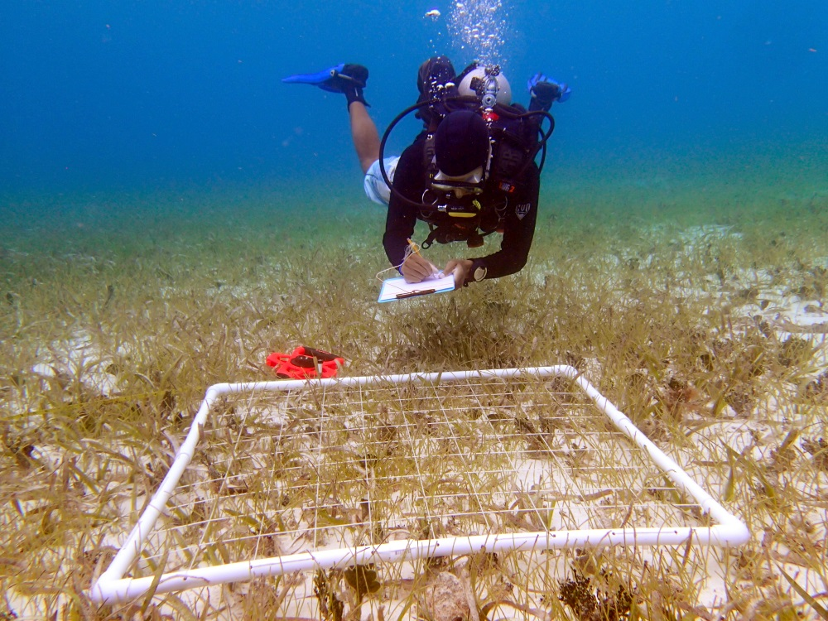

How to cite this work: Protocol: Name of the MarineGEO Protocol. (2020) Tennenbaum Marine Observatories Network, MarineGEO, Smithsonian Institution.



## Introduction

*Please provide an introduction for the protocol which briefly explains the context and purpose for the information being gathered.*

## Measured Parameters

*Please indicate what this protocol seeks to quantify.*

## Requirements

Number of Personnel: ex. 1-2 people

Estimated Total Time Per Location: *(indicate the number of people and the length of time)*

Preparation: *ex. 1 person x 1 day*

Field work:

Post-processing:

Data processing:

Replication: *ex. At least three (3) sites per habitat.*

*Please list any required materials for the survey design, fieldwork, or post-processing steps. Provide links where necessary or indication if an item will be provided by the network.*

## Methods

Fully review this and any additional protocols necessary for the sampling excursion. Address any questions or concerns to [marinegeo@si.edu](mailto:marinegeo@si.edu) before beginning this protocol.

*Please provide a step-by-step description of the process which participants can follow easily. Methods can be broken down into sub-sections, such as preparation, fieldwork (i.e. deployment, monitoring, retrieval), and post-processing of the samples. Include any photos or tables that will be helpful or necessary to complete these steps.*

## Data Submission

1. Scan the completed field data sheets and save both paper and electronic versions locally. We do not require you to submit the scanned forms.
2. Enter data into the provided data entry template. Each template is an Excel spreadsheet. Please provide as much protocol and sample metadata as possible, such as the protocol version and contact information. Use the “notes” columns to provide additional information or context if a relevant column doesn’t already exist, rather than renaming or creating columns.
3. Use our online submission portal to upload the Excel Spreadsheet: <https://marinegeo.github.io/data-submission>
4. Contact us if you have any questions: [marinegeo@si.edu](mailto:marinegeo@si.edu)