Salt Marsh Fauna



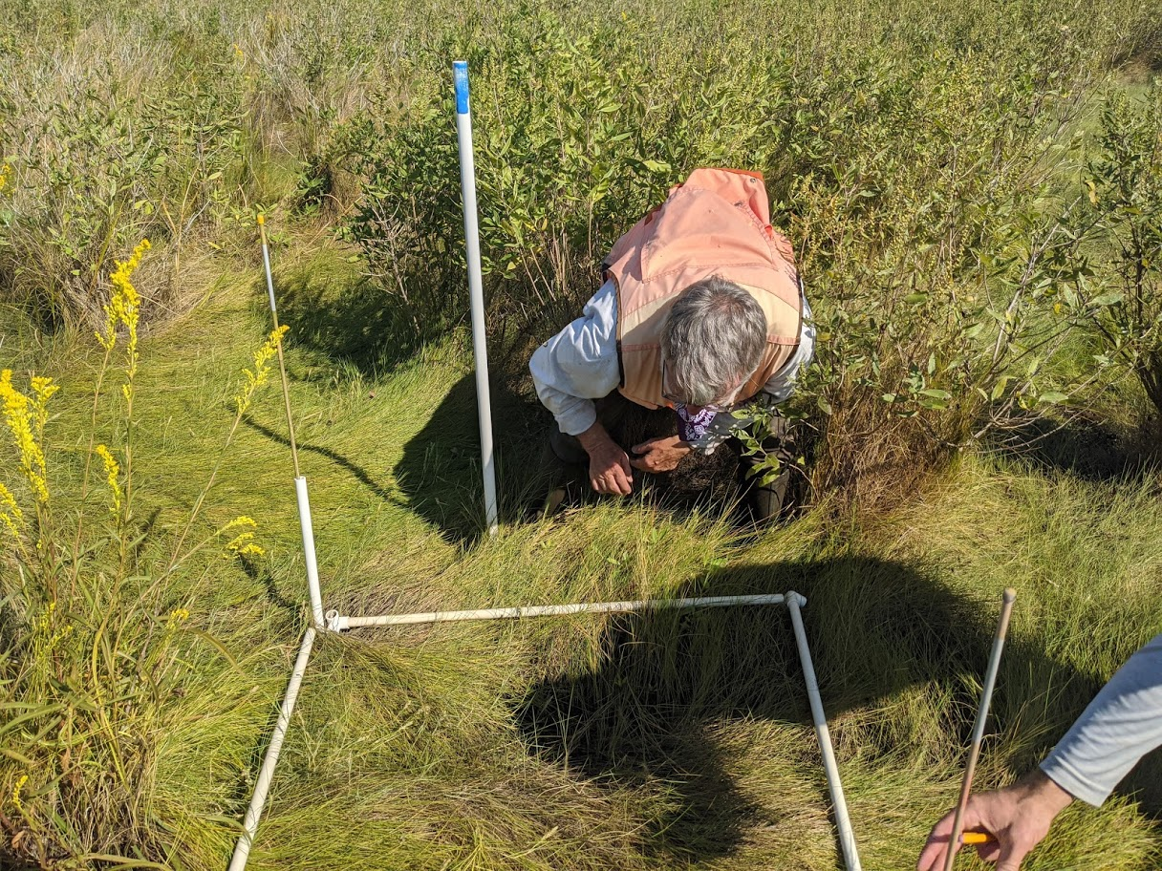

How to cite this work: Protocol: Salt Marsh Fauna. (2021) Tennenbaum Marine Observatories Network, MarineGEO, Smithsonian Institution.





Introduction

Tidal salt marshes support a variety of invertebrate species living within and among vegetation, root structures, and sediments. Marsh ecosystem structure and function depend, in part, on the abundance and diversity of these taxa and the services they provide. This protocol provides a standardized methodology for estimating species composition and abundance of saltmarsh invertebrate infauna and epifauna. Prior to starting fieldwork, permanent marsh transects should be established using the Salt Marsh Survey Design Protocol. Infaunal samples are taken with a hand coring device designed to collect a standard volume of sediment for calculation of infaunal densities. Epifauna are surveyed visually within a 0.25m2 area of select plots. Lab processing steps entail separating infauna from detritus, identifying species, and counting individuals.

Measured Parameters:

* Infaunal density (individuals / cm3) and taxonomic composition
* Epifaunal density (individuals / 0.25m2) and taxonomic composition
* Crab burrow counts (burrows / 0.25m2)
* Bivalve/gastropod shell length (mm)
* Crab carapace width (mm)



Requirements

Personnel: 3 people

Estimated Total Time Per Location (*n* = 3)

Preparation: 1-person x 1-2 hours

Fieldwork: 3 people x 1 day per marsh

Post processing: 1-person x 0.5 day

Lab work: 1-person x 1 week

Data processing: 1-person x 0.5 day

Replication: 3 replicate plots per marsh, 3 marshes per region

Materials:

*Fieldwork*

* 6.3 cm (2.5 inch) diameter aluminum sediment corer
* 3.78 L (1 gallon) sealable bags (9)
* 3 m folding ruler (3)
* Epifaunal abundance datasheets
* 150 m dial caliper (2)
* Hand-held GPS pre-loaded with transect and plot coordinates
* Water-proof labels (9)
* Permanent marker
* Small cooler with ice

*Lab Work*

* 70% ETOH + 10% rose bengal solution
* 20 mL glass scintillation vials (9)
* 1.0 mm sieve
* Fine tip squeeze bottle
* Petri dishes
* Dissecting microscope
* Forceps



Methods

Fully review this and any additional protocols necessary for the sampling excursion. Address any questions or concerns to [marinegeo-protocols@si.edu](mailto:marinegeo-protocols@si.edu) before beginning this protocol.

Preparation

1. Review and complete the Salt Marsh Survey Design Protocol for selection and establishment of permanent sampling sites.
2. Review this protocol and print datasheets on waterproof paper prior to starting fieldwork.
3. Print waterproof labels (*n* = 9) including sampling date, marsh site, transect number, and plot number for each infauna sample to be taken and label zip-locks bags with permanent marker.
4. Measure 10 cm from the opening of the hand corer and make a horizontal mark with permanent marker (Fig. 1).
5. Before heading into the field, fill a container with ice for sample storage.
6. Plan to sample at low tide when marsh is not inundated.

Fieldwork Part 1: Infauna

1. Along the middle transect of each marsh site, infauna cores are taken at the 1st, 3rd, and 5th plots (Fig. 1), (*n* = 9 cores).

**Figure 1.** Example of 6.3 cm diameter hand corer marked with 10 cm depth line.

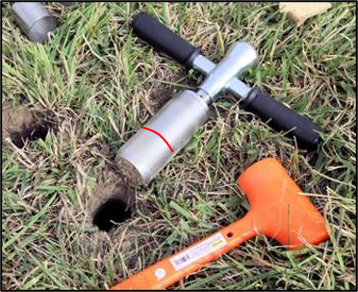

1. Using the random number table provided (Table 1), close your eyes and choose a number from the table. This number corresponds to a quadrant within the larger 1m2 plot. Take the sediment core diagonally adjacent to this quadrant (Fig. 2) in each plot.
2. Using the aluminum hand corer, take a 10-cm deep, 6.3-cm diameter sediment core approximately 50 cm away from the selected corner of the plot (Fig. 2). Press the hand corer vertically into the substrate to the 10 cm depth line, twisting if necessary to cut through roots.
   * If there is standing water at your chosen sample point, move left or right to the nearest patch of exposed substrate.
3. Place the sediment sample in a pre-labeled gallon-size (3.78L) zip-lock bag along with the associated water-proof label for that plot. Place each bag in the ice-filled cooler for transport back to the lab.
   * Infaunal samples should be processed within 24-h of collection.

**Figure 2.** (A) Random number table (RNT) for selection of quadrant for infauna and epifauna sampling. (B) Example location of infauna core given random selection of “2” from RNT. Note that random numbers need only be selected once per transect.

Fieldwork Part 2: Epifauna

1. Epifaunal surveys are conducted along with infaunal sampling at the 1st, 3rd, and 5th quadrat of the middle transect of each marsh site (*n* = 9 surveys).
2. Epifauna are surveyed within the 0.25m2 quadrant selected in Fieldwork Part 1 (Fig. 2)
3. To demarcate the 0.5m x 0.5m area of the larger plot to survey, subdivide the plot into quarters using 2 foldable rulers laid perpendicular to each other across the plot.
4. Identify and count all macroinvertebrate taxa present on the substrate surface and clinging to vegetation within the selected 0.25m2 area.
   * For bivalves and shelled gastropods, measure total length (mm)(Fig.3) of the first 25 individuals per species, count the rest.
   * For crabs, measure carapace width (mm) (Fig. 3).
   * Release all animals after processing.
   * If unidentifiable species are encountered, photograph each for potential identification later.
5. If present, count and record the number of crab burrows within the 0.25m2 area,
6. Repeat Fieldwork Parts 1 and 2 for the 1st, 3rd, and 5th plot of the middle transect of each marsh site.

Lab work: Part 1

1. Print all lab data sheets and scintillation vial labels containing the sampling date, marsh name, transect number, and plot number.

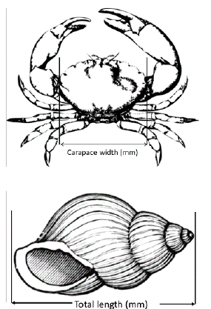

**Figure 3.** Length measurement diagram for crabs and shelled molluscs.

1. Pour the contents of each zip-lock bag into a 1mm sieve and gently rinse a squeeze bottle with tap water.
2. Continue rinsing, taking care not to use too much pressure to avoid damaging fragile specimens, until all sediment is washed away and only animals and larger pieces of debris remain in the sieve.
3. Discard any large debris then gently transfer all animals into a 20 ml scintillation vial containing 70% ETOH / 10% Rose Bengal solution.
4. For each vial, attach an exterior label and include an interior waterproof label.
5. Repeat for all samples, making sure to thoroughly rinse sieve between uses.
6. Store vials until the end of the field season.

Lab work: Part 2

1. Transfer the contents of each vial into a 10-cm Petri dish for identification.
2. Using a dissecting microscope, identify each taxon in each sample to species and record the species name on the infaunal abundance datasheet. If you cannot reliably identify a taxon to species, identify it to the lowest taxonomic group that you feel confident. Then, give it a provisional name (e.g., Nereid polychaete A). Photograph unidentified species and label image file names with the sample information and the provisional species name you assigned on the data sheet. These images can be used to later clarify the species’ identity. *Be sure to maintain the naming scheme for all future samples* (especially if samples are processed by different people).
   1. Count only macroinfauna and exclude meiofauna (e.g. nematodes and copepods).
   2. Only count animals that were alive at the time of collection: discard exoskeletons.

* For gastropods, gently break open shells to verify that the individual was alive when collected. Only count shells that have tissue inside.
  1. Count only full specimens or those with anterior portions intact. Discard disembodied limbs, posterior ends of polychaetes, amphipods, etc.

1. Count and record the number of individuals for each species on the provided lab sheet.
2. Return all specimens to the labeled 20-mL vial, fill with 70% ethanol, and seal for long-term storage.



Data Submission

1. Scan the completed field data sheets and save both paper and electronic versions locally. We do not require you to submit the scanned forms.
2. Enter data into the provided data entry template. Each template is an Excel spreadsheet. Please provide as much protocol and sample metadata as possible, such as the protocol version and contact information. Use the “notes” columns to provide additional information or context if a relevant column doesn’t already exist, rather than renaming or creating columns.
3. Use our online submission portal to upload the Excel Spreadsheet: <https://marinegeo.github.io/data-submission>
4. Contact us if you have any questions: [marinegeo-protocols@si.edu](mailto:marinegeo-protocols@si.edu)