Salt Marsh Survey Design



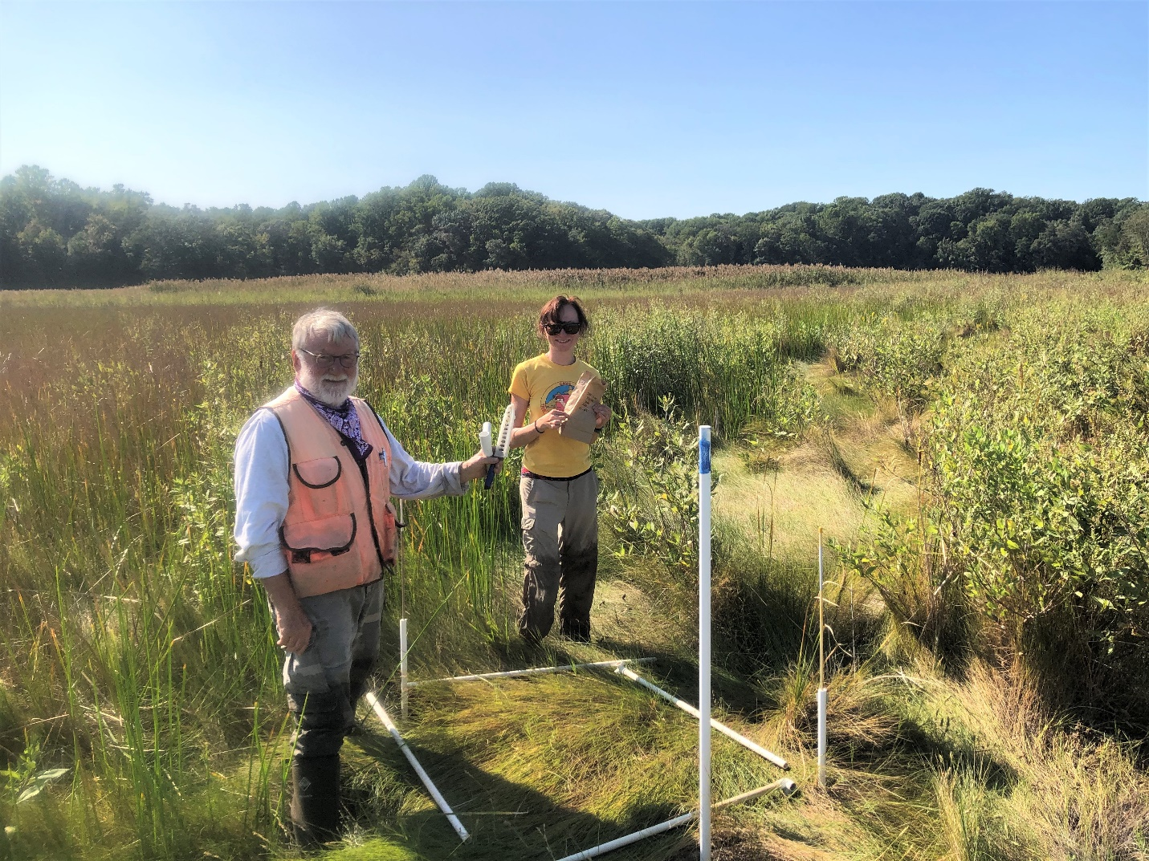

How to cite this work: Protocol: Salt Marsh Survey Design. (2021) Tennenbaum Marine Observatories Network, MarineGEO, Smithsonian Institution.





Introduction

Coastal salt marshes are biogenic wetland habitats defined by regular inundation with salt water from tides. Plant species diversity is typically low and comprised of salt and submersion-tolerant species. Salt marshes provide a variety of services including erosion protection, essential habitats for fish and invertebrates, nutrient filtering, and carbon sequestration. Principal threats include coastal development, accelerating sea level rise, and pollution from land-based sources. Salt marshes have a near-global distribution although they are most prevalent along protected shorelines in the mid to high latitudes. Given their widespread occurrence and position at the land-sea interface, salt marshes are ideal ecosystems to examine responses to global change.

This document provides an overview of MarineGEO’s standardized methodology for estimating key ecological parameters in salt marshes including plant species composition, above-ground primary productivity, infaunal and epifaunal diversity and abundance, consumption rates, and sediment organic matter. Also provided are site selection and establishment procedures and an integrated workflow. Marsh vegetation surveys are conducted during the period of annual maximum standing biomass in the late summer or early fall. Prior to data collection, marsh transects must be selected and plots established for permanent sampling.

Modules

Core (Required)

* Marsh plant species cover and allometry (biotic and abiotic cover, species composition, stem widths, stem heights, live stem density)
* [Predation](https://marinegeo.github.io/assets/modules/predation-assay/marinegeo_protocol_predation_assay.pdf) (bait loss, ‘Squidpops’)

Recommended

* [Beach seine](https://marinegeo.github.io/modules/fish-seines), [Trawl](https://marinegeo.github.io/modules/fish-trawls), and/or [Visual census](https://marinegeo.github.io/assets/modules/visual-census/marinegeo_protocol_visual_census.pdf) (mobile fish and invertebrate abundance, length, composition)
* [Sediment organic matter](https://marinegeo.github.io/assets/modules/sediment-organic-matter/marinegeo_protocol_sediment_organic_matter.pdf) (bulk density, organic carbon)
* Saltmarsh fauna (infauna/epifauna species composition, infauna/epifauna abundance, crab burrow counts)



Requirements

Personnel: 3 people

Estimated Total Time Per Marsh Site (*n* = 3 transects)

Preparation: 1-person x 1 day

Fieldwork: 3 people x 1 day

Sample Post-processing: Variable - see individual protocols

Data processing: 1-person x 1-2 days

Materials:

* 150 cm length of PVC (15/marsh)
* 80 cm length of PVC (30/marsh)
* Metal tags for quadrat identification (15/marsh)
* Handheld GPS unit
* 50-meter transect tape
* Small cable ties (15/marsh)
* All materials from Core and Recommended materials (see individual protocols)

**Figure 1**. Sampling diagram of a single marsh site showing replicate transects and relative placement of surveys for core and recommended modules. Note that transects are separated by a minimum of 20 meters and quadrats are spaced at 10-meter intervals.



Workflow

Preparation

1. Using an engraving tool or similar, inscribe unique identifying codes onto the metal tags for every plot to be established (*n* = 45) (Ex: marsh A, transect 1, plot 1 = “A1-1”) (Fig. 2).

Site Selection and Establishment

1. Identify 3 salt marshes, each in separate bays or sub-estuaries, for permanent sampling. Each marsh should be typical of your region, reasonably accessible, at least 60 meters long (along shore) and 50 meters wide (perpendicular to shore)
   * Transects should run approximately parallel to the dominant environmental gradient (e.g., tidal elevation, salinity) (Fig. 1).
2. Within each marsh, identify 3 transect locations containing 50 linear meters of vegetated area perpendicular to shore and separated from one another by at least 20 meters.
3. At each transect location, measure 40 meters perpendicular to shore heading into the marsh using a transect tape. Beginning at the shore (0 m), mark plot locations every 10 meters on the righthand side of the tape (facing away from shoreline) using 150 cm PVC sight poles to mark the near corner of each plot (Fig. 1; Fig. 2). Record plot coordinates with a handheld GPS unit.
   * If a 10-meter increment falls over a tidal creek or other non-living obstacle (e.g. boulder, un-vegetated mud flat, large piece of wrack), make note and reposition the plot as close as possible to the original location on the far side of the obstacle along the transect, heading away from shore.
4. Mark 2 diagonal corners quadrats of each 1m x 1m quadrat with 80 cm lengths of PVC driven into the marsh (Fig. 2).
5. Using a small cable tie, attach a metal tag engraved with respective transect and plot numbers to the PVC corner post adjacent to the sight pole in each plot (Fig. 2).

**Figure 2.** Diagram of a 1m2 plot with painted PVC sight pole, diagonal corner posts, and engraved metal identification tag attached to a corner post.

Fieldwork Overview: Vegetation, invertebrates, SOM

1. At each plot, conduct vegetation sampling (*Marsh plant species cover and allometry protocol*).
2. For plots with invertebrate and SOM samples (1st, 3rd, 5th plot of the middle transect of each marsh site; Fig.1), conduct epifaunal surveys, take infaunal cores, and take SOM samples following the respective MarineGEO protocols.
3. Repeat for all transects and marsh sites.

Fieldwork Overview: Predation assay, beach seines/trawls

1. Once per field season (late summer/early fall) conduct a [predation assay](https://marinegeo.github.io/assets/modules/predation-assay/marinegeo_protocol_predation_assay.pdf) at each marsh site (*n* = 25 ‘squidpops’).
   * Position squidpops roughly every 2m, running along shore, perpendicular to vegetation transects (Fig. 1).
2. *RECOMMENDED:* Before deploying predation assay, and again at retrieval, quantify fishes and large mobile invertebrates by conducting either a [beach seine](https://marinegeo.github.io/assets/modules/fish-seines/marinegeo_protocol_beach_seines.pdf) or [trawl](https://marinegeo.github.io/assets/modules/fish-trawls/marinegeo_protocol_fish_trawls.pdf) along shore in front of marsh vegetation transects (Fig. 1)

Sample post-processing:

1. Vegetation surveys (marsh plant species cover and allometry) require no post-processing.
2. *RECOMMENDED* modules*:* 
   * Infaunal cores should be pre-processed within 24-h; once preserved, infauna may be processed at leisure.
   * Sediment organic matter samples should be processed within 1-3 days.



Data Submission

1. Scan the completed field data sheets and save both paper and electronic versions locally. We do not require you to submit the scanned forms.
2. Enter data into the provided data entry template. Each template is an Excel spreadsheet. Please provide as much protocol and sample metadata as possible, such as the protocol version and contact information. Use the “notes” columns to provide additional information or context if a relevant column doesn’t already exist, rather than renaming or creating columns.
3. Use our online submission portal to upload the Excel Spreadsheet: <https://marinegeo.github.io/data-submission>
4. Contact us if you have any questions: [marinegeo-protocols@si.edu](mailto:marinegeo-protocols@si.edu)