Marsh Plant Species

Composition and Allometry



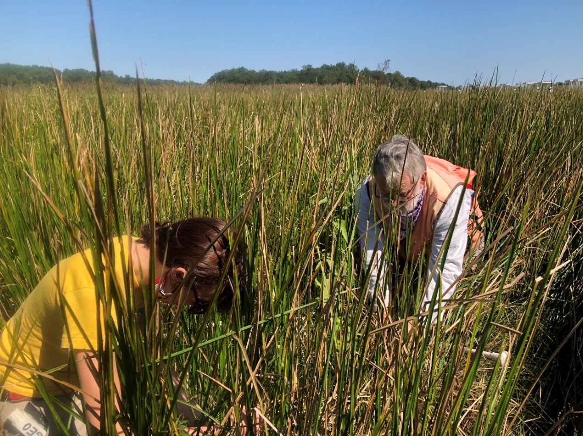

How to cite this work: MarineGEO Salt Marsh Habitat Monitoring Protocol (2021). Olson, Jack, Tennenbaum Marine Observatories Network, MarineGEO, Smithsonian Institution. https://doi.org/10.25573/serc.14896194.v1





## Introduction

Long-term monitoring of salt marsh plant species composition and above-ground biomass provides information on the condition of a salt marsh and the quality of ecosystem functioning. Over time, such data allows for analysis of community shifts in the context of changing environmental conditions. This protocol provides standardized methods for estimating plant cover, species composition, and annual production of above-ground biomass. Allometric equations used to estimate biomass will need to be adapted or developed for species present at each MarineGEO location conducting salt marsh monitoring. Contact [marinegeo-protocols@si.edu](mailto:marinegeo@si.edu) to discuss adapting this protocol to your local marsh species.

Measured Parameters:

* Percent cover
* Stem density, height, basal diameter, stem diameter at 40 cm (stems/m2, cm, mm, mm)



## Requirements

Personnel: 3 people

Estimated Total Time Per Location (*n* = 3)

Preparation: 1-person x 1-2 hours

Fieldwork: 3 people x 1 day per marsh

Post processing: 1-person x 0.5 day

Data processing: 1-person x 0.5 day

Replication: 5 replicate quadrats per transect, 3 replicate transects per marsh, 3 marshes per region

Materials:

*Fieldwork*

* 1 m x 1 m collapsible PVC quadrat
* 10 cm x 10 cm fixed PVC quadrat
* 150 mm dial caliper (2)
* 3 m folding ruler (3)
* Species cover [datasheets](https://doi.org/10.25573/serc.14896194)
* Species allometry [datasheets](https://doi.org/10.25573/serc.14896194)
* Hand-held GPS pre-loaded with transect and plot coordinates
* Permanent markers



## Methods

Fully review this and any additional protocols necessary for the sampling excursion. Address any questions or concerns to [marinegeo-protocols@si.edu](mailto:marinegeo@si.edu) before beginning this protocol.

Preparation:

1. Review and complete salt marsh survey design protocol.
2. Review and print this protocol.
3. Print [datasheets](https://doi.org/10.25573/serc.14896194) on waterproof paper.
4. Plan to sample at low tide when marsh is not inundated.
5. Surveys are to be conducted during the period of annual maximum standing biomass in the late summer or early fall. All vegetation surveys should be conducted within a period of 2-3 weeks.

Fieldwork Part 1: Species composition

1. Once the first plot in a transect is located, position the 4 PVC segments of the collapsible 1 m2 quadrat within the diagonal corner posts of the plot, making sure to maintain 90° angles at each corner (Fig. 1).
2. Identify all plant taxa rooted within or overhanging the plot to the species level.
   * Visually estimate the two-dimensional cover of all species and assign into discrete cover-class bins (Table 1).
3. It may help to estimate cover by subsections of plot and combine for a final estimate
4. Estimate non-living cover of the following categories:
   * Surface litter (leaf litter)
   * Standing litter
   * Bare substrate
   * Open water
   * Wrack
5. If there has been a physical disturbance within the plot (e.g. animal digging, fallen tree, shoreline erosion) make a note on the datasheet.

**Table 1.** Modified Braun-Blanquet cover class bins and corresponding percentages.

|  |  |
| --- | --- |
| Cover Class Bin | Cover (%) |
| 0 | 0 |
| + | <1 |
| 1 | 1-5 |
| 2 | 6-25 |
| 3 | 26 -50 |
| 4 | 51-75 |
| 5 | 76-100 |

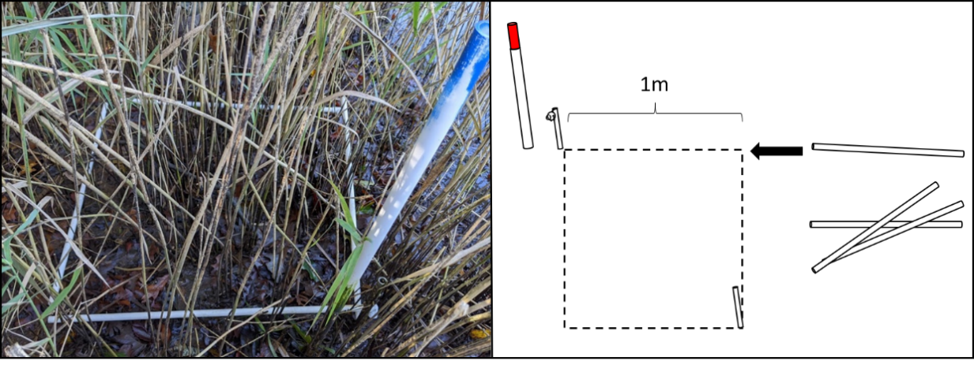

**Figure 1.** Deployment of collapsible 1m2 PVC quadrat.

Fieldwork Part 2: Species density and allometry

1. After finishing the species cover protocol in each plot, leave the collapsible quadrat in position on ground and place an extended ruler across plot, roughly dividing it in half.
2. Two people count living stems by species for all plants rooted inside of the plot; each person restricting their counts to half of the plot as marked by the ruler.
3. After stems have been counted for all species *(*see Fieldwork Part 2a and 2b*), haphazardly choose 8 representative individuals of each species to measure.
4. For each plant selected, measure its maximum stem height (cm), stem diameter at ground level (mm), and stem diameter (mm) at 40cm above the ground. If stem does not extend to 40cm, take only the basal diameter but make note on the datasheet.
5. Repeat Fieldwork Parts 1 and 2 for each plot (*n* = 5), transect (*n* = 3), and marsh site (*n* = 3).

*\* Fieldwork Part 2a: Highly abundant species density and allometry*

1. In some cases, a species may be so abundant (> 500 stems/plot) that counting all stems is overly time consuming. In such situations it is acceptable to take a random subsample of stem densities, heights, and widths.
2. First, using the random number table provided (Table 2), close your eyes and point to a single digit on the table. The number you choose corresponds to a quadrant within the larger 1m2 plot (Fig. 2).
3. Drop a pencil into the selected quadrant from shoulder height.
4. Note the position of pencil’s tip and place the small, 10 cm x 10 cm PVC quadrat such that is it centered over that point.
5. Count all living stems of the species in question which are rooted within the small quadrat.
6. Haphazardly select 8 individual plants of that species rooted within the small quadrat and for each, measure maximum stem height (cm), stem diameter at ground level (mm), and stem diameter (mm) at 40cm above the ground. If a stem does not extend to 40cm, take only the basal diameter but make note on the datasheet.

**Figure 2.** (A) Random number table (RNT) for selection of quadrants for highly abundant species subsampling. (B)Quadrant number assignments relative to position of PVC sight pole.

*\* Fieldwork Part 2b: Shrub allometry*

1. For shrub species (i.e. perennial, woody),identify the number of distinct bushes within the plot.
2. For each bush, record the total number of live and dead stems rooted within the plot.
3. Measure the diameter (mm) at 40 cm for 6 stems per bush, maintaining an equal proportion of live/dead measurements if possible (i.e. 3/3). If there aren’t enough live or dead stems to do so, measure all stems of the limiting category and substitute the remainder with the other category.

**Figure 3.** Example of the procedure for taking two-dimensional shrub canopy measurements from a single bush using folding rulers.

* + If a bush does not have 6 total stems, measure the diameter of all stems present regardless if they are alive or dead.

1. Measure the maximum height (cm) of each bush.
2. Measure the maximum dimensions of the canopy of each bush in two dimensions (cm x cm) (Fig. 3).



## Data Submission

1. Scan the completed field data sheets and save both paper and electronic versions locally. We do not require you to submit the scanned forms.
2. Enter data into the [provided data entry template](https://doi.org/10.25573/serc.14896194). Each template is an Excel spreadsheet. Please provide as much protocol and sample metadata as possible. Use the “notes” columns to provide additional information or context if a relevant column doesn’t already exist, rather than renaming or creating columns.
3. Use our online submission portal to upload the Excel Spreadsheet: <https://marinegeo.github.io/data-submission>
4. Contact us if you have any questions: [marinegeo-protocols@si.edu](mailto:marinegeo-protocols@si.edu)