MarineGEO Sampling Event and Environmental Monitoring Protocol

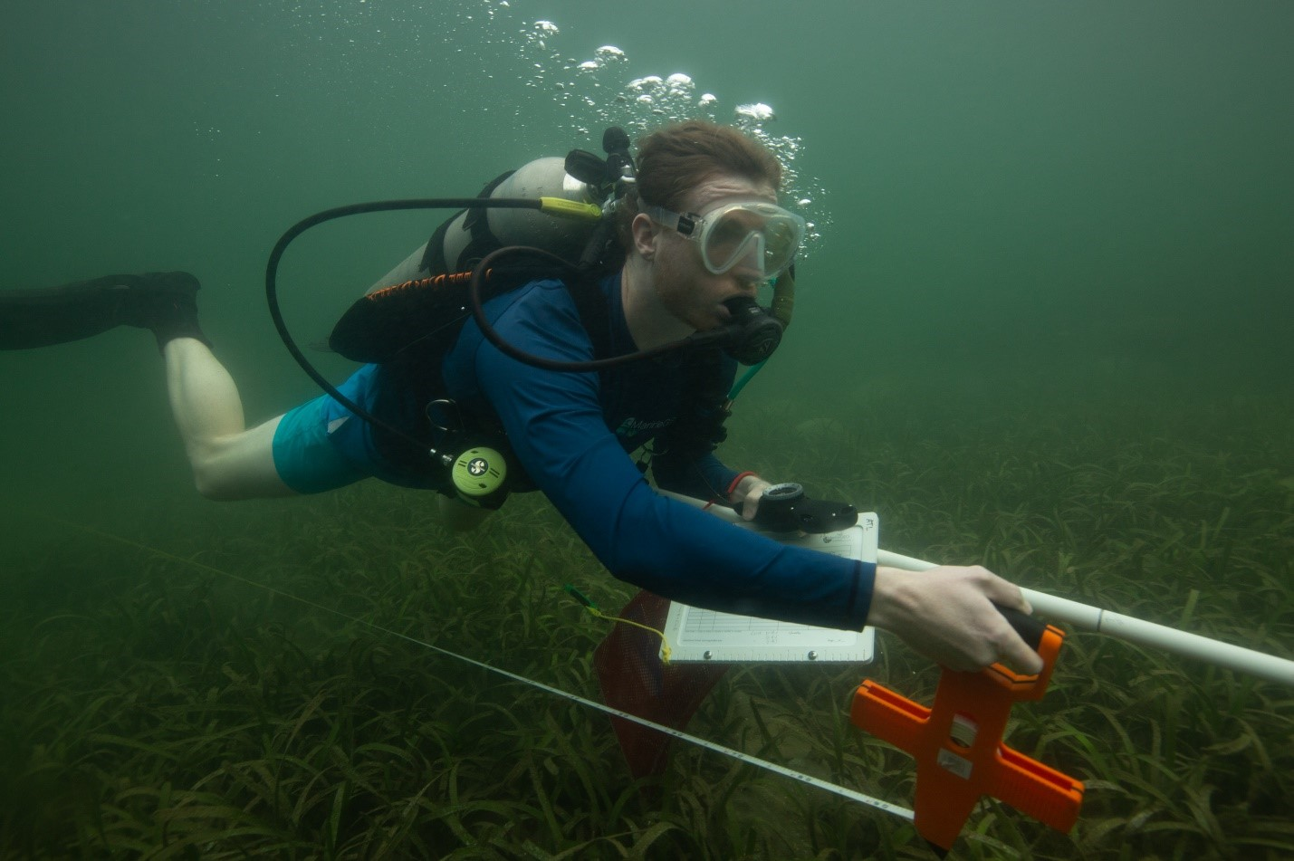

How to cite this work: MarineGEO Sampling Event and Environmental Monitoring Protocol. (2021) Harper, Leah, Tennenbaum Marine Observatories Network, MarineGEO, Smithsonian Institution. https://doi.org/10.25573/serc.14555511.v3

## Introduction

Use this protocol to collect appropriate metadata for each sampling locality at least once per field season.

## Measured Parameters

Qualitative and quantitative site characteristics such as coordinates, depth, salinity, and dissolved oxygen.

## Requirements

Number of Personnel: 1-2 people

Estimated Total Time Per Location:

Preparation: 1 person x 0.5 hours

Field work: 1 person x 0.25 hours

Post-processing: None

Data processing: 1 person x 0.5 hours

## Materials:

* Clipboard with datasheet on waterproof paper
* Pencil
* Camera
* Hand-held GPS
* Environmental monitoring instrument(s) (e.g., YSI or other sonde)

## Methods

Fully review this and any additional protocols necessary for the sampling excursion. Address any questions or concerns to [marinegeo-protocols@si.edu](mailto:marinegeo-protocols@si.edu) before beginning this protocol.

**Preparation:**

1. Review the habitat survey design protocols for selection of permanent sites.

**Fieldwork:**

1. Locate permanent transect markers. Record coordinates of transect start and end points on the Sampling Event field sheet.
2. Measure temperature, salinity, and dissolved oxygen with your sonde (or other instrument of choice) and record on your datasheet.
3. Record minimum and maximum depth along each transect.
4. Record site notes if relevant. These can include:
   1. Perturbations: major recent storms, algal blooms, vessel groundings
   2. Weather conditions
   3. Tidal height
5. Take 1-3 representative photos of the site.
6. Optional: consistent images for time series. Take seascape photo at a permanent marker at the starting point of the central transect, facing your survey site.
   1. Take photo from a uniform height.
   2. Select a height that allows you to capture the landscape (if intertidal) or seascape (if subtidal).
   3. Capture the landscape/seascape horizontally, but include more benthos than water column
   4. Once you have established the optimal height to capture your landscape/seascape, use a framer (your permanent marker if it is the correct height) to maintain uniform photo height. (A PVC t-shaped framer works well)
   5. Take photo in the same direction each time
   6. Take a compass heading in the chosen direction, record the heading, store the information where all potential photographers of your site will find it
   7. Use wide angle lens or camera setting
   8. Record photo metadata on fieldsheet: file number, camera used, exact location, direction

## Data Submission

1. Scan the completed field data sheets and save both paper and electronic versions locally. We do not require you to submit the scanned forms.
2. Enter data into the [provided data entry template](https://doi.org/10.25573/serc.14555511). Each template is an Excel spreadsheet. Please provide as much protocol and sample metadata as possible. Use the “notes” columns to provide additional information or context if a relevant column doesn’t already exist, rather than renaming or creating columns.
3. Use our online submission portal to upload the data entry spreadsheet (.xlsx file extension): <https://marinegeo.github.io/data-submission>
4. Contact us if you have any questions: [marinegeo@si.edu](mailto:marinegeo@si.edu)