MarineGEO Sampling Event and Environmental Monitoring Protocol



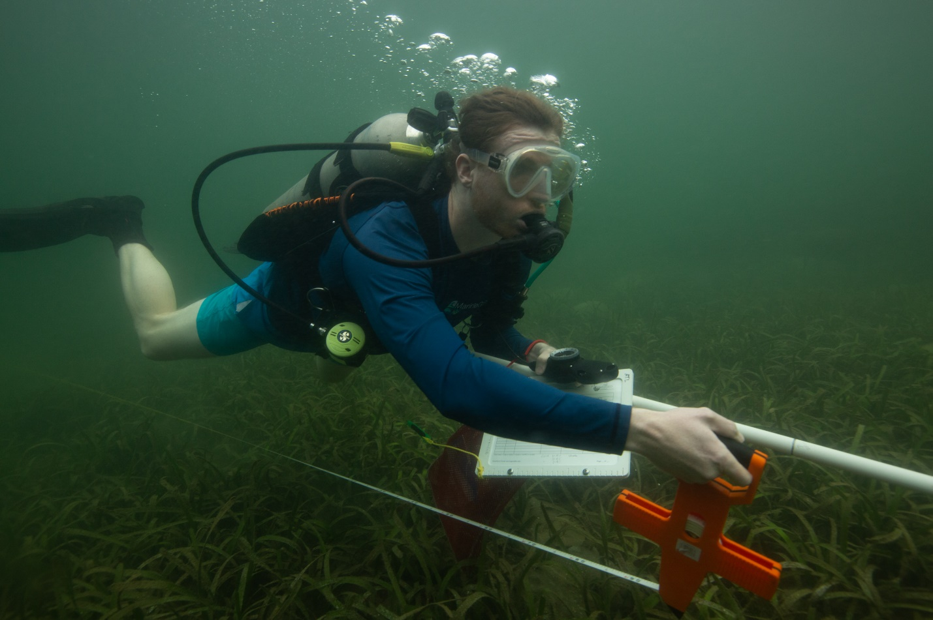

How to cite this work: MarineGEO Sampling Event and Environmental Monitoring Protocol. (2021) Harper, Leah, Tennenbaum Marine Observatories Network, MarineGEO, Smithsonian Institution. https://doi.org/10.25573/serc.14555511.V1





## Introduction

Use this protocol to collect appropriate metadata for each sampling locality at least once per field season, and to deploy temperature loggers to track temperature throughout the year. The protocol collects qualitative and quantitative site characteristics such as coordinates, depth, temperature, salinity, and dissolved oxygen.



## Requirements

Number of Personnel: 1-2 people

Estimated Total Time Per Location:

Preparation: 1 person x 0.5 hours

Field work: 1 person x 0.25 hours

Post-processing: None

Data processing: 1 person x 0.5 hours

## Materials:

* Clipboard with the [Sampling Event & Environmental Monitoring Datasheet and Temperature Logger Datasheet](https://doi.org/10.25573/serc.14555511) on waterproof paper
* Pencil
* Camera
* Hand-held GPS
* 2 EnvLogger temperature loggers
* Environmental monitoring instrument(s) (e.g., YSI or other sonde)
* Smartphone with EnvLogger application downloaded (for data retrieval)



## Methods

Fully review this and any additional protocols necessary for the sampling excursion. Address any questions or concerns to [marinegeo-protocols@si.edu](mailto:marinegeo-protocols@si.edu) before beginning this protocol.

Preparation**:**

1. Review the protocol design documents for selection of permanent sites.
2. Print the two [datasheets](https://doi.org/10.25573/serc.14555511), “Sampling Event & Environmental Monitoring Datasheet” and the “Temperature Logger Datasheet”.
3. Use the EnvLogger App to name your loggers with a unique identifier.
4. Label the plastic casings of your EnvLogger temperature loggers with the same unique identifiers.
5. Record the logger name and serial numbers in the [Temperature Logger Datasheet](https://doi.org/10.25573/serc.14555511).
6. In the EnvLogger App, set your loggers to start their missions around the time you plan to deploy.

* Set loggers to record at **two-hour** intervals, with time set to Coordinated Universal Time (UTC).
* Set loggers to record at **0.5°C resolution.**
* Select the “pretty dates” option, which will log on the hour. See EnvLogger handbook for more detailed instructions: <https://marinegeo.github.io/assets/environmental-monitoring/envlogger_documentation.pdf>

Fieldwork**:**

1. Locate permanent transect markers. Record coordinates of transect start and end points on the [Sampling Event & Environmental Monitoring Datasheet](Sampling%20Event%20&%20Environmental%20Monitoring%20Datasheet).
2. Measure temperature, salinity, and dissolved oxygen with your sonde (or other instrument of choice) and record on your datasheet.
3. Deploy two EnvLogger temperature loggers, one each at opposite ends of the site. Loggers should be secured at least 30cm from the substratum and in a location you will be able to easily relocate. Attaching the loggers to permanent transect markers is recommended.
   1. Record logger locations, either lat/long or location e.g. “start of transect 2”, and the depth they are deployed to on the Temperature Logger datasheet.
4. Record minimum and maximum depth along each transect on the sampling event datasheet.
5. Record site notes if relevant. These can include:
   1. Perturbations: major recent storms, algal blooms, vessel groundings
   2. Weather conditions
   3. Tidal height
6. Take 1-3 representative seascape photos of the site.
7. Optional: consistent images for time series. Take seascape photo at a permanent marker at the starting point of the central transect, facing your survey site.
   1. Take photo from a uniform height.
   2. Select a height that allows you to capture the landscape (if intertidal) or seascape (if subtidal).
   3. Capture the landscape/seascape horizontally, but include more benthos than water column
   4. Once you have established the optimal height to capture your landscape/seascape, use a framer (your permanent marker if it is the correct height) to maintain uniform photo height. (A PVC t-shaped framer works well)
   5. Take photo in the same direction each time
   6. Take a compass heading in the chosen direction, record the heading, store the information where all potential photographers of your site will find it
   7. Use wide angle lens or camera setting
   8. Record photo metadata on fieldsheet: file number, camera used, exact location, direction

EnvLogger Retrieval

1. EnvLoggers should remain at each site year-round
2. If possible, download temperature data quarterly
   1. Bring your logger to the surface. Use the EnvLogger App to retrieve data.
   2. Remove any fouling material on your logger.
   3. Return your logger to its location
3. Using the EnvLogger application, email the data to yourself. Alternatively, move the data from your smartphone to a laptop or PC using another method, such as Bluetooth, Dropbox, iCloud, etc. Contact marinegeo-data@si.edu if you have any issues extracting the data from your device.
4. After one year has passed, replace each logger with a new logger when downloading temperature data.



## Data Submission

1. Scan the completed field data sheets and save both paper and electronic versions locally. We do not require you to submit the scanned forms.
2. Enter data into the [provided data entry template](https://doi.org/10.25573/serc.14555511). Each template is an Excel spreadsheet. Please provide as much protocol and sample metadata as possible. Use the “notes” columns to provide additional information or context if a relevant column doesn’t already exist, rather than renaming or creating columns.
3. Use our online submission portal to upload the Excel Spreadsheet: <https://marinegeo.github.io/data-submission>
4. Contact us if you have any questions: [marinegeo-protocols@si.edu](mailto:marinegeo-protocols@si.edu)