Protocol: SED-BIOME

2020 – 2021 MarineGEO Network Research Project



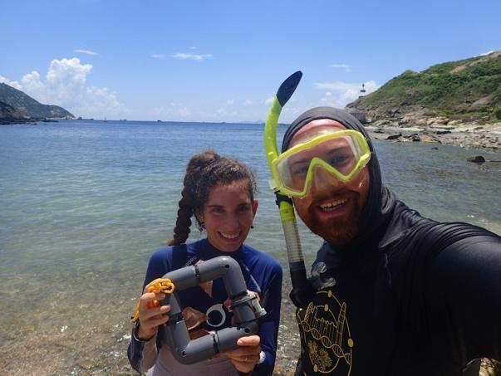

How to cite this work: Protocol: SED-BIOME. (2020) Tennenbaum Marine Observatories Network, MarineGEO, Smithsonian Institution and the Swire Institute of Marine Science, The University of Hong Kong.



**Introduction**

This protocol will provide instructions for the 2020-2021 MarineGEO Network project: “SED-BIOME” led by Hong Kong University. Contact the project leader, Dr. Isis Guibert, if you have any questions: iguibert@hku.hk.

Additional copies of this protocol, field datasheets, data entry templates, literature, and more can be found at: <https://marinegeo.github.io/projects/sed-biome/>.

**Requirements**

Personnel: 2 people minimum, 3-4 preferable

Estimated Total Time Per Location (n = number of replicates per location):

Preparation: 1 person x 1 day

Field work: 2-4 people x 1 day

Post processing: 2-3 people x 2 days

*Estimated times will vary by site and conditions

Replication:

16 frames containing 4 tea-bags each (n = 8 frames for each of two treatments: control and fertilized)

6 porewater samples (n = 3 for each treatment)

12 sediment mini-cores (n = 4 for each treatment and n = 4 extra sediment)

2 sediment traps with 3 jars each (n = 3 jars for each treatment)

4 Hobo loggers (n = 2 for each treatment)

Materials:

Make sure that you have all the materials required: some materials need to be provided or procured by the partners as they cannot be sent through post. If any materials are missing from the kit (see checklist on next page), please contact Dr. Isis Guibert (iguibert@hku.hk) immediately.

Each partnered site has been pre-assigned a number and the materials included in the kit will be pre-labelled with your site’s number. Please, do not alter any of the labels. If any labels are missing or incoherent, please contact Dr. Isis Guibert ([iguibert@hku.hk](mailto:iguibert@hku.hk)).

Each kit should also contain a welcome letter, QR codes to access the later version of the protocol and video, and a personalized map to help you prepare to deploy and retrieve the experimental setup. QR codes to access the data spreadsheet and submit them online will be also available. If the QR code or map are missing or incoherent, please contact Dr. Isis Guibert ([iguibert@hku.hk](mailto:iguibert@hku.hk)).

**Materials checklist**

Fieldwork – Deployment

Materials included in the kit :

* 8 frames (20cm x 20cm) filled with Fertilizer with red buoyant chain, label and tea bags
* 8 frames (20cm x 20cm) (no fertilizer) with yellow buoyant chain, label and tea bags
* 2 sediment traps (3 labeled jars and 1 PVC pipe per trap, to be assembled)
* Small shovel/trowel
* Map

Materials required from the partner:

* 40 pieces of rebar (40 cm long)
* 2 pieces of rebar (50 cm long)
* 1 or 2 hammer(s)
* Zip ties (> 40)
* 4 Hobo logger (e.g. HOBO Pendant temp/light)
* 1 or 2 Transect tape(s)
* 1 GPS

Fieldwork – Retrieval

Materials included in the kit :

* 6 Rhizon samplers (refer to the picture on page 4)
* 2 retainers
* 6 x 10ml syringes
* 6 x 15ml falcon tubes
* 12 mini-cores (4 x “SiteX-C”; 4 x “SiteX-F”; 4 x “SiteX- Extra Sediment” )
* Lids of the jars for the sediment traps
* Map

Materials required from the partner:

* 100m Transect Tape
* Cooler filled with ice
* Pruning shears
* Zip ties and large Ziplock bags (1-Gallon)
* 1-2 large box(es) or totes to transport the frames
* Nitrile gloves
* 1-2 Waterproof permanent marker
* Tape for securing syringe plunger in field (we recommend using masking tape)
* 8 labelled Corers (we recommend using a 5 cm diameter x 10 cm length core; the corers are of use only if your site is muddy and you can’t use the Rhizon samplers)

Post-Processing

Materials included in the KIT:

* 16 x 50ml pre-filled falcon tubes with RNAlater
* 4 empty 50ml falcon tubes

Materials required from the partner:

* 8 sterilized (autoclaved), sealable storage containers with lids that hold at least 50mL of material (prepare extra just in case)
* 8 sterilized (autoclaved) spatulas (prepare extra just in case)
* 500ml Beaker (or jar)
* 6 glass containers
* Nitrile gloves
* Parafilm
* 10% bleach
* 70% Ethanol

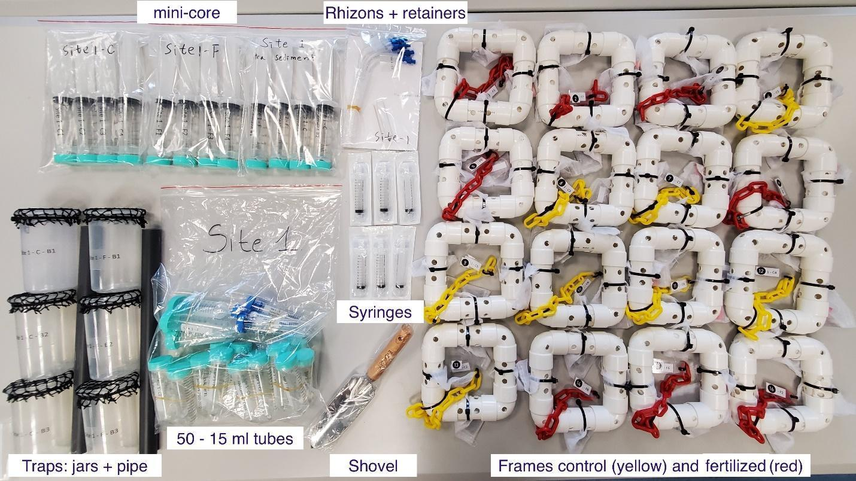

*1 Material from the KIT*

**Methods**

Fully review this and any additional protocol materials (including the video tutorial) before attempting to deploy/retrieve the experimental setup. We encourage all partners to take pictures of the experiment and share them with us. Please use #SEDBIOME and tag @SIMarineGEO if you share pictures on twitter. Address any questions or concerns to Dr. Isis Guibert (iguibert@hku.hk) before beginning this work.

A minimum of 2 people will be necessary to deploy and retrieve the experimental setup in the field, however, we recommend 3-4 people participate in the field so that you can have 1 or 2 people above water to prepare and pass equipment to the people working underwater.

All deployment/retrieval materials should be prepared prior to the field work. We recommend allocating a full day of field work. Estimated time will vary based on site conditions.

In this protocol, we will use “siteX” to refer to your specific site number (e.g. if your site number is 1, siteX = site 1).

**Preparation**

*Hobo logger:*

1. Perform a calibration check of your Hobo loggers. A calibration check consists of data loggers recording for 30 minutes in a warm bath, 30 minutes in a cool-down bath, and 30 minutes in a cold bath. For your reference, an example of calibration check procedure is available online.
2. Program the Hobo logger to record the temperature every hour. Do not use the light recording function for loggers that record irradiance because it uses too much battery power.
3. Attach the Hobo logger to the corner of one on the fourth frames indicated on the provided map

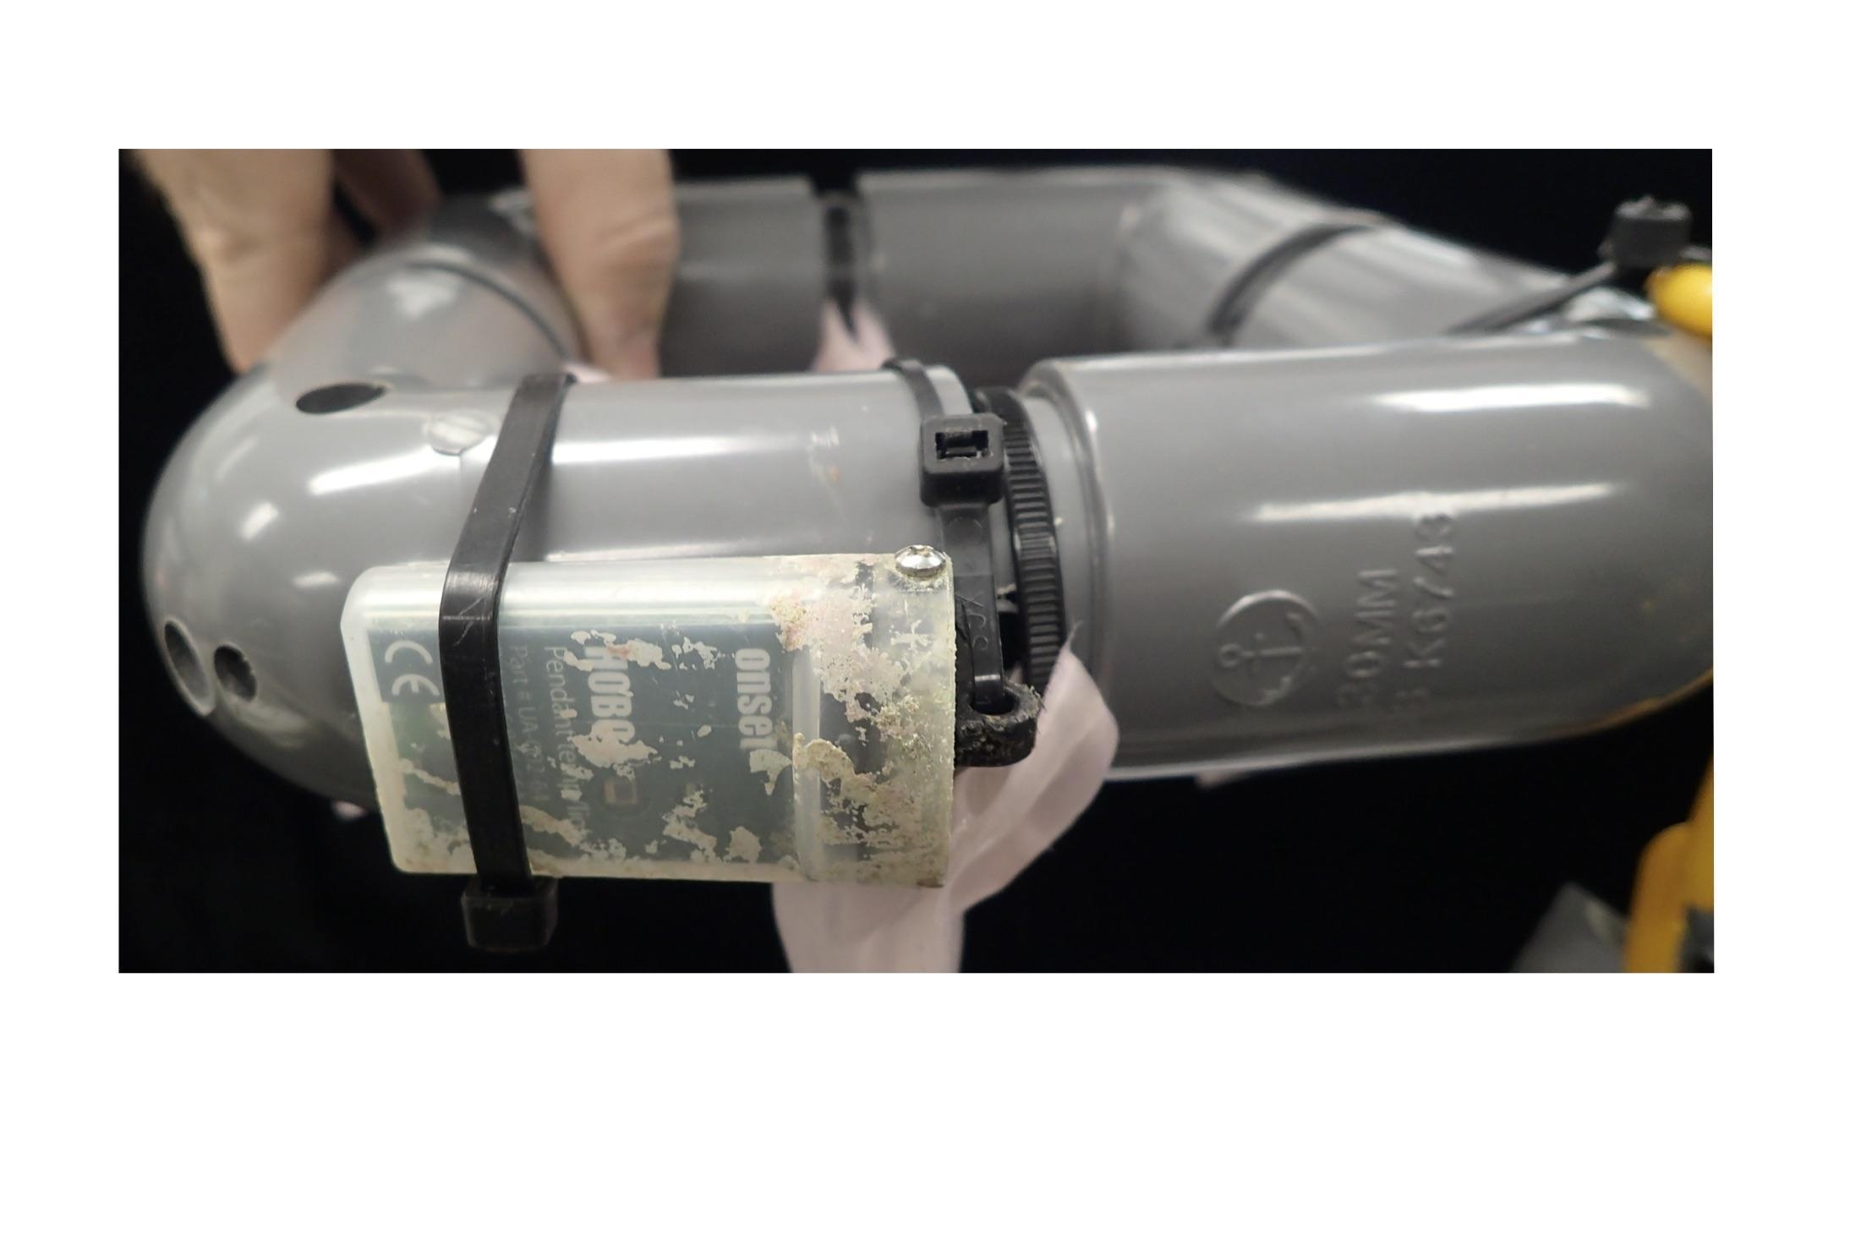

2 *Hobo logger attached on a frame*

*Assembling sediment traps:*

1. Weight the empty jars and **Record the weight on the excel sheet provided under “weight_initial_jar”.** *Note: if a weight is already recorded, overwrite the data.*
2. Fasten the labeled plastic jar (with black mesh), siteX-C-b1, to one of the grey PVC pipes using two zip ties (one higher up on the jar, and one lower) such that the bottom of the jar is 10cm from the bottom of the PVC pipe.
3. Repeat this for jars labeled, SiteX-C-b2, and SiteX-C-b3 so that each jar is equally spaced in a triangular arrangement and they are all aligned vertically.
4. Repeat this for 3 jars SiteX-F-b1/b2/b3.

*Note: Refer to the video to see how to secure the jars.*

**Site Selection**

*Choosing a site*: We recommend working in an easily accessible shallow area (between 0.5-3 m depth at Mean Low Water) that is at least 5m from any structured habitat (e.g. docks and piers, seagrass, marsh, etc.). We recommend working in a protected site from infrequent storms to avoid disturbance of the set up during the experiment. Participants may use snorkel or SCUBA depending on the ease of use. For partners that are planning to use snorkel, we recommend working in a shallow area such that the water level at low tide never goes below 0.5m depth, and if using SCUBA, 1m in depth. We recommend at least 2 people (plus 1 or 2), 1-2 to deploy the experimental setup and at least 1 to assist. Given that there will be a lot of materials to bring into the field, we also recommend using a floating platform, such a small boat or kayak, that the assistant(s) can use to pass materials to/from.

*Environmental data*: We require each partner to record the temperature during the experiment. If you are able to record other environmental data such as salinity, dissolved oxygen, pH, turbidity, total coliform count or E. coli, please send along those data when submitting the temperature data.

**Fieldwork: Deployment**

Each frame is numbered and should be placed 5m apart along the transect parallel to shore at a constant depth. Please use the map in your kit and follow the number order to deploy the frames. The sediment traps should be deployed along the transect at 17.5m and 62.5m. They should be deployed 1m offshore from the transect line where the frames were deployed (cf map) to avoid impeding the sedimentation on the frames. The sediment trap should be deployed for 3 months. If your sedimentation rate is too high, please retrieve the traps at 1.5 months, follow the procedure below to process them in the lab, and replace them.

Experimental Setup

*Refer to the map to ensure each frame/sediment trap is placed in their pre-designated order and location*

GPS coordinate and deployment date

Record the GPS coordinate at the start point and end point of your transect, and the date of deployment. *Note: The GPS coordinate and date of deployment will need to be provided in each excel spreadsheet received by the partner.*

**Tea Bag Frames**

1. For each frame, use the shovel to dig a 10cm deep, 20x20cm wide, square hole in the sediment
2. Place the frame in the hole with the tea bags facing downward
3. Secure the frame by inserting two 40cm metal bars into the sediment on opposite inner corners of the frame and zip tie the bars to the frame. *Note: Refer to the video to see how to secure the frames*
4. Cover the frame with 10cm of displaced sediment but take care not to bury the buoyant chain. If the frame has a Hobo logger attached, it should be buried along with the frame. *Note: Each frame should be spaced at least 5m apart. Use the transect tape to place the frame at the required distance. The frames should be positioned as referred in the map provided*
5. After all frames have been deployed and any disturbed sediments have settled, deploy the sediment traps

**Sediment Traps**

*If possible, we recommend going on site from time to time after the deployment to ensure that the sediment traps are still there and replace them if needed. The sedimentation rates are important data for this study.*

1. For each trap, hammer the metal bar into the seabed with enough material exposed enough such that the PVC pipe can be placed over the metal bar with at least 5cm of metal bare showing above the PVC pipe
2. Place the PVC pipe onto the metal bar
3. Secure the trap by holding the PVC pipe firmly onto the seabed and secure two zip ties to the metal bar such that the locking mechanism of the zip ties keep the PVC pipe from moving vertically on the metal bar
4. The trap labeled siteX-C should be deployed at 17.5m along the transect (1m offshore from the transect line where the frames were deployed) and SiteX-F, at 62.5m. *Note: Refer to the map to see where to deploy the traps and refer to the video to see how to deploy them. The trap should be left for 90 days, but if your sedimentation rate is too high, please retrieve the trap after 1.5 months and replace them.*

**Fieldwork: Retrieval – After 90 days**

Tea Bag Retrieval and Porewater/Sediment Sampling:

We recommend carrying out the retrievals during low tide if possible. After the retrieval, the mini-core samples and the tea bags need to be processed immediately. Those steps can take a few hours. Retrieve the sediment traps first because any action at the site will likely stir up the seabed and introduce additional sediment into the traps, compromising natural sedimentation measurements.

**Sediment Traps**

1. For each plastic sediment jar, cut the zip tie holding the black mesh and gently remove the mesh
2. Secure the lid onto the jar
3. Either cut the zip ties holding the jar to the PVC pipe or simply pull them off the jar
4. Repeat for each jar on each sediment trap
5. Remove the PVC and metal bar. *Note: if the visibility is poor, wait until the end of the sampling to remove the PVC pipe and metal bar to avoid any disturbance*

**Sampling the extra sediment for organic matter**

*Use the mini-core in the Ziplock “SiteX Extra sediment”*

Above water – wearing nitrile gloves

1. Take the sediment samples SiteX-C-sediment #1-#2 and siteX-F-sediment #1-#2. Please, refer to the map to know where to sample the sediment. Make sure that you are getting at least 30ml of sediment (not water). If you didn’t sample enough, empty the mini-core and try again nearby. *Note: Refer to the video to see how to sample the sediment with the mini-core. Those 4 samples can be used “as practice” since you can try again. You won’t be able to do so when sampling the sediment in the middle of the frame. Sediment sampling for metabarcoding can only be taken once because the mini-core will disturb the sediment*
2. On the boat or the beach, secure the plunger with tape. *Note:* *That step can be done by your colleagues if they are not snorkeling/diving. We recommend using masking tape*

**Sampling the frames:**

***Please note that if a frame where the pore water and sediment sampling is required is missing you need to randomly choose another similar (control or fertilized) frame to do the sampling. Please record the changes into the spreadsheet.***

**Start with the frame number 1**

1. Refer to the map to see what to sample for each frame. Always start by sampling the porewater and then the sediment, if required, before sampling the frame with the tea bags and hobo. The porewater and sediment samples should be collected in the middle of the frame

Porewater Sampling

*Note: if your site is really muddy, it might take a longer time to sample the porewater (≥ 20min). Please take this time into account when you plannify the retrieval. Please try to sample the porewater in one frame first and If after 20min you can’t get 10ml of porewater, please follow protocol B.*

***Protocol A***

*Above water – wearing nitrile gloves*

1. Open the syringe
2. Remove the protection cap that is screwed on the female luer lock. *Note: Refer to figure 3*
3. Screw the syringe directly onto the luer and hand that to the snorkeler/diver along with a retainer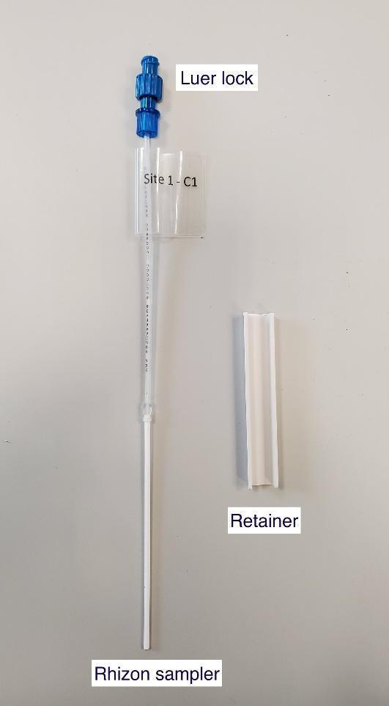

*Below water – wearing nitrile gloves*

1. Insert the rhizon sampler vertically into the sediment, in the middle of the frame: between the metal securing bars of the appropriate frame
2. Slowly draw back the syringe piston and place the retainer between the butt of the piston and the grip of the barrel to secure the piston into position. Take care to ensure the rhizon sampler remains vertical and inserted in the sediment during extraction
3. Extract at least 10ml of water before removing the rhizon sampler from the sediment. *Note: Depending to the site and sediment type, this procedure can take 30s to several minutes (usually 2-3min)*
4. Hand the sample to the person on the surface.

*Above water – wearing nitrile gloves*

1. Holding the retainer in place to keep the piston up, **unscrew the rhizon sampler from the syringe.** *Note: Make sure to remove the sampler before pouring the seawater into the tube. The samplers act as filters.*
2. Remove the retainer and carefully transfer the seawater to the 15ml falcon tube. *Note: the 15ml tubes and rhizon sampler are pre-labelled, make sure to transfer the seawater into the matching tube*

***Protocol B***

*Please follow this protocol only if it takes more than 20min to get 10ml of porewater*

***If you follow this protocol, please place the corer in the sediment first, then sample the sediment for the metabarcoding analysis using the mini-cores just next to the corer and then remove the corer to sample the sediment and porewater.***

1. Using a clean labelled corer (5 cm diameter x 10 cm length) collect vertically the sediment in the middle of the frame. We recommend collecting around 250g of sediment or more.
2. Place the corer on ice

Sediment sampling

*Sediment sampling can only be taken once and in the middle of the frame.*

*Below water – wearing nitrile gloves*

1. Remove the lids of the mini-core underwater just before sampling
2. Put the core vertically in the sediment, in the middle of the frame, and pull the piston out slowly while pushing the mini-core deeper. *Note: Be careful to avoid sampling seawater as much as possible.*
3. Remove the mini-core and close it immediately. *Note: Close the mini-core before fully taking it out to ensure keeping the sediment and not sampling seawater*
4. Hand the sample to the person on the surface where they should secure the plunger with tape and place the mini-core on ice in the cooler. Position the mini-core vertically so that the lid is at the bottom and the piston upward. *Note:* *This should help you to process the sample more easily. That step can be done by your colleagues if they are not diving. We recommend using masking tape.*

Frame sampling

1. Remove the frame with the tea bags and Hobo logger (if there is one). For each frame make sure that the label and tea bags are present. *If the label of the frame is missing, place the frame in the Ziplock bag and label it. You should be able to determine the label of the frame by its position along the transect. If a tea bag is detached from the frame, attach it with a zip tie or place the frame together with the tea bags in a large Ziplock bag. It is important to know which tea bags go with each frame in case the tea bags’ labels are missing. Use the pruning shears to detach the frame from the metal bars, and remove all infrastructure from the site*

**Sediment traps**

1. Remove the PVC and metal bar if you haven’t done it yet

**Post-Processing**

The sediment, porewater and tea bags should be processed immediately after the retrieval when going back to the laboratory.

We recommend having one person taking care of the sediment sampling for the metabarcoding analysis while 2 persons process the tea bags and sediments trap. If you are limited in number, please start first by the sediment sampling for metabarcoding analysis. Note that there are two types of sediment, the sediments sampled in the middle of the frame which are the sediment sampling for metabarcoding analysis, and the sediment sampled close by the sediment trap which are the sediment sampling for the organic matter content. The two types of sediment sampling should be processed differently. Please follow the instructions for each type of sediment sampling.

## Sediment Sampling for metabarcoding analysis:

Refer to the picture (4) “Materials for post-processing the sediment samples” to have an example of the material needed.

1. Wipe down surfaces with 10% bleach and 70% ethanol
2. Turn on a UV light for 15 minutes. *Note: processing the sediment samples should be done in a clean environment. If you don’t have a clean room or a UV workstation, please work in the cleanest environment you have*
3. Without shaking the sample, remove the tape from the mini-core
4. Carefully and slowly, remove the piston as to not agitate the sediment within
5. Discard the water into a Beaker (or a jar)
6. Replace the piston and pour the sediment into the sterilized container
7. Mix the sediment with the spatula
8. Pour **20ml** of sediment into Falcon tube #1 and the rest into Falcon tube #2 (but **not much more than 20ml**). *For each sample you should have received 2 x 50ml pre-filled with RNAlater and pre-labelled falcon tubes to aliquot the sediment. Please make sure to avoid overflowing and having sediment in the screw threads to be able to seal the Falcon tubes*
9. Repeat steps 3-8 for all the samples. *Note: the mini-core as well as the prefilled tubes should be annotated siteX-C1 to C4 and siteX-F1 to F4.*
10. Secure all Falcon tubes first with parafilm and then seal with electrical/insulation tape. Be sure the seal is *very* tight as the containers can expand during transit and lead to leakage. *Note: Avoid having sediment trapped in the threaded tops that would inhibit a tight seal and potentially cause leakage*
11. Place the samples at 4ºC overnight before storing them at -20ºC

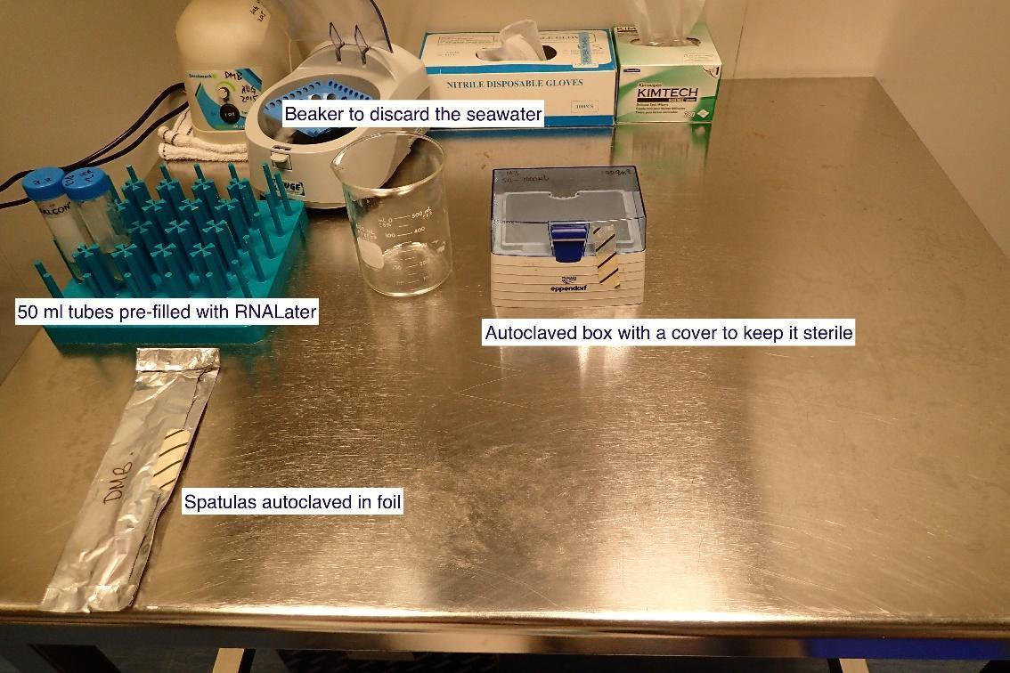

*4 Materials for post-processing the sediment samples*

**Sediment Sampling for organic matter (“Extra sediment”):**

1. Without shaking the sample, remove the tape from the mini-core
2. Carefully and slowly, remove the piston as to not agitate the sediment within
3. Discard the water into a Beaker (or a jar)
4. Pour the sediment into the Falcon tube. *Note: the falcon tube should be labeled SiteX-C #1 and #2 and SiteX-F #1 and #2*
5. Dry the Falcon tube at 60 ºC for 48 hours or until it is completely dry
6. Secure all Falcon tubes with tape and parafilm, as instructed above

**Porewater samples:**

*Please follow the protocol A if you collected the porewater with the rhizon sampler and follow protocol B if you collected the samples with a corer.*

*Please record into the spreadsheet which protocol you used and if the samples were filtered or not with the Rhizon sampler.*

**Protocol A**

1. Secure all 15ml Falcon tubes with parafilm
2. Store the porewater at -20 ºC

**Protocol B**

1. Centrifuge the sediment at 8000g for 20 minutes
2. Transfer the porewater in a sterile tube. *Note: If you do not have enough Rhizon samplers for all the samples, for the samples that you can’t filter with a Rhizon samplers please transfer them directly into the 15ml Falcon tubes labelled provided before storing them at -20ºC. Do not forget to record on the spreadsheet which samples were filtered and which weren’t.*
3. To filter the samples with the Rhizon sampler, first open the syringe provided
4. Remove the protection cap that is screwed on the female luer lock. *Note: Refer to figure 3*
5. Screw the syringe directly onto the luer and hand that to the snorkeler/diver along with a retainer
6. Insert the rhizon sampler vertically into the tube
7. Slowly draw back the syringe piston and place the retainer between the butt of the piston and the grip of the barrel to secure the piston into position.
8. Extract at least 10ml of water before removing the rhizon sampler from the sediment.
9. Holding the retainer in place to keep the piston up, **unscrew the rhizon sampler from the syringe.** *Note: Make sure to remove the sampler before pouring the seawater into the tube. The samplers act as filters.*
10. Remove the retainer and carefully transfer the seawater to the 15ml falcon tube labelled provided. *Note: the 15ml tubes and rhizon sampler are pre-labelled, make sure to transfer the seawater into the matching tube*
11. Secure all 15ml Falcon tubes with parafilm
12. Store the porewater at -20 ºC

**Tea Bag Decomposition:**

The four ***mesh bags*** attached to the frame will each have a ***tea bag*** which contains ***loose tea leaves.*** The first mesh bag on the right of the buoyant chain always contains a Rooibos tea bag and it’s followed by a green tea bag. The frames are labelled with the name of the site (e.g SiteX) from C1 to C8 (or F1 to F8). Based on the frame label, the tea bags are labelled SiteX –CX/FX Rooibos 1-16 or Green 1-16. The labels are numbered anti-clockwise.

1. Before removing the mesh bags from the frame, make sure that the tea bags have their laminated label, if not add a new one. *Note: Refer to the figure 5 to determine the label of the tea bag*
2. Remove the mesh bags from the frame by cutting the zip ties.
3. Place the tea bags for 30min in RO/DI water
4. Carefully clean each tea bag for 20s in a bath by massaging gently under water to remove as much sediment as possible. Change the water after washing 5-10 bags. *Note: Refer to the video to see how to clean the tea bags*
5. Dry the tea bags in a drying oven for 48h at 70°C. *Note: If you can’t process the samples after 48h, place them in a desiccator to avoid accumulating moisture*
6. Remove the tea bags from the mesh bags. Do not weigh any loose material inside the mesh bags/outside the tea bags. Cut the tea bags open and pour the oven-dried loose tea leaves into a tared container to weigh the loose tea(to within 0.001g). Weigh all the loose tea leaves in each tea bag, emptying and taring the container between tea bags. *Note: If you are working in a humid area, the best way to weigh the tea is to pour it in a small pre-weighed Ziplock bag and remove the air before closing it (do not forget to tare the Ziplock bag first). If you use this method, please use a new Ziplock bag for each tea bag. Please be consistent, use the same balance and methods of waiting for all your samples.*
7. Upload the data in the sheet. See the Data Submission section on page 14. *Note: Each partner should receive a pre-filled data sheet for the tea bags. Please use the data sheet provided for your site*

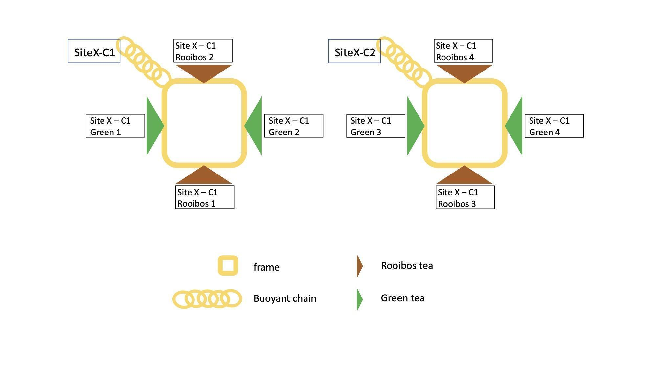

*5 Illustration of a frame and the labelled tea bags*

**Frames:**

1. Open the frames labelled F1-F8 (fertilized frames with a red tag) to take out the sausages filled with fertilizer
2. For each frame record in the spreadsheet the presence or absence of fertilizer

*Note: if you have no use of the frames, you can send them back to us with the samples.*

**Sediment Trap Samples:**

1. Examine the plastic sediment jars to determine how to proceed. If organisms (e.g. tube worms/algae) are growing on the inner wall of the jar, firmly attached and will be difficult to remove entirely without losing sediment, skip to ***B: in new glass containers***. Otherwise, proceed with the following steps. Please skip to ***B: in new glass containers*** in case you haven’t weighed the jars before deployment.

***A: in the original plastic sediment jars - You must have recorded the initial weight of the jars before deployment***

1. The original plastic sediment jars have already been weighed - the weight is listed on the excel sheet provided. Remove any organisms from the outside of the sediment jar.
2. If there are any animals on top of the sediment in the plastic jar at this point, remove them carefully with tweezers, avoiding sediment. Take note of all invertebrates found inside the sediment jar during these steps, on the excel sheet.
3. Allow the sediment in the water to settle out to the bottom of the glass container. *Note: This step can take several hours to a day. The jars can be placed at 4*º*C while waiting.*
4. Remove as much water as possible without disturbing the sediment. Remove any remaining small invertebrates (e.g. mussels, tube worms etc.) from the sediment. Shake any sediment off from the animals/tools or rinse with a small amount of RO/DI water back into the glass container.
5. Oven dry the sediment at 60ºC in a drying oven until it is completely dry. *Note: This step can vary in time depending on the amount of water left in the jar*
6. Before weighing, ensure there are no more organisms on the inner wall of the jar. These can be picked off by tweezers. Also, ensure the **outside** of the plastic jar is completely clean. We suggest gently scraping with spatula, scrubbing with a new, clean scour pad or paper towel. This should be done dry or with ethanol and allowed to air dry before weighing. **Make a note on the excel sheet if the plastic label is removed.**
7. Weigh each plastic jar with the dried sediment (to within 0.001 g)
8. Fill out the excel sheet provided

***B: in new glass containers***

1. Pre-weigh 6 empty glass containers. Write down the weight on the container and copy the labels of the respective sediment jars onto the new glass containers. **Record the weight on the excel sheet provided under “weight_initial_jar”.** *Note: Each partner should receive a pre-filled data sheet for the sediment traps. Please use the data sheet provided for your site. If a weight is already recorded, simply erase it and add the correct weight.*
2. If there are any animals on top of the sediment in the plastic jar at this point, remove them carefully with tweezers, avoiding sediment. Take note of all invertebrates found inside the sediment jar during these steps, on the excel sheet.
3. Pour the seawater and sediment into the pre-weighed glass containers
4. Allow the sediment in the water to settle out to the bottom of the glass container. *Note: This step can take several hours to a day. The jars can be placed at 4*º*C while waiting.*
5. Remove as much water as possible without disturbing the sediment. Remove any remaining small invertebrates (e.g. mussels, tube worms etc.) from the sediment. Shake any sediment off from the animals/tools or rinse with a small amount of RO/DI water back into the glass container.
6. Oven dry the sediment at 60ºC in a drying oven until it is completely dry. *Note: This step can vary in time depending on the amount of water left in the glass container.*
7. Weigh each glass container with the dried sediment (to within 0.001 g)
8. Fill out the excel sheet provided

**Hobo Loggers:**

1. Connect the Hobo loggers to a computer with HOBOware installed. HOBOware is a free software used to extract data from loggers. Download the software and find resources to help install and extract data here: <https://www.onsetcomp.com/hoboware-free-download/>
2. Extract the logger data as CSVs. Each logger should have a unique file
3. Add the frame number associated with the logger to the CSV as a column
4. Submit the CSVs as part of the data submission process described below

**Online Data Submission**

* 1. Save the completed excel data sheets locally.
  2. Provide as much protocol and sample metadata as possible, such as the protocol version and contact information. Use the “notes” columns to provide additional information or context if a relevant column doesn’t already exist, rather than renaming or creating columns.
  3. Use our online submission portal to upload Excel and CSV spreadsheets: <https://marinegeo.github.io/data-submission>. You can also use the QR code provided to be directed to the website.

**Sediment and Porewater Sample Shipping**

**BEFORE shipping:**

Please send an email to Dr. Isis Guibert: [iguibert@hku.hk](mailto:iguibert@hku.hk) to inform her that you are ready to ship and **wait for her reply**.

**Prepare the package:**

* 1. Make sure that all the samples are well sealed to avoid any gas exchange or leakage. Please, use electrical tape over the parafilm.
  2. Place each tube in a whirl-pack (or a clean ziplock) and place them in a box.

*Note: The Whirl-pack (or ziplock) will avoid having cross-contamination if the tubes leak or break. Please make sure to close them well.* ***We recommend using a Whirl-pack if possible as they are sterile and seem to prevent the tubes from leaking****. To make sure that the tubes are not loose in the package you can use tube polystyrene foam racks, cardboard boxes or use a small box to pack the tubes and make sure they are not loose.*

* 1. Make sure that the samples are upright and pack the box tightly with minimal air and sealed properly to limit heat transfer. We recommend using a Styrofoam box.

*Note: Due to a long shipping time (probably a week) and difficulties to ship with dry ice, please ship the samples frozen without gel pack or dry ice. We recommend packing in a small box that fits the content as the shipping cost increases with the size of the package.*

**Prepare required documents:**

1. Fill out the invoice ([invoice_partner](https://marinegeo.github.io/assets/projects/sed-biome/Invoice_partner.xlsx)) and the detailed list ([Detailed_list](https://marinegeo.github.io/assets/projects/sed-biome/Detailed-list.xlsx)). The fields highlighted in yellow need to be filled out. *Note: The reference number should be given to you by the shipping company you use. The Incotem (destination) is already pre-filled.*
2. Print the two excel files and the RNALater safety sheet
3. Add the three documents to the package

**Ship the package:**

* 1. Mail sediment and porewater samples as soon as possible to:

Dr. David M. Baker and Guibert Isis

6S-19, Kadoorie Biological Sciences Building

The University of Hong Kong

Pokfulam road,

999077 Hong Kong

+85263134035

+85267751690

iguibert@hku.hk

dmbaker@hku.hk

qle@legendre.cn

* 1. Share the **tracking number**, **filled invoice** and **size of the package** with Dr. Isis Guibert: [iguibert@hku.hk](mailto:iguibert@hku.hk) and Quynh Ngan LE [qle@legendre.cn](mailto:qle@legendre.cn)