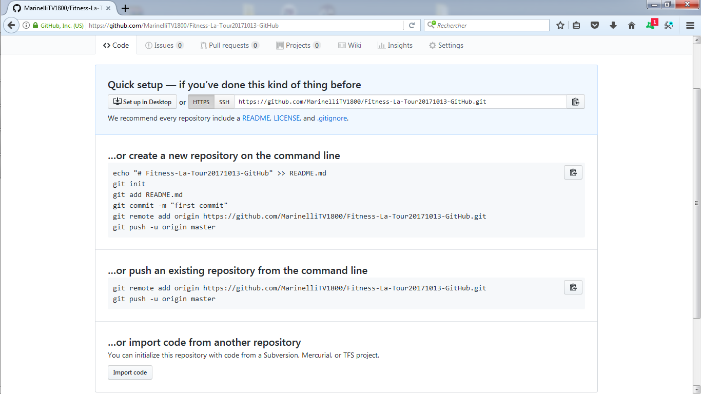

https://github.com/MarinelliTV1800/Fitness-La-Tour20171013-GitHub