# Object-Oriented Programming

Before we dive into this module about OOP, we strongly recommend going through our module 1 about C# basics. You will find many valuable pieces of information, which will help you significantly to follow along with this module.

# Classes and Constructors

The class is the root of the word classification. When we create our class we systematically arrange information and behavior into a meaningful entity. We don’t use classification only in the software development, we are doing that in a real life as well. So, this only explains how classification is important in a software development process. The classes are reference data types, and if you want to learn more about data types you can visit our article in module 1 about C# basics.

## Adding New Elements in a Solution Explorer

Even though we can create our new classes in the Program.cs file, it is the much better solution to create a new class file. To do that, we need to right-click on our project name, choose Add and then New Item:

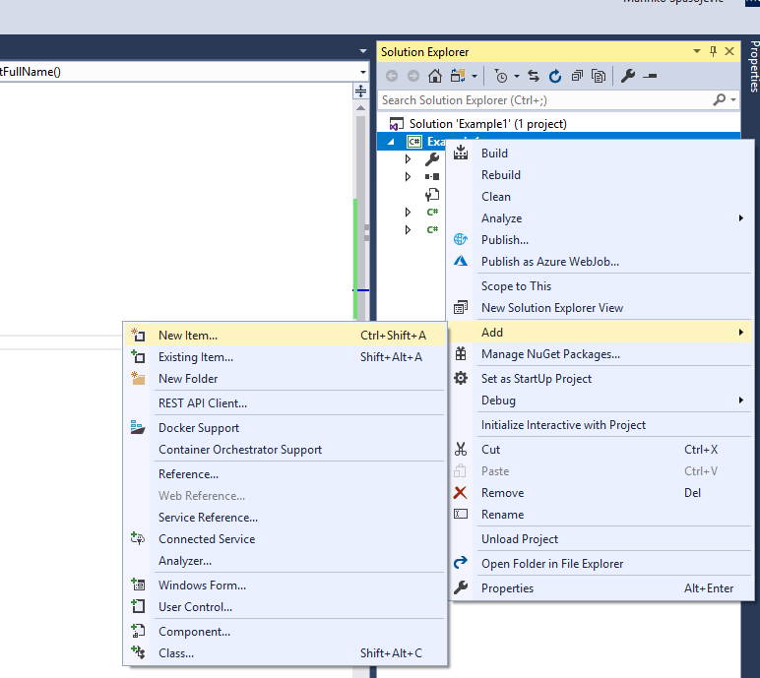

Then, we need to choose a class file and add it a name:

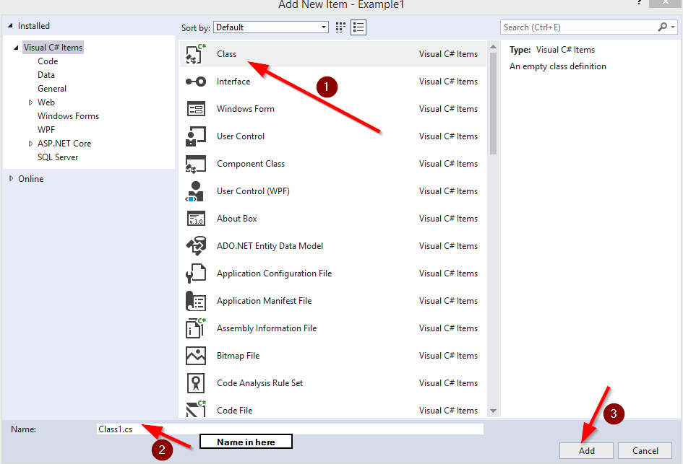

## Defining Classes and How to Use Them

In C#, to define a class we need to use the class keyword. All the data and methods occur in the class body between two curly braces:

public class Student

{

private string _name;

private string _lastName;

public string GetFullName()

{

return _name + ' ' + _lastName;

}

}

The classes body contains two private fields (variables in a class are called fields) name and lastName (if you are not familiar with the access modifiers keywords: private, public etc. you can read more about it in our module 1 about C# basics), and one public method GetFullName.

As we know from our module 1 C# basics, the class is a reference type, so to initialize it we need to use the new keyword:

class Program

{

static void Main(string[] args)

{

Student student = new Student();

}

}

Now with the student object we can access the data from the Student class.

It is very important not to confuse the terms class and object. The class is a type definition but an object is an instance of that type. We can have several object instances of the same class.

## Constructors

When we use the new keyword to create an object, the CLR uses the class definition to construct that object for us by calling a constructor method.

A constructor is a special method that has the same name as a class, doesn’t return any value (not even void) and can take parameters. It runs automatically when we create an instance of a class. So, every time we use the new keyword to instantiate a class, we are calling a constructor of that class.

Every class must have a constructor. If we don’t write one, the compiler automatically generates one for us. That type of constructor is called a **default constructor**. A default constructor will reset all the data inside a class, to their default values. So, in our example, the fields name and lastName will have an empty string as a value at a beginning.

We can write our own default constructor as well:

public class Student

{

private string _name;

private string _lastName;

public Student()

{

_name = string.Empty;

_lastName = string.Empty;

}

public string GetFullName()

{

return _name + ' ' + _lastName;

}

}

## Constructor Overloading

Our classes are not restricted on having just one constructor method. We can create more of them in a single class:

public class Student

{

private string _name;

private string _lastName;

public Student()

{

_name = string.Empty;

_lastName = string.Empty;

}

public Student(string name, string lastName)

{

_name = name;

_lastName = lastName;

}

public string GetFullName()

{

return _name + ' ' + _lastName;

}

}

Now we have two options to instantiate our class, first one with the default values (which we don’t have to write) and the overloaded one, which provides us with a possibility to set the values of our fields:

class Program

{

static void Main(string[] args)

{

Student student = new Student(); //default constructor

Student student1 = new Student("John", "Doe");//overloaded constructor

Console.WriteLine(student1.GetFullName());

}

}

One important thing to have in mind. If we create our own constructor for a class, the compiler won’t create a default one for us. So if we want to have a default one and the overloaded one, we must create both of them.

## Partial Classes

In a real-world project, our class can be pretty large due to its own high functionality. That kind of classes could become less readable and tough to maintain. To avoid that, we can use partial classes.

A partial class is nothing more than a part of a single class. To define partial classes, we need to use the partial keyword in each file:

partial class Student

{

private string _name;

private string _lastName;

public Student()

{

_name = string.Empty;

_lastName = string.Empty;

}

}

partial class Student

{

public Student(string name, string lastName)

{

_name = name;

_lastName = lastName;

}

public string GetFullName()

{

return _name + ' ' + _lastName;

}

}

# Properties

A property is a member that provides a flexible tool to read and write the value of a private field. We use them as a public data members but actually, they are specific methods called accessors.

In this article, we are going to talk more about properties and how to use them in C#.

## Property Syntax

The syntax of a property declaration can be represented in the following way:

Access_Modifier Type PropertyName

{

get

{

//read actions

}

set

{

//write action

}

}

As we can see, a property can contain two blocks of code. The get block contains statements that execute when we read from a property. The set block contains statements that execute when we write to a property:

public class Student

{

private string _name;

private string _lastName;

public string Name

{

get { return _name; }

set { _name = value; }

}

public string LastName

{

get { return _lastName; }

set { _lastName = value; }

}

public Student(string name, string lastName)

{

_name = name;

_lastName = lastName;

}

public string GetFullName()

{

return _name + ' ' + _lastName;

}

}

In the example above we see that our private fields are now exposed through the properties. If we want to read the value of the _name field all we have to do is to call a Name property with the student object. The same applies to the _lastName field. Moreover, if we want to set a value to our fields, all we have to do is to call a set block of our properties:

class Program

{

static void Main(string[] args)

{

Student student = new Student("John", "Doe");

string name = student.Name; //call to a get block of the Name property

string lastName = student.LastName; // call to a get block of the LastName property

student.Name = "David"; //call to a set block of the Name property

student.LastName = "Dauni"; // call to a set block of the LastName property

}

}

Our properties can have a complex code inside get or set blocks. They are not limited only to read a value or just to write a value. We can use conditions or method calls etc. in the get or set blocks:

public int X

{

get

{

return _x;

}

set

{

_x = CheckValue(value);

}

}

private int CheckValue(int val)

{

//code execution in here

}

## Read-Only and Write-Only Properties

We can declare a property that only has a get block and not the set. That kind of property is called Read-Only property. If we create a read-only property, we can only read the value of a private field. If we try to set it, the compiler will throw an error:

public string Name

{

get { return _name; }

}

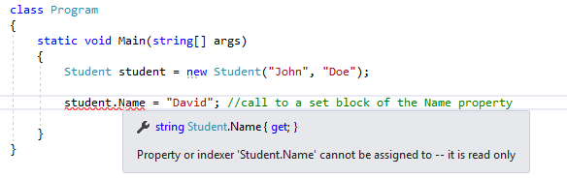

In the same way, as we can create a read-only property, we can create a write-only property. That type of property has only the set block and not the get. Of course, we can only set the values with this type of property and not to read it:

public string Name

{

set { _name = value; }

}



## Property Accessibility

We can specify an access modifier for our property (public, private…) if we want to restrict its availability. But in C# we can even override the accessibility of get or set accessors. So, what we can do is to declare a public property which has the public get accessor and private set accessor. If our property is a public one, we don’t have to add the public keyword for the get accessor, it is going to be public anyway:

public string Name

{

get { return _name; }

private set { _name = value; }

}

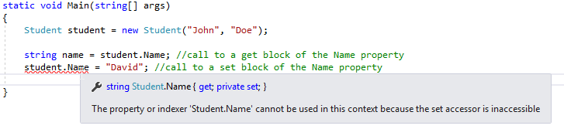

This means that we can read in all the classes from our Name property, but we can set it only inside the Student class.

When we use an accessor overriding inside the property, we must pay attention to the following rules:

* We can change the accessibility level of only one accessor. There is no point in having both accessors modified. If we want to modify both accessors, we should just modify the property access level.
* We can’t use access modifier on the get or set blocks that are less restrictive of the access modifier applied on a property itself. So, if our property is private, there is no point in having the get or set blocks public.

## Auto-Implemented Properties

If no additional logic is required in a property accessor, we can use the auto-implemented properties for more readable and concise way of declaring properties. The auto-implemented property consists only of the get and set keywords, nothing more:

public string Name { get; set; }

public string LastName { get; set; }

When we declare the properties like this, the compiler creates a private field for us, which could be accessed only through the property’s get or set accessors.

So in our example instead of:

private string _name;

public string Name

{

get { return _name; }

set { _name = value; }

}

We can just write:

public string Name { get; set; }

In the Visual Studio tool we are even going to get a suggestion to use an auto property:

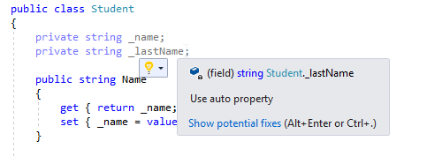

# Static Methods, Static Classes, and Extension Methods

In this article, we are going to talk about static members in C#, when and why to use them.

## About Static Methods

We can often find that many methods belong to the instance of a class. And that is quite normal behavior with the software development in C#. But we can see some methods which are independent of the specific class instance. Those kind of methods are the static ones. So, the static methods are the methods which don’t belong to an instance of a class, can interact only with other static elements and have the static keyword in the method description.

For example method Sqrt(). This method calculates the square root of a number, and we don’t have to instantiate the Math class (which the Sqrt belongs in) because this method is a static method.

So, why is the Sqrt method a static method and not a nonstatic one?

Well, the Sqrt accepts only one argument and it is enough to do its job. We provide an argument number and the method returns a square root of that number. We didn’t mention the Math class at all, do you see that? That’s because we don’t have to. The Math class doesn’t provide any feature to help the Sqrt method to do its job. It only provides a space for the Sqrt method to reside in.

When we have a case like this one, it is usually a good solution to create a method as a static one.

## Working with a Static Method

To call a static method, as we said, we don’t need an instance of a class. We can call it with the following syntax: ClassName.MethodName(arguments…);

So, when we want to use the Sqrt method or any other method from the Math class, we can call it like this: Math.Sqrt(16);

## Creating a Static Field by Using the Const Keyword

If we prefix our field with the const keyword, we can declare a field as static but that its value can never change. The keyword const is short for constant. A const field doesn’t use the static keyword in its declaration, but it is nevertheless static.

We can create a const variable in the following way: AccessModifier const Type Name = Value ;

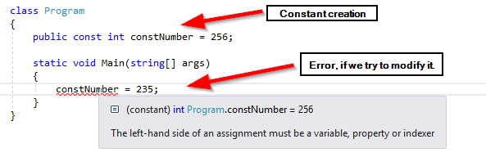

## Static Class

In C#, next to static methods we can declare static classes as well. The static class can contain only the static members. Its purpose is to act as a holder for the utility methods and fields. There is no point in instantiating this type of classes by using the new keyword. Furthermore, we can’t do that at all. But we can create a default constructor as long as it is a static one. Any other type of constructor is illegal:

public static class TestClass

{

private static int number;

static TestClass()

{

number = 54;

}

}

## About Extension Methods and How to Use Them

Let’s suppose that we want to add a new feature to the string type, for example, the FirstLetterUpperCase functionality that always makes the first letter of a string with upper case. We can write a normal method for that purpose:

public static string FirstLetterUpperCase(string word)

{

char letter = Char.ToUpper(word[0]);

string remaining = word.Substring(1);

return letter + remaining;

}

static void Main(string[] args)

{

string word = "football";

string newWord = FirstLetterUpperCase(word);

}

But, as we can see, we need to send a word as a parameter every time and to accept a value every time as well. This is not a wrong approach but we can do it better. There's where the extension methods become very useful.

An extension method enables us to extend an existing type with additional static methods. We must create that kind of methods inside a static class and they have the first parameter prefixed with the “this” keyword.

But why do we have to place a prefix in front of the first parameter?

Because that parameter is an indicator that tells to the compiler which type we extend.

So here is the previous example but with the extension method:

public static class StringExtensions

{

public static string FirstLetterUpperCase(this string word)

{

char letter = Char.ToUpper(word[0]);

string remaining = word.Substring(1);

return letter + remaining;

}

}

class Program

{

static void Main(string[] args)

{

string word = "football".FirstLetterUpperCase();

Console.WriteLine(word);

Console.ReadKey();

}

}

Excellent.

We are done with the static members and now we have a great knowledge, which we can use while developing our C# applications.

# Anonymous Types and Nullable Types

In this article, we are going to talk about anonymous classes, how to create them, and why are they useful. Moreover, we are going to talk about nullable types and how to use them with the value types and what properties we have with the nullable types.

## Anonymous Classes

An anonymous class is a class that does not have a name. This could sound strange but it is useful in some parts of development, especially with the query expressions.

We can create an anonymous class simply by using the new keyword in front of curly braces:

myAnonymousObj = new { Name = "John", Age = 32 };

This class contains two properties the Name and the Age. The compiler will implicitly assign the types to the properties based on the types of their values. So, the Name will be of type string and the Age of type int.

But now, we can ask, what the type of the myAnonymousObj is? And the answer is that we don’t know, but this is the point of anonymous classes. But in C# this is not a problem, we can declare our object as an implicitly typed variable by using the var keyword:

var myAnonymousObj = new { Name = "nesto", Age = 32 };

The var keyword causes the compiler to create a variable of the same type as the expression that we use to initialize that object. So let’s see a couple of examples with well-known types:

var number = 15; // the number is of type int

var word = "example"; //the word is of type string

var money = 987.32; //the money is of type double

We can access to the properties of our anonymous object the same way we did with regular objects:

Console.WriteLine($"The name of myAnonymousObject is {myAnonymousObj.Name}, the age is {myAnonymousObj.Age}");

## Nullable Types

The null value is useful for initializing reference types. So, it is logical that we can’t assign the null value to the value type because the null is itself a reference. The following statement will throw an error:

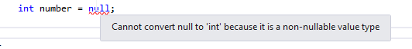

However, C# provides us with a modifier that we can use to declare a value type as a nullable value type. We can use the ? to indicate that value type is nullable:

int? number = null;

We can still assign an integer value to our nullable value type:

int? number = null;

int another = 200;

number = 345;

number = another;

This is all valid. But if we try to assign a value of our nullable type to the variable of an int type, we are going to face a problem:

int? number = null;

int another = 200;

another = number; //this is the problem

This makes sense if we consider that the variable number might contain the null but the variable another can’t contain the null at all.

## Properties of Nullable Types

The nullable types expose a few properties which can come in handy while working on our projects. The HasValue property indicates whether a nullable type contains a value or it is a null. The Value property enables us to retrieve the value of the nullable type it is not a null:

int? number = null;

number = 234; //comment this line to print out another result

if(number.HasValue)

{

Console.WriteLine(number.Value);

}

else

{

Console.WriteLine("number is null");

}