# Module 3 – Web Development Basics

# HTML Document Setup and Basic Elements

In this article, we are going to learn about the basic HTML document setup and how to use some basic HTML elements.

## About HTML

HTML stands for Hyper Text Markup Language and it describes the structure of Web pages by using markup. All the HTML elements are represented as tags, which we will describe in more detail a bit later. We can’t see these HTML tags in a browser, HTML uses them just to render the content on the page.

To work with examples, we are going to use VisualStudio Code editor. To create a new HTML file click on File menu and then NewFile. We get the untitled document. So, all we have to do is to save it with the .html extension at the end of the document name.

## HTML Document

Every HTML file must start with the document type declaration:

<!DOCTYPE html>

The HTML document begins with the <html> tag and ends with the </html> closing tag.

Inside the <html> tag, we use the <body></body> tags to specify the body of the HTML document:

<!DOCTYPE html>

<html>

<body>

This is some text inside the body tag.

</body>

</html>

Between the <html> and the <body> tag, we use the <head></head> tags. The <head> tag contains the metadata about the HTML document. With metadata, we define doucment title, styles, character set, links, script and other informations. For all the mentioned metadata, we can specify tags: <title>, <style>, <meta>, <link>, <script> and <base> :

<!DOCTYPE html>

<html>

<head>

<meta charset="utf-8">

<title>This is page title.</title>

</head>

<body>

This is some text inside the body tag.

</body>

</html>

## HTML Headings

We can define headings in HTML with the tags from <h1> to <h6>. The <h1> tag produce the most important heading and <h6> the least important one:

<!DOCTYPE html>

<html>

<head>

<meta charset="utf-8">

<title>This is page title.</title>

</head>

<body>

This is some text inside the body tag.

<h1>This is heading 1</h1>

<h2>This is heading 2</h2>

<h3>This is heading 3</h3>

<h4>This is heading 4</h4>

<h5>This is heading 5</h5>

<h6>This is heading 6</h6>

</body>

</html>

Result:

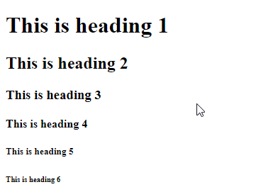

## HTML Paragraph

To define paragraph in HTML, we use the <p> tag:

<p>

This is the first paragraph.

</p>

<p>

This is the second paragraph.

</p>

Result:

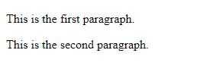

## HTML Div Element

We use the <div> element to represent a block or a section of the HTML content. We can think of it as a placeholder for our content:

<div>

<h3>This is the first document section</h3>

<p>

Some content in here.

</p>

</div>

<div>

<h4>This is the second section.</h4>

<p>

This is some other content.

</p>

</div>

Result:

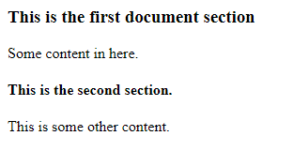

## HTML Span Element

The <span> tag is an inline element in HTML and it will not start in another row:

<div>

<p>Span tag example</p>

<span>Content in the frist span tag </span>

<span>and content in the second span tag.</span>

</div>

Result:

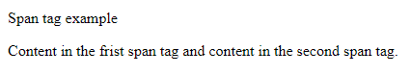

## HTML Images

To display image in the HTML document, we can use the <img> tag. This tag is self-closing tag, which means that we don’t have the </img> tag.

The sole <img> tag is not enough to display image, we need to use additional attribute src, which describes the path to the image. If the image is in the same place as the HTML document then for the path we can use just image name and extension. But if the image is outside the folder where the HTML document is, we need to use this syntax: ../image-name-and-extension.

One more attribute is required by HTML standards and it is the alt attribute. With it we can specify what user see if the image is not loaded:

<p>This is Code Maze picture:</p>

<img src="code-maze.png" alt="Code-Maze Picture" />

Result:

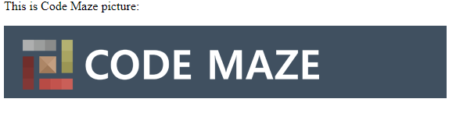

## HTML Links

We can use links in HTML to direct a user to another HTML page. In HTML we specify links with the <a> tag. As with the <img> tag, we need additional attributes to specify on which location this link is pointing and do we want to open that page in the same tab we are currently on or in another one. To specify location we use the href attribute:

<p>Using links</p>

<a href="https://codemaze.com">This is link to the Code-Maze site.</a>

Result:

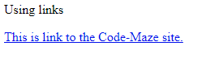

If we want to open the linking document in a new tab, we can use the target attribute with the _blank value:

<p>Using links</p>

<a href="https://codemaze.com" target="_blank">This is link to the Code-Maze site.</a>

## Empty HTML Elements

Html elements without content are called empty elements. The <br /> is an empty element. We use the <br> tag to create a line break in the HTML content.

## Conclusion

We have learned about the basic setup in HTML document and how to use basic HTML elements to render content on the HTML page. There are a lot more elements that we can use in HTML and we are going to cover many of them in the future articles.

In the next article, we are going to talk about formatting in HTML and how to use formatting elements.