**How to run the second phase of the project:**

1. Download the input file, output file, and Parsing.java file

2. Create a new folder and place all 3 files inside. (preferably on your desktop)

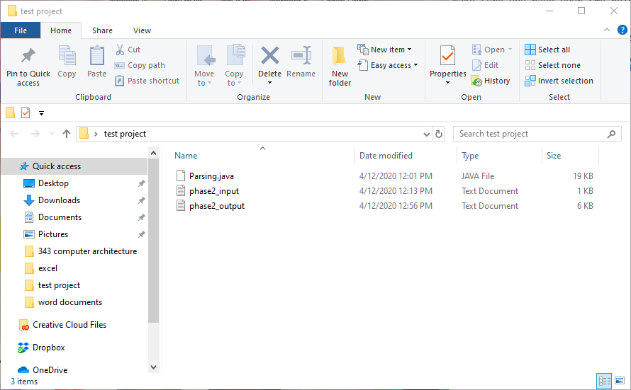

3. open the cmd and change the directory to match the folder you created:

“cd [path]” (e.g. cd "C:\Users\MARINOS NEW\Desktop\test project")

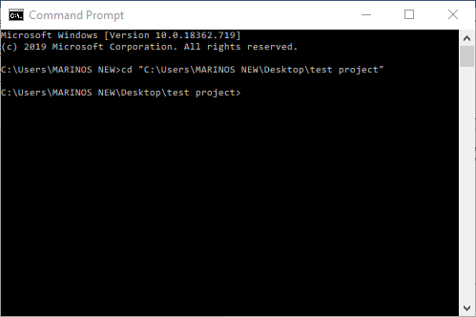

4. Now type in the cmd type “javac Parsing.java”

(if successful 3 .class files should have been created; i.e.

GetURLInfo.class, Parsing.class, and WebpageReaderAgent.class

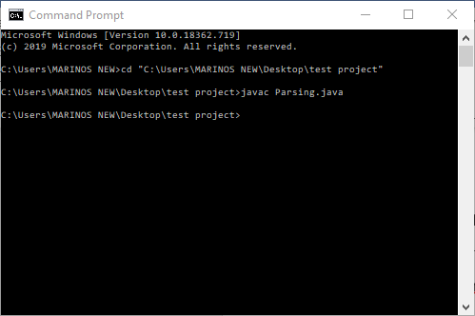

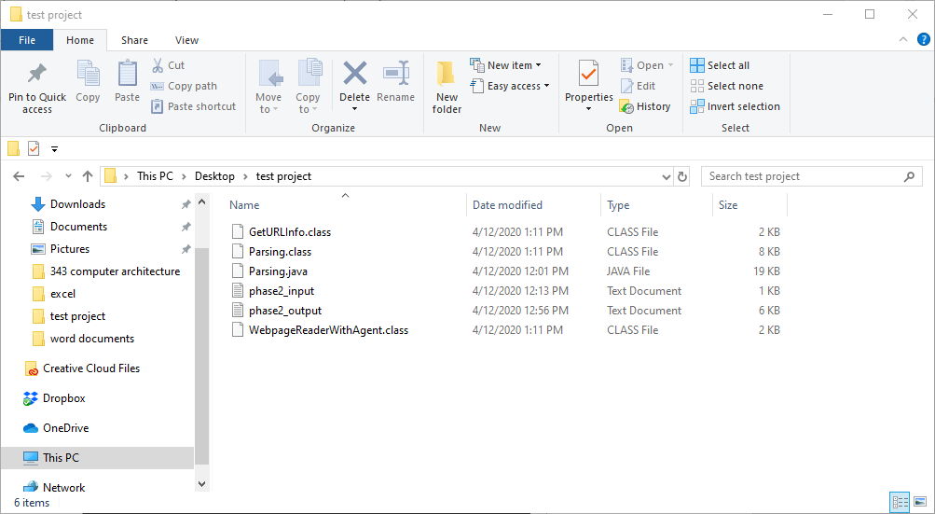

5. Now type "java Parsing -d "file_path" -o output_file -i input_file"

(e.g. java Parsing -d "C:\Users\MARINOS NEW\Desktop\test project" -o phase2_output.txt -i phase2_input.txt)

* MAKE SURE YOU DON'T HAVE THE ANY OF FILES OPEN WHILE IT READS AND WRITES TO THEM.
* MAKE SURE YOU SURROUND THE FILEPATH IN " "
* MAKE SURE YOU REMEMBER TO ADD .TXT TO INPUT/OUTPUT FILE
* IF AN ERROR OCCURS, TRY TO COMPILE AGAIN.

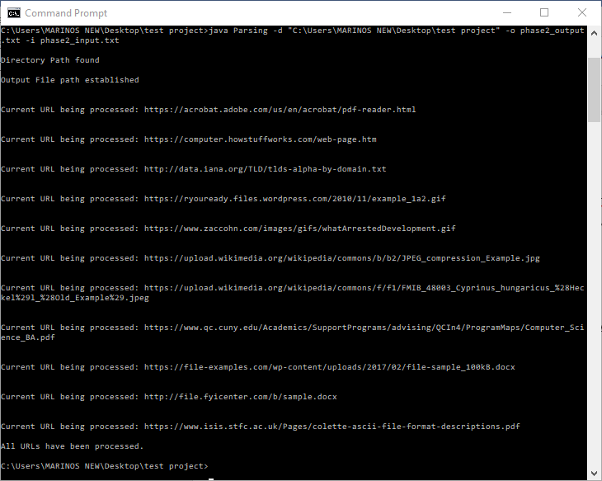

6. If successful, after all the URLs have processed the cmd will state that it is finished.

Now you will be able to view all of the URL data inside of the output file, and the created files will appear inside the folder you created.

