**Jobider Global Payments**

# **Making international payments can be a complex process. Jobider Global Payments makes it easy for you.**

Jobider Global Payments is a complete payment platform that enables clients to effortlessly pay for work done by service providers. It also helps job bidders access their earnings quickly and efficiently. Jobider Global Payments offers:

## **Flexible Payment Solutions for Clients**

With Jobider Global Payments, Clients can easily pay their contractors around the world.

Jobider provides clients, tools to help clients seamlessly track payments to job bidders as well as their choice between the following funding options (this will link to a page in the FAQs – details below):

* PayPal
* Credit Card

## **Secure, Quick, Low-Cost Withdrawals for International Job Bidders**

Jobider Global Payments provides job bidders a simple and easy way to access their earnings. Jobider Global Payments offers job bidders the following withdrawal methods:

* PayPal

## **Low-Cost Withdrawals for Australian Job Bidders**

Jobider Global Payments provides Australian job bidders with flexible methods to withdraw earnings fast:

# **Get Started**

## **Clients**

Just add your credit card or PayPal account, and you’re ready to start. More Details . . .

## **Job Bidders**

Your earnings will accrue in your Jobider account until you withdraw them. To withdraw your Jobider earnings, you first need to add a withdrawal method to your Jobider account. After you have added your withdrawal method, you can request withdrawals to that account any time. More Details . . .

Funding options should link to FAQ under “Contact Help and Support” and users will read these:

## **What Payment Methods Can I Use to Pay Job Bidder Services?**

Clients may use their Visa, MasterCard, American Express, or PayPal to pay Job Bidders.

### **How do I pay job bidders using my credit card?**

Jobider accepts Visa, MasterCard and American Express. To add your credit card, or PayPal Account to your Jobider account, please log in to your Jobider accounts and follow these steps:

**Please note that I got these steps from the withdrawal process in Elance. Perhaps the developers can advise you on how we can do this on Jobider?**

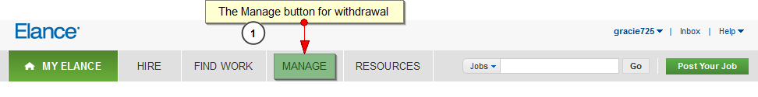

1. Click on the **Manage** tab in the top navigation. Choose **Financial Accounts** from the drop down list.

**This is what you will see when you click on Financial Accounts on Elance website:**

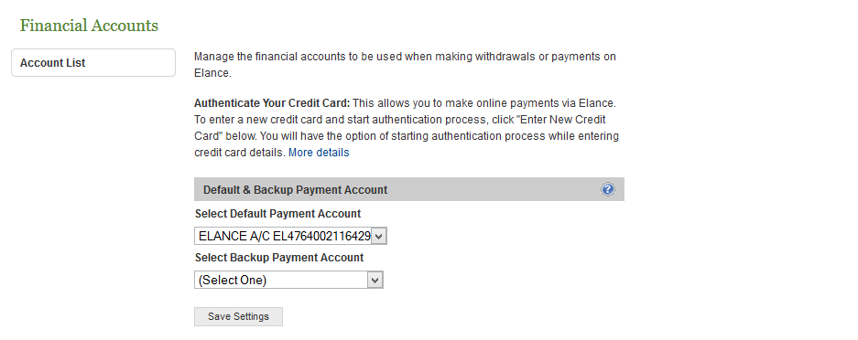

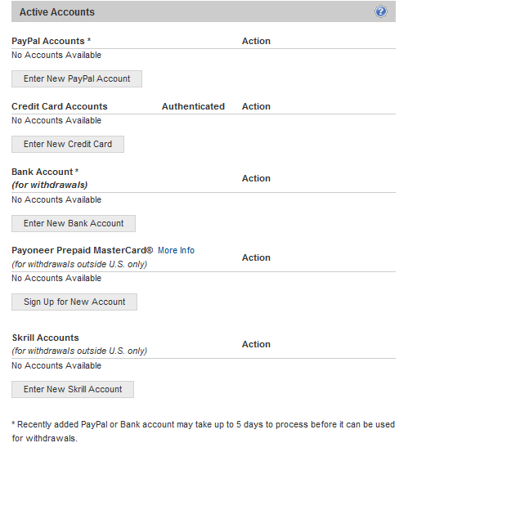

1. Click **Enter New Credit Card** button.

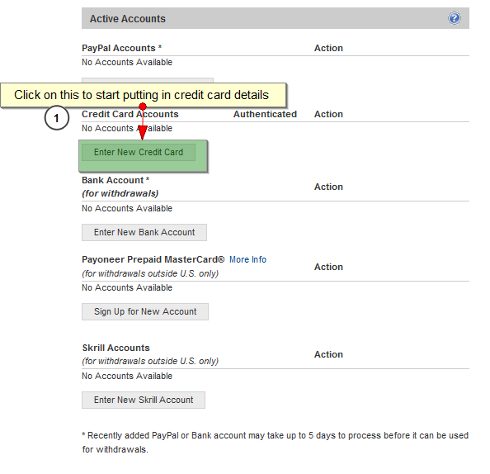

**After clicking on “Enter New Credit Card,” this will appear:**

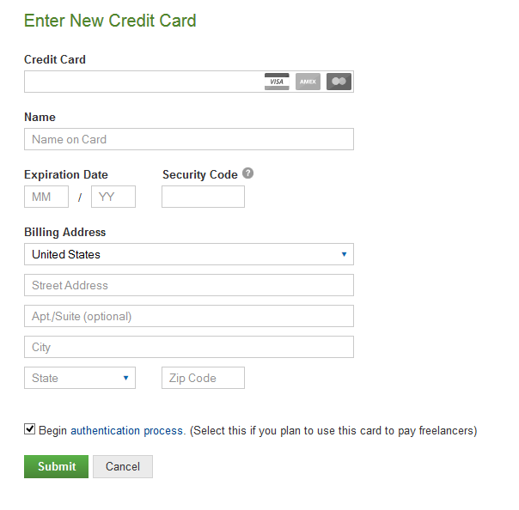

1. Enter your credit card details.
2. Review your credit card details. Please make sure everything is correct and click **Submit**.
3. A confirmation message will appear. Once it is added, the new credit card will be your primary payment method.

You may be required to authenticate your credit card in most cases. Please click here for more information about the credit card authentication process.

### **How do I pay job bidders using PayPal?**

Clients who have a PayPal account can use it to fund payments to job bidders through the Jobider platform.

**Please note that paying a job bidder using PayPal is a violation of Jobider terms of service**

To add your PayPal account as a payment method for job bidder services, please log in to your Jobider account and follow these steps:

**Again please take note that these are the steps in Elance.**

1. Click on the **Manage** tab in the top navigation. Choose **Financial Accounts** from the drop down list.



**This page appears after clicking on Financial Accounts:**





1. Click on **New PayPal Account**

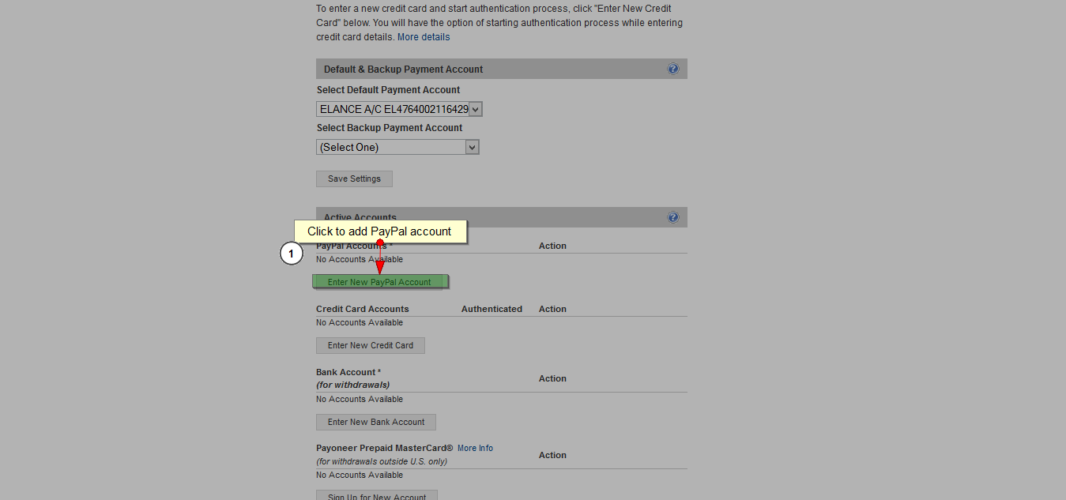

1. A message will appear, directing you to log in to PayPal to confirm that your PayPal account is valid. You will need to agree to a Billing Agreement with Jobider. PayPal will require you to have a payment source, such as a credit card, on file, in order to sign the agreement. Click on **Agree and Continue**.
2. A confirmation message will appear. Once it is added, the new PayPal will be your primary payment method.

## **How Do I Get My Credit Card Authenticated?**

We may ask you to authenticate your credit card as a security measure. We ask Clients to go through this process to make certain that you are the owner of the card who also has complete access to the account information.

There is no authentication required if your preferred payment method is PayPal. For more information on how to add your PayPal to your Jobider account, please click here.

Jobider authentication is only available for credit cards with a billing address in one of the supported countries in our list. If your credit card country is not supported, you can use PayPal.

## **Instructions on how to complete credit card authentication**

To authenticate your credit card, log in to your Jobider account and follow these steps:

**Based on Elance platform:**

1. Click on the **Manage** tab in the top navigation. Choose **Financial Accounts** from the drop down list.
2. If you do not have a credit card listed, click on **Enter New Credit Card** and enter your credit card information. If you already have your credit card listed, click on **Authenticate**.
3. Please check your credit card statement or contact your credit card issuer to retrieve the EXACT amounts. These amounts will be refunded to you within 5 business days. However, if you are having your credit card authenticated as part of the Payment Verified process, these amounts cannot be refunded.
4. When the 2 charge amounts appear, click **Confirm Authentication**. Enter the exact amounts as they appear on your credit card statement regardless of your local currency. You will see a confirmation page stating that your card has been authenticated, if the amounts that you enter are correct.

Please note that the two amounts charged to your credit card may not immediately show up in your credit card account. MasterCard and Visa may take up to 3 or 4 business days. American Express can take up to 5 business days.

You should complete the authentication process within 90 days. If you still want to authenticate your credit card after 90 days have passed, you have to start the process again.

**Important:** When you have added a newly authenticated credit card or PayPal account, it will be assigned as your default payment method. Please click here for additional information about default payment methods.

## **Supported Countries (As listed on Elance)**

Jobider supports credit card authentication for the following countries.

* Andorra
* Argentina
* Armenia
* Aruba
* Australia
* Austria
* Bahamas
* Bangladesh
* Belgium
* Bermuda
* Bolivia
* Bosnia and Herzegovina
* Brazil
* Brunei Darussalam
* Canada
* Cayman Islands
* Chile
* China
* Costa Rica
* Croatia (Hrvatska)
* Czech Republic
* Denmark
* Dominican Republic
* Egypt
* El Salvador
* Estonia
* Fiji
* Finland
* France
* France, Metropolitan
* Germany
* Gibraltar
* Greece
* Greenland
* Guam
* Hong Kong
* Hungary
* Iceland
* India
* Indonesia
* Ireland
* Israel
* Italy
* Jamaica
* Japan
* Jordan
* Kuwait
* Latvia
* Luxembourg
* Pakistan
* Palestine
* Panama
* Peru
* Philippines
* Macedonia
* Marshall Islands
* Mexico
* Monaco
* Montenegro
* Netherlands
* New Zealand
* Norway
* Poland
* Portugal
* Puerto Rico
* Romania
* Russia
* Saint Kitts And Nevis
* San Marino
* Saudi Arabia
* Serbia
* Singapore
* Slovak Republic
* South Africa
* South Korea
* Spain
* Sri Lanka
* Sweden
* Switzerland
* Taiwan, Province of China
* Thailand
* Turkey
* Ukraine
* United Arab Emirates
* United Kingdom (including Scotland and Wales)
* United States of America
* United States Minor Outlying Islands
* Venezuela
* Vietnam
* Virgin Islands (U.S. or British)