SP4CE SURVIVAL

**Health recommendations:**

* **Try to rest for about 15 minutes for every hour of play.**
* **Do not play if you are very tired or have had little sleep.**
* **Always play in well-lit rooms and stay as far away from the screen as possible. Under normal conditions, some people may experience epileptic seizures when exposed to flashing lights or shapes, making them susceptible to seizures while watching TV or playing video games.**
* **Even gamers who have never suffered from epileptic seizures may suffer from epilepsy without knowing it. Consult your doctor before using a video game if you suffer from epilepsy or if you experience dizziness, blurred vision, muscle spasms or other involuntary movements, disorientation, confusion or seizures.**

English version

**INDEX**

**CONTROLS** 2

**WELCOME MENU** 2

**LOG IN** 2

**REGISTRY** 3

**PLAY OFFLINE** 3

**OPTIONS** 4

**EXIT** 4

**MAIN MENU** 5

**PLAY** 5

**DIFICULTIES** 6

**PROFILE** 6

**LEADERBOARD** 7

**GAME SCREEN** 8

**POST-GAME** 9

**GENERAL TIPS** 10

# **CONTROLS**

**Attention:** *Sp4ce Survival only works with keyboard and mouse.*

|  |  |
| --- | --- |
| **Action** | **Command** |
| Move up | W |
| Move right | A |
| Move down | S |
| Move left | D |
| Pause | Esc |
| Shoot | Left Mouse Click |

# **WELCOME MENU**

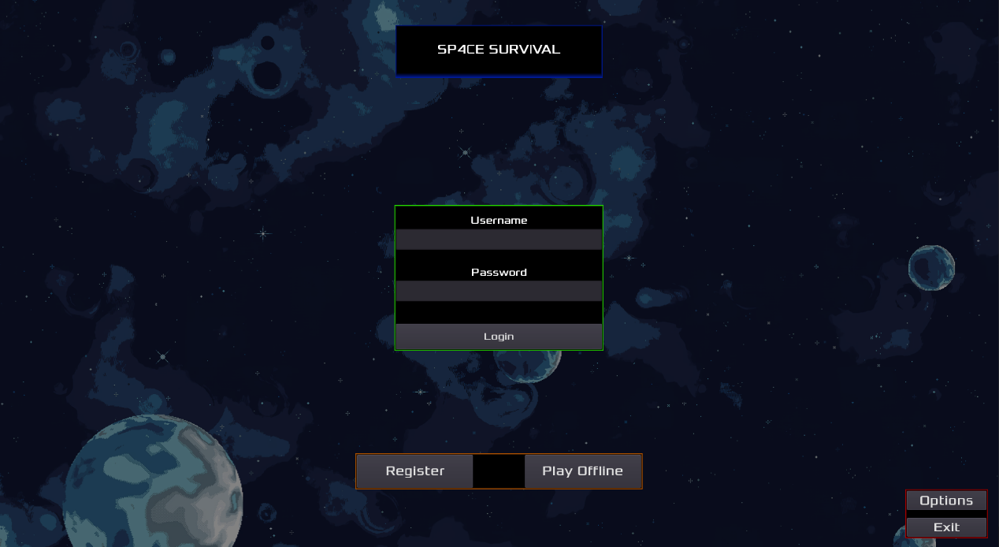

Here you can select the following options:

## **LOG IN**

If you are already registered, you can log in by simply entering your username and password.

## **REGISTRY**

If you decide to register, you must fill in the following fields:

* Username
* E-mail address
* Password
* Confirm Password

If the registration was successful, you will be logged in automatically.

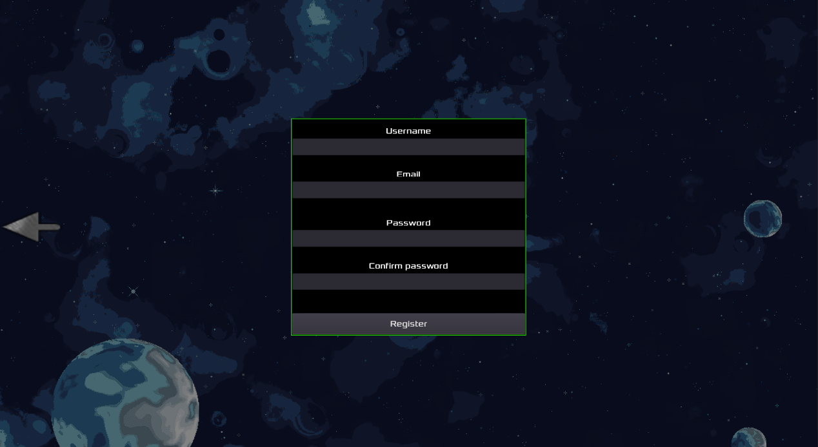

## **PLAY OFFLINE**

By clicking on this button, you can play without worrying about having an internet connection or an account.

**Note:** *The information will be stored for the duration of the game session, i.e. if you exit the game, your score will be deleted. Scores will never be stored online.*

## **OPTIONS**

In the options menu, you can customise your game settings.

**Language**: Choose between two languages, English and Spanish. By default the second option will be chosen.

**Sound**: You can mute any kind of sound coming from the game.

**Screen:** You can select whether you want to play in full screen mode.

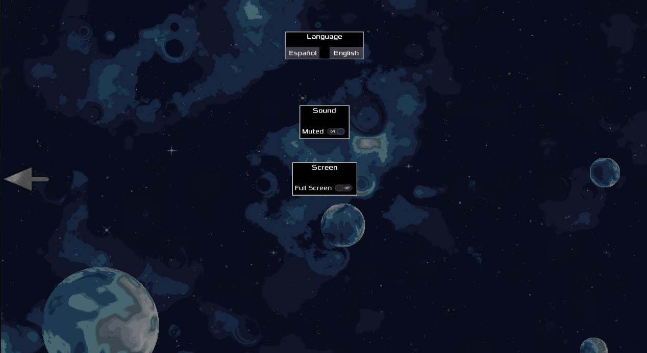

## **EXIT**

If you choose this option, you will exit the game safely.

# **MAIN MENU**

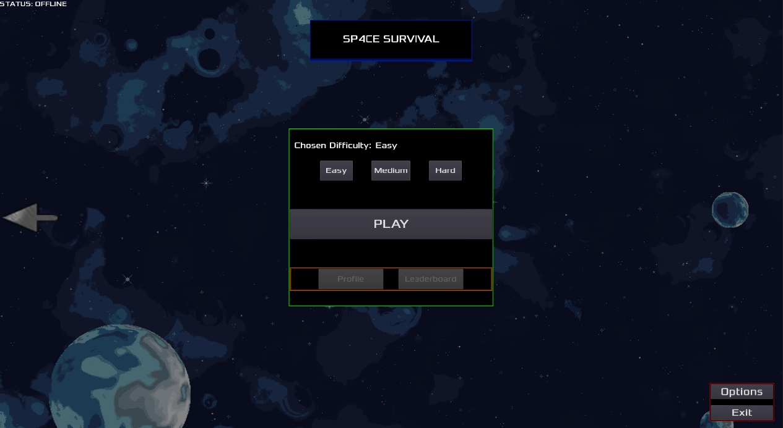

## **PLAY**

Games have a duration of 90 seconds. During this time, you must hold out for as long as possible, avoiding any contact with enemies.

The player can partially defend against them by firing projectiles that destroy both a type of enemy projectile and the enemy ship itself.

The enemy expels *two* types of projectiles at random:

* Type 1 – Player-Destructible



* Type 2 – Non-player destructible



***Scoring*** shall be calculated according to these rules:

* 1 second held: +1
* 1 enemy ship destroyed: + 10
* 1 enemy T1 shell destroyed: +3

In addition, if the full 90 seconds are withstood: + 1000

## **DIFICULTIES**

You will be able to select from three difficulties, which will affect your survivability as well as your final score.

* ***Easy***: Resist 3 hits - x2 to the score obtained.
* ***Normal***: Resist 2 hits - x4 to the score obtained.
* ***Difficult***: Resist 1 hit - x7 to the score obtained.

## **PROFILE**

**Please note**: *This menu can only be accessed in online mode.*

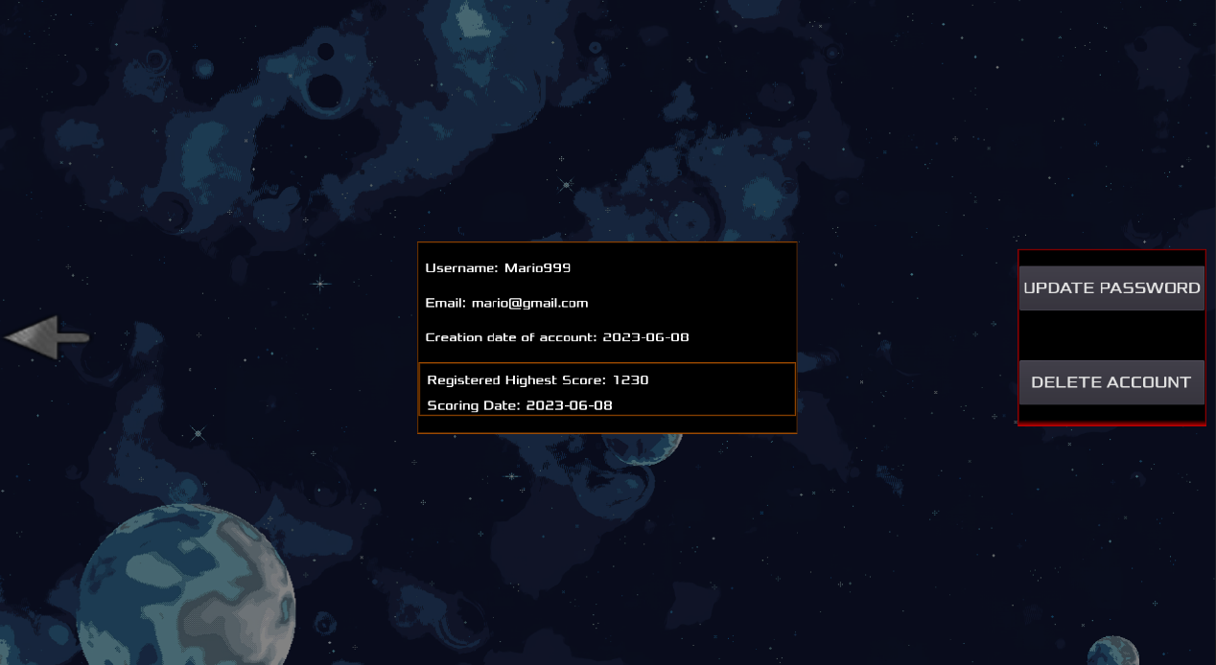

In this menu, you can:

* Display personal information.
* Update the password.
* Delete the account permanently.

## **LEADERBOARD**

**Please note**: *This menu can only be accessed in online mode.*

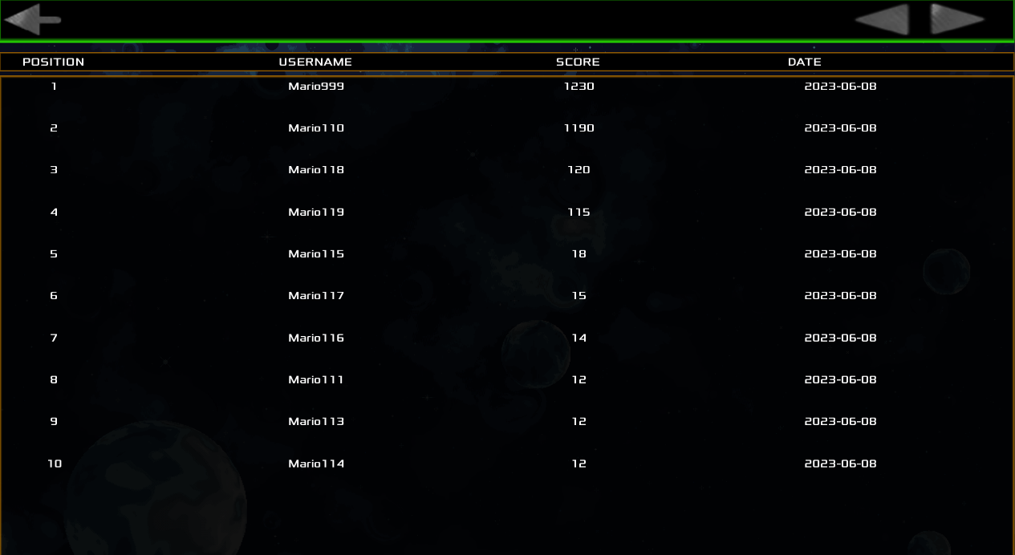

In this menu you will be able to visualise in order, the highest scores registered, the user who obtained them, and the date they were obtained.

You can navigate between pages using the arrows in the top left corner.

# **GAME SCREEN**

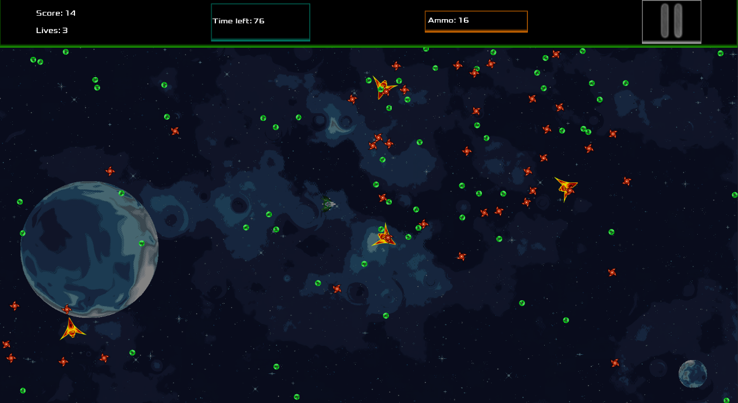

Relevant player information can be found in the top section.

* ***Score***: Score obtained at the current time, without applying difficulty multiplication.
* ***Lives***: Number of lives the player currently has.
* ***Time Remaining***: The time remaining until the end of the game is displayed.
* ***Ammunition***: Remaining ammunition that the player has. They are infinite, but the magazine is 20 and it takes some time to reload. It is done automatically once it reaches 0.
* ***Pause button***: Alternative to pause the game.

# **POST-GAME**

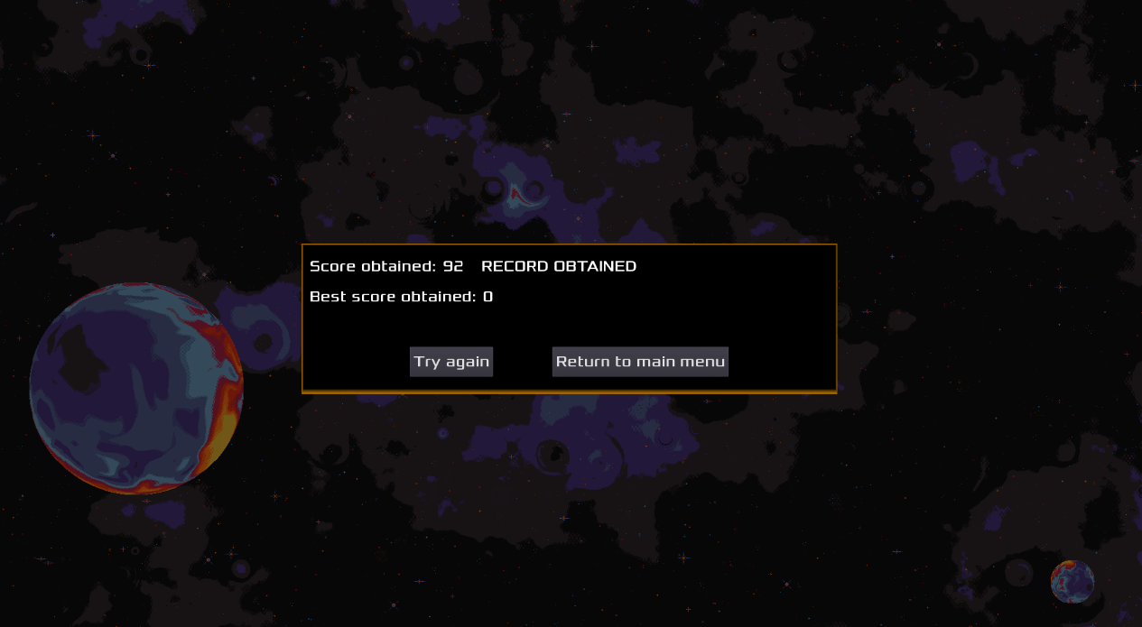

In this menu you can see the score obtained, multiplied by the level of difficulty and the highest score recorded.

You are allowed to retry the level at the same difficulty level, or return to the main menu.

# **GENERAL TIPS**

* The use of a monitor with a resolution of ***1920 x 1080*** is ***recommended***. As a ***minimum***, ***1280x720 is*** recommended***.***
* The game is still a ***bullet hell,*** andto improve your score you will have to find the balance between aggressiveness in eliminating enemies and agility in avoiding contact.
* You can use the ***easy*** mode as a ***tutorial***.