**TL;DR**: this program extracts a given zip, moves the extracted files to the paths specified in a csv file (creating the directories that did not exist before and giving them full permissions). Finally, if every file has been moved, the zip and the (empty) extracted folder are deleted.

**How the program works**

The program starts by searching for the zip file in the path specified in the parameters. If it exists, it gets extracted in that same path, and if there is a folder inside, its name is saved for later deletion. After that, it starts reading the csv file line by line, creates the directory in the second column if it does not exist and gives it full permissions (in a Linux environment only). Continuing on, the file on the first column is moved to its respective directory (located in the second column of its line in the csv file). After everything is done moving, the zip file is deleted along the extracted folder that was inside it (if there was any).

**File structure**

So that the program runs correctly, the files needed have to have a specific structure:

* The zip file will have files in its root, and might contain only one folder, containing only other files (and no more folders).

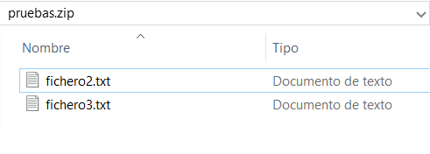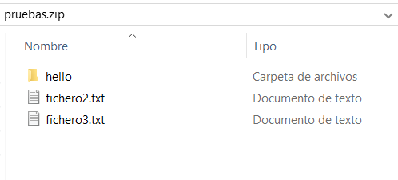

Ilustración 1_EjemploZip2

Ilustración 2_EjemploZip1

These images show the two ways the zip can be structured. In "Ilustración 2_EjemploZip1", the "hello" folder won’t have another folder inside it.

* The csv file will have two columns: the first one will contain the relative path to the file inside the zip (if the file is in the zip’s root, then the relative path will just be the name of the file with its extension. If the file is inside a folder, then the relative path will be the name of the folder and the name of the file with its extension). The second column will contain the absolute or relative path to which the file will be moved (just the path, without the name of the file). If the first column is empty but the second one is not, then a directory will be created but no files will be moved there.

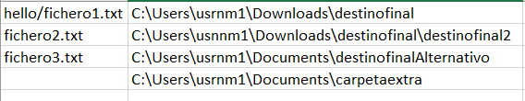

Continuing with the example shown in the image "Ilustración 2_EjemploZip1", this image shows the structure that the csv file should have in Windows. The first three lines move the file in the first column to the absolute path in the second column. The last line creates the folder "carpetaextra" in the path "C:\Users\usrnm1\Documents".

Same example as above but in a Linux environment. While absolute paths were used in the other example, relative paths are being used in this one (which is to say, in this example, the folders will be created in the directory in which the program has been executed).

**Executing the program**

This program can be started through the console, or with a script, with the command  
"java -jar <path to the jar>\dir_auto.jar <path to the zip file>\file.zip <path to the csv file>\file.csv" for Windows, or  
"java -jar <path to the jar>/dir_auto.jar <path to the zip file>/file.zip <path to the csv file>/file.csv" for Linux environments,  
without the quote marks and replacing what’s in between the <> for the path to the files.

The jar accepts two parameters: the path to the zip file and the path to the csv file, in that order. In the source code there is an alternative to find the files automatically (both the zip and the csv). In this case, the zip and csv files will be the only ones with their respective extensions in the folder they are located. To change to this behaviour in the source code, the Main class has to be modified to create both the UnzipFile and the CsvReader object with a no arguments constructor.

Command examples: if the current working directory is the folder "dirProject", the jar is in "dirProject\bin", the zip file with name "filesToMove.zip" is in "dirProject" and the csv file with name "fileLocations.csv" is in "dirProject\textDocuments", the command to use is the following:

* For Windows:

java -jar bin\dir_auto.jar filesToMove.zip textDocuments\fileLocations.csv

* For Linux:

java -jar bin/dir_auto.jar filesToMove.zip textDocuments/fileLocations.csv