TFM:

RAW DATA: .fastq.gz de RNA-seq paired-end. Mirar pdf procedente de macrogen
Paired-end sequencing allows users to sequence both ends of a fragment and generate high-quality, alignable sequence data. Paired-end sequencing facilitates detection of genomic rearrangements and repetitive sequence elements, as well as gene fusions and novel transcripts.
In addition to producing twice the number of reads for the same time and effort in library preparation, sequences aligned as read pairs enable more accurate read alignment and the ability to detect insertion-deletion (indel) variants, which is not possible with single-read data.1 All Illumina next-generation sequencing (NGS) systems are capable of paired-end sequencing.
Paired-end sequencing involves the sequencing of both ends of each cDNA fragment rather than sequencing only one end (https://www.ncbi.nlm.nih.gov/pmc/articles/PMC5442695/#!po=10.9375)

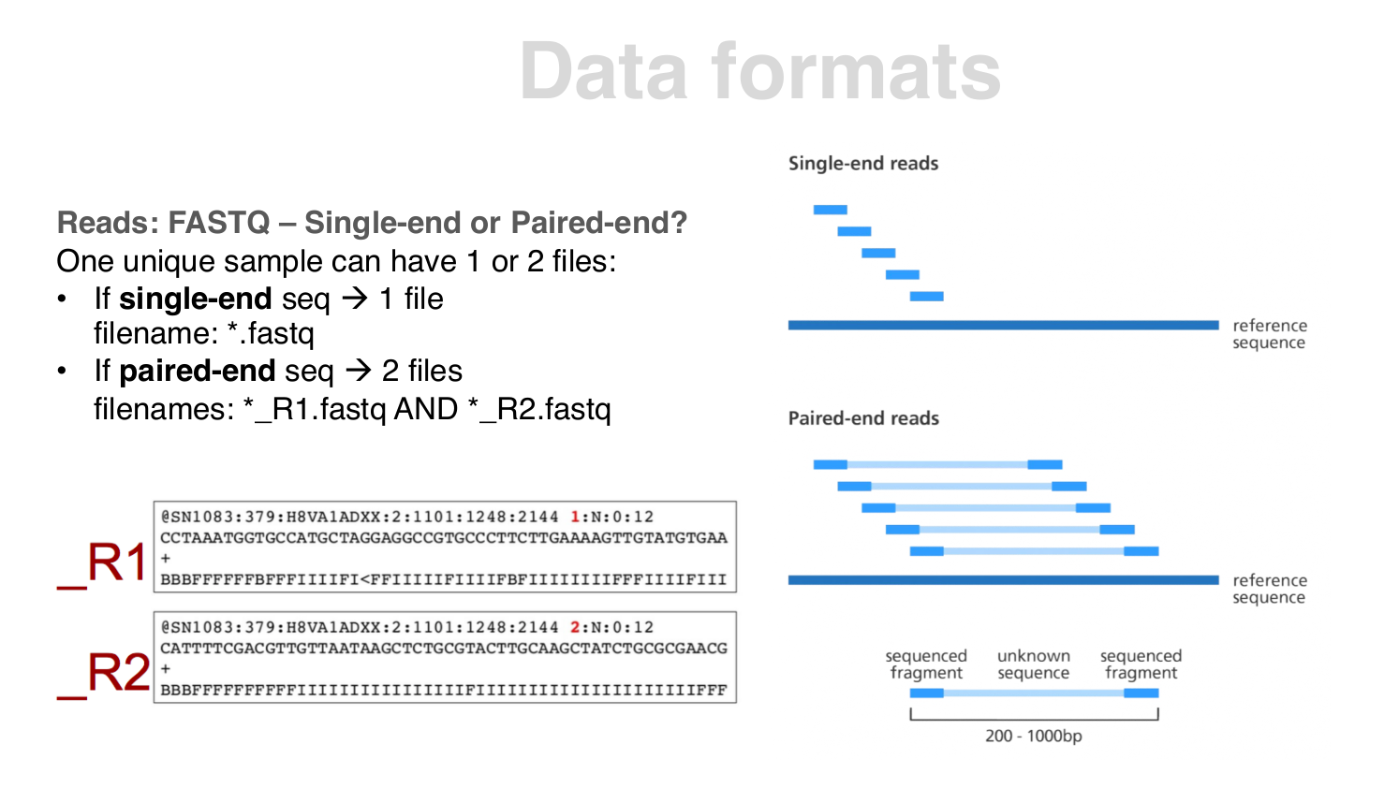
FASTQC: fastqc -t 7 -o out/dir input

Primero:
Descarga del Genoma de Referencia de la pagina: https://ftp.ncbi.nlm.nih.gov/genome/refseq/…. Después, en este apartado elegimos vertebrate_mammalian y elegimos homo_sapiens. En este directorio usaremos los fna (formato fasta) y el gff (anotaciones de las diferentes caracteristicas del genoma. https://www.ensembl.org/info/website/upload/gff.html).
Importante la organización de la carpeta de trabajo.
Debemos indexar el genoma de referencia: usaremos star.
Importante: el fichero del genoma de referencia debe estar unzipped
El comando será:
STAR --runThreadN 6 --runMode genomeGenerate --genomeDir out/star/genome_index
--genomeFastaFiles res/genome/GCF_000001405.39_GRCh38.p13_genomic.fna
--sjdbGTFtagExonParentTranscript Parent --genomeSAindexNbases --sjdbGTFfile res/genome/GCF_000001405.39_GRCh38.p13_genomic.gff --sjdbOverhang 150
Este indexado tendrá como input el fasta y gff del genoma de referencia y solo se necesitará realizarlo una vez por genoma. Lo guardaremos en la carpeta star_index.
Debemos establecer el WD:
cd /Escritorio/RNA-seq\ IRBLLEIDA
export WD=$(pwd)
echo $WD

Segundo:
Realizaremos el mapeo de las muestras al genoma de referencia, previamente indexado, también con star. Como input usaremos los fastq del RNA-seq (añadir comando extra al tratarse de paired end).
Este mapeado se hará para determinar el grado de homologia, identificar dominios funcionales, comparar el gen con sus productos, encontrar posiciones homologas ,identificar diferencias
The basic options to run a mapping job are as follows:
STAR --runThreadN 4 --genomeDir out/star/genome_index/ --readFilesIn data/RNA-1_1.fastq.gz data/RNA-1_2.fastq.gz --readFilesCommand zcat --outFileNamePrefix out/star/alignment
--runThreadN: NumberOfThreads
--genomeDir /path/to/genomeDir
--readFilesIn /path/to/read1[/path/to/read2]
--genomeDir specifies path to the genome directory where genome indices where generated
--readFilesIn name(s) (with path) of the files containing the sequences to be mapped (e.g.RNA-seq FASTQ files). If using Illumina paired-end reads, the read1 and read 2 files have to be supplied.
STAR can process both FASTA and FASTQ files. Multi-line (i.e. sequence splitin multiple lines) FASTA (but not FASTQ) files are supported.
If the read files are compressed, use the –readFilesCommand UncompressionCommandoption, where Uncompression Command is the un-compression command that takes the file name asinput parameter, and sends the uncompressed output to stdout. For example, for gzipped files (*.gz) use --readFilesCommand zcat OR--readFilesCommand gunzip -c.

Mapping multiple files in one run:
Multiple samples can be mapped in one run with a single output. This is equivalent to concatenating the read files before mapping, except that distinct read groups can be used in --outSAMattrRGlinecommand to keep track of reads from different files. For single-end reads use a comma separated list(no spaces around commas), e.g.:--readFilesIn sample1.fq,sample2.fq,sample3.fq

For paired-end reads, use comma separated list for read1, followed by space, followed by comma separated list for read2, e.g.:--readFilesIn s1read1.fq,s2read1.fq,s3read1.fq s1read2.fq,s2read2.fq,s3read2.fq

--outSAMtype BAM SortedByCoordinate output sorted by coordinate Aligned.sortedByCoord.out.bamfile, similar to samtools sort command. If this option causes problems, it is recommended to reduce--outBAMsortingThreadNfrom the default 6 to lower values (as low as 1).
Aligment: SAM or BAM
• SAM is the human readable text format (.sam extension)
• BAM is the binary, machine efficient format (.bam extension)
• Both contains exactly the same information and are interconvertible (samtools): https://samtools.github.io/hts-
specs/SAMv1.pdf

comando para pasar a .bam: samtools view -Sb filename.sam > filename.bam
otras opciones: http://www.htslib.org/doc/samtools.html
For example: to convert a BAM to a compressed SAM with CSI indexing:
samtools view -h -O sam,level=6 --write-index in.bam -o out.sam.gz
To convert a SAM to a compressed BAM using BAI indexing:
samtools view --write-index in.sam -o out.bam##idx##out.bam.bai
Para comprobar qué tal ha ido el mapeado, observamos el log.final.out en el cual aparecen las estadisticas del mapeado, muy util para el quality control
more $WD/out/star/alignment/Log.final.out

Reporte del pipeline:

conda install -y multiqc
mkdir -p out/multiqc
multiqc -o out/multiqc $WD

https://raw.githubusercontent.com/alexdobin/STAR/master/doc/STARmanual.pdf

NO DEBEMOS MARCAR DUPLICADOS, YA QUE PERDERIAMOS MUCHA INFORMACION DE EXPRESION AL TRATARSE DE RNA SEQ (AMPLICONES)

The higher the QPhred, the lower the probability that the base calling is erroneous

Posteriormente, debemos ver la calidad del alineamiento. Utilizaremos QualiMap

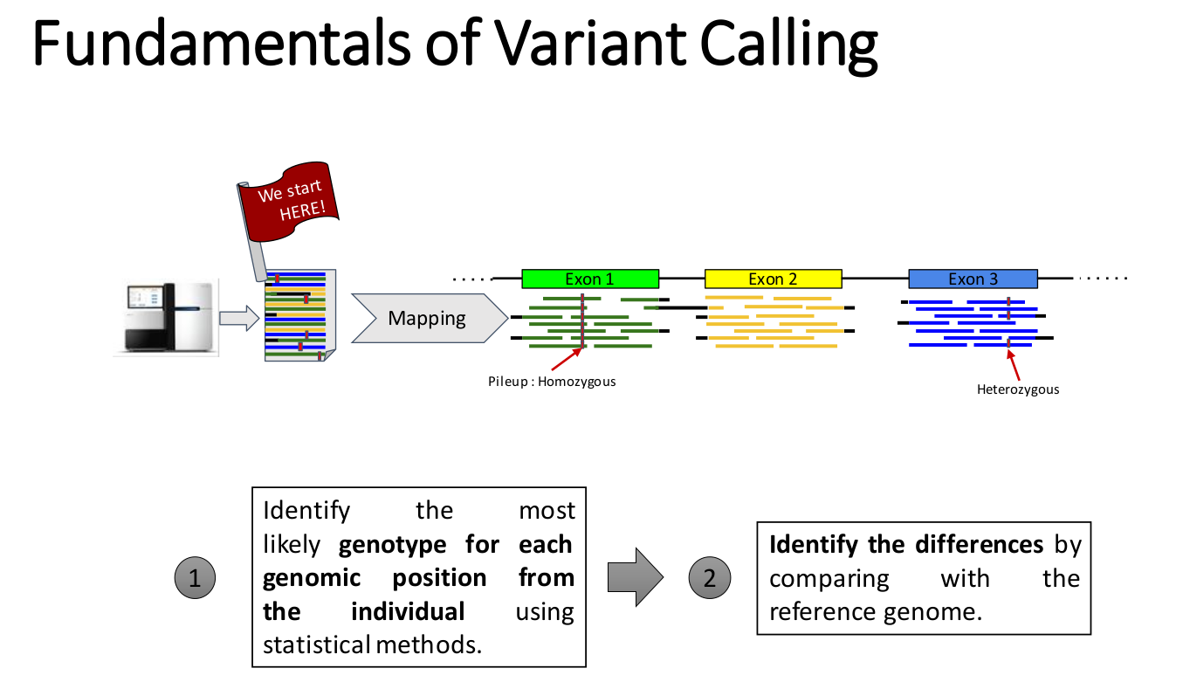

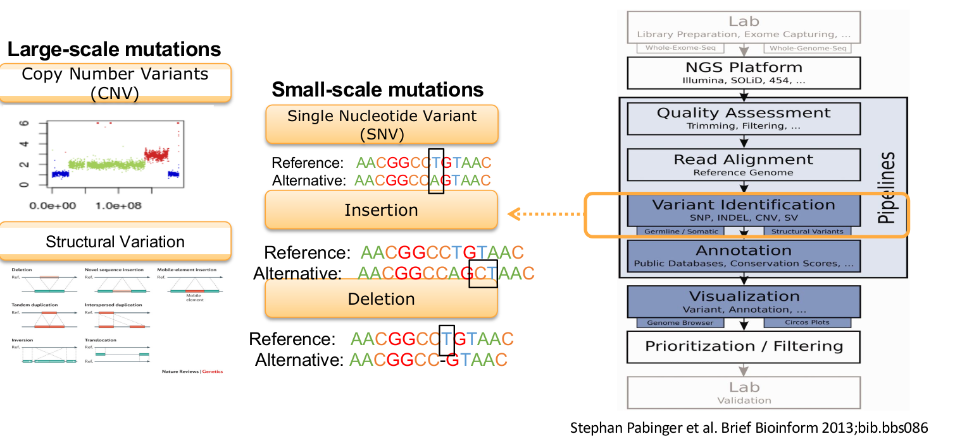
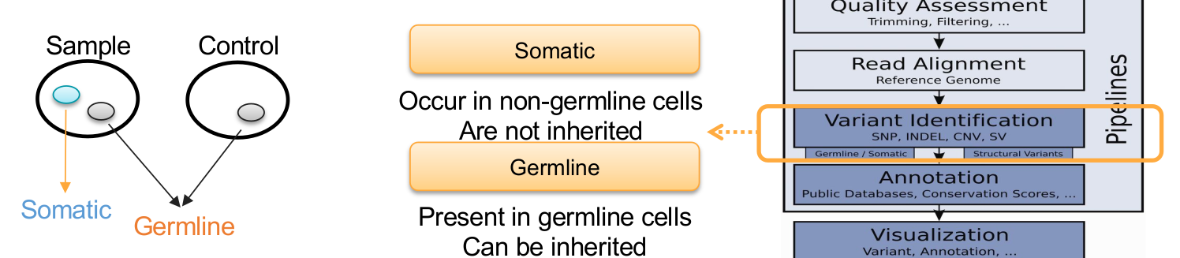

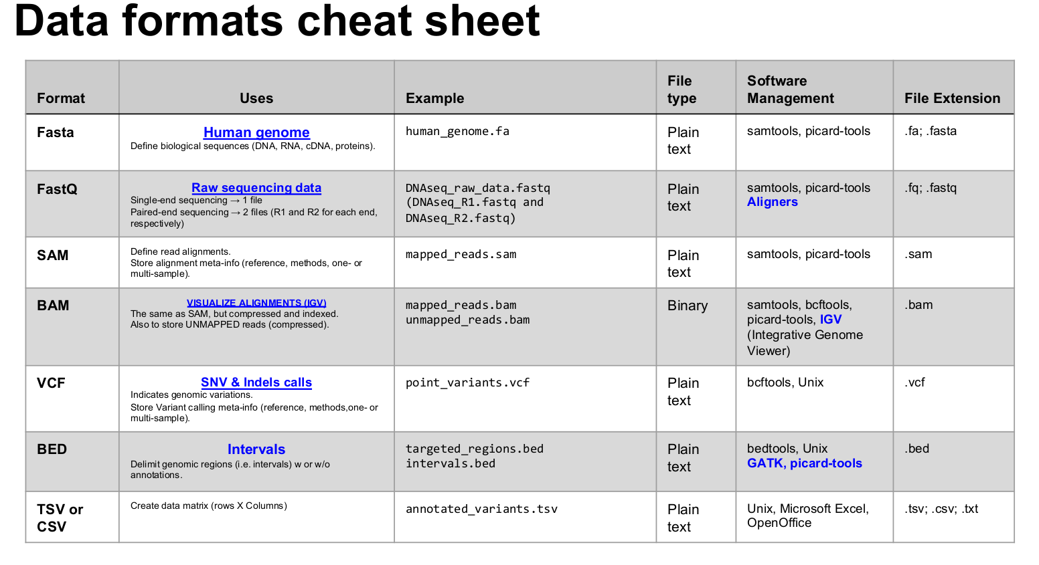

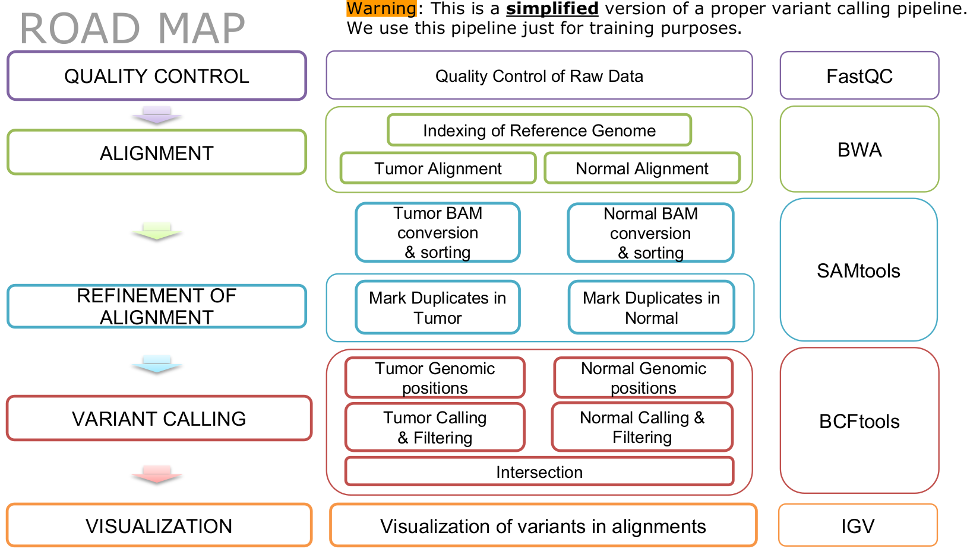

https://www.ncbi.nlm.nih.gov/pmc/articles/PMC2949280/
https://www.ncbi.nlm.nih.gov/pmc/articles/PMC4053844/?report=reader
https://bmcgenomics.biomedcentral.com/articles/10.1186/s12864-017-3797-0

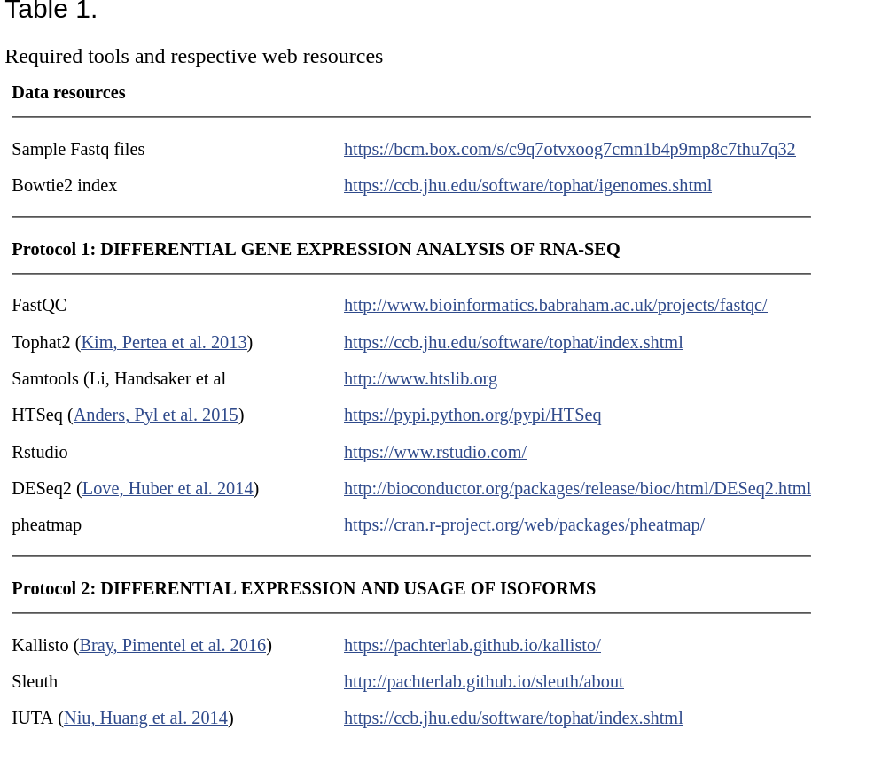
DIFFERENT PIPELINES TO ANAYLISIS RNA-seq:

https://www.ncbi.nlm.nih.gov/pmc/articles/PMC6373869/#!po=6.09756
https://genomebiology.biomedcentral.com/articles/10.1186/s13059-016-0881-8
https://bmcbioinformatics.biomedcentral.com/articles/10.1186/s12859-019-2728-2
https://www.rna-seqblog.com/tag/pipeline/
https://www.bioconductor.org/packages/devel/workflows/vignettes/rnaseqGene/inst/doc/rnaseqGene.html
https://www.frontiersin.org/articles/10.3389/fgene.2020.00220/full

TRANSCRIPTIONAL PROFILING IN PSORIASIS USING RNASEQ
https://www.ncbi.nlm.nih.gov/pmc/articles/PMC3381505/#!po=27.7778

PIPELINE RNA-SEQ Differential Gene Expression:

STAR para indexar el genoma
-Requisitos: mkdir -p out/star/genome_index; mkdir -p res/genome; mv GCF* res/genome
-Command line indexing: STAR --runThreadN 20 --runMode genomeGenerate --genomeDir out/star/genome_index --genomeFastaFiles res/genome/GCF_000001405.39_GRCh38.p13_genomic.fna --sjdbGTFfile res/genome/GCF_000001405.39_GRCh38.p13_genomic.gtf --sjdbOverhang 150

Control de Calidad: FastQC (Secuenciacion (pre-cutadapt)).
-Command line of FastQC: fastqc -t 7 -o out/dir input

Cutadapt: para eliminar los adaptadores
-Command line: script_cutadapt.sh
cutadapt -j 6 -m 20 -a AGATCGGAAGAGCACACGTCTGAACTCCAGTCA -o out/cutadapt/RNA-25_1.fastq.gz data/RNA-25_1.fastq.gz
cutadapt -j 6 -m 20 -a AGATCGGAAGAGCGTCGTGTAGGGAAAGAGTGT -o out/cutadapt/RNA-25_1.fastq.gz data/RNA-25_2.fastq.gz

cutadapt -j 6 -m 20 -a AGATCGGAAGAGCACACGTCTGAACTCCAGTCA -A AGATCGGAAGAGCGTCGTGTAGGGAAAGAGTGT -o out/cutadapt/RNA-25_1.fastq.gz -p out/cutadapt/RNA-25_2.fastq.gz data/RNA-25_1.fastq.gz

-Adapter Sequences:
- Read 1: AGATCGGAAGAGCACACGTCTGAACTCCAGTCA
- Read 2: AGATCGGAAGAGCGTCGTGTAGGGAAAGAGTGT

Control de Calidad: FastQC (secuenciación (post-cutadapt)).
-Command line of FastQC (script_fastqc.sh): fastqc -t 7 -o out/fastqc input

STAR: alinear con las muestras.
-Command line alignment: STAR --runMode alignReads --runThreadN x --outSAMtype BAM Unsorted SortedByCoordinate --genomeDir out/star/genome_index/ --readFilesCommand zcat --outFileNamePrefix out/star/alignment_x/ --readFilesIn out/cutadapt/RNA-x_1.fastq.gz out/cutadapt/RNA-x_2.fastq.gz

Control de calidad del alineamiento: QualiMapQC. Se necesita que el bam/sam esté ordenado por coordenadas para realizar el QualiMapQC.
-Command line of QualiMap: qualimap bamqc -bam align_RNA_29/RNA-29Aligned.sortedByCoord.out.bam -nt 7 -p strand-specificity-forward. NO CONSIGO SACAR LA ESPECIFICIDAD DE LA STRAND (EN EL REPORTE DE MacroGen PONE QUE ES STRAND, POR LO TANTO USAREMOS LA OPCION EN FEATURECOUNTS 1)

Count mapped read of each gene: HTSeq or featureCounts:
Samtools: ordenar el .bam por read names: (PROBAR AMBAS) SOLO PARA HTSEQ
-Command line: samtools sort -n -o RNA-29_Aligned.sortedByName.out.bamfile -O bam input-file

-Command line: htseq-count -f bam -r pos -s yes <alignment file> GCF_000001405.39_GRCh38.p13_genomic.gtf

-Command line: featureCounts -T 7 -p -s 1 -t exon -g gene -a /media/mario/My\ Passport/IRBLLEIDA/Exome-Sequencing/reference/GCF_000001405.39_GRCh38.p13_genomic.gtf -o counts.txt align_RNA_29/RNA-29Aligned.sortedByCoord.out.bam align_RNA_30/RNA-30Aligned.sortedByCoord.out.bam align_RNA_31/RNA-31Aligned.sortedByCoord.out.bam align_RNA_32/RNA-32Aligned.sortedByCoord.out.bam

featureCounts -T 7 -p -s 1 -t exon -g gene -a /media/mario/My\ Passport/IRBLLEIDA/Exome-Sequencing/reference/GCF_000001405.39_GRCh38.p13_genomic.gtf -o counts.txt align_RNA_29/RNA-29Aligned.sortedByCoord.out.bam align_RNA_30/RNA-30Aligned.sortedByCoord.out.bam align_RNA_31/RNA-31Aligned.sortedByCoord.out.bam align_RNA_32/RNA-32Aligned.sortedByCoord.out.bam

Editar con Excel o con la línea de comandos para quedarnos solo con la matriz de datos. Hay que eliminar ciertas columnas y la primera fila

DESeq2: para analizar la expresion diferencial
-Command line: Rstudio (differential_expression.R)

