Arrays
Data structure that allows you to store a sequence of values, all of the same type.
Can have arrays for any primitive type and also have arrays for any class.
Indexed, starting at 0

Declaring
Specify the type of the elements, then include square brackets in the declaration, which is the key for Java to identify the variable as an array.
The square brackets can follow the type as shown in the first two examples.
You can also put the square brackets after the variable name.
Don’t specify a size in the array declaration.
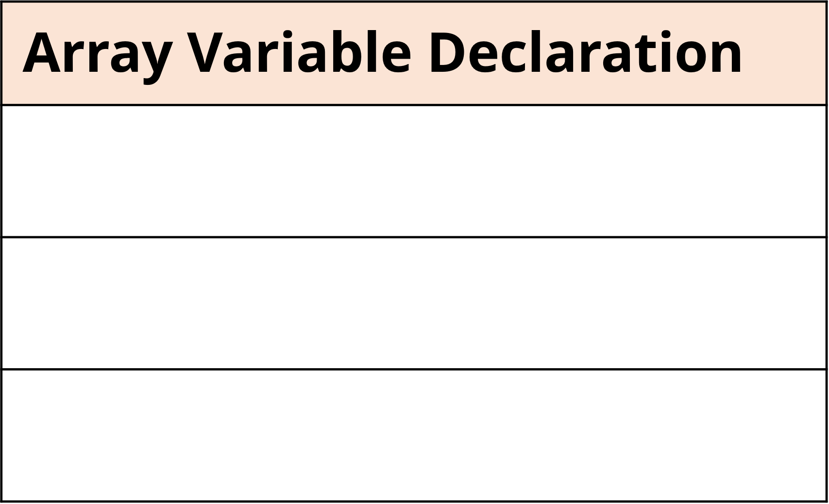
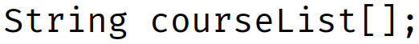
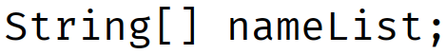
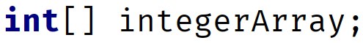

Instantiating
new keyword
Square brackets are required when using the new keyword and a size is specified - elements in the array. size of an array, once created, is fixed. Can only assign values to one of the ten elements

Array initializer
Specify the values the array to be initialized to, in a comma-delimited list, within curly braces. Length of the array can be determined by Java
Java allows us to drop the new int[] with brackets -> Anonymous array

