A very brief introduction to R and RStudio

# Mario Cortina Borja, PPP/ICH/UCL

## Tuesday 26th May 2020, 2pm BST

This 2-hour workshop will focus on the very basics of the language and environment for statistical computing and graphics. Please install the latest versions of R and RStudio on your machine. This is important, as some packages used in the workshop may not install correctly (or at all) if R is not up to date.

Download and install the latest version of R (4.0.0) [here](https://cran.ma.imperial.ac.uk/) Save the file R-4.0.0.exe in, for example, your Downloads directory, and run it from there. – this will install R in your computer.

Download and install RStudio [here](https://rstudio.com/) Save and run the file RStudio-1.2.5042.exe – this will install RStudio, which is the environment where we’ll run R.

Once you’ve installed R and RStudio, you should have an RStudio.exe icon in your desktop; attach it to the taskbar – this creates a blue icon with an R. Click on it, this runs RStudio and R. Please note that there may be problems if you are connected to a Virtual Private Network (VPN), for example in a University-passworded computer. Just disconnect the VPN for now.

If the installation was completed successfully, you should see something like this (the colours may change):

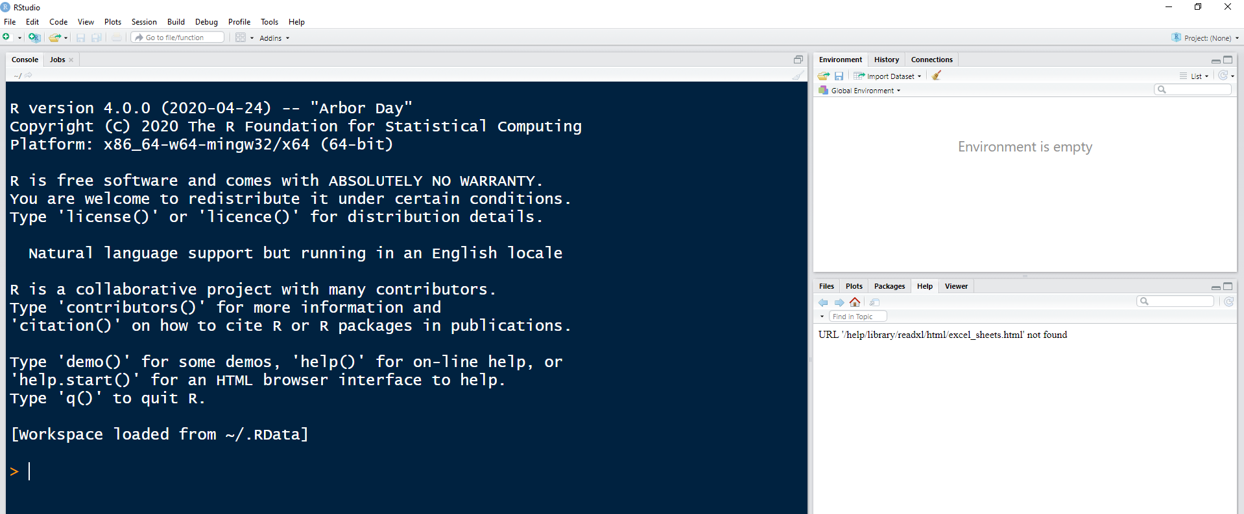

It’s convenient to create RStudio projects which are associated with R working directories. To begin, in Windows, create a directory for this session, for example:

C:\Users\YOUR_NAME\Documents\Crash_R_May2020

Now create an RStudio project in this directory. RStudio projects make it straightforward to divide your work into multiple contexts, each with their own working directory, workspace, history, and source documents. In RStudio, go to the File tab (top left-hand-side of menu bar) -> New Project; you should see something like this:

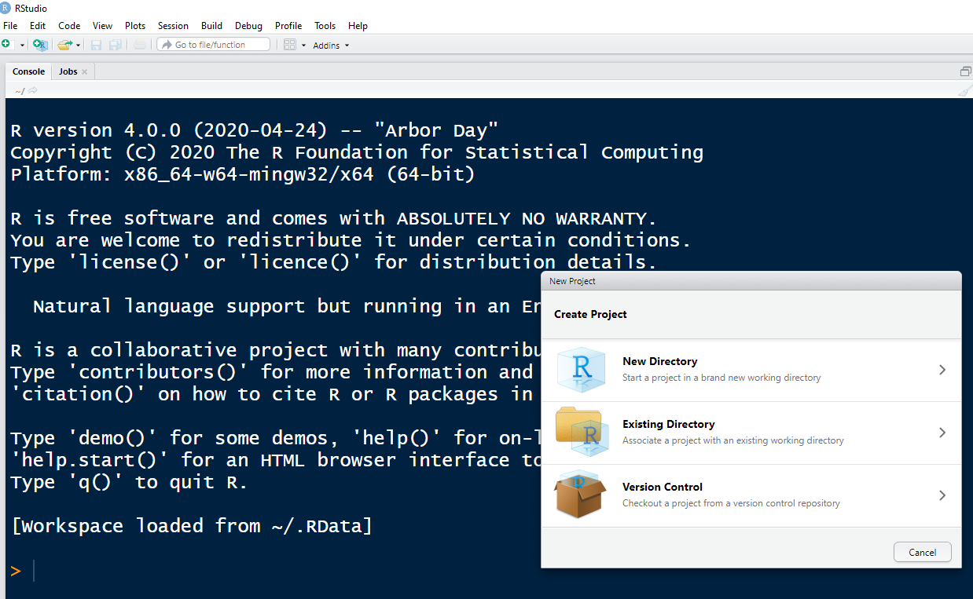

Click on Existing Directory (though you could have created a new directory from here; let’s use the Directory you’ve just created: C:\Users\YOUR_NAME\Documents\Crash_R_May2020):

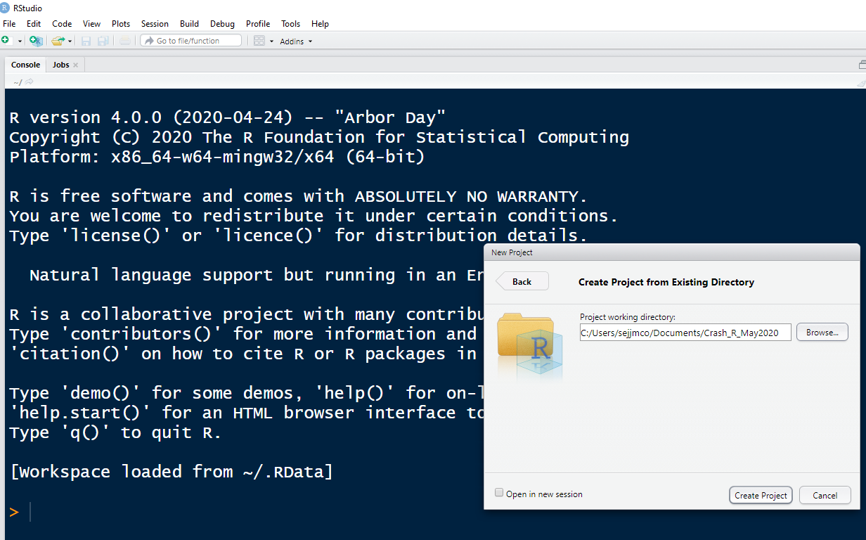

Click on Create Project, you should now see something like this:

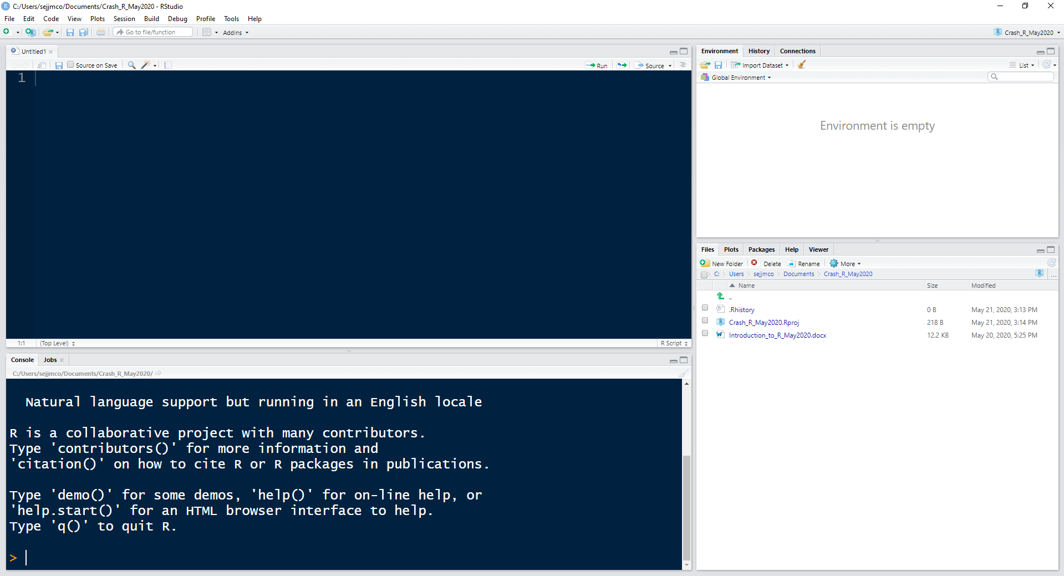

There are four windows in RStudio – from top left, clockwise, they are:

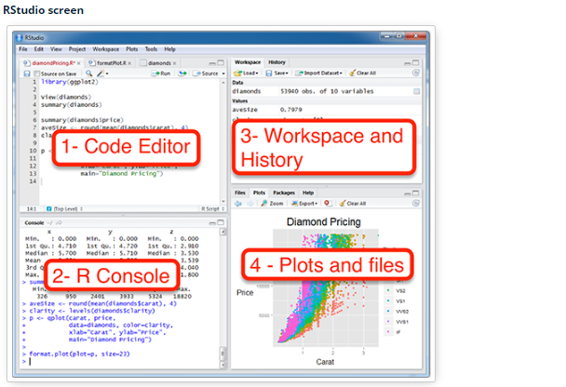

You have now a project file (with an .Rproj extension) within the project directory. This file contains various project options (discussed below) and can also be used as a shortcut for opening the project directly from the filesystem. You can run RStudio from Windows, starting in a particular directory by double clicking the .Rproj file.

We will now install some packages to be used in the session. By convention, R objects are written in courier font. It’s important that you install the packages before the workshop so we can all start from there.

Run RStudio from the directory you’ve just created, and type on the Code Editor this: (note that anything type after # is a comment, and that R is case-sensitive)

### Your_initials; date; anything you want!

install.packages(“tidyverse”)

To run specific lines of code, simply select the line(s) with your mouse in the Code Editor window

Note that installing the tydiverse suite of packages might take some time, especially when it tries to install the package Rcpp; it took about 10 minutes in my very old laptop. Once the tydiverse packages are installed you see the cursor (denoted by “>”) at the bottom left hand side of the R-Console. Now go back to the Code Editor and type Control+Enter, or click with your mouse on the Run tab on top of the Code Editor. This transfers the code to R; R is an interpreter, as opposed to a compiled language: this means that it simply translates in real time your commands.

Now type in the Code Editor install.packages(“MASS”)

This should install (very quickly) the package MASS (Modern Applied Statistics with S-Plus). You don’t have to install packages every time you run Rstudio, only once. To use a package (also called libraries) in your RStudio session, type, for instance,

library(tidyverse)

library(MASS)

You may comment out the lines in the Code Editor that you used to install a package, for example:

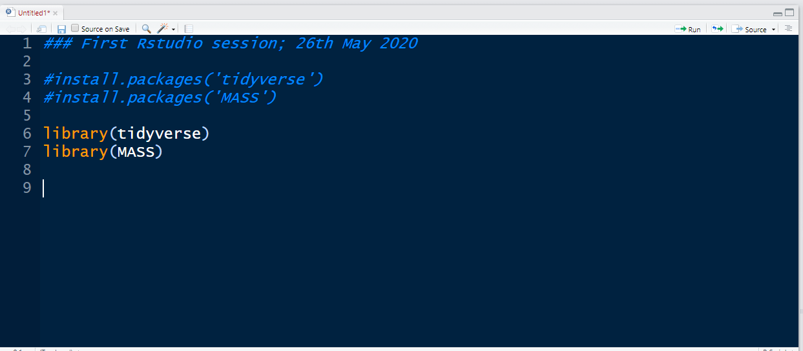

From the File tab in RStudio (top right hand side) choose Save As… and save your code, for instance as prog20200521.R – it’s important that you add the extension .R so that RStudio recognises it as a file with R code. Now close R using the top left hand side X; it will ask you if you want to save the .RData object: say yes. The .RData object is the file containing all the R objects in the project. It’s important that you save it so that it can be used the next time you open RStudio in that working directory.

That’s it! You’re ready to start the workshop.