

|  |
| --- |
| PrototypoVersao_02 |
| 21/04/20 14:57 |
| **Author:** John Doe  **File name:** PrototypoVersao_02.vp  **Version** 1.0 |

|  |
| --- |
| Site Map |
|  |

01. Site Map / PrototypoVersao_02 

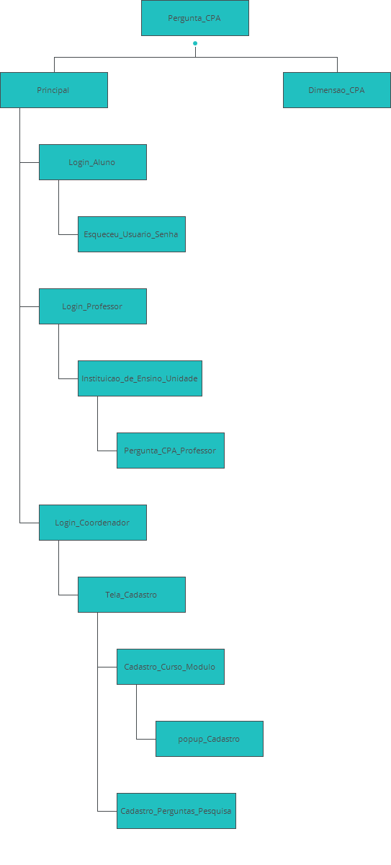

|  |
| --- |
| Screens |
|  |

02. Screens / PrototypoVersao_02 

Principal

|  |
| --- |
|  |

Tela Principal Site TGI

Interactions

|  |  |
| --- | --- |
| 1 | **on Click:** goes to 'Login_Aluno' with effect: fade 🡪 goes to 'Login_Aluno' 🡪 |
| 2 | **on Click:** goes to 'Login_Professor' 🡪 |
| 3 | **on Click:** goes to 'Login_Coordenador' 🡪 |

02. Screens / PrototypoVersao_02 

Login_Aluno

|  |
| --- |
|  |

Interactions

|  |  |
| --- | --- |
| 4 | **on Click:** goes to 'Esqueceu_Usuario_Senha' 🡪 |
| 5 | **on Click:** goes to 'Pergunta_CPA' 🡪 |
| 6 | **on Click:** goes to 'Principal' 🡪 |

Requirements

|  |  |
| --- | --- |
| 5 | **Botao_Entrar:** Ao ser acionado direciona para a área do aluno |

02. Screens / PrototypoVersao_02 

Login_Professor

|  |
| --- |
|  |

Interactions

|  |  |
| --- | --- |
| 7 | **on Click:** goes to 'Esqueceu_Usuario_Senha' 🡪 |
| 8 | **on Click:** goes to 'Instituicao_de_Ensino_Unidade' 🡪 |
| 9 | **on Click:** goes to 'Principal' 🡪 |
| 10 | **on Click:** goes to 'Login_Aluno' 🡪 |

02. Screens / PrototypoVersao_02 

Login_Coordenador

|  |
| --- |
|  |

Interactions

|  |  |
| --- | --- |
| 11 | **on Click:** goes to 'Esqueceu_Usuario_Senha' 🡪 |
| 12 | **on Click:** goes to 'Tela_Cadastro' 🡪 |
| 13 | **on Click:** goes to 'Principal' 🡪 |
| 14 | **on Click:** goes to 'Login_Aluno' 🡪 |

02. Screens / PrototypoVersao_02 

Cadastro_Curso_Modulo

|  |
| --- |
|  |

Interactions

|  |  |
| --- | --- |
| 15 | **on Click:** goes to 'popup_Cadastro' 🡪 |

02. Screens / PrototypoVersao_02 

Cadastro_Perguntas_Pesquisa

|  |
| --- |
|  |

02. Screens / PrototypoVersao_02 

Pergunta_CPA

|  |
| --- |
|  |

Interactions

|  |  |
| --- | --- |
| 17 | **on Click:** goes to 'Principal' 🡪 |
| 18 | **on Click:** goes to 'Dimensao_CPA' 🡪 |

02. Screens / PrototypoVersao_02 

Pergunta_CPA_Professor

|  |
| --- |
|  |

Interactions

|  |  |
| --- | --- |
| 19 | **on Click:** goes to 'Principal' 🡪 |
| 20 | **on Click:** goes to 'Dimensao_CPA' 🡪 |

02. Screens / PrototypoVersao_02 

Instituicao_de_Ensino_Unidade

|  |
| --- |
|  |

Interactions

|  |  |
| --- | --- |
| 21 | **on Click:** goes to 'Principal' with effect: pop 🡪 |
| 22 | **on Click:** goes to 'Pergunta_CPA_Professor' 🡪 |

02. Screens / PrototypoVersao_02 

Dimensao_CPA

|  |
| --- |
|  |

Interactions

|  |  |
| --- | --- |
| 23 | **on Click:** goes to 'Principal' with effect: pop 🡪 |

02. Screens / PrototypoVersao_02 

Esqueceu_Usuario_Senha

|  |
| --- |
|  |

Interactions

|  |  |
| --- | --- |
| 24 | **on Click:** goes to 'Principal' 🡪 |
| 25 | **on Click:** goes to 'Login_Aluno' 🡪 |

02. Screens / PrototypoVersao_02 

Esqueceu_Usuario_Professor

|  |
| --- |
|  |

Interactions

|  |  |
| --- | --- |
| 26 | **on Click:** goes to 'Principal' 🡪 |
| 27 | **on Click:** goes to 'Login_Professor' 🡪 |

02. Screens / PrototypoVersao_02 

popup_Cadastro

|  |
| --- |
|  |

Interactions

|  |  |
| --- | --- |
| 28 | **on Click:** goes to 'Tela_Cadastro' 🡪 |
| 29 | **on Click:** goes to 'Cadastro_Curso_Modulo' 🡪 |

02. Screens / PrototypoVersao_02 

Tela_Cadastro

|  |
| --- |
|  |

Interactions

|  |  |
| --- | --- |
| 30 | **on Click:** goes to 'Cadastro_Curso_Modulo' 🡪 |
| 31 | **on Click:** goes to 'Cadastro_Perguntas_Pesquisa' 🡪 |
| 32 | **on Click:** goes to 'Principal' 🡪 |