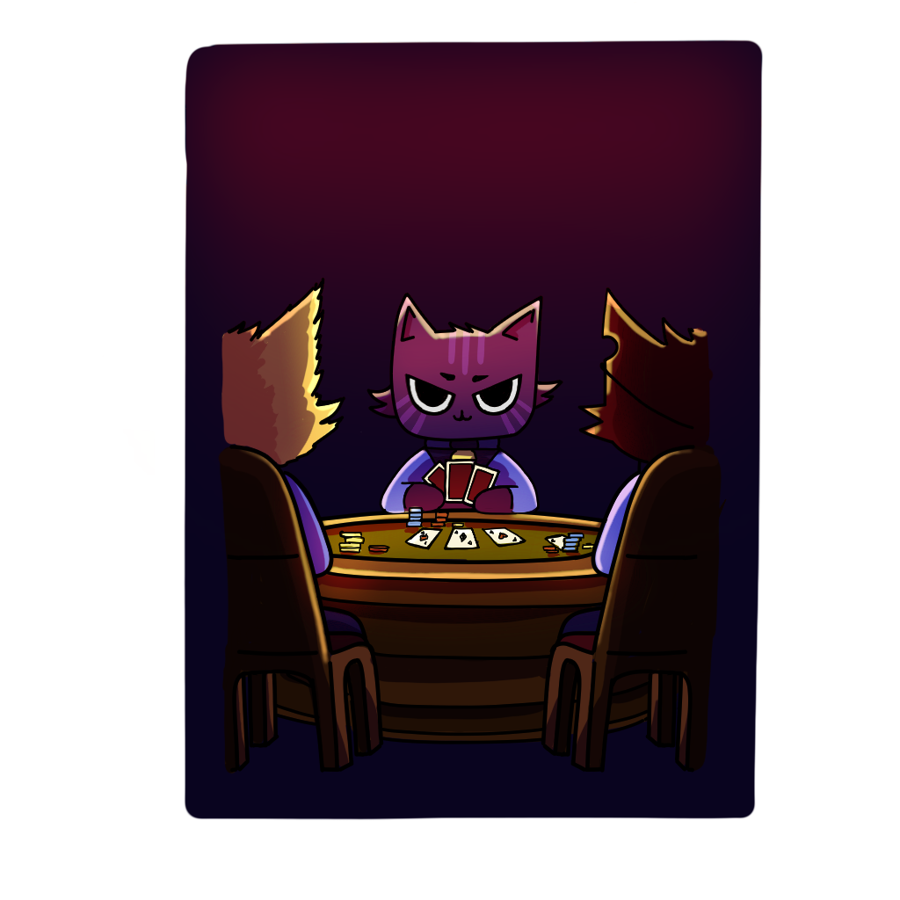
NEKOSMIC DEALERS
GAME DESIGN DOCUMENT

Prepared by:
Mario Gavín Clavero
Mario Sanz Sancho
Pablo Sánchez Hernández
Sandra Garijo Gracia
TABLE OF CONTENTS
Game Analysis 3
Mission Statement 3
Genre 3
Platforms 3
Target Audience 4
Gameplay 5
Rooms 8
Raids 12
Storyline & Character 13
Concept Art 15
Game Aesthetics 16
Control Scheme & User Interface 16
Flowcharts 18

Game Analysis
NekosmiCat Dealers is an idle resources management game for mobile phones. The player will take control of a spaceship and will have to improve his ship and hire workers to level up and obtain the best ship and criminal organization in the galaxy.
The ship contains a lot of different rooms, each one provides the player with some resources, like the bar and the hangar, or improvements and protections for the ship, like the lasers or the shields, or better conditions for their workers, like the bedroom and the bathroom. With the resources that the rooms generate, the player can unlock new rooms, improve the ones he already has or hire workers for the different rooms.

Mission Statement
Nekosmic Dealers is like Fallout shelter but with cats and space aesthetics. Get resources, improve the ship, hire people, and avoid the police or the competition to close your business to get the best ship in the galaxy.
Your cat workers will produce and manage resources such as drugs and selling them on the bar and the hangar. The more cats you have working on your ship the more money and reputation you will get.
Improve your crew, get the best criminal ship, and maybe in the future, the best spaceship float.

Genre
Nekosmic Dealers is a resource management game. The player can not only get more resources and money but can also lose them due to a bad management. The player must know how or when he must spend his resources to not lose progress and keep improving.

Platforms
The targeted platform is Android smartphones. The game will be available on the Google Play Store.

Target Audience
The game is mainly targeted to young people, due to its thematic and aesthetics. Especially for those who are casual players.
Young male adults (18-24), specially from the east of Asia, on countries like Japan or South Corea. We focus on these countries especially because of the aesthetics of the game, similar to many Japanese mobile games.

Persona 1:
Name: Sota Yamanaka, 21 years old
Occupation: Student in the Kyoto University

Scenario 1 + Description:
He enjoys reading and watching series and films in his free time. He is always busy with his tasks or hanging out with friends. Due to his busy schedule, he is a casual gamer, as he doesn't spend much of his time playing videogames. He loves futuristic movies and series set in space, so he didn't hesitate to download Nekosmic Dealers when a classmate told him about it one day on the train to the university. Nekosmic has both the aesthetics and Sota's favourite theme, as well as being a game that doesn't require many hours of gameplay to progress, and he can enter it in his free time to collect rewards.

Scenario 2:
Sota has a younger sister who is 16 years old and they love to watch films and shows together as they share the same interests. Although his sister plays many more hours of video games than Sota and is more midcore than casual, they like to download the same games and fight each other over who gets the highest level or the most resources. Every day they compare the level of their Nekosmic ship, how many workers they have, how many rooms they have unlocked... and especially the appearance of their workers (it's random and you can get a worker with an adorable design or a terrifying one) as they did with the animal crossing neighbours.

Persona 2:
Son Heung-min, 25 years old
Occupation: Astronomer

Scenario + Description:
Son Heung-min is an astronomer who has always been fascinated by outer space. Since he was a child, he was a big fan of Star Wars, he has watched each movie at least 20 times and had played at all the video games in the saga he could find. This is one of the reasons to study astronomy. However, now he has start to work at full time, so he finds that he doesn't have as much free time for his hobbies as he had before. Searching for a space game that don’t require a lot of time at day he found Nekosmic Dealers which is perfect for his busy schedule and fits perfectly with his tastes.

Gameplay
Overview of Gameplay
To improve the ship the player must click on a room and a little menu with all the information about that room will appear. That information contains the level of the room, how much resources it’s producing in that moment, the number of current workers in that room and how much does it cost to upgrade it. The player must decide if he could afford upgrade the room or if he must save some resources in case he suffers some attacks.
To assign the workers the player has hire to the rooms, he must drag and drop them to the room they want, and they will start working. He can only drop them on unlocked rooms.
Key Features:
- Drag and drop: move your workers on the ship to place them on different areas.
- Click: click on buttons to open menus, hire workers, upgrade the rooms...
- Resources Management: take care of how and when do you spend your resources, you don’t know when the police or the competence may appear.

Player Experience
At the beginning of the game, you will find a ship in the middle of space with most of the rooms blocked, having only the control station.
The Assistant will appear to guide you and help you unlock new rooms and hire some workers. From this point on, you will be the one to decide which rooms to upgrade and unlock, according to your level, and whether to invest resources or not.
You will have to face other threats such as police raids, attacks from other ships, meteor rains and internal problems of your workers. To avoid/solve these problems you will have to invest in improving the ship.

Gameplay Guidelines
The game will not have profanity or realistic violence, because, although it is not intended for children due to its plot and the aspects that appear such as drugs or gambling addiction, we want the game to be for children over 12. Even if our target audience is more 18-24 years, we want other people outside our target audience to play it if they like the game. The above-mentioned topics will not appear explicitly, being the drugs simple plants or merchandise, and the casino will appear as a simple room, with no possibility for the player to interact with it other than to improve it to generate more resources.

Game Objectives & Rewards
Levels: The game has a levelling system that will allow the player to unlock new content and new rooms. In order to level up, the player needs to upgrade the ship, unlock certain rooms to get more reputation.
Reputation: It is achieved by defeating the enemies that come to attack our ship. The enemies attack will be automatic, the game will calculate the power of the enemies (it will be random but stronger the player stronger the enemies) and the level of the player’s equipment (laser and shields).
The player will also get some reputation earning money from their rooms.

Gameplay Mechanics
The game has a money indicator, a merchandise indicator, a reputation indicator, and a gem indicator. These resources will increase as time goes by and our rooms generate resources (money and merchandise), when we sell the merchandise in the hangar or the bar (money) or when the player sees advertisements or enters daily to get his rewards (gems).
At the start of the game the player has no worker so his avatar will have to do all the work. Later, the player will be given the option to hire workers to whom he will have to pay a salary and create rooms for his use and comfort. The player will be able to drag workers and assign them to rooms to work in. In the hiring menu the player will be presented with three different random workers. If he is not convinced by their stats, he can pay gems to refresh the options. When he hires someone, three new ones appear.
To upgrade a room the player only must click on it and a menu will appear with all the information of the room and the option to upgrade the room with the cost it involves.

Level Design
As the levels advance, new rooms will be unlocked:
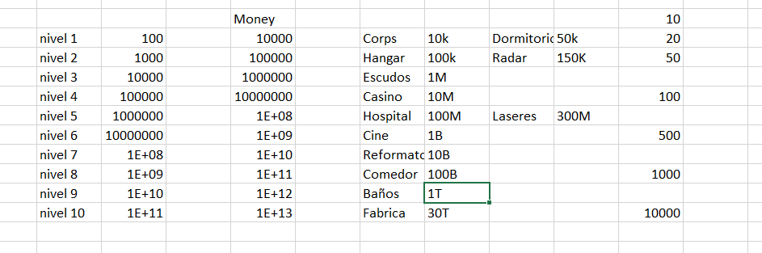
Level 0: Control Station, Bar
Level 1: Crop, Bedrooms
Level 2: Hangar, Radar
Level 3: Shields
Level 4: Casino
Level 5: Hospital, Lasers
Level 6: Cinema
Level 7: Reformatory
Level 8: Lunchroom
Level 9: Bathroom
Level 10: Droid Factory

Rooms
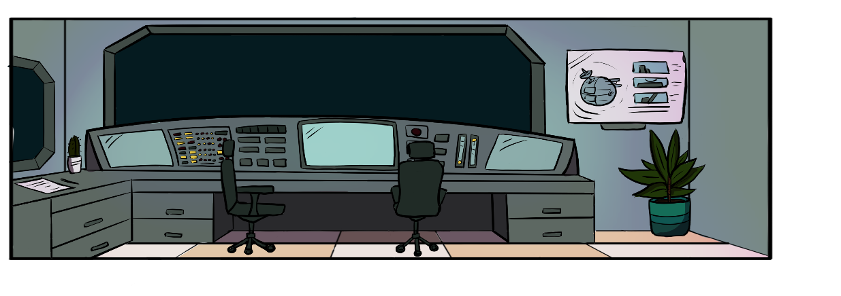
Command Room: The boss is the only one who can stay on this room.

Bar: receives customers and generates money from the sale of drinks and merchandise when the crops are unlocked. It must be closed before the police arrive.
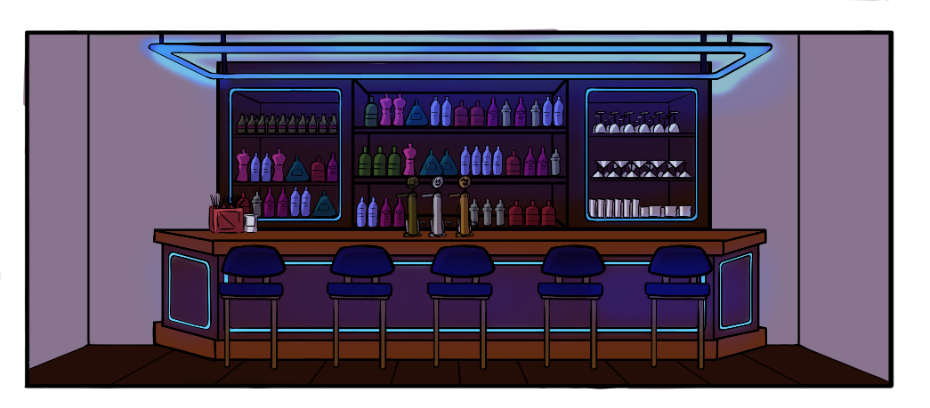

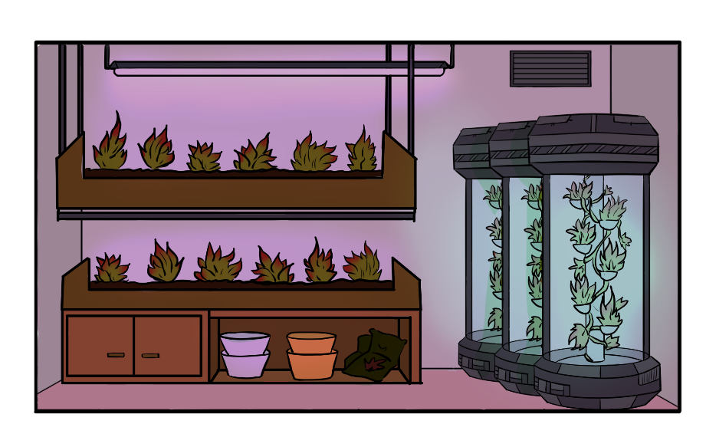
Crop: generates merchandise to be sold through the bar or hangar. Must be closed before the police arrive.

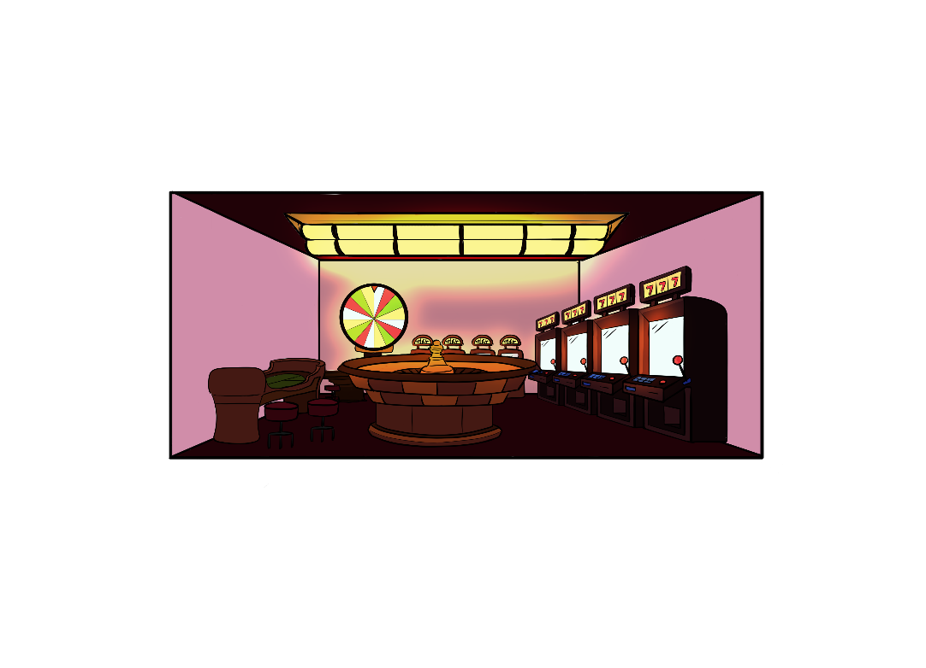
Casino: only generates money over time. It must be closed before the police arrive.

Radar: allows to detect the police earlier to close the rooms.
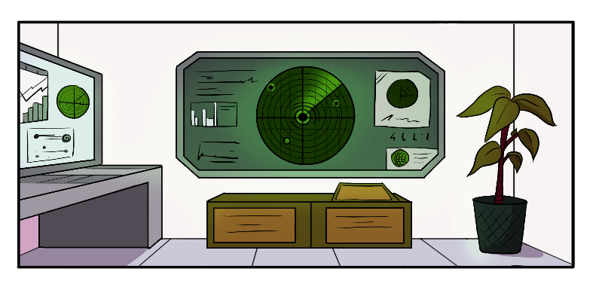

Bedroom: It’s a rest room, worker can be healed here from any kind of issue.
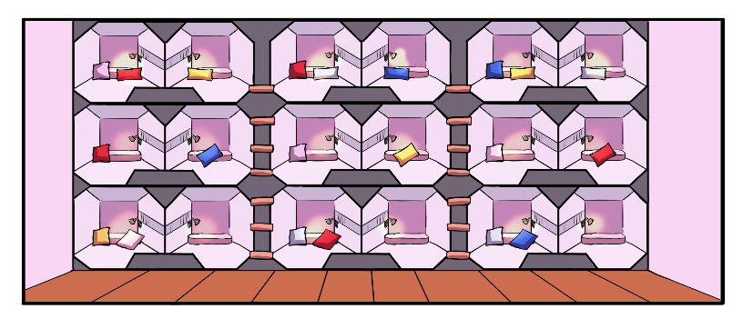

Hangar: allows to sell larger quantities of merchandise every x amount of time.
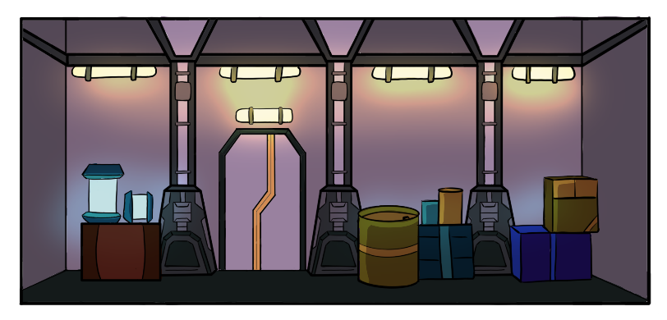

Shields: It increases the possibility of blocking attacks and avoid the damages and the economic loses.
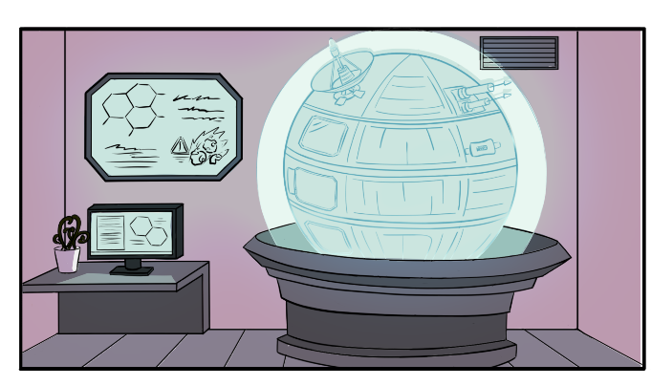

Hospital: allows to treat sick workers to avoid their death. It needs to be upgraded to treat more people faster. It’s more effective than the rest rooms.
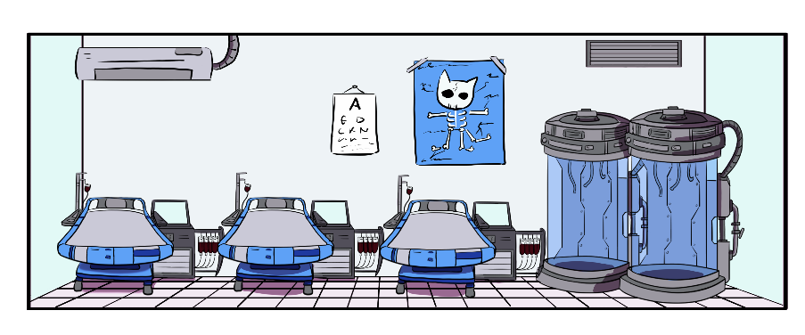

Lasers: The same as the Shields, it increases the possibility of blocking attacks and avoid the damages and the economic loses.
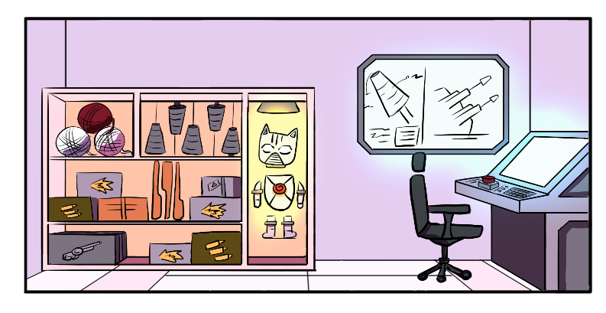

Reformatory: allows to treat rebel workers. It needs to be upgraded to treat more people and faster. It’s more effective than the rest rooms.
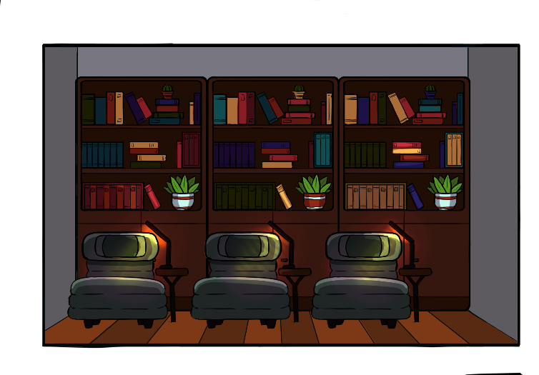

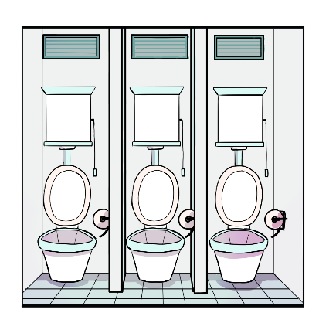
Baths: The same as the Bedroom, it’s another rest room for the workers.

Cinema: generates money over time. It should be closed before the police arrive.
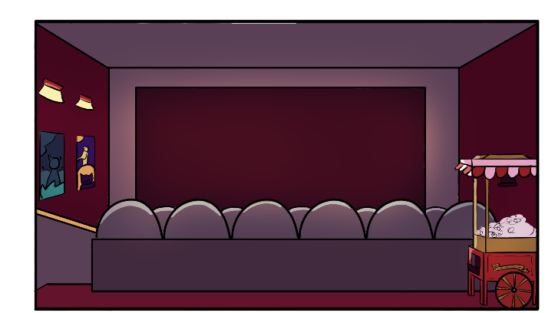

Lunchroom: generates money over time.
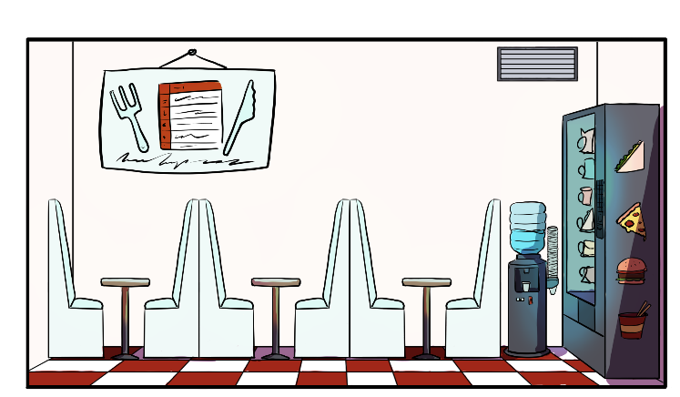

Droid factory: generates new merchandise over time to be sold in the hangar, at the same time it also generates money. It must be closed before the police arrive.
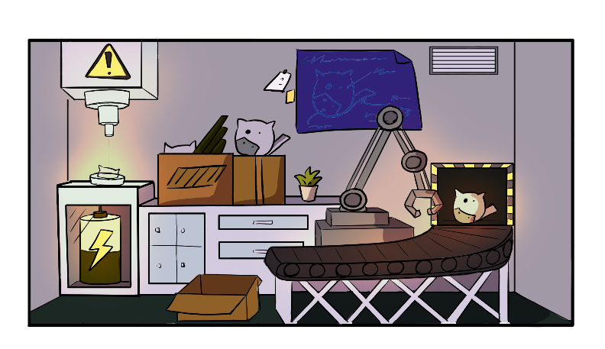

Raids
The raids have a chance to happen once in 6 days, once it happens it restarts the count.
Police
The police may appear randomly and close the business until the player pays the pertinent bill (the more rooms and the higher the level, the higher the bill). The player must pay the bill to unlock the rooms.
Moments before the police arrive the player will be warned of their arrival, having a few seconds to close (by clicking on it) each of the rooms that generate resources. At first the police will arrive almost at the same time as the warning, so the player must improve the radar to increase those seconds of reaction.
In addition to the bill, the police will also confiscate part of the player's money and merchandise.

Meteor rain
The player may suffer the damage of a meteor rain, which will lead to economic losses, in a random way, and it will also make damage to the rooms. To reduce and avoid the damage, the player must improve the ship's shields. The damage can leave the rooms disables, and the player may will have to pay to repair it.

Attackers
Also, other pirate ships can randomly attack the player and cause economic and worker losses. To avoid this, the player must upgrade the ship's lasers. If he manages to eliminate the attackers, apart from not suffering any loss, the player will gain reputation, essential for levelling up.

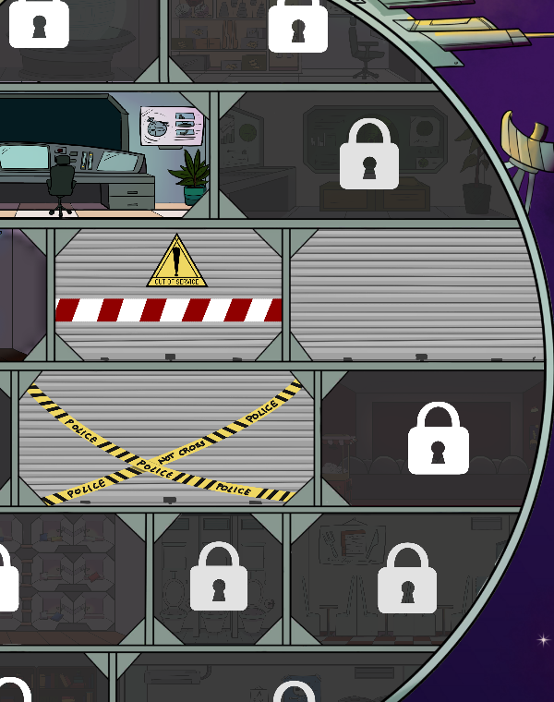



Storyline & Character
You used to work in another base together with your partner, and you were the best in the industry. But one day he betrays you, takes over the whole ship and you are forced to start from scratch. The only one who stays by your side is your loyal Assistant, who found you a new ship to start again your business. Your goal is to surpass is to create the best criminal ship of all times.

Main character:
At the beginning of the game, there are no workers, so it will be the player himself who will perform the tasks to get resources. The character will be walking around the ship, and you can assign him to certain rooms to work. Unlike the workers he has no special stats, and he can’t die or get ill. Also, he is the only one who can be assigned to the command room.

Assistant:
This is who will guide the player at the beginning of the story. He is not a playable player, nor will he be seen around the ship working, he will only give advice and guidance to the player. He is cheerful, optimistic and helpful.

Workers:
The game has a lot of different workers, both in appearance and stats, that will determine what he is good at working on. They can get sick, die and reveal themselves, so the player cannot ignore the rooms intended for his workers: the rooms, to increase the number of workers; the hospital, to take care of sick people; the rehabilitation centre, to take care of rebels; and the bathrooms and the lunchroom, to lower the probability of getting sick or revealing themselves.
- Salary
The workers receive a salary at the end of the day, if the player does not have enough money to pay it will increase the possibility of rebellion. The better the statistics, the higher the worker's salary will be, although it does not depend only on this, it also has some randomness.
- Statistics
The statistics of the workers are: the rooms they can work in, the loyalty level, the happiness level, and their health bar.
- States: Illness, Rebel, Depressed
When they have an issue, they start making less money for the player, and an icon with the issue they are suffering appear on top of the worker.
The worker can become ill if they don’t have some rest rooms like the bedroom or the bathroom. They will start losing health the player must send him to the hospital or he can even send him to a rest room, but it will heal slower.
The same happens with the fidelity level and the happiness level, if their fidelity is so low, they have more chances to become an Impostor.
- Impostor
The Impostor will kill one worker per day until the player realizes and fire him. The indicator or the impostor is very similar to the rebel one, so is not that easy for the player to find him before he kills more people.

Concept Art
Early concept arts
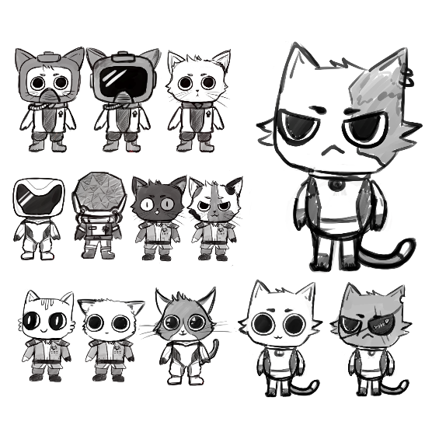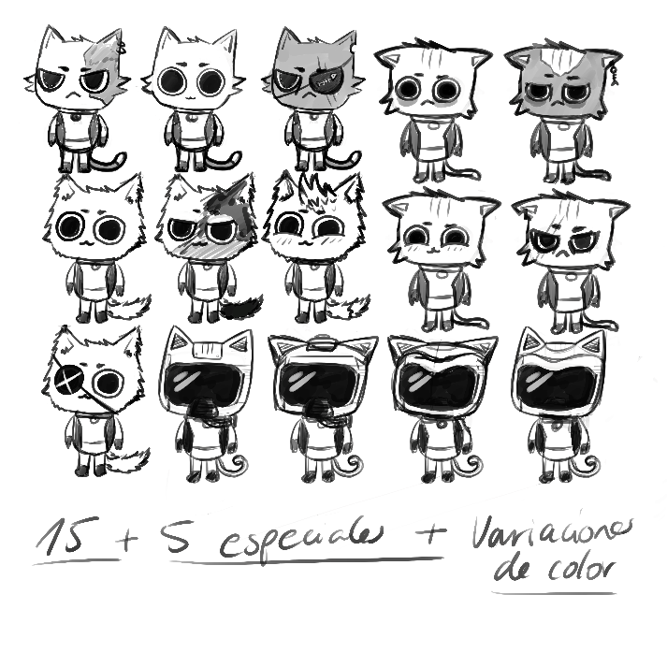
Ship Concept Art
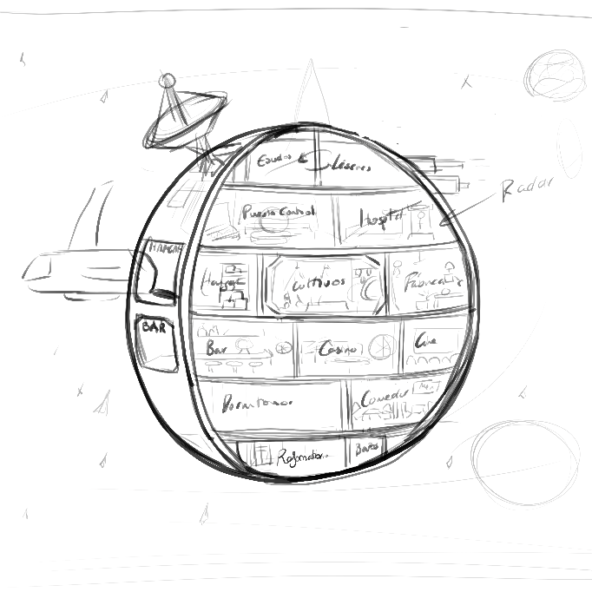
Final Designs

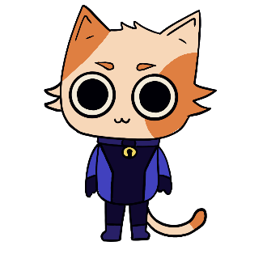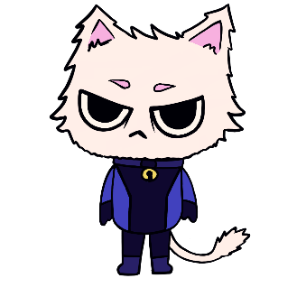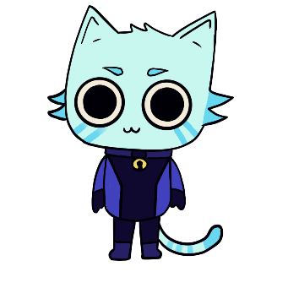

Game Aesthetics
The game has a cartoon 2D style. We want to give a serious subject, such as the plantation of illegal substances and casinos, an adorable aesthetic, like the videogame Cult of the Lamb, that's why we will also use cats instead of humans.
It is set in space. The player will be able to drag workers, who will be walking around the ship, to assign them in new rooms. The player will be able to interact with almost all the elements of the scene: the rooms to improve them and obtain resources, and the workers to take them to other rooms.

Control Scheme & User Interface
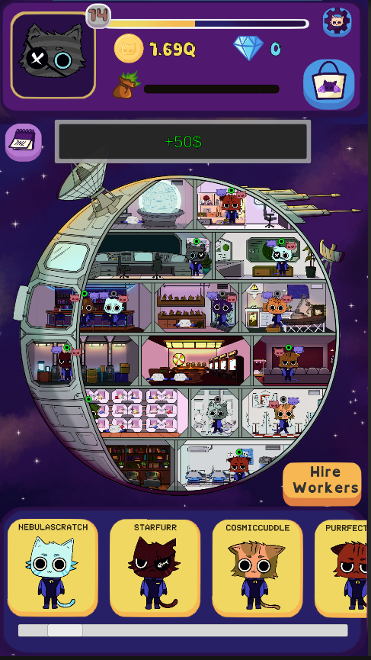
The UI will be made for maximum comfort for mobile players, presenting all important information up front, all buttons use images instead of text when possible.
On the screen, the player will see the 4 resource indicators, his avatar with his current level, the settings button and the shop buttons, the ship in the central part with all the rooms and the workers assigned to each one, and at the bottom the workers he has hired at that moment (whether assigned or not), and the button to hire more staff.
The options button will open a panel where the player can change the volume of the music and sound effects, mute them, and exit the game.
Clicking on a room opens a panel that the current stats of the room, the level, the number of workers that can be working at the same time, and the price to keep upgrading if possible. Also, the buttons to close the room for the police raids and the sell merchandise button in the bar.
By clicking on the workers cards at the bottom, the player can open the worker stats and see all the information. Also, he can drag them to assign them to the room of his choice.
The hire button at the bottom right opens a menu with three possible workers, as well as a button to refresh the options.
The player can fire the workers at any time in the workers panel, for example when they are the impostors, or they are dead and not currently working.
Flowcharts
Start Game
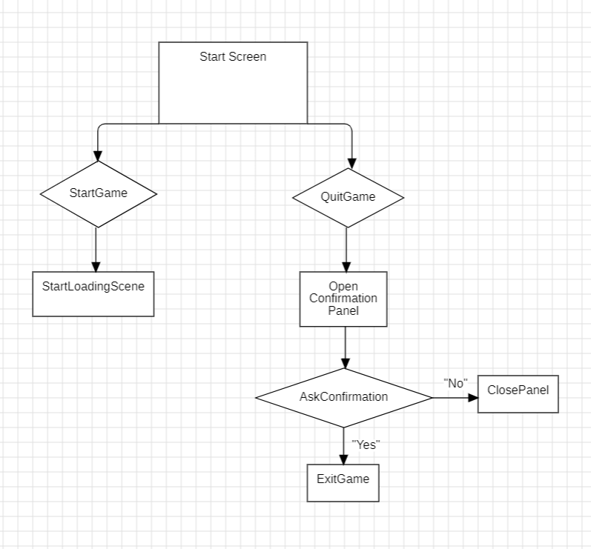
Options Panel
