**Refactoring Airport Application**

What needs to be refactored:

* Long Methods
* Long Parameter List
* Duplicated Code
* Better organization of data

**Long Methods:**

Before:

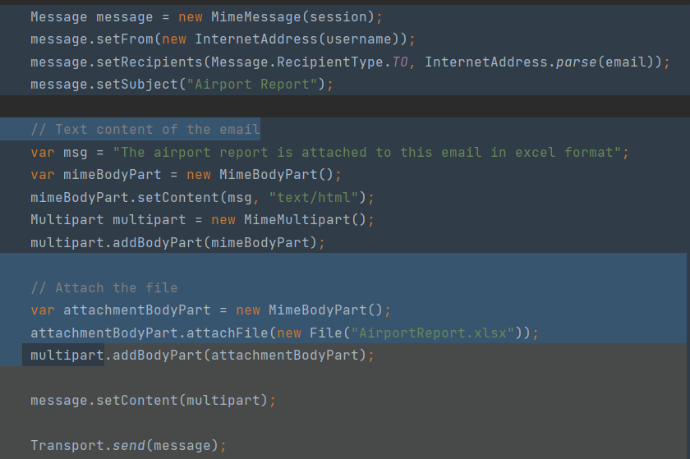

After Extract Method refactoring:

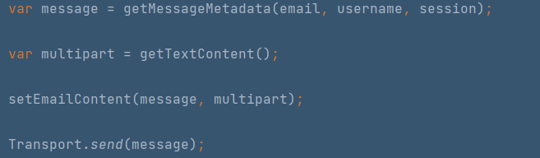

Before: 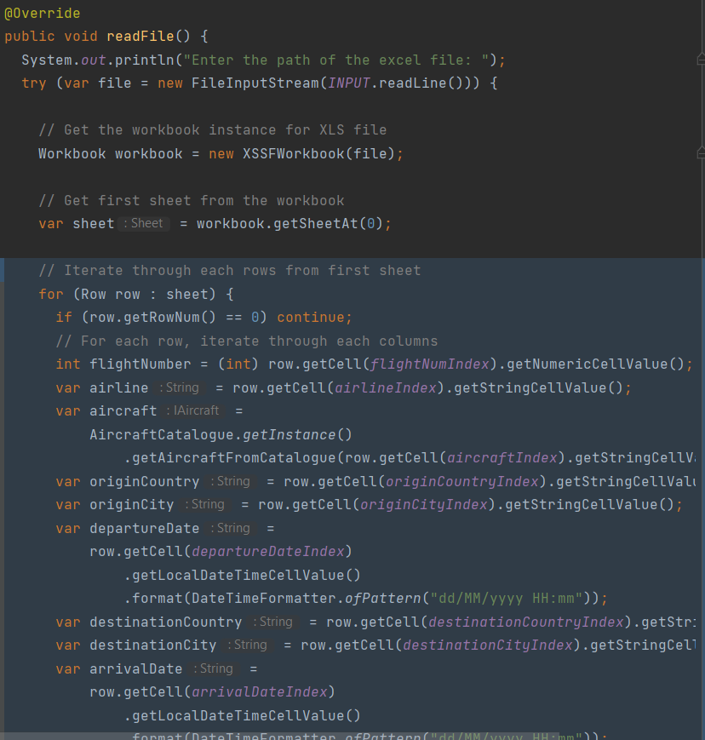

After Extract Methods:

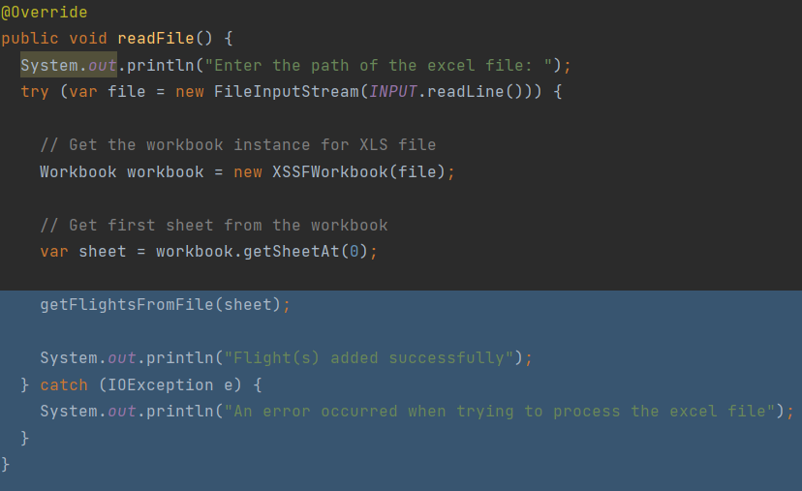

**Long Parameter List:**

Before:

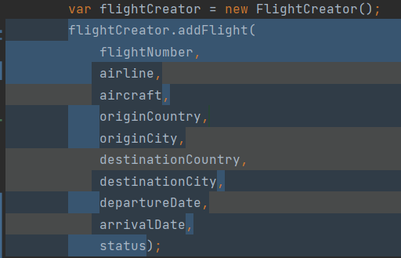

After Introduce Parameter Object and Preserve Whole Object:

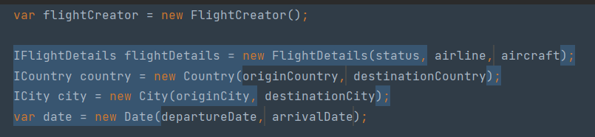

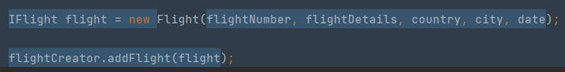

**Duplicated Code:**

Before:

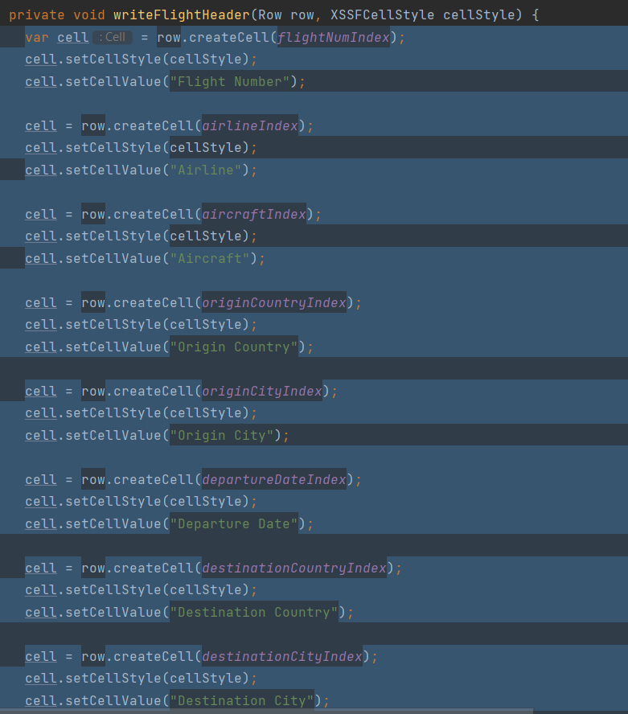

After Extract Method:

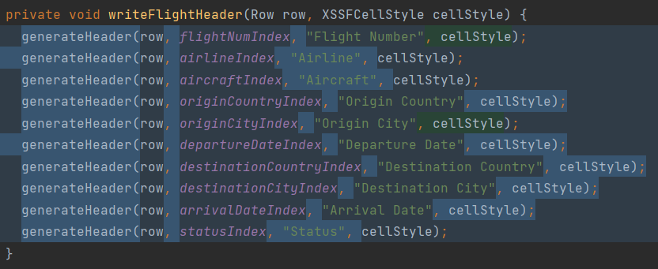

**Organizing Data:**

Before:

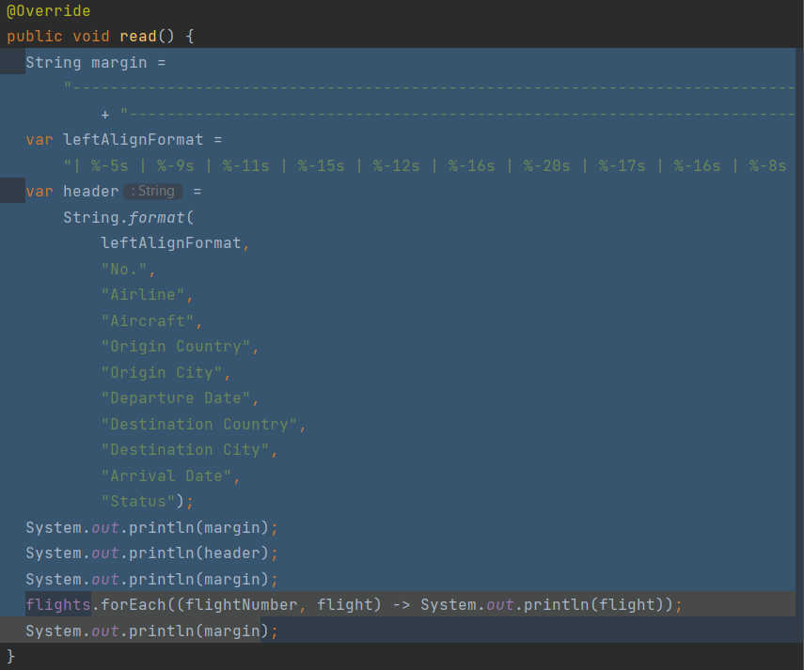

After Replace Data Value with Object:

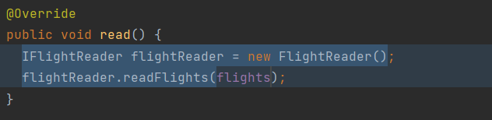

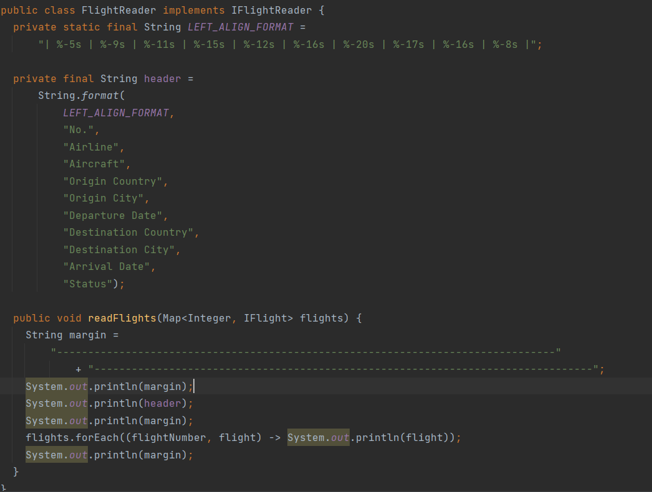

Before:

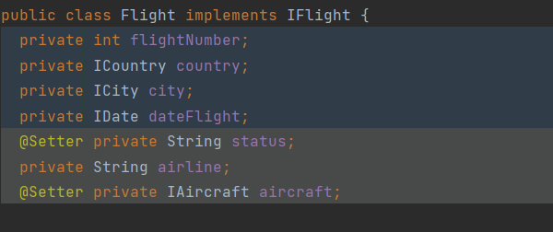

After Extract Class:

