Dimention Calc

Mario Niemand

MCSE

CTU-2018

Table of Contents

Front End 2

Home Screen: 2

Mass Converter 2

Exchange Converter 3

Interest 4

Arrays 5

Back End 6

Code of Dimension calculator : 6

How I fixed Errors 21

# Front End

## Home Screen:

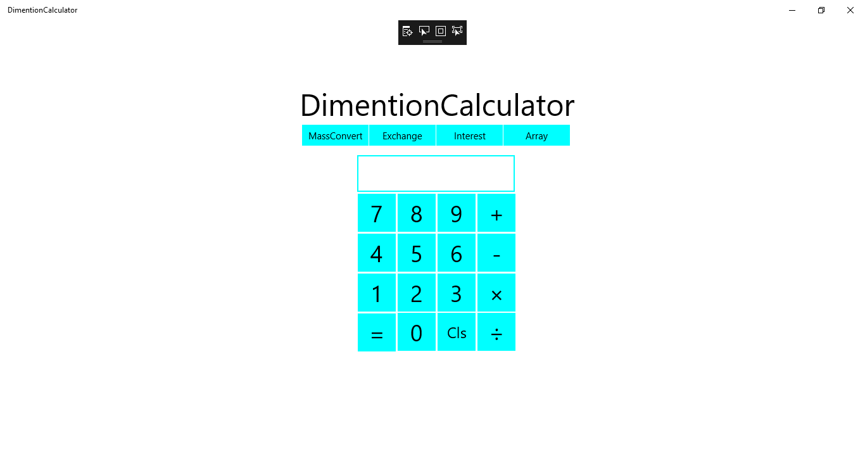

The UI is a user friendly layout. The navigation is located below the heading Dimension Calculator. Using the onscreen keys you can calculate basic day to day problems.

## Mass Converter

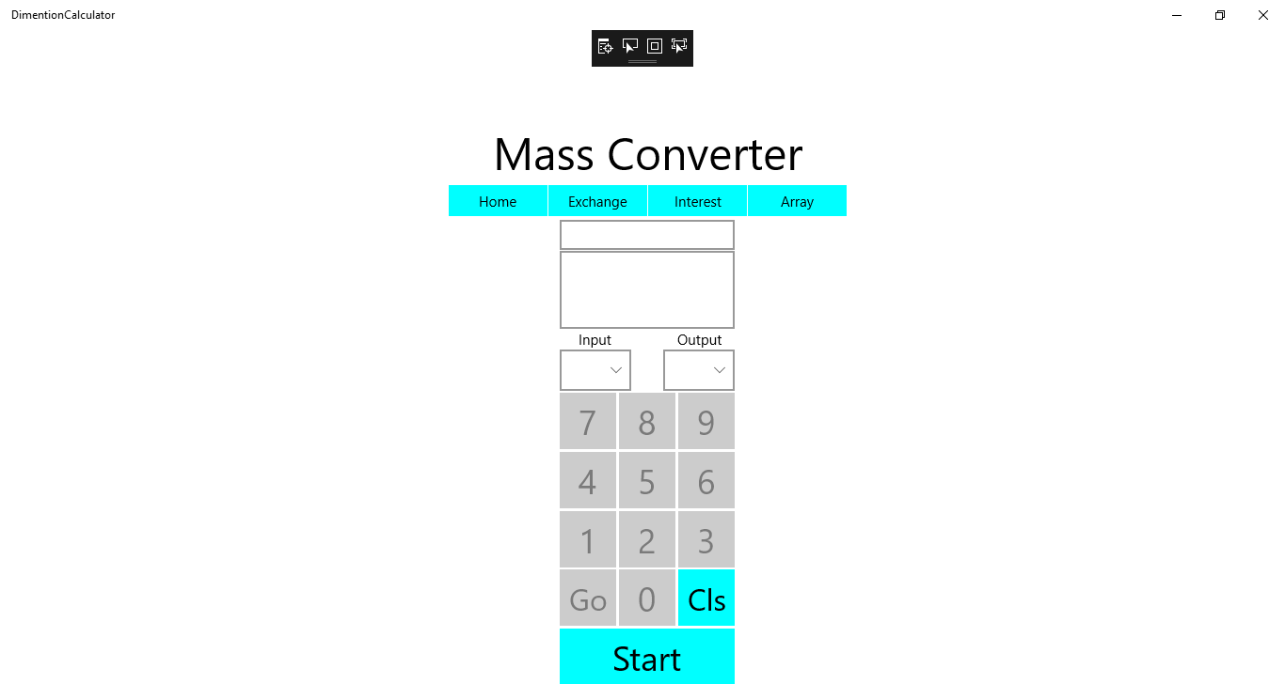

1. First the user must select a value in the dropdown list named input.
2. Then the user must select a value in the second dropdown list named output.
3. After this the user can press the start button located at the bottom.
4. This triggers the number buttons to light up which indicates it can now be used.
5. Then after the user used the buttons to select the value he wants press the start button to convert the mass.

## Exchange Converter

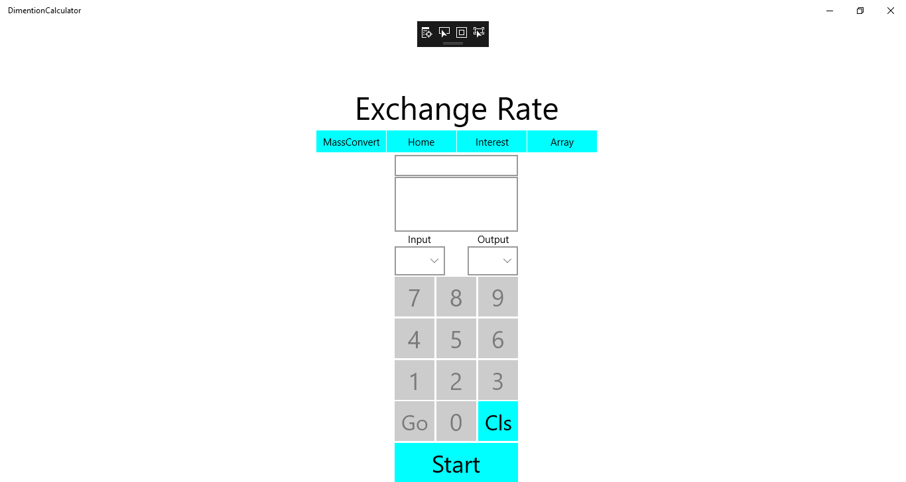

1. First the user must select a value in the dropdown list named input.
2. Then the user must select a value in the second dropdown list named output.
3. After this the user can press the start button located at the bottom.
4. This triggers the number buttons to light up which indicates it can now be used.
5. Then after the user used the buttons to select the value he wants press the start button to convert the Currency.

## Interest

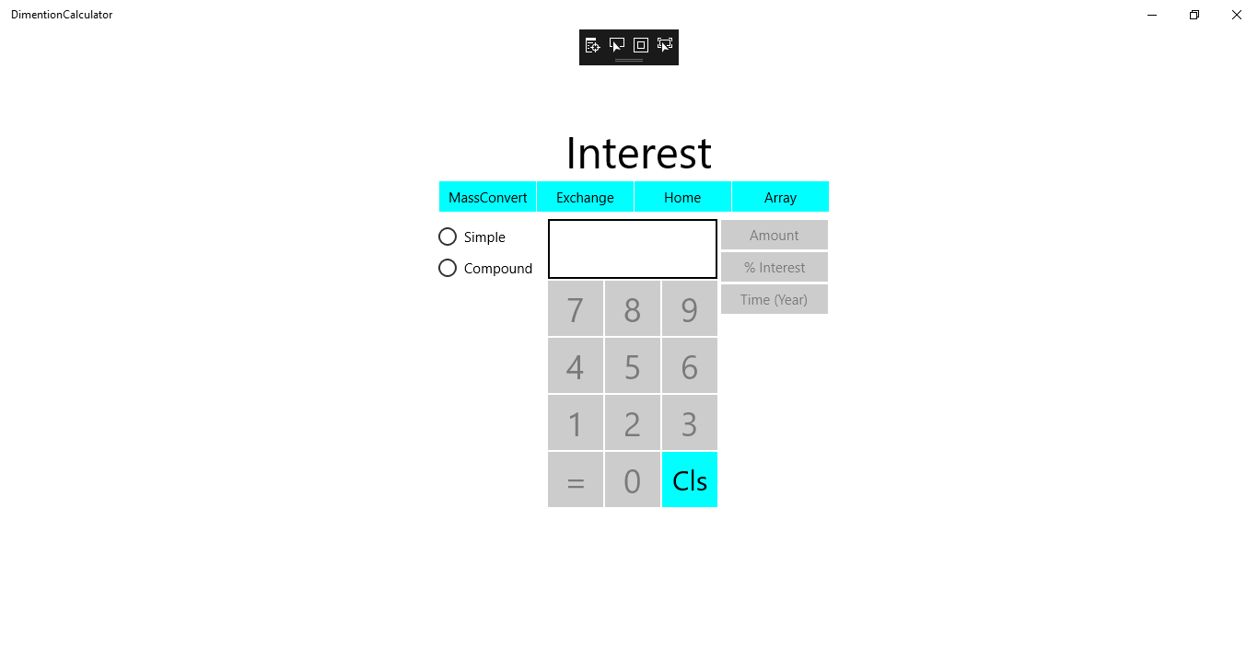

1. Select the type of interest calculation in the left, either simple or compound.
2. After the type is selected the buttons lights up indicating the user can now input his value.
3. On the right is what type of value the user is currently using.
4. After the user inputted their value press the button on the right that Is lighted up named Amount.
5. Then the interest % lights up indicating the user must input a %.
6. From that point the user has to click the interest button on the right.
7. Then the button lights up on the right named time and then the user has to input the amount of years the interest has before clicking on the button time.
8. The interest is indicated in the textbox.
9. You can use the cls button to clear the screen.

## Arrays

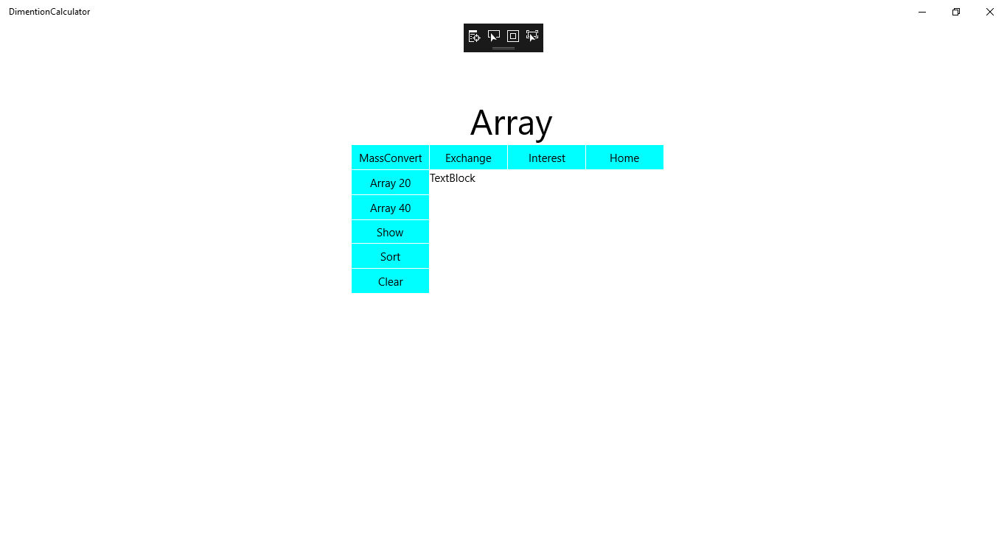

1. The buttons Array 20 and Array 40 generates 20 or 40 random numbers.
2. The show button in the left shows the numbers that’s generated.
3. The sort button below the show button then sorts the generated numbers.
4. Clear button clears the textbox that the numbers are in.

# Back End

## Code of Dimension calculator :

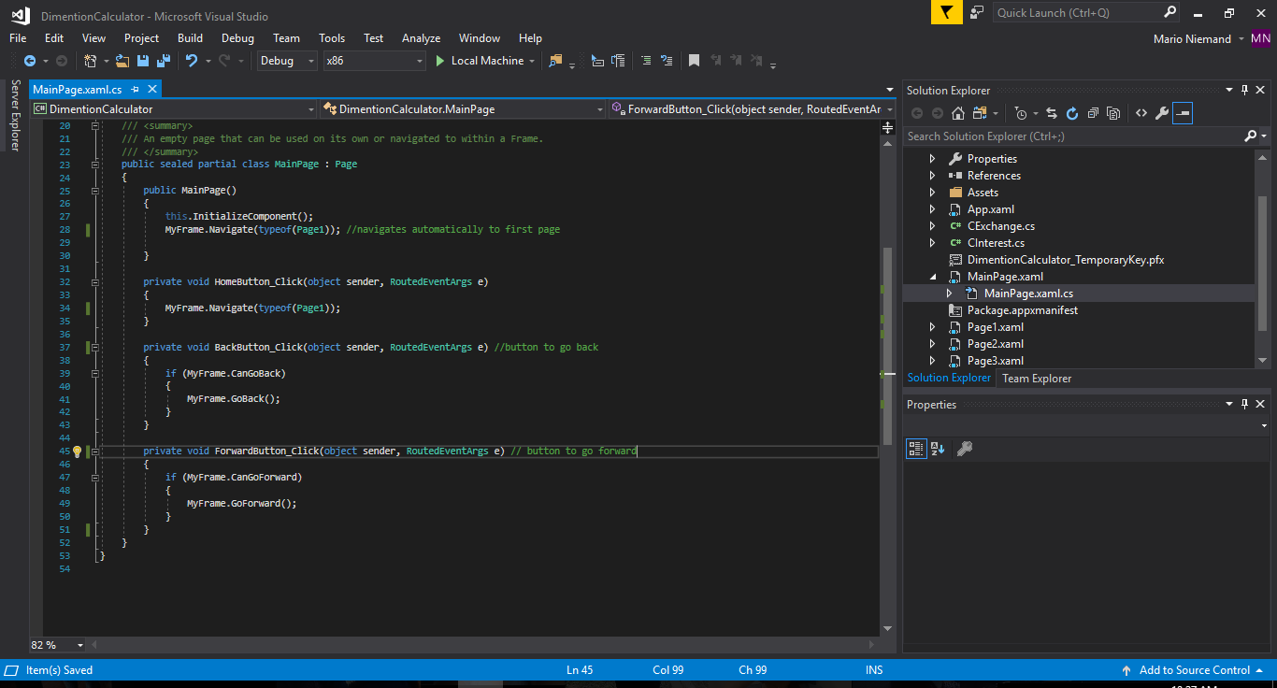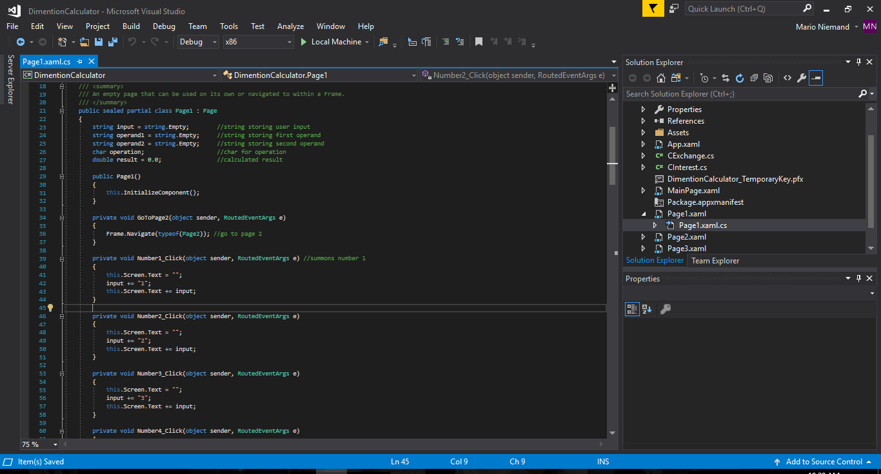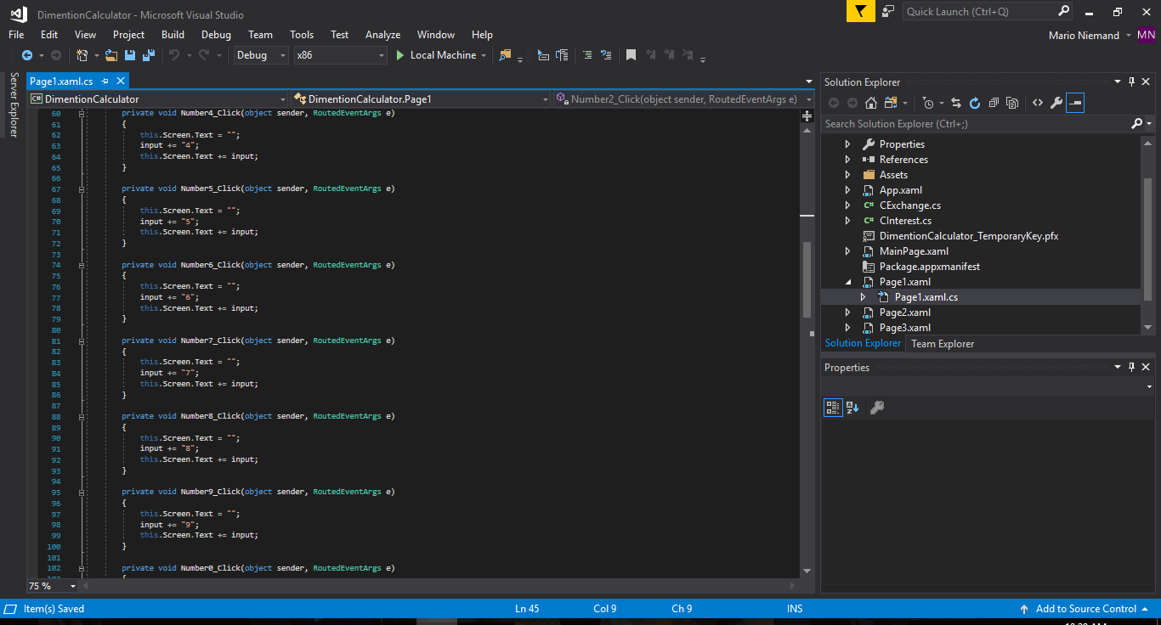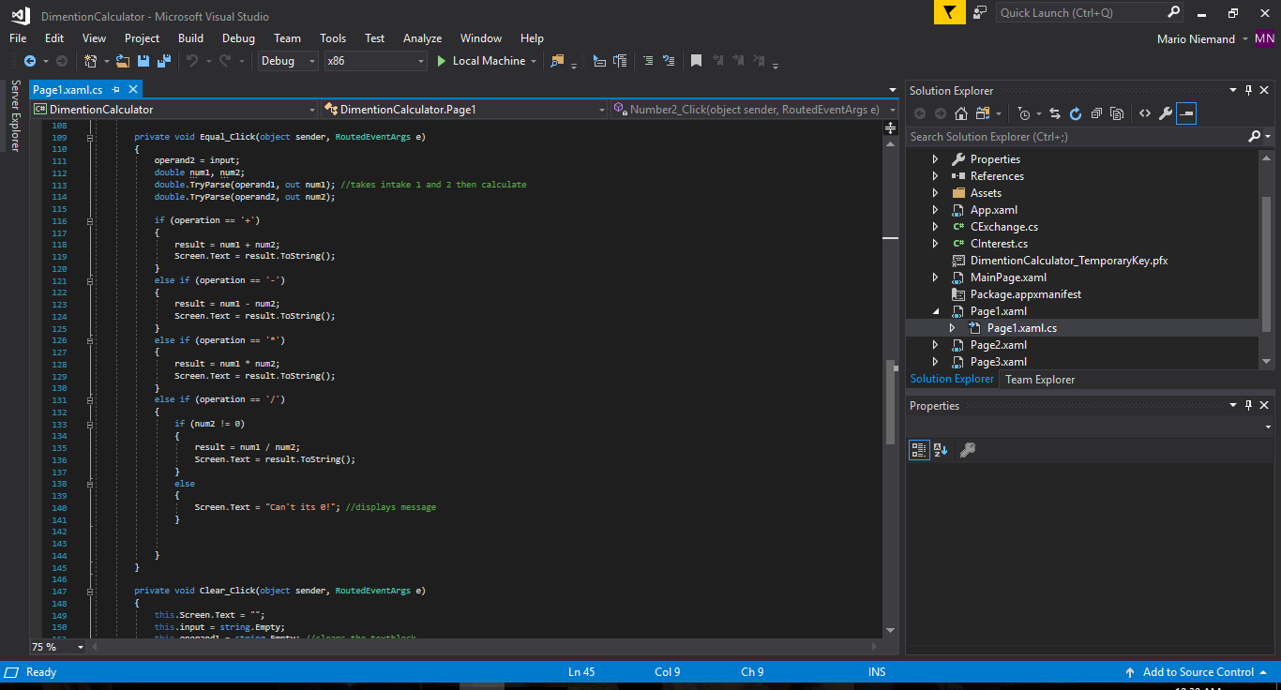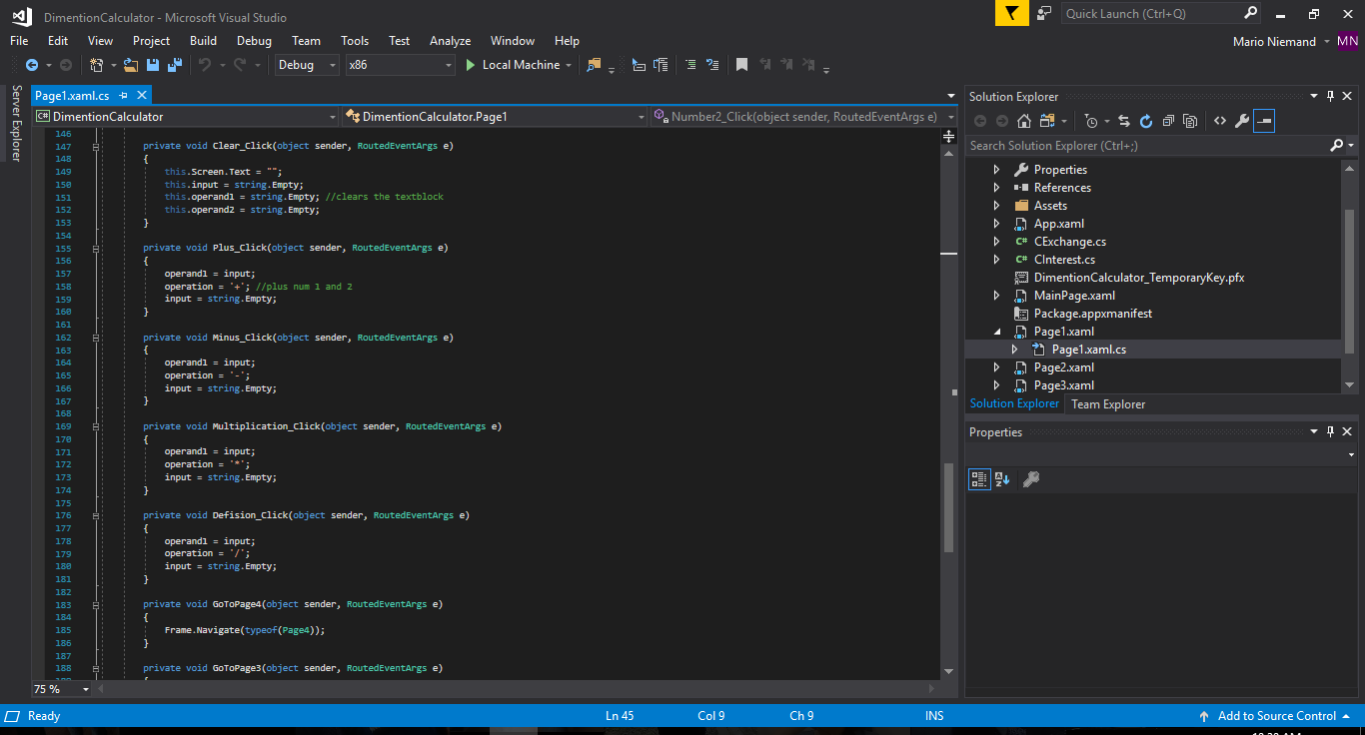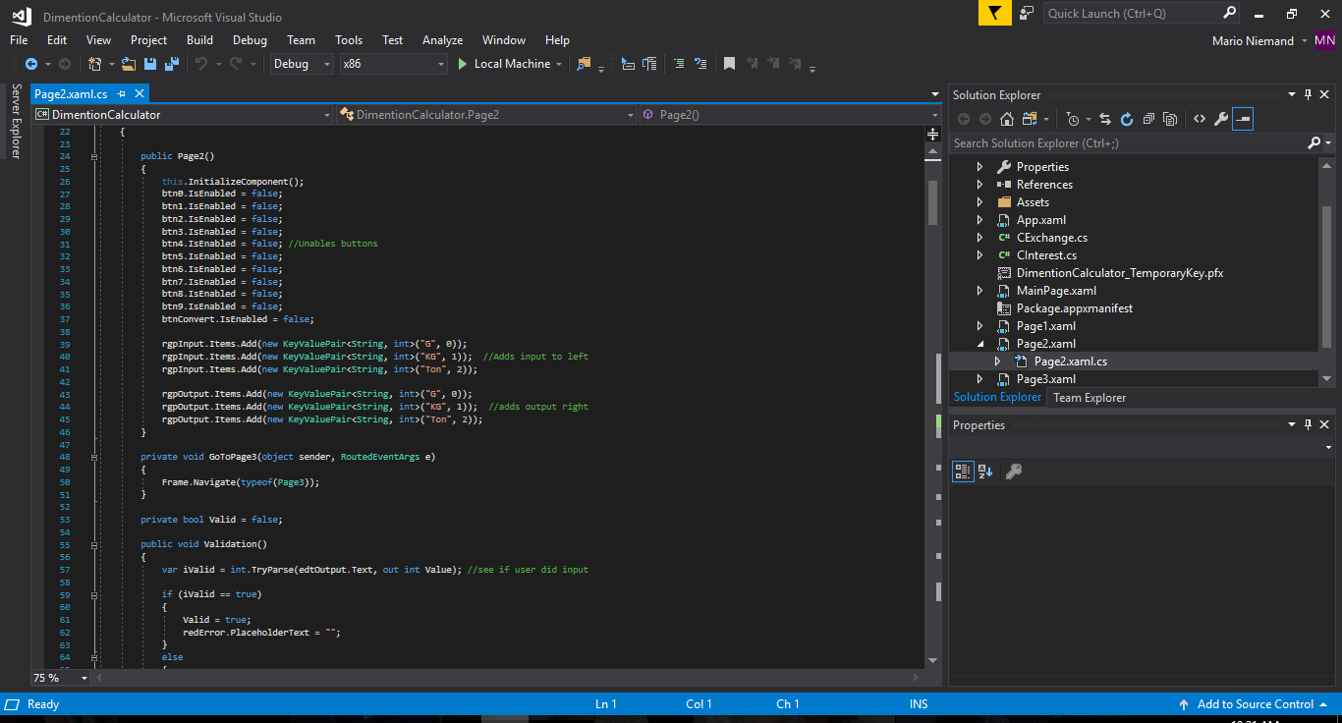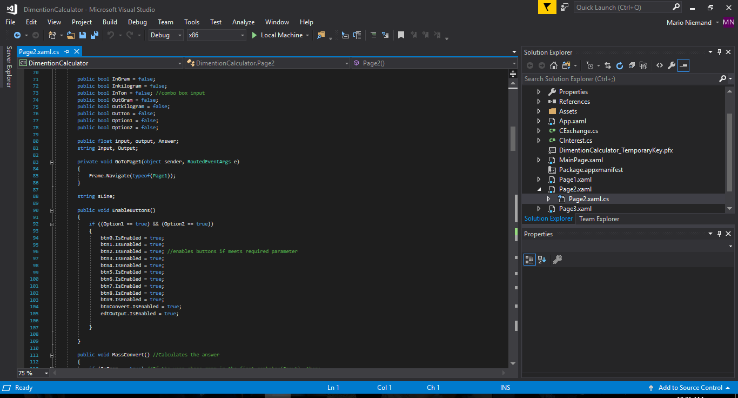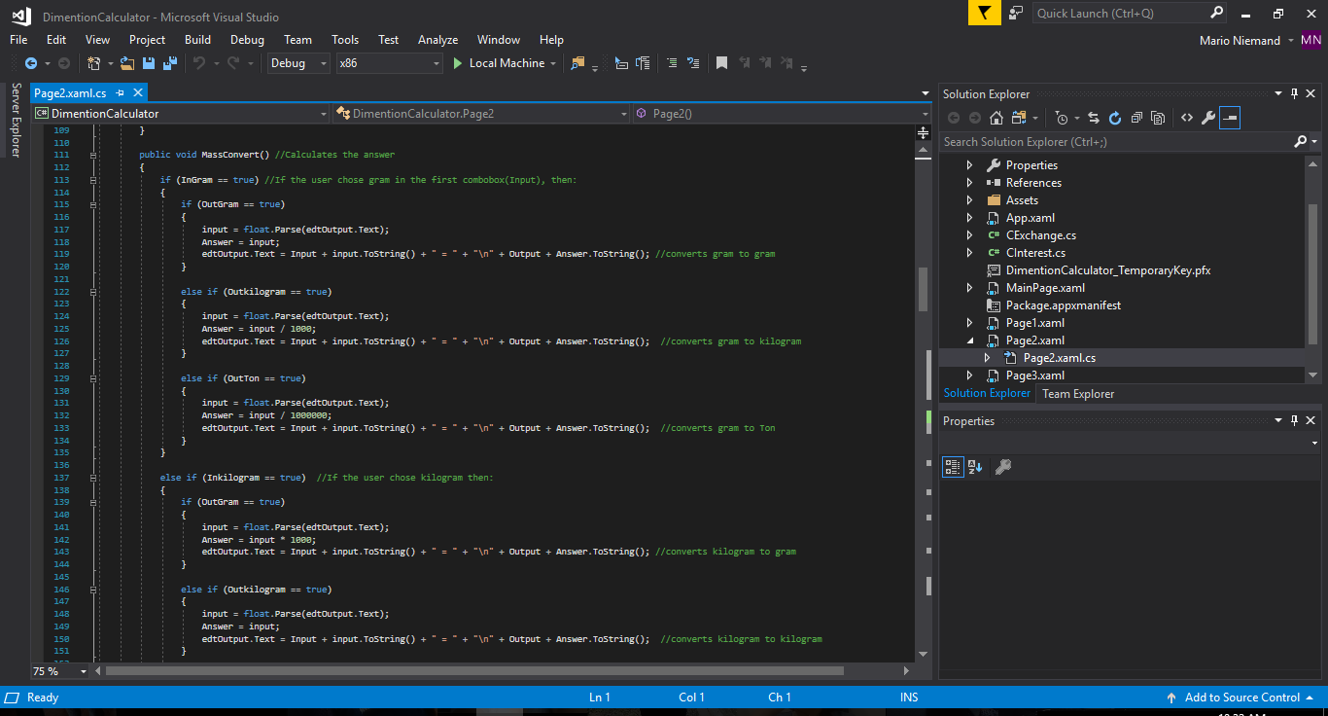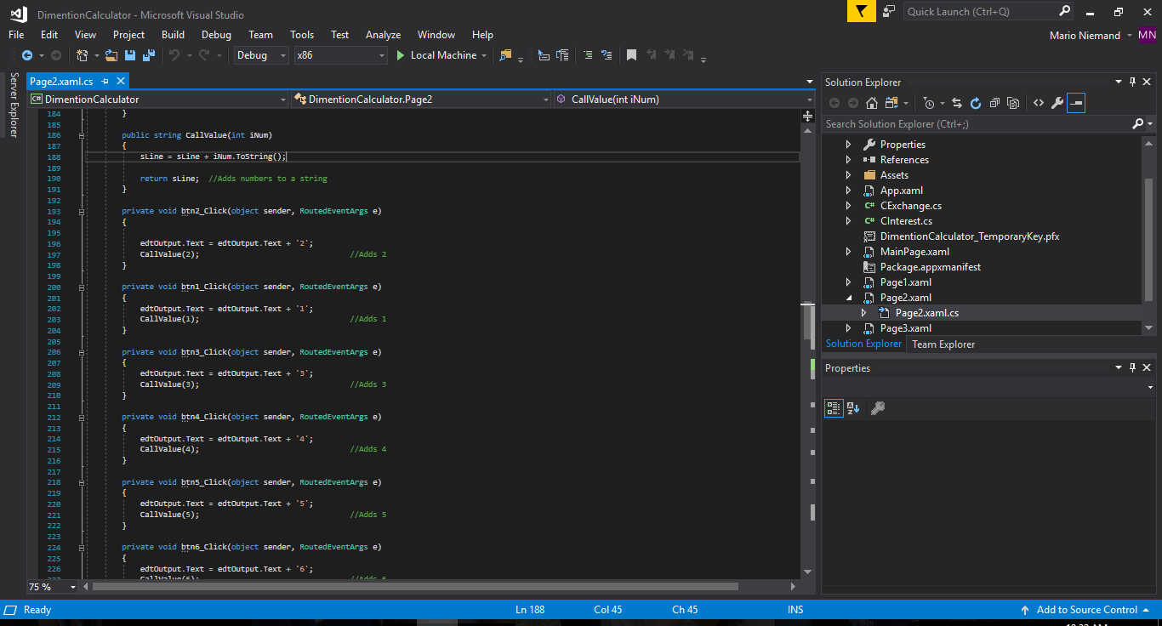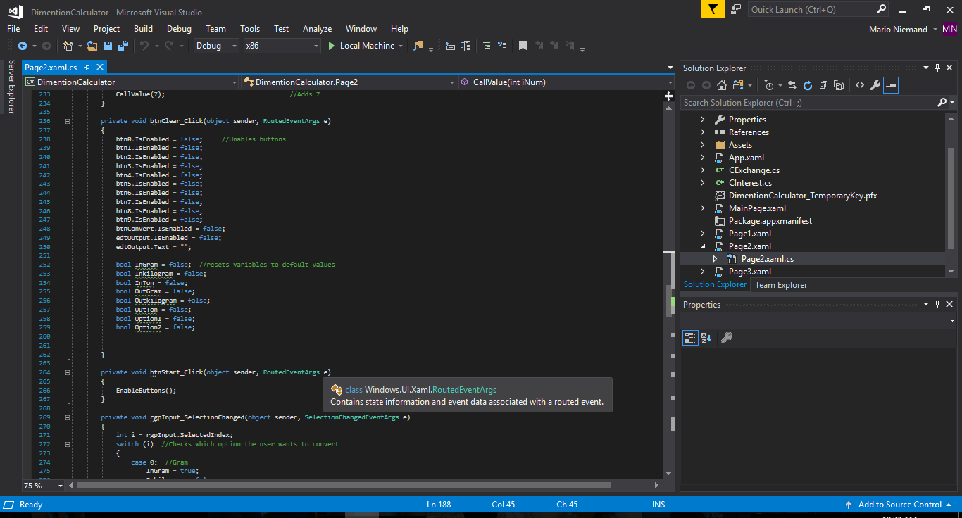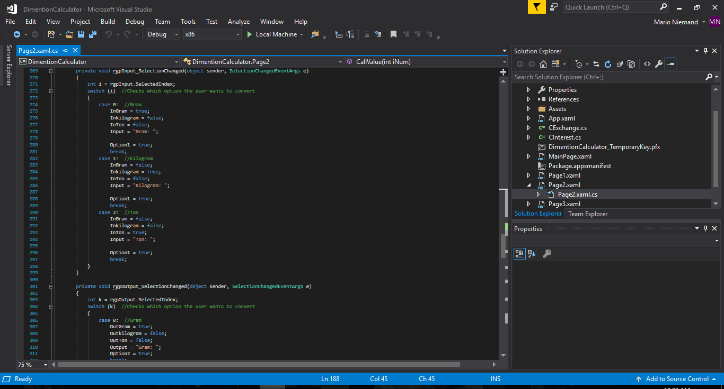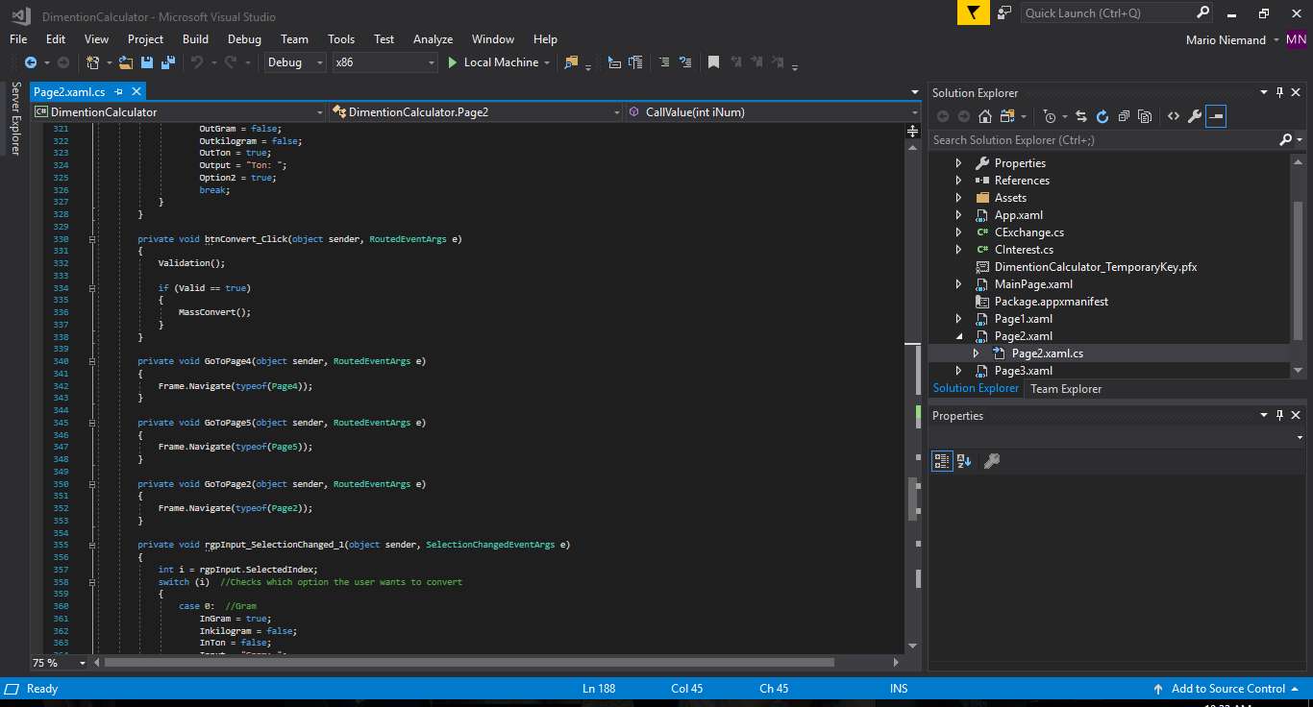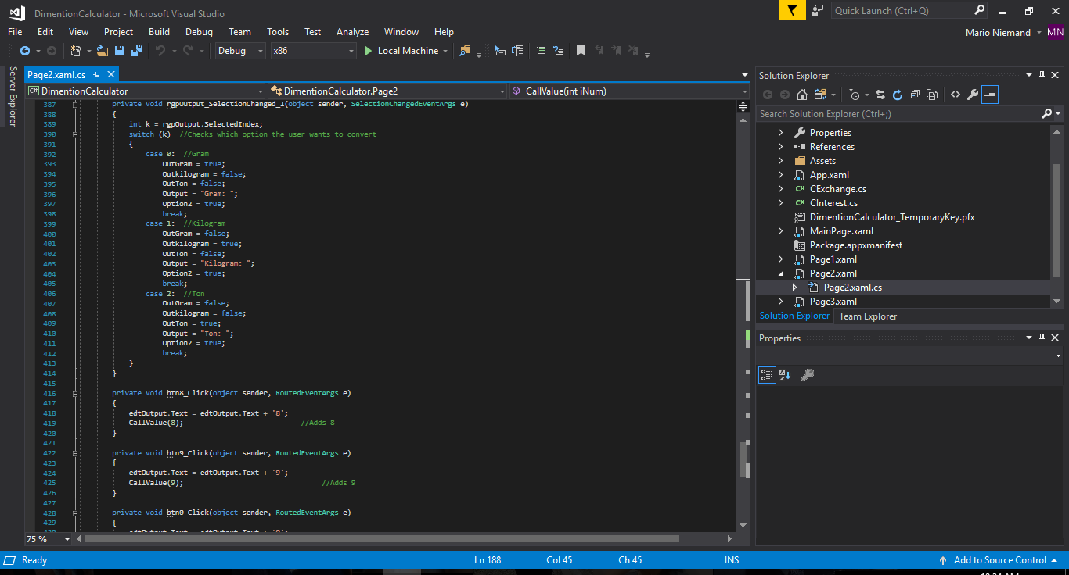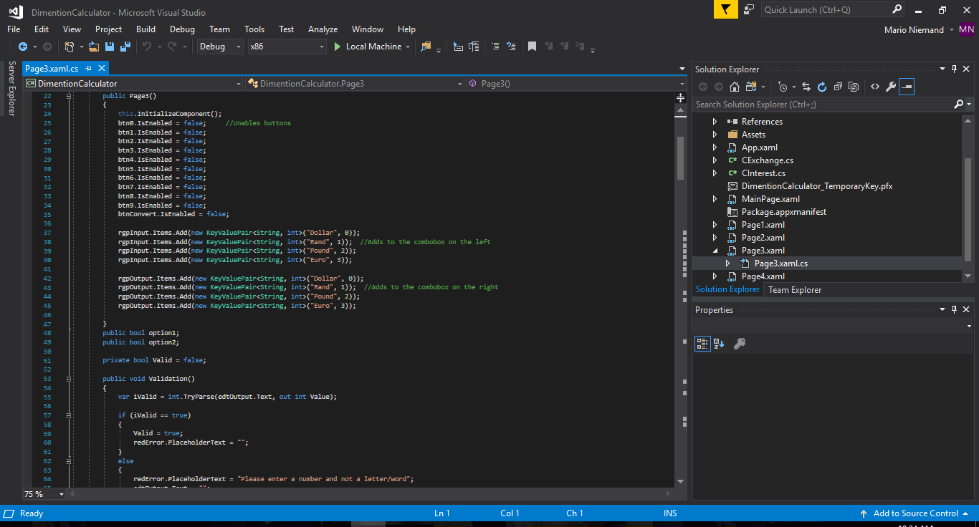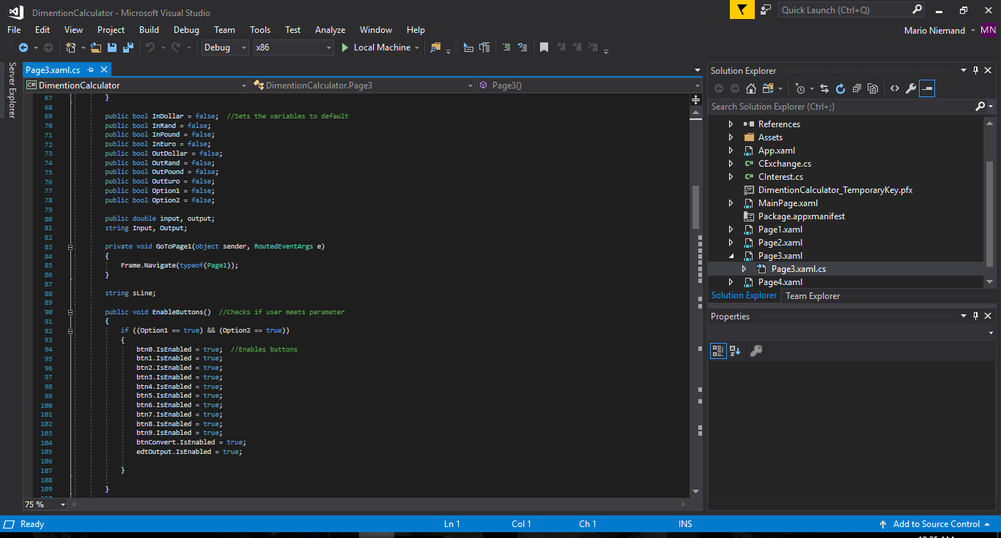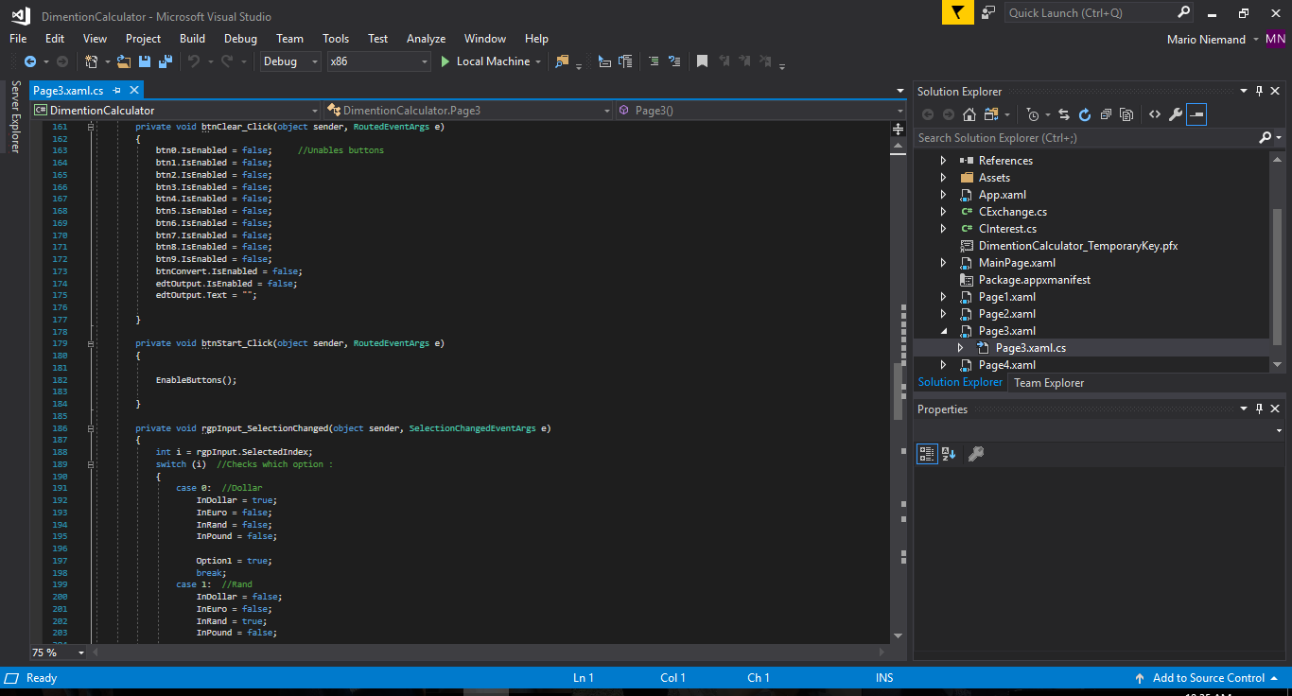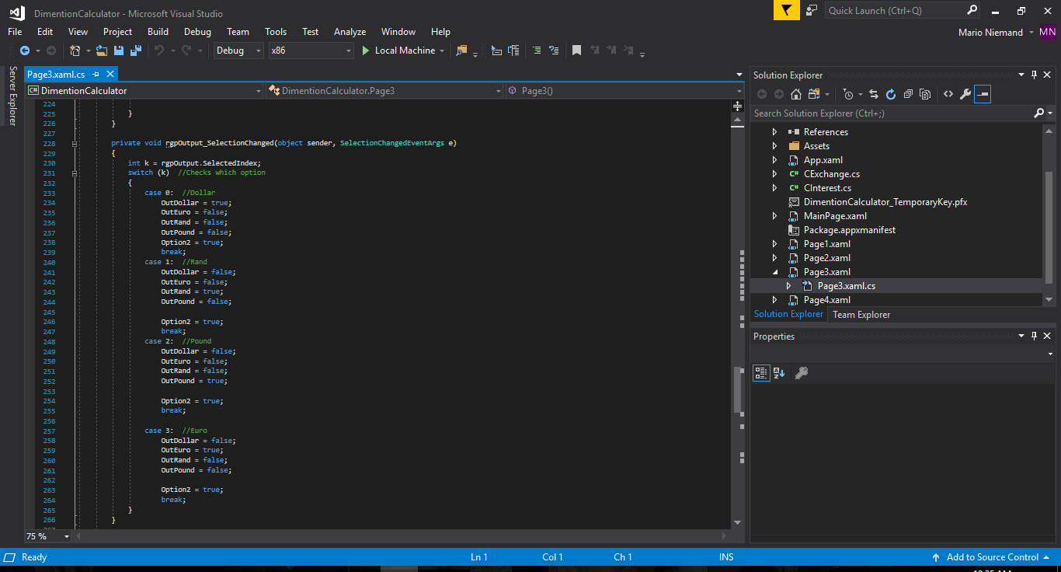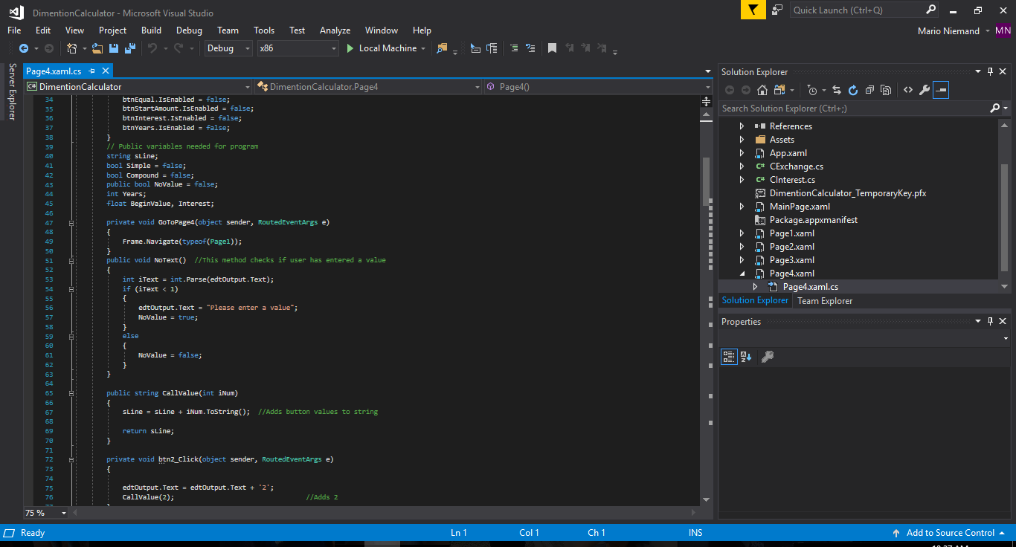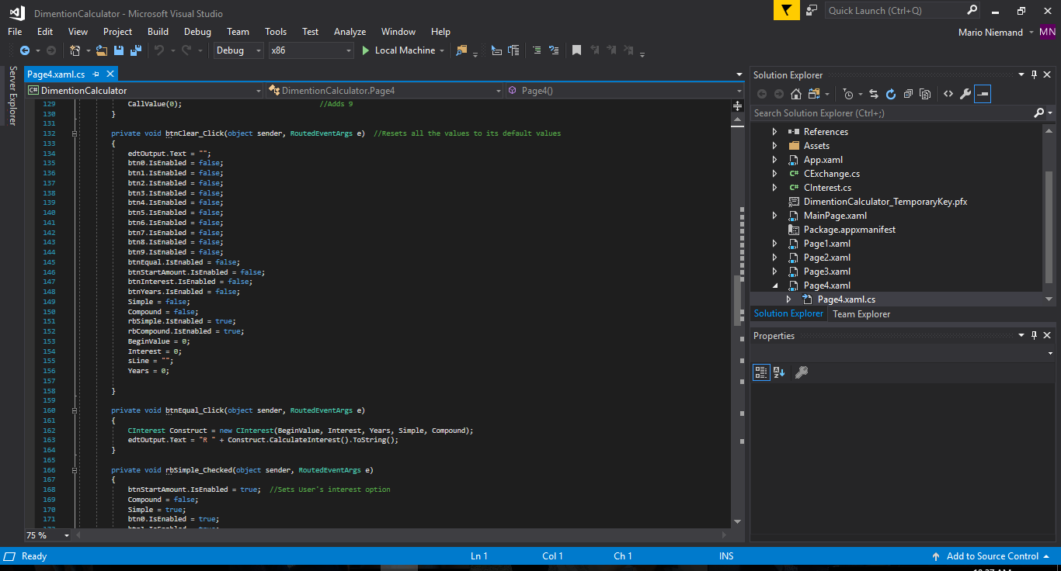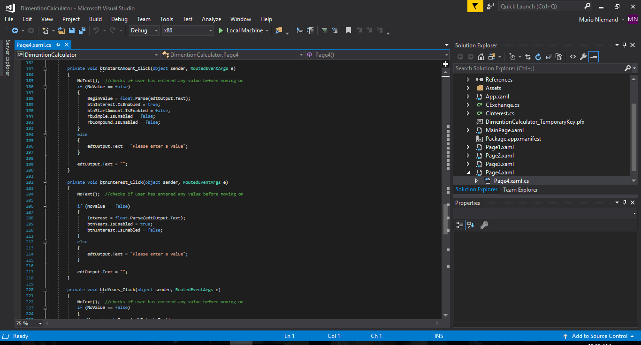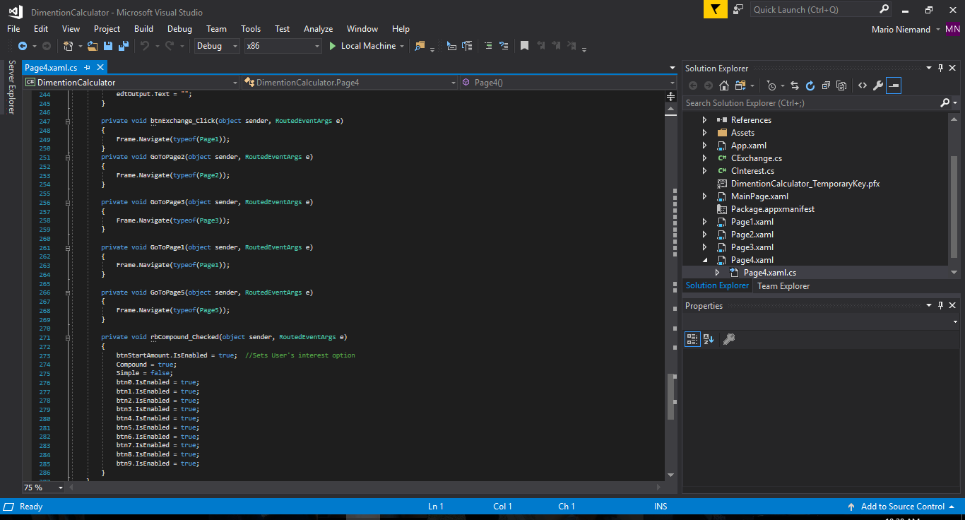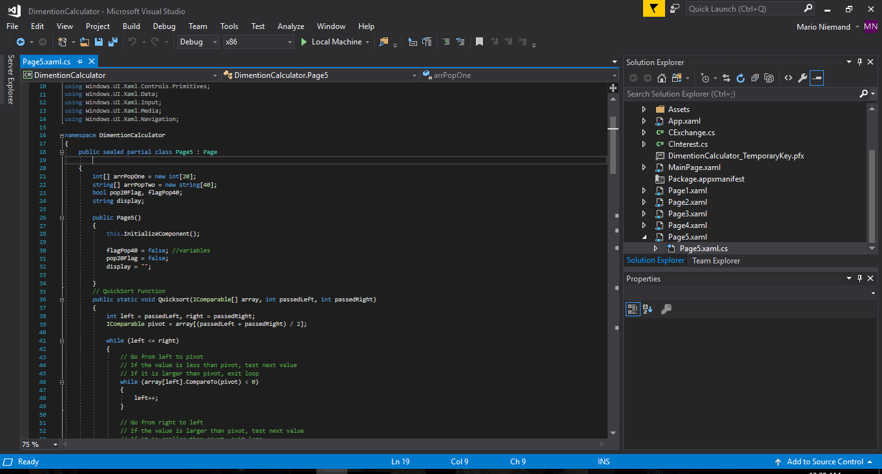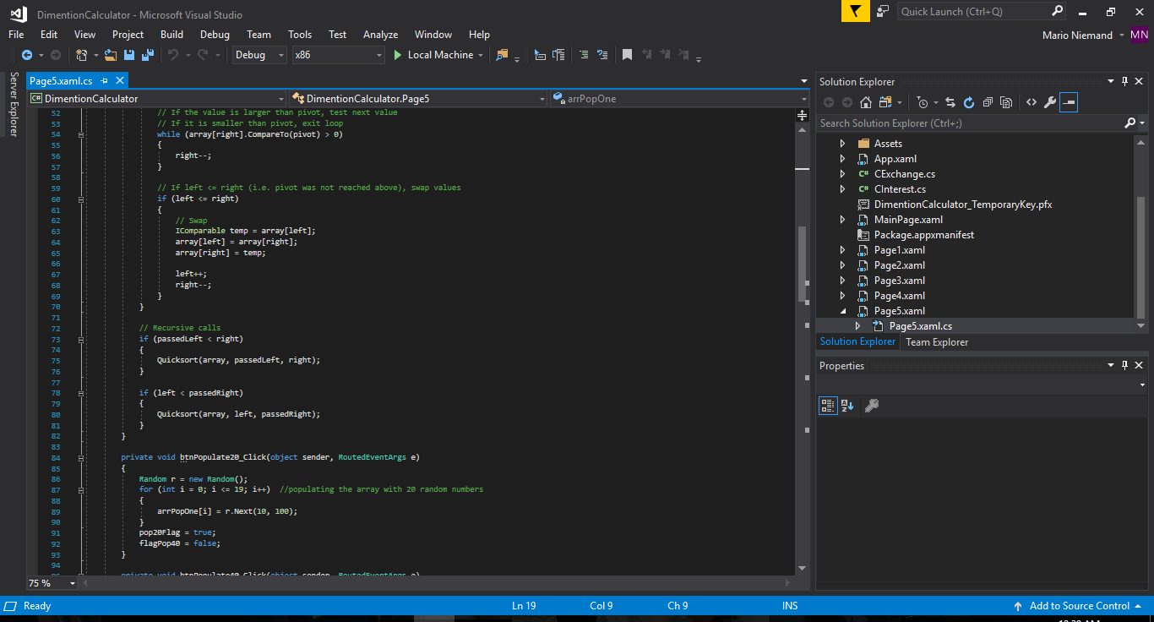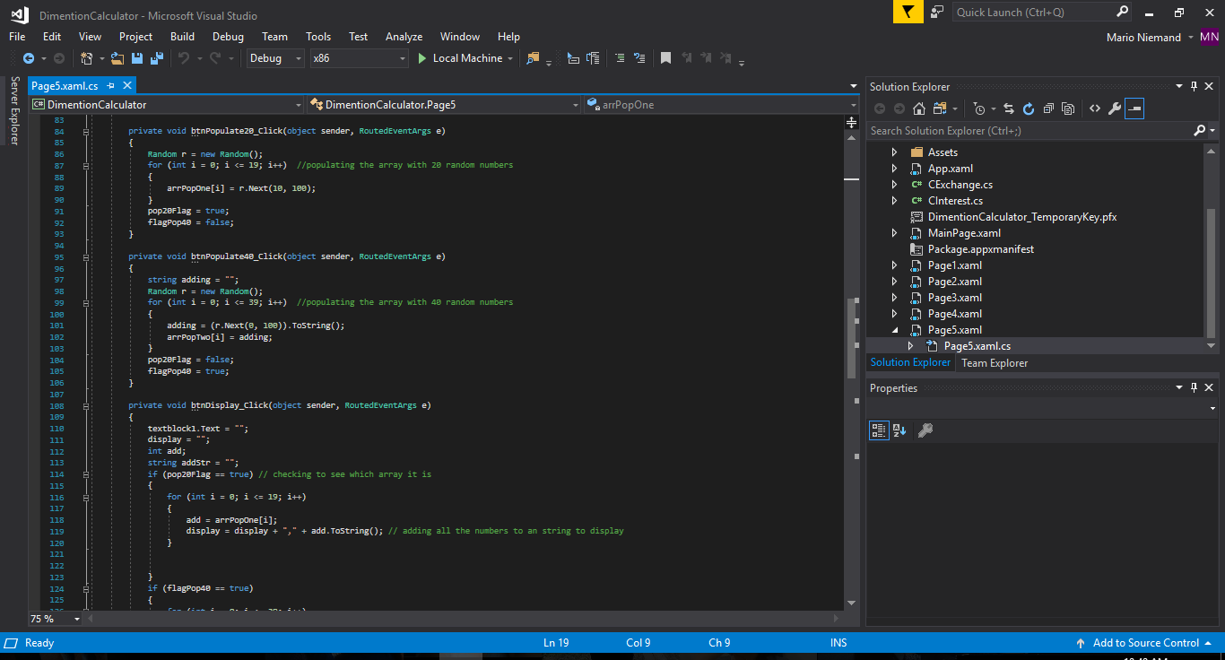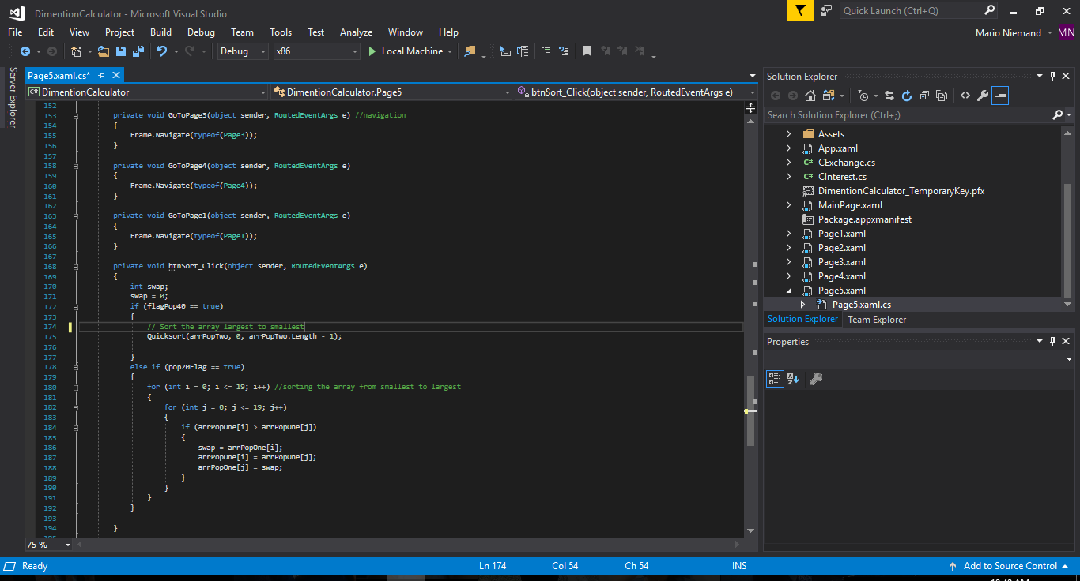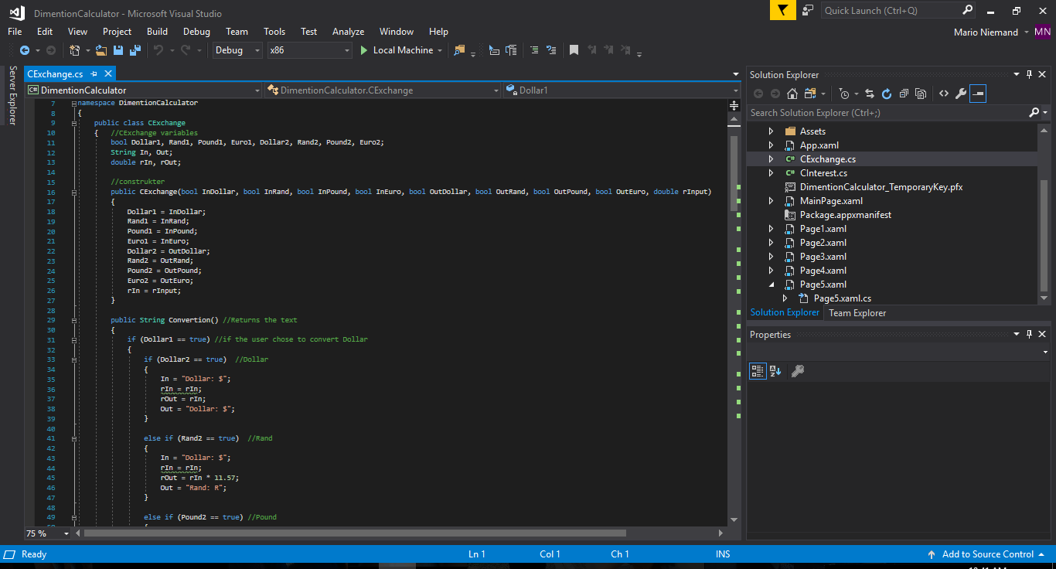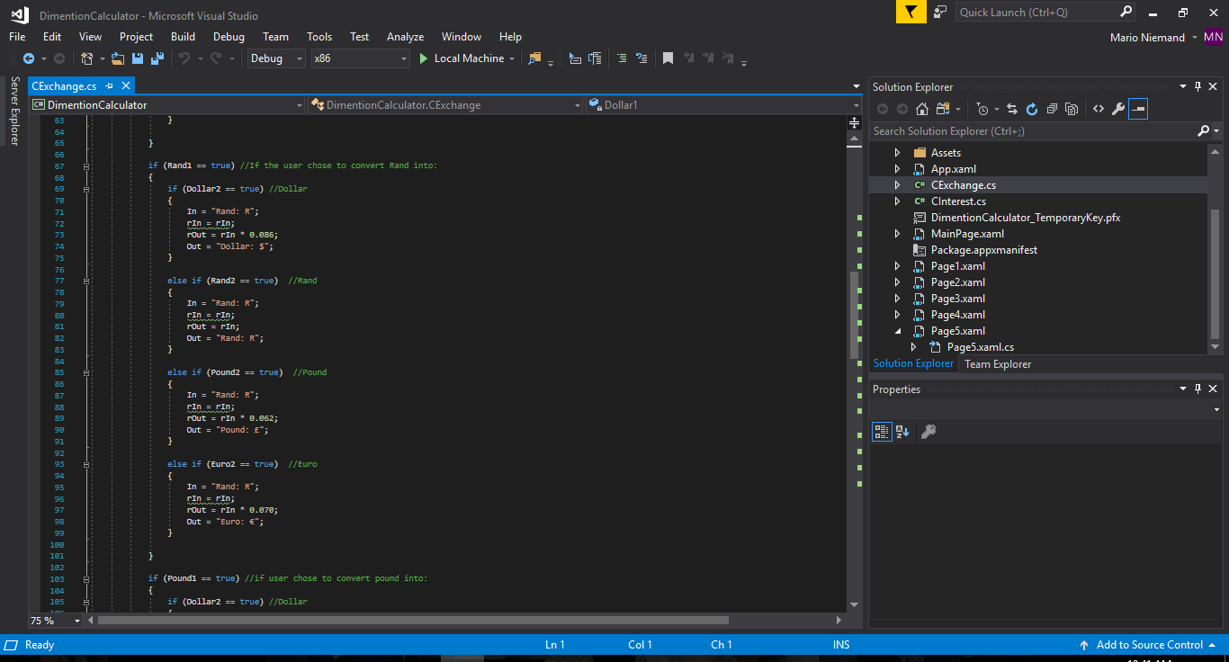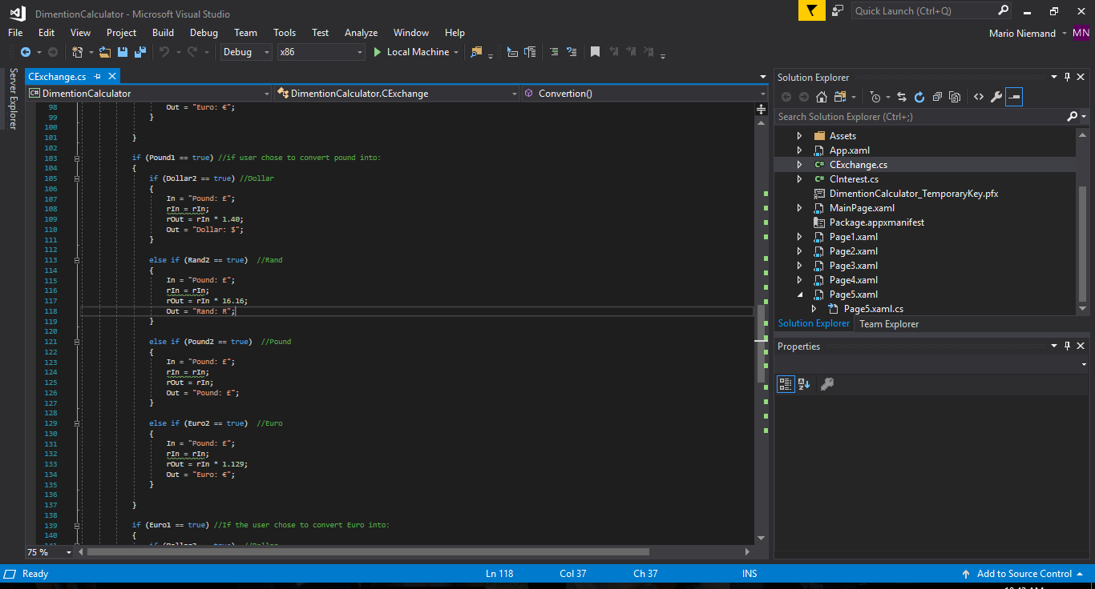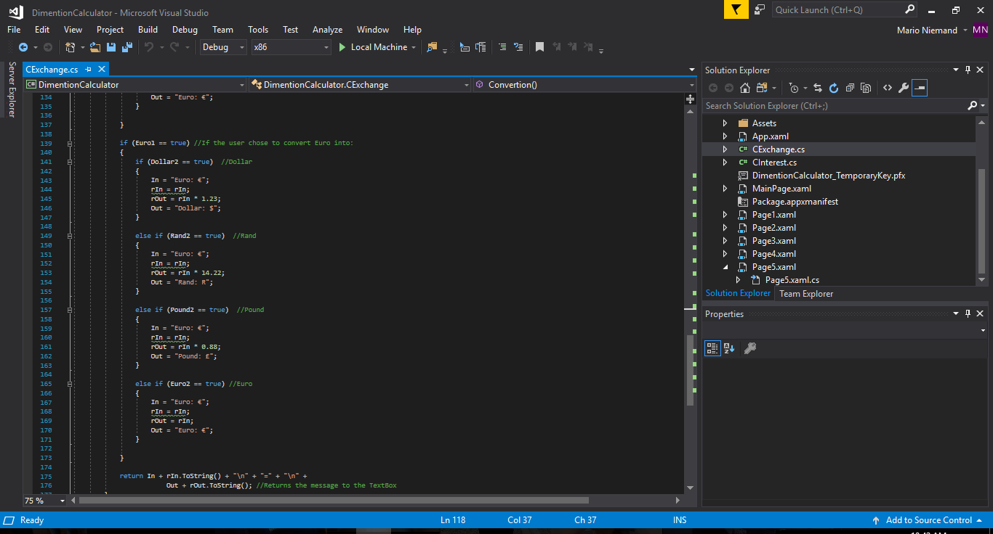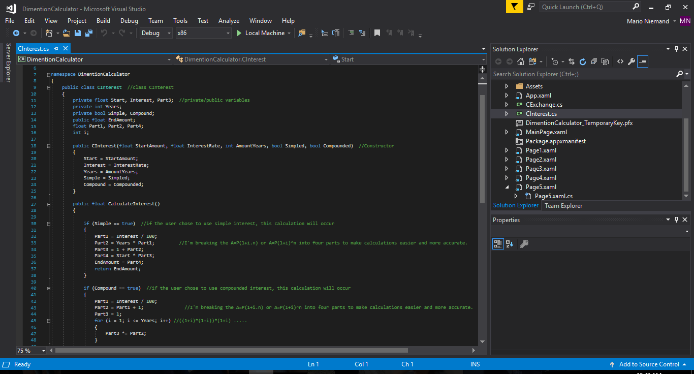

## How I fixed Errors

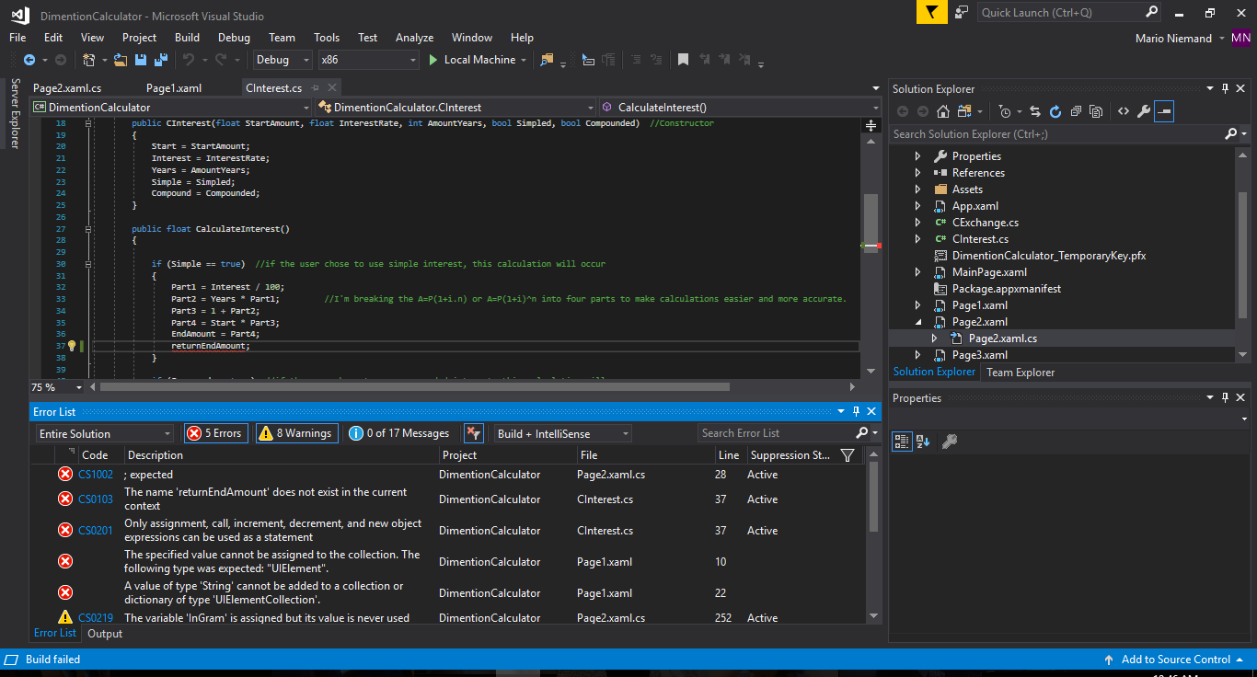

I fixed the errors by debugging my code then going to the sources of the problems and solving them.

My first problem was minor and just needed a semicolon.

My second error is that my variable was not declared, and I moved my variable to a public type.

My third problem was that I had a variable name spelled not the same and I just copied the name over.

My last error was that I didn’t declare my string and just used it so I declared the string inside the same class as the function.