Website (Iframe,videos,etc.)

Mario Niemand

MCSD

CTU-2018

Table of Contents

Front End: 2

Home Page 2

Gallery Page 2

Contact Page 3

Social Page 3

About Page 3

Back End Code of project: 4

# Front End:

## Home Page

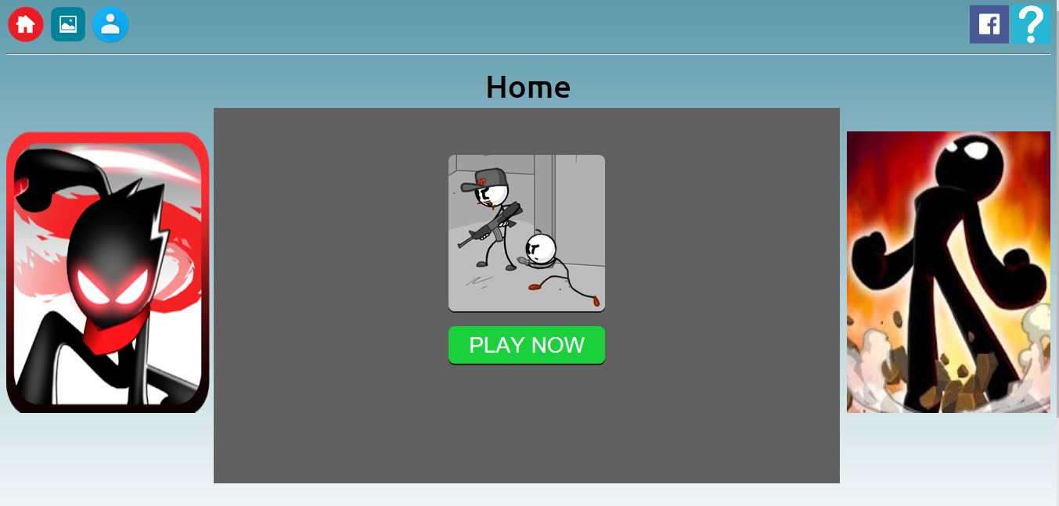

Here I used a iframe inside my div to play a game that’s located on a external website on my own website.

## Gallery Page

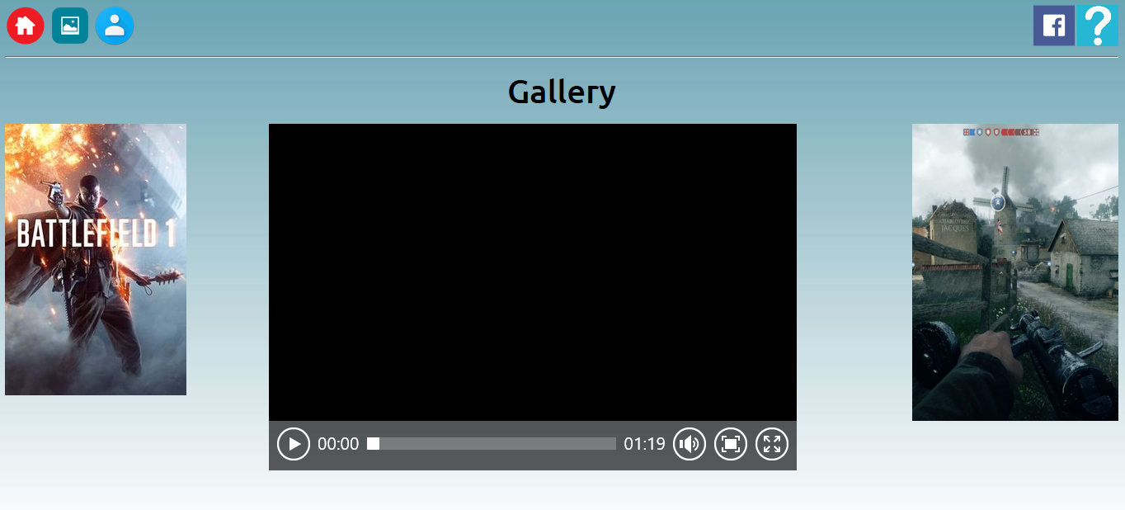

Here I played a youtube video from my website containing the new battlefield trailer.

## Contact Page

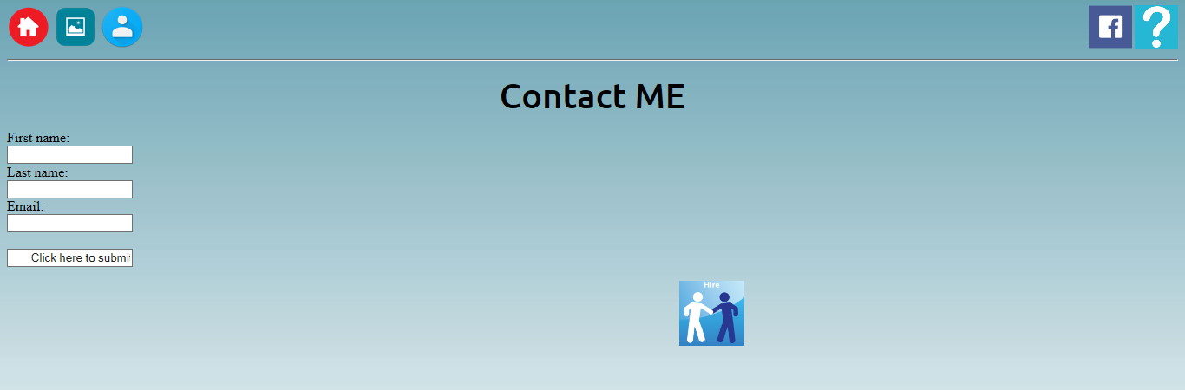

Here I created a submitting section that send a email directly to me containing the user’s problem etc.

## Social Page

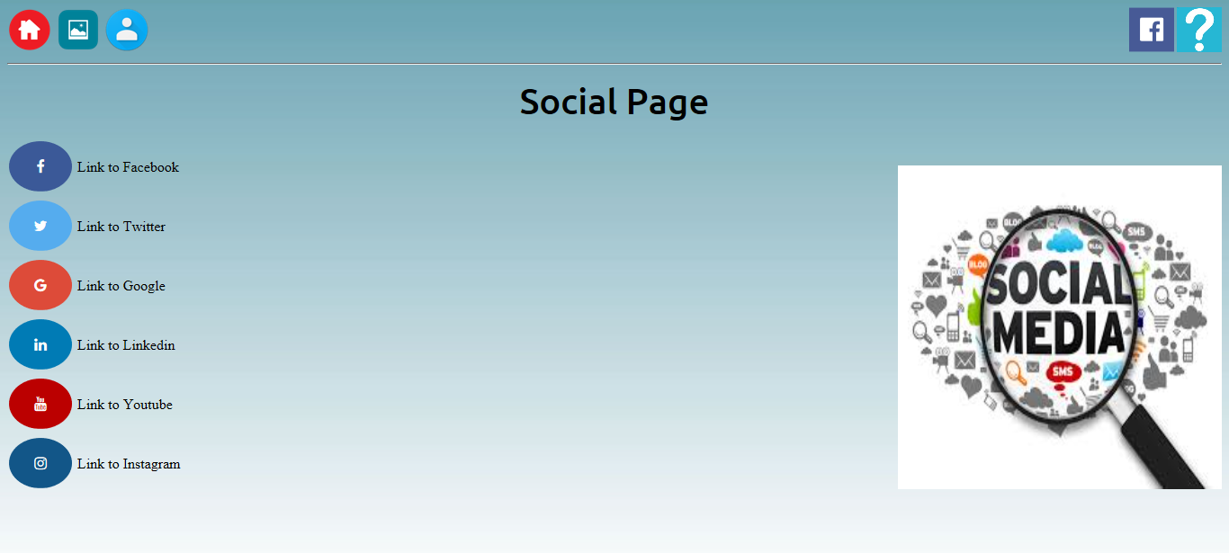

Ive created social links to all the best known websites where I have accounts.

## About Page

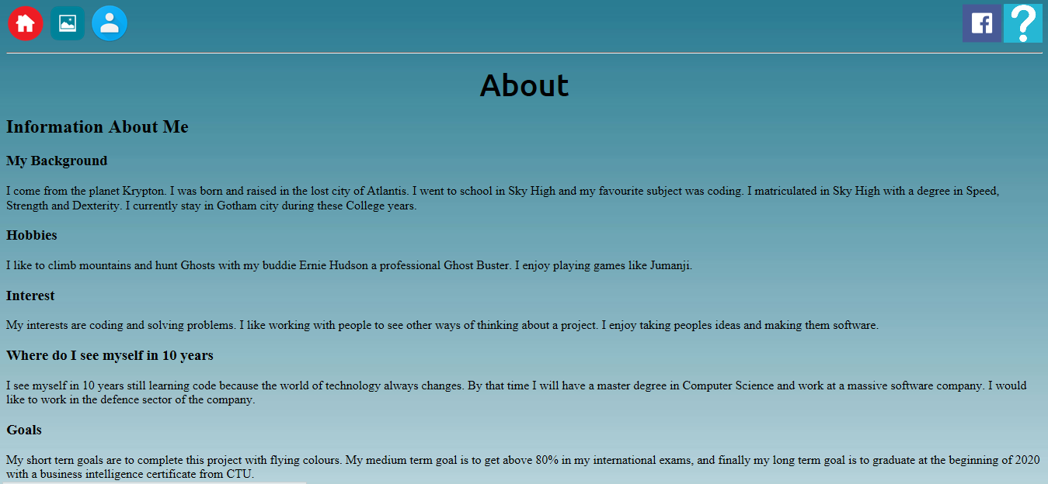

# Back End Code of project:

