# **RoundUp Sales**

**FREE E-BOOK**

# 5 things we love on Hubspot CRM



# 

## 1. Smarketing Tools

# Smarketing is the process of integrating the sales and marketing processes of a business. The objective is for the sales and marketing functions to have a common integrated approach.This can lead to annual revenue growth of up to 20%, according to a study in 2010.

# The objective is to promote the product or service to potential buyers and at the same time integrate this process with the sales department's activities.

# Sales and marketing departments should meet frequently and agree on a common terminology, and use data throughout the entire sales and marketing process to identify good prospects and to follow up on how well they are followed up.

# Smarketing works best when a firm does closed loop reporting by tracking its success with particular prospects from the marketing stage through direct sales efforts.

# Everything inside the software directly links Marketing and Sales.

# E.g: When a contact within the CRM takes a certain action on your website or social media post, or opens a particular email, you can round-robin assign that contact to a salesperson and automatically change their status to “lead.”

# The problem with about 60% of other software programs is that they *only* cover one aspect of a CRM – sales.

# If you want the marketing side of things, you’ll either need: A completely separate tool; To buy an additional add-on.

# And if it requires a separate tool, it’ll have to be integrated with a third party like Zapier.

# (Hubspot’s CRM is all-inclusive, for one price and with *unlimited users*.)

## 

## 

## 

## 2.Spectacular Insights

# Hubspot provides useful insights like automated workflows, task management, tagging, and lead scoring which is an important way to automate your marketing and sales actions.

# Lead scoring is a methodology used to rank prospects against a scale that represents the perceived value each lead represents to the organization. The resulting score is used to determine which leads a receiving function (e.g. sales, partners, teleprospecting) will engage, in order of priority.

However, all of the above when installed without proper linking to the original sources of leads and traffic behaviour might not make complete sense for business purposes.

Hubspot goes deeper and links the aforementioned information and actions with the correct analytics on deal stages and revenue.

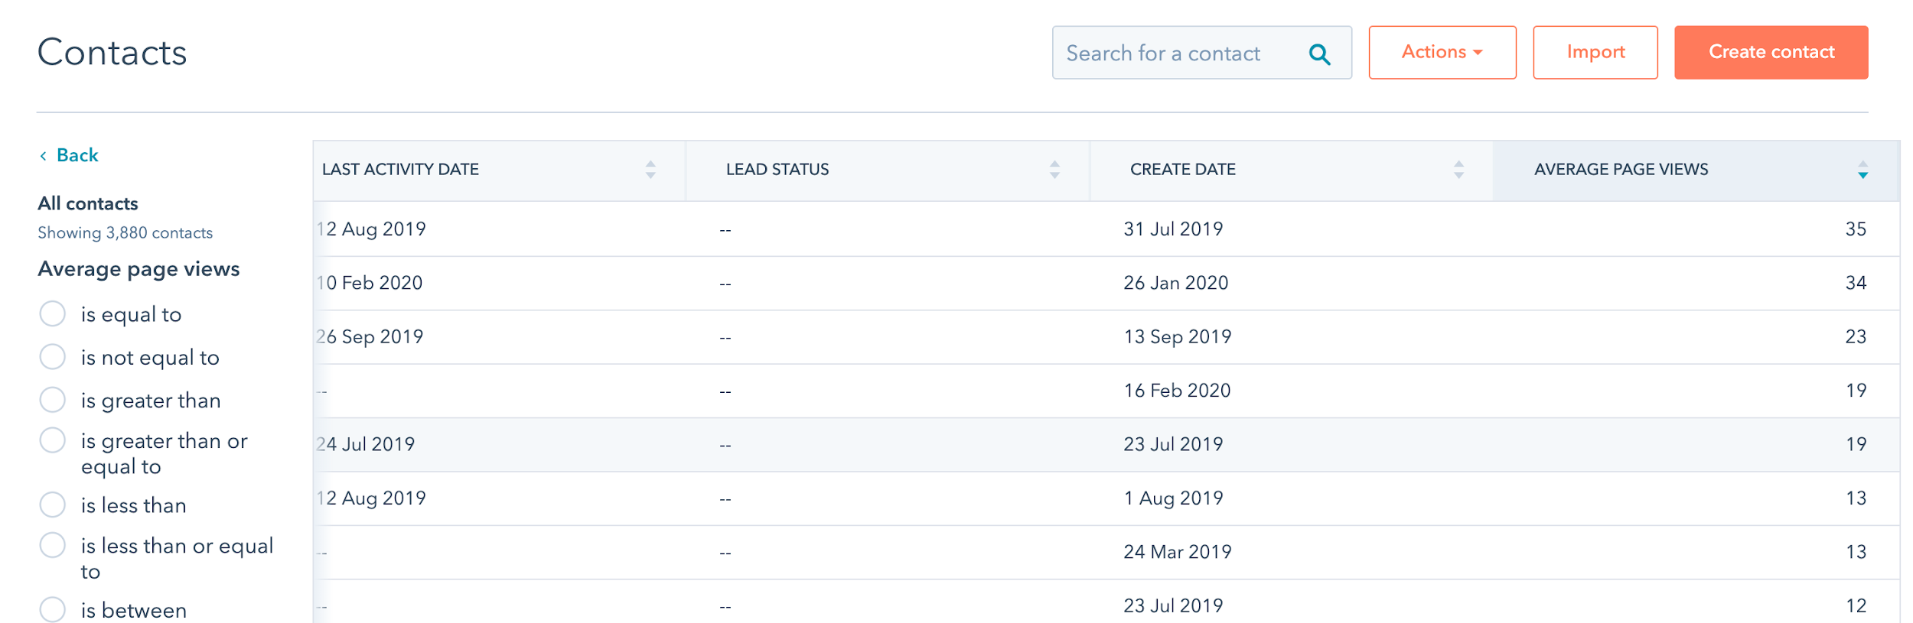

## 3.Revenue Tracking, Reporting and OVerall Activity tracking

HubSpot is great to keep track of revenue, keeping an eye on progress. These reports offer the ability to adapt strategy.

This allows for revenue reports to track closed revenue for the year and set quotas.

Another area in which HubSpot’s reporting tools come in really handy is with daily sales activity.

Often sales team members have daily, weekly, monthly and annual sales goals to meet.

HubSpot allows their users to set reports to monitor overall sales/productivity activity.

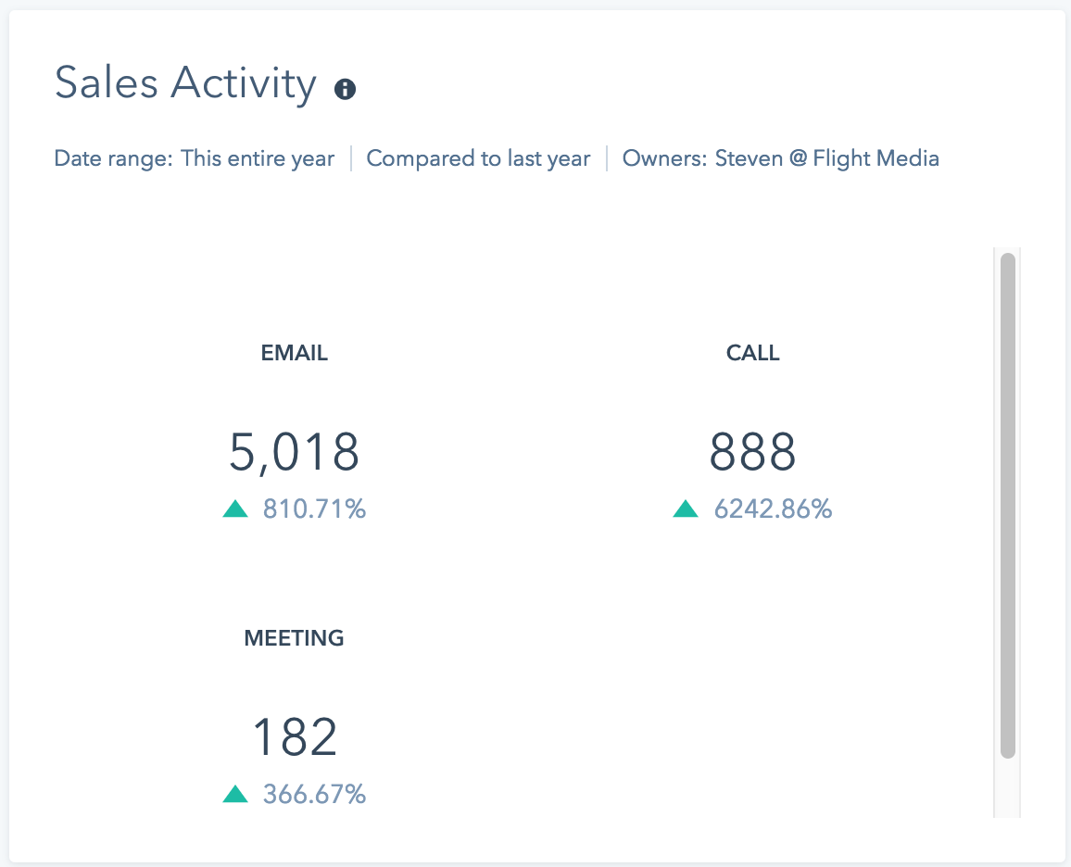

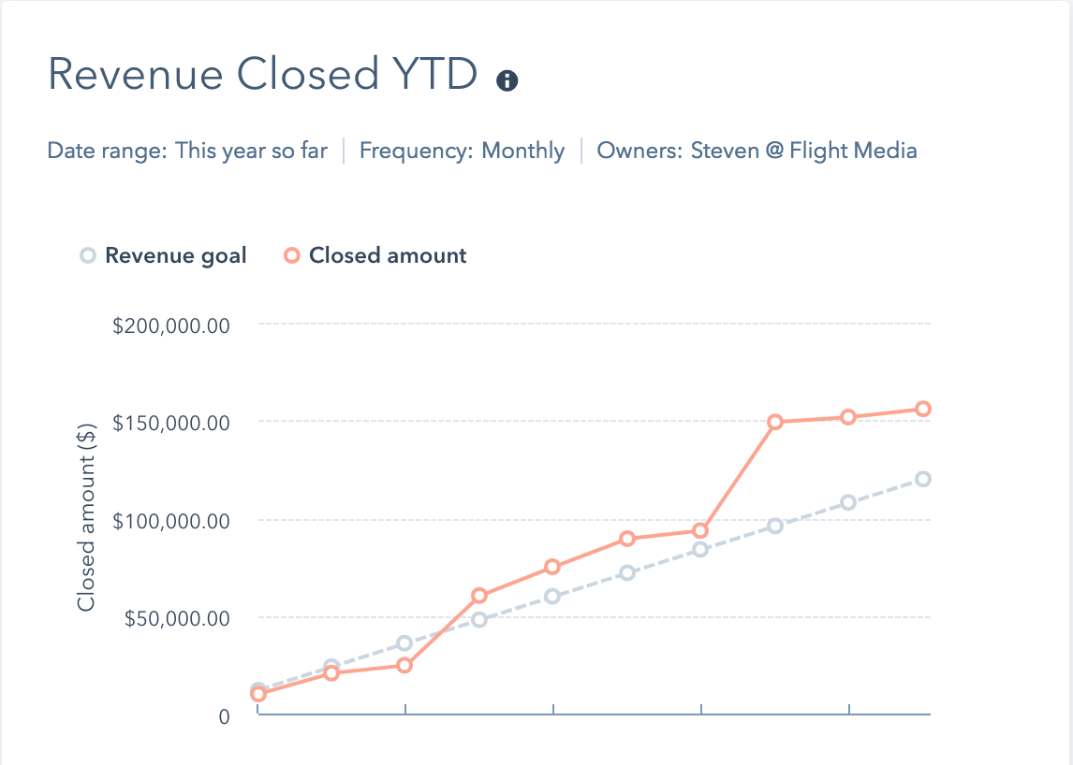

## 3.Sales Sequences

With the sequences tool, you can send a series of targeted, timed email templates to nurture contacts over time. When contacts reply to the email or book a meeting, they will automatically [unenroll](https://knowledge.hubspot.com/articles/kcs_article/sequences/unenroll-from-sequence) from the sequence.

Sequences use a mix of personalized, well-timed emails and follow-up task reminders to automate your communication with your leads

## 

## 

## 

## 

## 

## 

## 

## 4.Meetings Tool

While there are a bunch of meeting tools out there like [Calendly](https://calendly.com/) or [Assistant.to](https://www.assistant.to/), Hubspot meeting tool surpasses expectations.

It’s slick, branded to your company, syncs with your calendar, integrates with the Sales Sequences tool, and adds the booked meeting to the lead’s contact record in the Hubspot CRM.

# 

## 5.Chatbots

Today’s buyers want more and more information and they want it delivered at the moment.

Hubspot allows for live chat to automatically connect chatters to the right people on a team: it allows for Routing customer inquiries to the services team, and to pass leads to the salesperson in charge of a business relationship.

Easily customize your chat widget to match the look and feel of your brand, and create targeted welcome messages for different web pages or segments of your audience so you can connect with the site visitors who matter — right when they’re most engaged.

Every conversation gets automatically saved and stored in your conversations inbox and on the contact’s timeline so your team has complete context and a crystal clear view of every interaction.

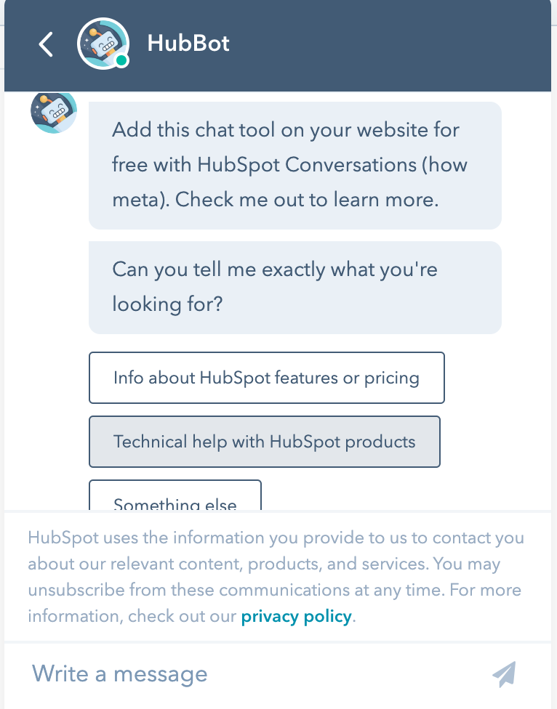

# Thank you for your time

# [Reach out if you want to know more](https://roundupsales.netlify.com/#About%20us)