# **RoundUp Sales**

**FREE E-BOOK**

# 7 Steps for designing a Website that Sells

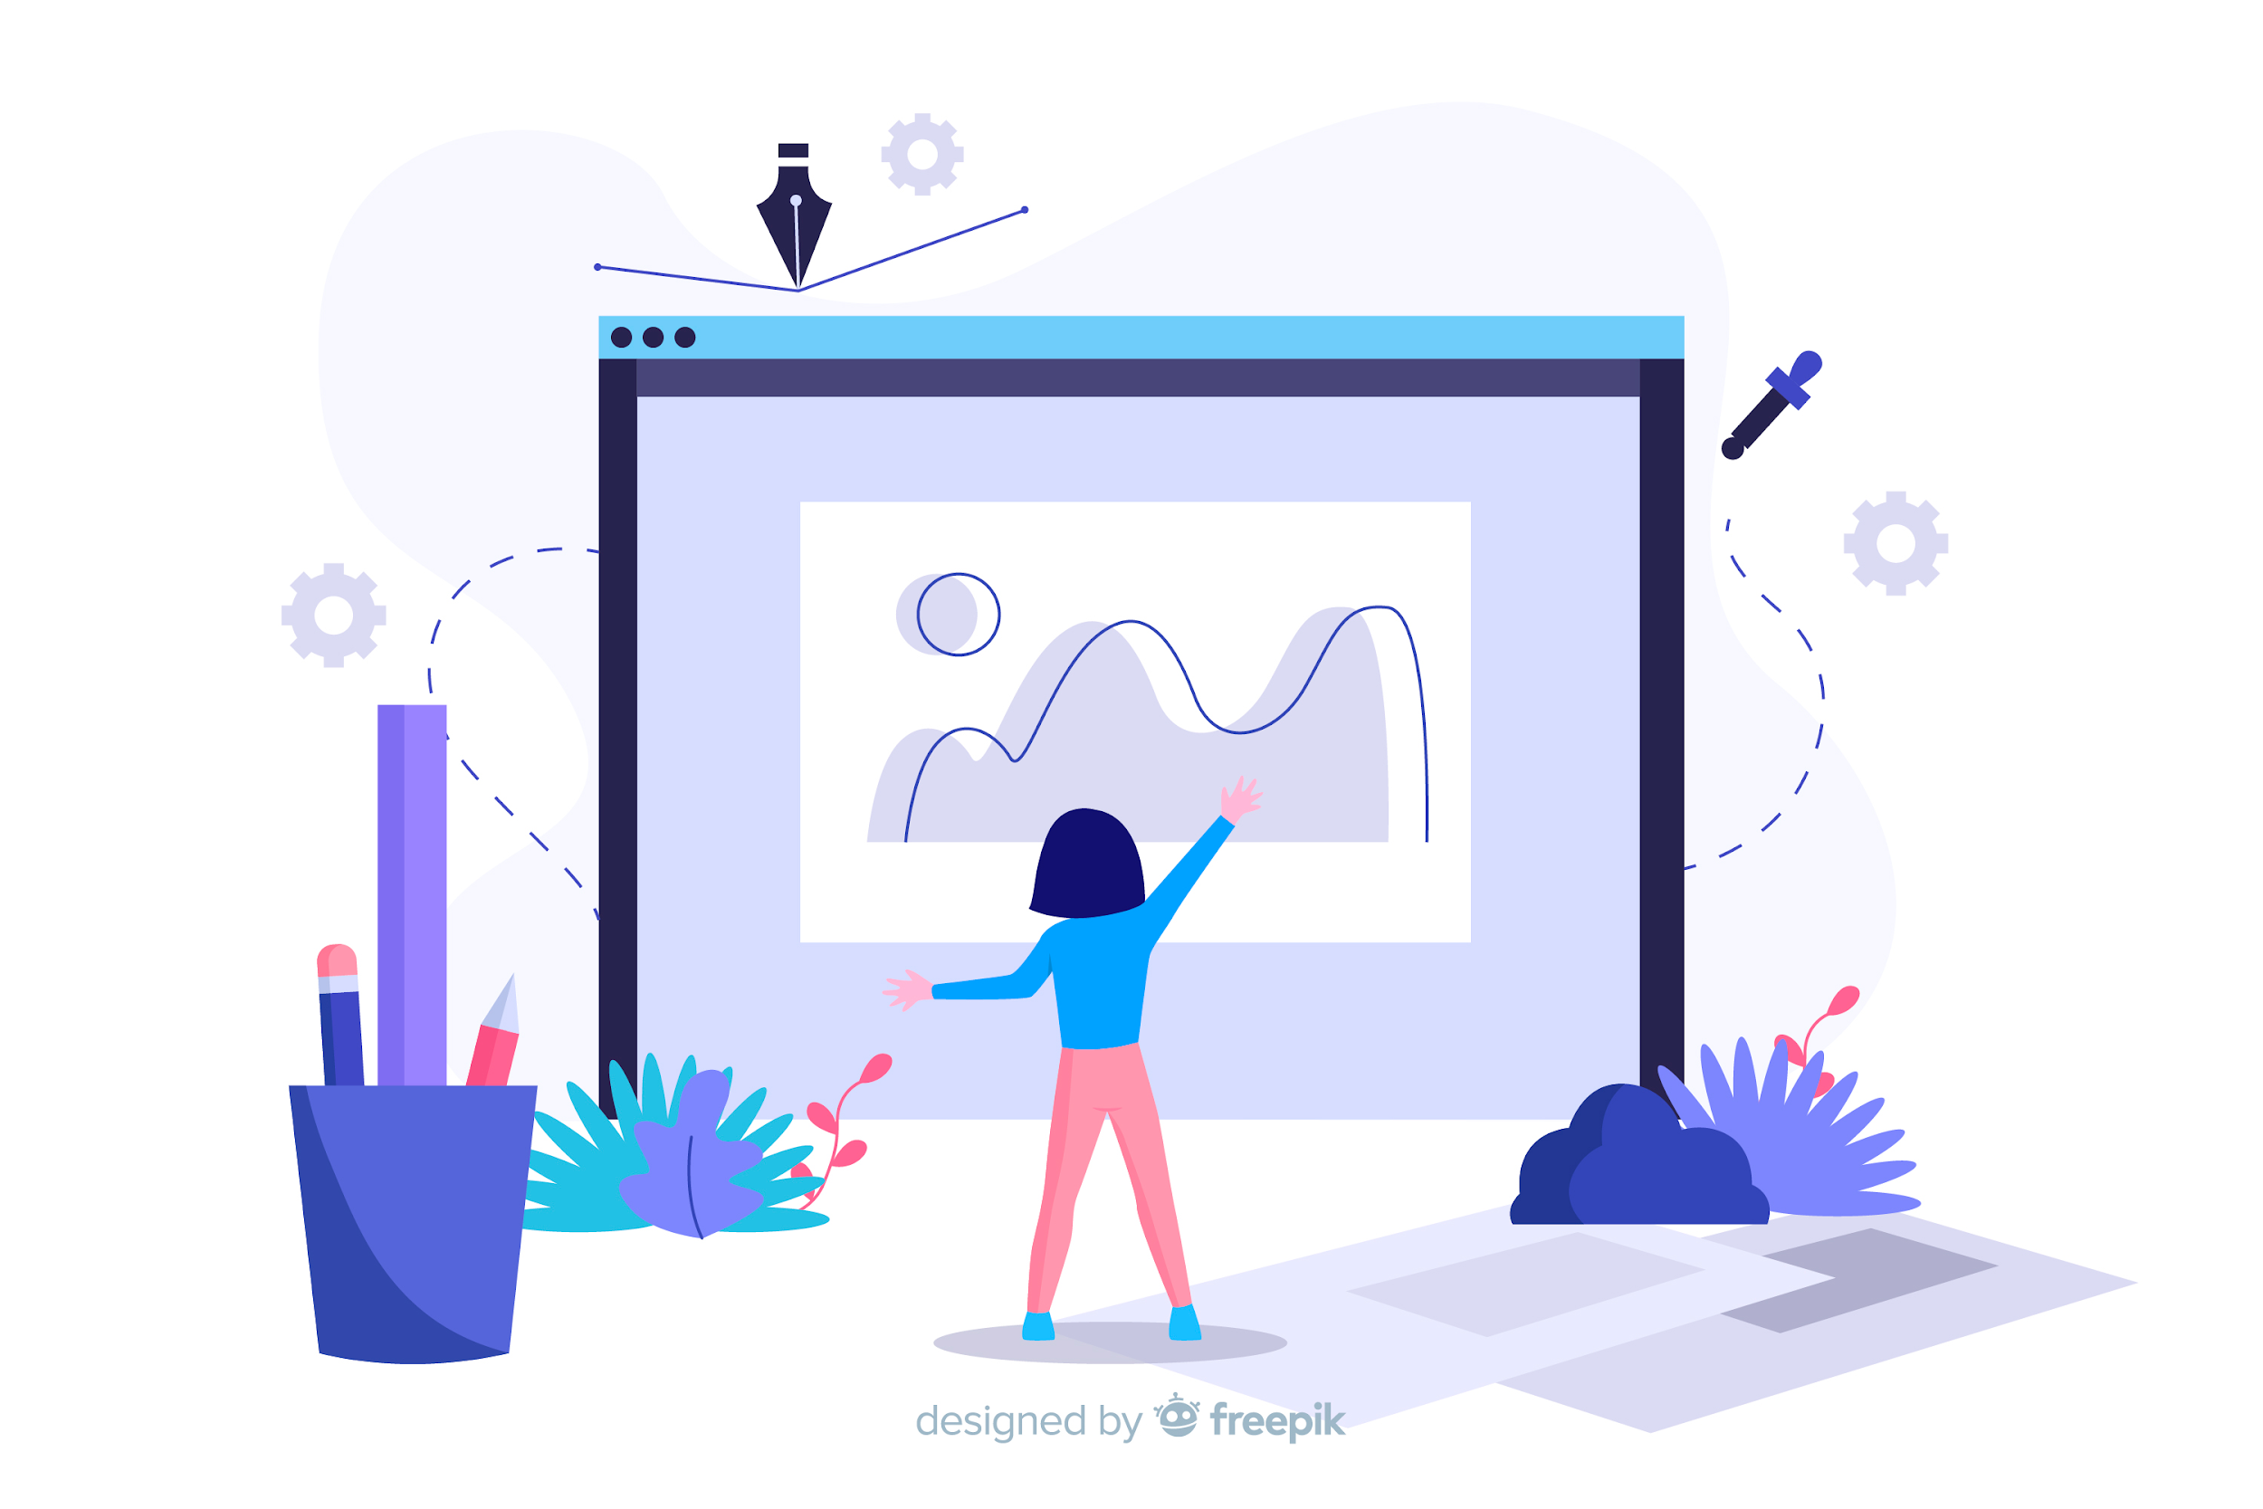

# 

# **1.** Know your Audience

The most important step is to be fully acquainted w/ your Audience. Users are more than numbers. They’re people who are looking for the perfect solution to their needs.

In order to have a successful and engaging website, it should have a simple and clear message that all visitors can understand.

However, if you build a website which is appealing for everyone, you most probably will not be able to reach the desired target market.

Ideally, if you can create buyer personas and know who you’re selling to and what they want, you will have a fireproof way of identifying potential buyers and know that you will be able to cater to your target audience needs if they do decide to go forward with a purchase.

A lot of Marketing and Sales Enablement companies, including RoundUp Sales can help you identify the key attributes you need to define in order to create buyer personas and help you choose the right technology to enable marketing automation actions that revolve around your conceptual framework.

# **2. Use** Content as the center of your Experience

Is your website purpose clear?

The main mission of your website is to host relevant content to your visitors and help them understand the problems that your products and/or services solve.

Your content is the single most important element in increasing customers.

Also if the aforementioned content can be conveyed in a simple and direct way, it will increase the speed with which your audience gets acquainted w/ your message.

Having the content you are able to provide produced in an orderly fashion and organized w/ the help of Content Management System, that allows you to deploy the latter in a Business driven way could help you increase efficiency in reaching your goals and improve overall experience.

In general, audiences like having coherency in the different messages and inputs they receive. Technology and the correct companies can help you guarantee the latter.

# **3.** Go Mobile

* In January 2019, 4.4 billion people were active internet users and 3.5 billion were social media users.
* More than half of all video streaming comes from a mobile device.
* In the US, consumers spent 90% of their mobile time in apps.
* Mobile internet has grown 504% in daily media consumption since 2011.
* 52.2% of all website traffic worldwide was generated through mobile phones in 2018.

In the business world, you have to stay ahead of the competition. So, if more and more users are using their mobile devices to search and make purchases online, you have to cater to that audience by having a mobile-friendly site. In fact, 85 percent of adults believe that a mobile site must be as good, if not better than, a desktop site.

Specialized companies can help you w/ achieving general accessibility.

# **4.** Design every page as a landing page

Currently websites have to forget the rationale where a user enters through the home page and navigates into the site.

The majority of visits for most sites begin on a page that is not the home page. Therefore, you need to design the site in such a way that whatever page a visitor lands on, key information is there.

# **5.** Get Straight to the point

70% of site activity is focused on the process of finding information. Even when users find online content interesting, about 80 percent will only scan a web page for “highlights” and move on. As little as 15% of site visitors actually read the entire contents of a page.

These metrics point out that helping your customer find what they are looking for is extremely important.

Web users typically scan a page first to determine if it’s what they’re after. If it is, they’ll continue reading. If not, they’ll go back to the list of search results. Remember that there are many ways to deliver messages — copy is only one tactic.

Providing content like e-books, guides, infographics, templates , can help you position yourself higher on the thought leadership scale and reach the extra mile.

Many companies and technology providers are already helping their customers align their website deliverables w/ their overall propositioning and marketing tactics.

# 

# **6.** Follow design and usability standards

Studies show that 75% of consumers judge the credibility of a business’ website based on the quality of it’s design.

A well-crafted web design helps your company website convert more visitors into customers.

There is a well known effect known as the aesthetic-usability effect. If people see a complicated and cluttered interface they may assume it is not very usable or is hard to learn.

On the other hand, if people see an attractive and simple-looking interface, they may start figuring out how it works right then and will want to give it a try.

This is applicable to both tangible and intangible products (services).

# **7.** Make evolution a constant priority

Periodic redesign is not enough.   
  
Websites and their maintenance are generally under-resourced and often neglected for long periods of time. They slowly become out-dated with old content, design and technology.

If the website is simply replaced, the investment put into it is lost, too. A better way., is continual investment in your website, allowing it to evolve over time.

Identifying the journey touchpoints that are causing problems for your users creates objectives that need to be solved.

For example, if your users are visiting your website but not converting, you should focus your efforts on improving the experience within the acquisition touchpoint.

There are multiple strategies and tactics to do this. A lot of modern technological solutions also come as a great way to aid teams in ordering the way they host and renew their content.

# Thank you for your time

# [Reach out if you want to know more](https://roundupsales.netlify.com/#About%20us)