# **RoundUp Sales**

**FREE E-BOOK**

# Inbound Marketing Checklist

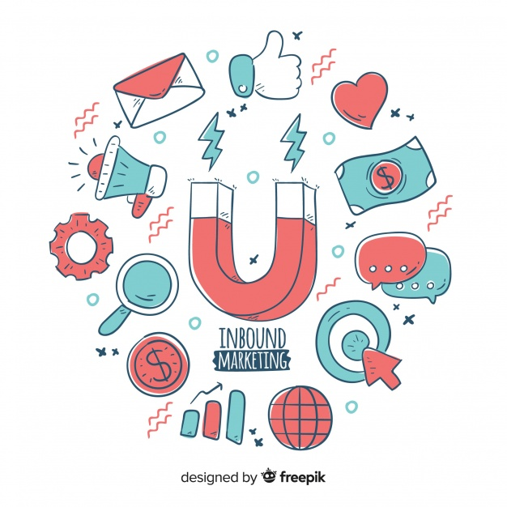

# 

# **1.** Identify your campaign Audience**.**

# **2.** Set your SMART Goals and Benchmark.

# **3.** Create your offers + landing pages.

# **4.** Plan+build your automation nurturing flows.

# **5.** Write a blogpost.

# **6.** Share it on Social Media.

# **7.** Add in Long-Tail Keywords.

# **8.** Consider paid search and other channels.

# **9.** Track your URLs.

# **10.** Report on your Results.

# **1.** Identify your campaign Audience**.**

Understand your buyer personas before launching into a campaign. This way you will guarantee that the way that you promote your content and consider the different possible buyer journeys is in line with what you have to sell.

* Create a customer profile. The people who are most likely to buy your products or services share certain characteristics.
* Conduct market research. You can learn about your target audience through primary and secondary market research.
* Reassess your offerings.

# **2.** Set your SMART Goals and Benchmark.

By making sure the goals you set are aligned with the five SMART criteria (Specific,Measurable, Attainable, Relevant, and Time-Bound), you have an anchor on which to base all of your focus and decision-making. Having SMART Goals can help you be sure that you will have tangible results to measure and to use as a comparison basis at the end of the campaign.

# **3.** Create your offers + landing pages.

Do not forget to optimize your landing pages for SEO. Have a clear value proposition and CTA (Call-to-Action) - usually a form for the user to complete.  
  
**4.** Plan+build your automation nurturing flows.

A campaign doesn’t end when leads convert on your landing page. Plan and build your follow up campaigns to nurture leads down your funnel.

E.g: A sequential email marketing campaign with 6 steps built to share content and information about relevant - buyer persona oriented - helpful information for the decision making process down the buying path.

# **5.** Write a blogpost.

Your blog gives you the opportunity to create relevant content for your customers. Use this as a marketing tactic to drive traffic back to your website. ... Post links - with relevant visuals - of your blog articles to your social sites. Give your social followers a reason to click through to your website.

# **6.** Share it on Social Media.

Social media is a brilliant way of attracting new or returning customers, which is an important part of your inbound marketing strategy. Your content marketing plan should entail paid, owned, and earned social media strategies that will achieve your business goals

Promote your blogpost and offer through social media to drive traffic into the top of your funnel.

# **7.** Add in Long-Tail Keywords.

Long-tail keywords get less search traffic, but will usually have a higher conversion value, as they are more specific. Again it all revolves around having a well-defined audience and coherent content.

It is important to guarantee that your campaign is SEO Friendly guaranteeing that the campaign is found long after you stop actively promoting it.

# **8.** Consider paid search and other channels.

Paid search ads help you generate more qualified leads.

Various channels might be relevant. Just make sure to measure and compare the effectiveness of each one.

# **9.** Track your URLs.

Where is your traffic coming from? And how are your visitors finding you? Tracking URLs might be a good first step.

# 

# 

# **10.** Report on your Results.

Work is more useful when it is measured.How did you perform according to your initial goals? What could have you done better?

# 

# Thank you for your time

# [Reach out if you want to know more](https://roundupsales.netlify.com/#About%20us)