**Project Plan**

**EasyWheelz**

| **Date : 12/02/2023** |
| --- |
| **Version : 0.1** |
| **State : Initial** |
| **Author : Mario Toshev** |

**Version history**

| **Version** | **Date** | **Author(s)** | **Changes** | **State** |
| --- | --- | --- | --- | --- |
| 0 .1 | 12.02.2023 | Mario Toshev | Initial version | Done |
| 0.2 | 7.03.2023 | Mario Toshev | Updated planning, scope and project organization | Done |
|  |  |  |  |  |

**Project assignment**

* **Context**

EasyWheelz is a new company joining the car rental industry offering a wide range of top-quality cars, flexible rental options, and exceptional customer service. However they are currently not using any kind of software for managing their business.

* **Goal of the project**

The goal of this project is to deliver a fast and reliable website.

There the employees will be able to manage the vehicles and bookings and also be able to view a statistic of how the vehicles are performing. The website should also make it easier for the customers to rent a car.

* **Scope and preconditions**

| **Inside scope:** | **Outside scope:** |
| --- | --- |
| Manade bookings | Hosting the website |
| See statistics about each car | Deployment of the website on the internet |
| Manage cars |  |
| Renting a car |  |
| 3 layer web application |  |
| Unit testing |  |
| Applied research document |  |
| Design document |  |
| ProjectPlan |  |

* **Strategy**

This project will be built using the agile methodology. This will make the development very flexible and also help with fulfilling the client's needs. Every sprint will consist of 3 weeks. For project management notion will be used, since it is very customisable, easy to use and free.There the backlog can be found (<https://available-fin-f42.notion.site/04366dd4140547f599a38558e4f1127d?v=84f3c585a6504bbf9048955ccd481f4a>). Only one developer will be working on this project.

* **Research questions and methodology**

How do I choose the right technologies for my project?

* Available backend frameworks:
* Spring Boot
* DropWizard

**For this research the literature study method.**

Spring Boot is a Java-based framework focusing on enterprise applications. It connects all Spring projects and helps to accelerate developers' productivity by offering many production-ready integrations.

Dropwizard pulls together stable, mature libraries from the Java ecosystem into a simple, light-weight package that lets you focus on *getting things done*.Dropwizard has *out-of-the-box* support for sophisticated configuration, application metrics, logging, operational tools, and much more, allowing you and your team to ship a *production-quality* web service in the shortest time possible.

For this project I chose Spring boot. It has an embedded server which makes debugging easier, it also has a lot of automated features that makes developing faster.

* **End products**

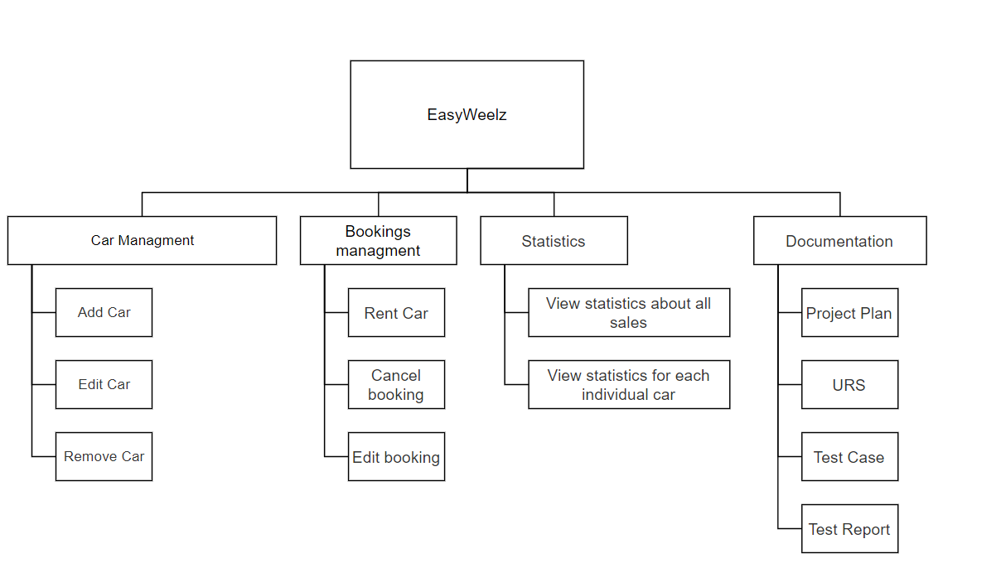

* **Project organization**
* **Stakeholders and team members**

| **Name** | **Abbreviation** | **Role and functions** | **Availability** |
| --- | --- | --- | --- |
| Mario Toshev | M.T. | everything | *Every working day between 9 am. and 16 pm.* |
| [Frank Coenen](https://git.fhict.nl/I874348) | [F.W.J.](https://git.fhict.nl/I874348) | tutoring | *Monday from 13 pm to 16 pm and Friday from 9 am to 12 am.* |
| [Márcio Paixão Dantas](https://git.fhict.nl/I886548) | M.P.D | tutoring | *Wednesday from 9 am to 12 am*  *and Friday from 13 pm to 16 pm.* |

**Activities and time plan**

* **Phases of the project**
* **First Sprint**
* Project Plan
* Initial back end (entities)
* CI configuration
* **Second sprint**
* Project plan update
* Design document
* Research document
* Initial frontend
* Base functionality on backend
* **Time plan and milestones**

A sprint consists of 3 weeks.

| **Phasing** | **Effort** | **Start date** | **Finish date** |
| --- | --- | --- | --- |
| * Sprint 1 |  | 05.02.2023 | 03.03.2023 |
| * Sprint 2 |  | 06.03.2023 | 24.03.2023 |
|  |  |  |  |

**⦁ Testing strategy and configuration management**

**⦁ Testing strategy**

The testing strategy that is going to be used for this project is unit testing, to ensure the proper working of each function.more than unt testing

**⦁ Configuration management**

For every feature a new branch will be made so there are no conflicts with the working version of the project.

Link to the git repo: https://git.fhict.nl/I476237/easywheelz

**⦁ Risk**

**⦁ Risk and mitigation**

One of the members is getting sick. In this project there is only one developer so depending on his condition there may be a delay for delivering the functionaries.

| **Risk** | **Prevention activities** | **Mitigation activities** |
| --- | --- | --- |
| Sickness | - | Work consistently so that the delay won’t affect the outcomes |
| Not enough feedback | Always ask for feedback | Always ask for feedback |
|  |  |  |