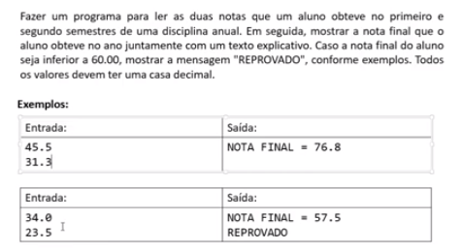

**import** java.util.Locale;

**import** java.util.Scanner;

**public** **class** Exercicio1 {

**public** **static** **void** main(String[] args) {

Locale.*setDefault*(Locale.***US***);

Scanner sc = **new** Scanner(System.***in***);

**double** nota1 = sc.nextDouble();

**double** nota2 = sc.nextDouble();

**double** notaFinal = nota1 + nota2;

System.***out***.printf("NOTA FINAL = %.1f%n", notaFinal);

**if** (notaFinal < 60.0) {

System.***out***.println("REPROVADO");

}

sc.close();

}

}

Resultado

45.5

31.3

NOTA FINAL = 76.8

Resultado

34.0

23.5

NOTA FINAL = 57.5

REPROVADO