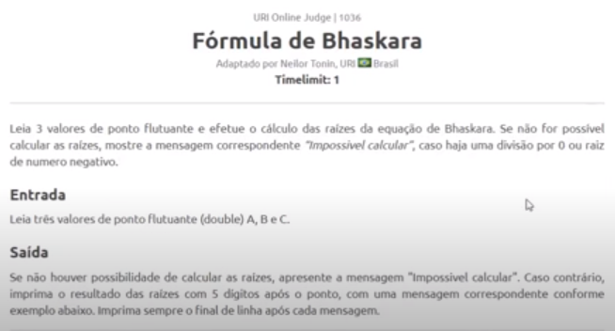

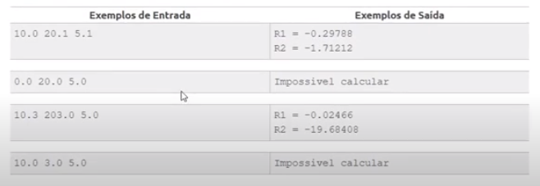

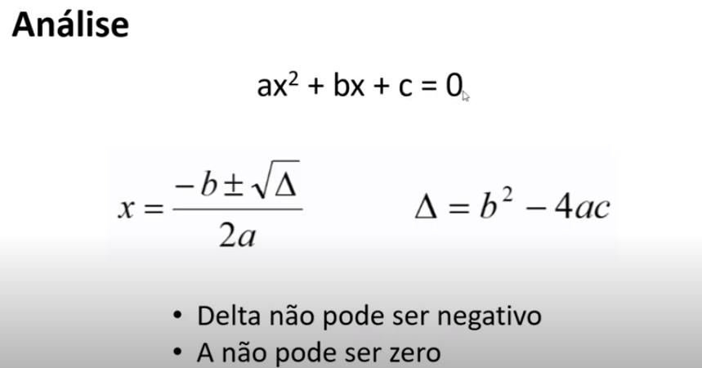

**import** java.util.Locale;

**import** java.util.Scanner;

**public** **class** Exercicio2 {

**public** **static** **void** main(String[] args) {

Locale.*setDefault*(Locale.***US***);

Scanner sc = **new** Scanner(System.***in***);

**double** a = sc.nextDouble();

**double** b = sc.nextDouble();

**double** c = sc.nextDouble();

**double** delta = b * b - 4.0 * a * c;

**if** (a == 0 || delta < 0.0) {

System.***out***.println("Impossivel calcular");

}

**else** {

**double** r1 = (-b + Math.*sqrt*(delta)) / (2.0 * a);

**double** r2 = (-b - Math.*sqrt*(delta)) / (2.0 * a);

System.***out***.printf("R1 = %.5f%n", r1);

System.***out***.printf("R2 = %.5f%n", r2);

}

sc.close();

}

}

Resultado

10.0 20.1 5.1

R1 = -0.29788

R2 = -1.71212

Resultado

0.0 20.0 5.0

Impossivel calcular

Resultado

10.3 203.0 5.0

R1 = -0.02466

R2 = -19.68408

Resultado

10.0 3.0 5.0

Impossivel calcular