Script03_ggplot.R
Marion
2026-09-03
library(tidyverse)
## ── Attaching core tidyverse packages ──────────────────────── tidyverse 2.0.0 ──
## ✔ dplyr 1.2.1 ✔ readr 2.2.0
## ✔ forcats 1.0.1 ✔ stringr 1.6.0
## ✔ ggplot2 4.0.3 ✔ tibble 3.3.1
## ✔ lubridate 1.9.5 ✔ tidyr 1.3.2
## ✔ purrr 1.2.2
## ── Conflicts ────────────────────────────────────────── tidyverse_conflicts() ──
## ✖ dplyr::filter() masks stats::filter()
## ✖ dplyr::lag() masks stats::lag()
## ℹ Use the conflicted package (<http://conflicted.r-lib.org/>) to force all conflicts to become errors
iris %>%
ggplot(
aes(x=Sepal.Length,
y=Sepal.Width)
) +
geom_point()
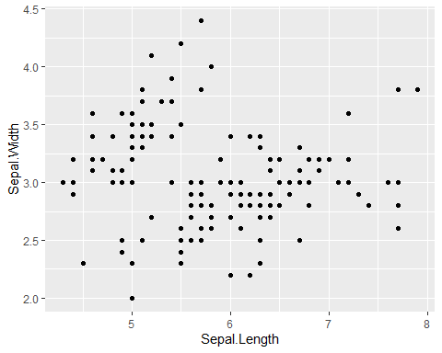
##aec(...,color = columname)
iris %>%
ggplot(
aes(x=Sepal.Length,
y=Sepal.Width,
color=Species)
)+
geom_point()
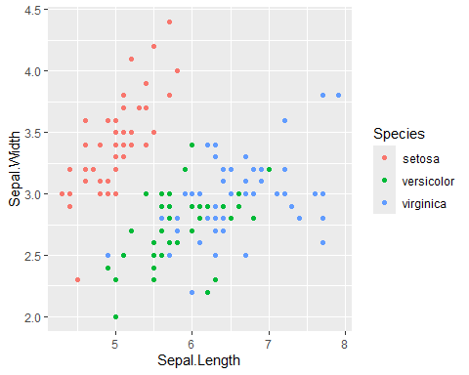
## Any Color You Like
iris %>%
ggplot(
aes(x=Sepal.Length,
y=Sepal.Width
))+
geom_point(color="blue")
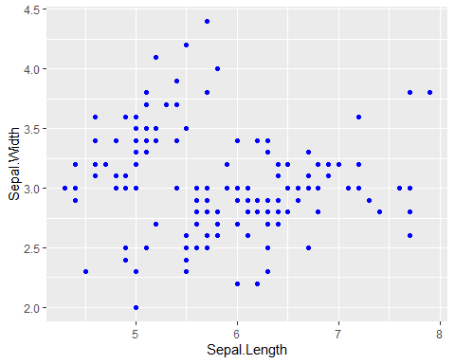
# Line Figure -------------------------------------------------------------
df_x<-tibble(x=1:50,
y= 2*x)
df_x %>%
ggplot(
aes(x=x,
y=y)
) +
geom_line()
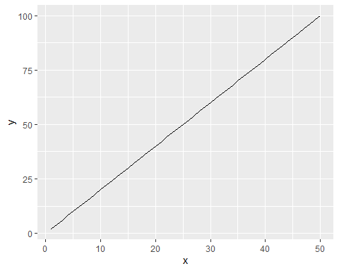
# Histogram ---------------------------------------------------------------
iris %>%
ggplot(
aes(x=Sepal.Length)
) +
geom_histogram()
## `stat_bin()` using `bins = 30`. Pick better value `binwidth`.
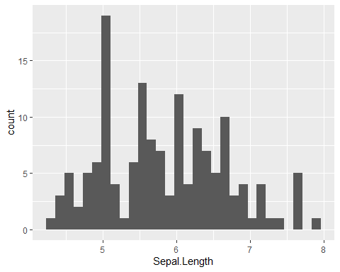
# Boxplot -----------------------------------------------------------------
iris %>%
ggplot(
aes(x=Species,
y=Sepal.Length)
)+
geom_boxplot()
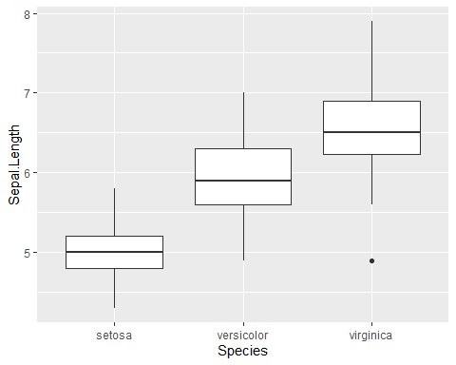
##Change Box-plot Color (border)
iris %>%
ggplot(
aes(x=Species,
y=Sepal.Length,
color=Species)
)+
geom_boxplot()
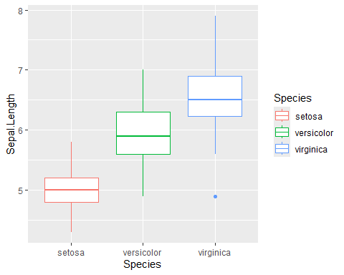
##Change Boxplot Color
iris %>%
ggplot(
aes(x=Species,
y=Sepal.Length,
fill = Species)
)+
geom_boxplot()
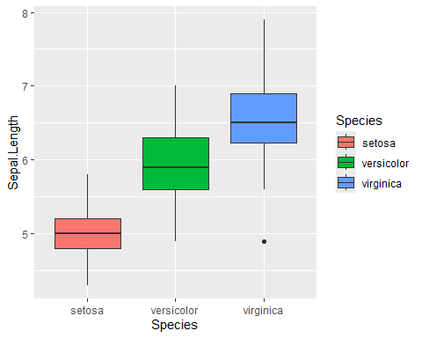
# Exercise ----------------------------------------------------------------
#Q1 Using "iris" data, identify longest Sepla. Length
#using arrange () fuction
arrange(iris, Sepal.Length)
## Sepal.Length Sepal.Width Petal.Length Petal.Width Species
## 1 4.3 3.0 1.1 0.1 setosa
## 2 4.4 2.9 1.4 0.2 setosa
## 3 4.4 3.0 1.3 0.2 setosa
## 4 4.4 3.2 1.3 0.2 setosa
## 5 4.5 2.3 1.3 0.3 setosa
## 6 4.6 3.1 1.5 0.2 setosa
## 7 4.6 3.4 1.4 0.3 setosa
## 8 4.6 3.6 1.0 0.2 setosa
## 9 4.6 3.2 1.4 0.2 setosa
## 10 4.7 3.2 1.3 0.2 setosa
## 11 4.7 3.2 1.6 0.2 setosa
## 12 4.8 3.4 1.6 0.2 setosa
## 13 4.8 3.0 1.4 0.1 setosa
## 14 4.8 3.4 1.9 0.2 setosa
## 15 4.8 3.1 1.6 0.2 setosa
## 16 4.8 3.0 1.4 0.3 setosa
## 17 4.9 3.0 1.4 0.2 setosa
## 18 4.9 3.1 1.5 0.1 setosa
## 19 4.9 3.1 1.5 0.2 setosa
## 20 4.9 3.6 1.4 0.1 setosa
## 21 4.9 2.4 3.3 1.0 versicolor
## 22 4.9 2.5 4.5 1.7 virginica
## 23 5.0 3.6 1.4 0.2 setosa
## 24 5.0 3.4 1.5 0.2 setosa
## 25 5.0 3.0 1.6 0.2 setosa
## 26 5.0 3.4 1.6 0.4 setosa
## 27 5.0 3.2 1.2 0.2 setosa
## 28 5.0 3.5 1.3 0.3 setosa
## 29 5.0 3.5 1.6 0.6 setosa
## 30 5.0 3.3 1.4 0.2 setosa
## 31 5.0 2.0 3.5 1.0 versicolor
## 32 5.0 2.3 3.3 1.0 versicolor
## 33 5.1 3.5 1.4 0.2 setosa
## 34 5.1 3.5 1.4 0.3 setosa
## 35 5.1 3.8 1.5 0.3 setosa
## 36 5.1 3.7 1.5 0.4 setosa
## 37 5.1 3.3 1.7 0.5 setosa
## 38 5.1 3.4 1.5 0.2 setosa
## 39 5.1 3.8 1.9 0.4 setosa
## 40 5.1 3.8 1.6 0.2 setosa
## 41 5.1 2.5 3.0 1.1 versicolor
## 42 5.2 3.5 1.5 0.2 setosa
## 43 5.2 3.4 1.4 0.2 setosa
## 44 5.2 4.1 1.5 0.1 setosa
## 45 5.2 2.7 3.9 1.4 versicolor
## 46 5.3 3.7 1.5 0.2 setosa
## 47 5.4 3.9 1.7 0.4 setosa
## 48 5.4 3.7 1.5 0.2 setosa
## 49 5.4 3.9 1.3 0.4 setosa
## 50 5.4 3.4 1.7 0.2 setosa
## 51 5.4 3.4 1.5 0.4 setosa
## 52 5.4 3.0 4.5 1.5 versicolor
## 53 5.5 4.2 1.4 0.2 setosa
## 54 5.5 3.5 1.3 0.2 setosa
## 55 5.5 2.3 4.0 1.3 versicolor
## 56 5.5 2.4 3.8 1.1 versicolor
## 57 5.5 2.4 3.7 1.0 versicolor
## 58 5.5 2.5 4.0 1.3 versicolor
## 59 5.5 2.6 4.4 1.2 versicolor
## 60 5.6 2.9 3.6 1.3 versicolor
## 61 5.6 3.0 4.5 1.5 versicolor
## 62 5.6 2.5 3.9 1.1 versicolor
## 63 5.6 3.0 4.1 1.3 versicolor
## 64 5.6 2.7 4.2 1.3 versicolor
## 65 5.6 2.8 4.9 2.0 virginica
## 66 5.7 4.4 1.5 0.4 setosa
## 67 5.7 3.8 1.7 0.3 setosa
## 68 5.7 2.8 4.5 1.3 versicolor
## 69 5.7 2.6 3.5 1.0 versicolor
## 70 5.7 3.0 4.2 1.2 versicolor
## 71 5.7 2.9 4.2 1.3 versicolor
## 72 5.7 2.8 4.1 1.3 versicolor
## 73 5.7 2.5 5.0 2.0 virginica
## 74 5.8 4.0 1.2 0.2 setosa
## 75 5.8 2.7 4.1 1.0 versicolor
## 76 5.8 2.7 3.9 1.2 versicolor
## 77 5.8 2.6 4.0 1.2 versicolor
## 78 5.8 2.7 5.1 1.9 virginica
## 79 5.8 2.8 5.1 2.4 virginica
## 80 5.8 2.7 5.1 1.9 virginica
## 81 5.9 3.0 4.2 1.5 versicolor
## 82 5.9 3.2 4.8 1.8 versicolor
## 83 5.9 3.0 5.1 1.8 virginica
## 84 6.0 2.2 4.0 1.0 versicolor
## 85 6.0 2.9 4.5 1.5 versicolor
## 86 6.0 2.7 5.1 1.6 versicolor
## 87 6.0 3.4 4.5 1.6 versicolor
## 88 6.0 2.2 5.0 1.5 virginica
## 89 6.0 3.0 4.8 1.8 virginica
## 90 6.1 2.9 4.7 1.4 versicolor
## 91 6.1 2.8 4.0 1.3 versicolor
## 92 6.1 2.8 4.7 1.2 versicolor
## 93 6.1 3.0 4.6 1.4 versicolor
## 94 6.1 3.0 4.9 1.8 virginica
## 95 6.1 2.6 5.6 1.4 virginica
## 96 6.2 2.2 4.5 1.5 versicolor
## 97 6.2 2.9 4.3 1.3 versicolor
## 98 6.2 2.8 4.8 1.8 virginica
## 99 6.2 3.4 5.4 2.3 virginica
## 100 6.3 3.3 4.7 1.6 versicolor
## 101 6.3 2.5 4.9 1.5 versicolor
## 102 6.3 2.3 4.4 1.3 versicolor
## 103 6.3 3.3 6.0 2.5 virginica
## 104 6.3 2.9 5.6 1.8 virginica
## 105 6.3 2.7 4.9 1.8 virginica
## 106 6.3 2.8 5.1 1.5 virginica
## 107 6.3 3.4 5.6 2.4 virginica
## 108 6.3 2.5 5.0 1.9 virginica
## 109 6.4 3.2 4.5 1.5 versicolor
## 110 6.4 2.9 4.3 1.3 versicolor
## 111 6.4 2.7 5.3 1.9 virginica
## 112 6.4 3.2 5.3 2.3 virginica
## 113 6.4 2.8 5.6 2.1 virginica
## 114 6.4 2.8 5.6 2.2 virginica
## 115 6.4 3.1 5.5 1.8 virginica
## 116 6.5 2.8 4.6 1.5 versicolor
## 117 6.5 3.0 5.8 2.2 virginica
## 118 6.5 3.2 5.1 2.0 virginica
## 119 6.5 3.0 5.5 1.8 virginica
## 120 6.5 3.0 5.2 2.0 virginica
## 121 6.6 2.9 4.6 1.3 versicolor
## 122 6.6 3.0 4.4 1.4 versicolor
## 123 6.7 3.1 4.4 1.4 versicolor
## 124 6.7 3.0 5.0 1.7 versicolor
## 125 6.7 3.1 4.7 1.5 versicolor
## 126 6.7 2.5 5.8 1.8 virginica
## 127 6.7 3.3 5.7 2.1 virginica
## 128 6.7 3.1 5.6 2.4 virginica
## 129 6.7 3.3 5.7 2.5 virginica
## 130 6.7 3.0 5.2 2.3 virginica
## 131 6.8 2.8 4.8 1.4 versicolor
## 132 6.8 3.0 5.5 2.1 virginica
## 133 6.8 3.2 5.9 2.3 virginica
## 134 6.9 3.1 4.9 1.5 versicolor
## 135 6.9 3.2 5.7 2.3 virginica
## 136 6.9 3.1 5.4 2.1 virginica
## 137 6.9 3.1 5.1 2.3 virginica
## 138 7.0 3.2 4.7 1.4 versicolor
## 139 7.1 3.0 5.9 2.1 virginica
## 140 7.2 3.6 6.1 2.5 virginica
## 141 7.2 3.2 6.0 1.8 virginica
## 142 7.2 3.0 5.8 1.6 virginica
## 143 7.3 2.9 6.3 1.8 virginica
## 144 7.4 2.8 6.1 1.9 virginica
## 145 7.6 3.0 6.6 2.1 virginica
## 146 7.7 3.8 6.7 2.2 virginica
## 147 7.7 2.6 6.9 2.3 virginica
## 148 7.7 2.8 6.7 2.0 virginica
## 149 7.7 3.0 6.1 2.3 virginica
## 150 7.9 3.8 6.4 2.0 virginica
iris %>%
arrange(desc(Sepal.Length))
## Sepal.Length Sepal.Width Petal.Length Petal.Width Species
## 1 7.9 3.8 6.4 2.0 virginica
## 2 7.7 3.8 6.7 2.2 virginica
## 3 7.7 2.6 6.9 2.3 virginica
## 4 7.7 2.8 6.7 2.0 virginica
## 5 7.7 3.0 6.1 2.3 virginica
## 6 7.6 3.0 6.6 2.1 virginica
## 7 7.4 2.8 6.1 1.9 virginica
## 8 7.3 2.9 6.3 1.8 virginica
## 9 7.2 3.6 6.1 2.5 virginica
## 10 7.2 3.2 6.0 1.8 virginica
## 11 7.2 3.0 5.8 1.6 virginica
## 12 7.1 3.0 5.9 2.1 virginica
## 13 7.0 3.2 4.7 1.4 versicolor
## 14 6.9 3.1 4.9 1.5 versicolor
## 15 6.9 3.2 5.7 2.3 virginica
## 16 6.9 3.1 5.4 2.1 virginica
## 17 6.9 3.1 5.1 2.3 virginica
## 18 6.8 2.8 4.8 1.4 versicolor
## 19 6.8 3.0 5.5 2.1 virginica
## 20 6.8 3.2 5.9 2.3 virginica
## 21 6.7 3.1 4.4 1.4 versicolor
## 22 6.7 3.0 5.0 1.7 versicolor
## 23 6.7 3.1 4.7 1.5 versicolor
## 24 6.7 2.5 5.8 1.8 virginica
## 25 6.7 3.3 5.7 2.1 virginica
## 26 6.7 3.1 5.6 2.4 virginica
## 27 6.7 3.3 5.7 2.5 virginica
## 28 6.7 3.0 5.2 2.3 virginica
## 29 6.6 2.9 4.6 1.3 versicolor
## 30 6.6 3.0 4.4 1.4 versicolor
## 31 6.5 2.8 4.6 1.5 versicolor
## 32 6.5 3.0 5.8 2.2 virginica
## 33 6.5 3.2 5.1 2.0 virginica
## 34 6.5 3.0 5.5 1.8 virginica
## 35 6.5 3.0 5.2 2.0 virginica
## 36 6.4 3.2 4.5 1.5 versicolor
## 37 6.4 2.9 4.3 1.3 versicolor
## 38 6.4 2.7 5.3 1.9 virginica
## 39 6.4 3.2 5.3 2.3 virginica
## 40 6.4 2.8 5.6 2.1 virginica
## 41 6.4 2.8 5.6 2.2 virginica
## 42 6.4 3.1 5.5 1.8 virginica
## 43 6.3 3.3 4.7 1.6 versicolor
## 44 6.3 2.5 4.9 1.5 versicolor
## 45 6.3 2.3 4.4 1.3 versicolor
## 46 6.3 3.3 6.0 2.5 virginica
## 47 6.3 2.9 5.6 1.8 virginica
## 48 6.3 2.7 4.9 1.8 virginica
## 49 6.3 2.8 5.1 1.5 virginica
## 50 6.3 3.4 5.6 2.4 virginica
## 51 6.3 2.5 5.0 1.9 virginica
## 52 6.2 2.2 4.5 1.5 versicolor
## 53 6.2 2.9 4.3 1.3 versicolor
## 54 6.2 2.8 4.8 1.8 virginica
## 55 6.2 3.4 5.4 2.3 virginica
## 56 6.1 2.9 4.7 1.4 versicolor
## 57 6.1 2.8 4.0 1.3 versicolor
## 58 6.1 2.8 4.7 1.2 versicolor
## 59 6.1 3.0 4.6 1.4 versicolor
## 60 6.1 3.0 4.9 1.8 virginica
## 61 6.1 2.6 5.6 1.4 virginica
## 62 6.0 2.2 4.0 1.0 versicolor
## 63 6.0 2.9 4.5 1.5 versicolor
## 64 6.0 2.7 5.1 1.6 versicolor
## 65 6.0 3.4 4.5 1.6 versicolor
## 66 6.0 2.2 5.0 1.5 virginica
## 67 6.0 3.0 4.8 1.8 virginica
## 68 5.9 3.0 4.2 1.5 versicolor
## 69 5.9 3.2 4.8 1.8 versicolor
## 70 5.9 3.0 5.1 1.8 virginica
## 71 5.8 4.0 1.2 0.2 setosa
## 72 5.8 2.7 4.1 1.0 versicolor
## 73 5.8 2.7 3.9 1.2 versicolor
## 74 5.8 2.6 4.0 1.2 versicolor
## 75 5.8 2.7 5.1 1.9 virginica
## 76 5.8 2.8 5.1 2.4 virginica
## 77 5.8 2.7 5.1 1.9 virginica
## 78 5.7 4.4 1.5 0.4 setosa
## 79 5.7 3.8 1.7 0.3 setosa
## 80 5.7 2.8 4.5 1.3 versicolor
## 81 5.7 2.6 3.5 1.0 versicolor
## 82 5.7 3.0 4.2 1.2 versicolor
## 83 5.7 2.9 4.2 1.3 versicolor
## 84 5.7 2.8 4.1 1.3 versicolor
## 85 5.7 2.5 5.0 2.0 virginica
## 86 5.6 2.9 3.6 1.3 versicolor
## 87 5.6 3.0 4.5 1.5 versicolor
## 88 5.6 2.5 3.9 1.1 versicolor
## 89 5.6 3.0 4.1 1.3 versicolor
## 90 5.6 2.7 4.2 1.3 versicolor
## 91 5.6 2.8 4.9 2.0 virginica
## 92 5.5 4.2 1.4 0.2 setosa
## 93 5.5 3.5 1.3 0.2 setosa
## 94 5.5 2.3 4.0 1.3 versicolor
## 95 5.5 2.4 3.8 1.1 versicolor
## 96 5.5 2.4 3.7 1.0 versicolor
## 97 5.5 2.5 4.0 1.3 versicolor
## 98 5.5 2.6 4.4 1.2 versicolor
## 99 5.4 3.9 1.7 0.4 setosa
## 100 5.4 3.7 1.5 0.2 setosa
## 101 5.4 3.9 1.3 0.4 setosa
## 102 5.4 3.4 1.7 0.2 setosa
## 103 5.4 3.4 1.5 0.4 setosa
## 104 5.4 3.0 4.5 1.5 versicolor
## 105 5.3 3.7 1.5 0.2 setosa
## 106 5.2 3.5 1.5 0.2 setosa
## 107 5.2 3.4 1.4 0.2 setosa
## 108 5.2 4.1 1.5 0.1 setosa
## 109 5.2 2.7 3.9 1.4 versicolor
## 110 5.1 3.5 1.4 0.2 setosa
## 111 5.1 3.5 1.4 0.3 setosa
## 112 5.1 3.8 1.5 0.3 setosa
## 113 5.1 3.7 1.5 0.4 setosa
## 114 5.1 3.3 1.7 0.5 setosa
## 115 5.1 3.4 1.5 0.2 setosa
## 116 5.1 3.8 1.9 0.4 setosa
## 117 5.1 3.8 1.6 0.2 setosa
## 118 5.1 2.5 3.0 1.1 versicolor
## 119 5.0 3.6 1.4 0.2 setosa
## 120 5.0 3.4 1.5 0.2 setosa
## 121 5.0 3.0 1.6 0.2 setosa
## 122 5.0 3.4 1.6 0.4 setosa
## 123 5.0 3.2 1.2 0.2 setosa
## 124 5.0 3.5 1.3 0.3 setosa
## 125 5.0 3.5 1.6 0.6 setosa
## 126 5.0 3.3 1.4 0.2 setosa
## 127 5.0 2.0 3.5 1.0 versicolor
## 128 5.0 2.3 3.3 1.0 versicolor
## 129 4.9 3.0 1.4 0.2 setosa
## 130 4.9 3.1 1.5 0.1 setosa
## 131 4.9 3.1 1.5 0.2 setosa
## 132 4.9 3.6 1.4 0.1 setosa
## 133 4.9 2.4 3.3 1.0 versicolor
## 134 4.9 2.5 4.5 1.7 virginica
## 135 4.8 3.4 1.6 0.2 setosa
## 136 4.8 3.0 1.4 0.1 setosa
## 137 4.8 3.4 1.9 0.2 setosa
## 138 4.8 3.1 1.6 0.2 setosa
## 139 4.8 3.0 1.4 0.3 setosa
## 140 4.7 3.2 1.3 0.2 setosa
## 141 4.7 3.2 1.6 0.2 setosa
## 142 4.6 3.1 1.5 0.2 setosa
## 143 4.6 3.4 1.4 0.3 setosa
## 144 4.6 3.6 1.0 0.2 setosa
## 145 4.6 3.2 1.4 0.2 setosa
## 146 4.5 2.3 1.3 0.3 setosa
## 147 4.4 2.9 1.4 0.2 setosa
## 148 4.4 3.0 1.3 0.2 setosa
## 149 4.4 3.2 1.3 0.2 setosa
## 150 4.3 3.0 1.1 0.1 setosa
#Q2 using "iris" data, filter individual
# Sepal.Width greater than 3.0, use "filter()"
iris %>%
filter(Sepal.Width>3.0)
## Sepal.Length Sepal.Width Petal.Length Petal.Width Species
## 1 5.1 3.5 1.4 0.2 setosa
## 2 4.7 3.2 1.3 0.2 setosa
## 3 4.6 3.1 1.5 0.2 setosa
## 4 5.0 3.6 1.4 0.2 setosa
## 5 5.4 3.9 1.7 0.4 setosa
## 6 4.6 3.4 1.4 0.3 setosa
## 7 5.0 3.4 1.5 0.2 setosa
## 8 4.9 3.1 1.5 0.1 setosa
## 9 5.4 3.7 1.5 0.2 setosa
## 10 4.8 3.4 1.6 0.2 setosa
## 11 5.8 4.0 1.2 0.2 setosa
## 12 5.7 4.4 1.5 0.4 setosa
## 13 5.4 3.9 1.3 0.4 setosa
## 14 5.1 3.5 1.4 0.3 setosa
## 15 5.7 3.8 1.7 0.3 setosa
## 16 5.1 3.8 1.5 0.3 setosa
## 17 5.4 3.4 1.7 0.2 setosa
## 18 5.1 3.7 1.5 0.4 setosa
## 19 4.6 3.6 1.0 0.2 setosa
## 20 5.1 3.3 1.7 0.5 setosa
## 21 4.8 3.4 1.9 0.2 setosa
## 22 5.0 3.4 1.6 0.4 setosa
## 23 5.2 3.5 1.5 0.2 setosa
## 24 5.2 3.4 1.4 0.2 setosa
## 25 4.7 3.2 1.6 0.2 setosa
## 26 4.8 3.1 1.6 0.2 setosa
## 27 5.4 3.4 1.5 0.4 setosa
## 28 5.2 4.1 1.5 0.1 setosa
## 29 5.5 4.2 1.4 0.2 setosa
## 30 4.9 3.1 1.5 0.2 setosa
## 31 5.0 3.2 1.2 0.2 setosa
## 32 5.5 3.5 1.3 0.2 setosa
## 33 4.9 3.6 1.4 0.1 setosa
## 34 5.1 3.4 1.5 0.2 setosa
## 35 5.0 3.5 1.3 0.3 setosa
## 36 4.4 3.2 1.3 0.2 setosa
## 37 5.0 3.5 1.6 0.6 setosa
## 38 5.1 3.8 1.9 0.4 setosa
## 39 5.1 3.8 1.6 0.2 setosa
## 40 4.6 3.2 1.4 0.2 setosa
## 41 5.3 3.7 1.5 0.2 setosa
## 42 5.0 3.3 1.4 0.2 setosa
## 43 7.0 3.2 4.7 1.4 versicolor
## 44 6.4 3.2 4.5 1.5 versicolor
## 45 6.9 3.1 4.9 1.5 versicolor
## 46 6.3 3.3 4.7 1.6 versicolor
## 47 6.7 3.1 4.4 1.4 versicolor
## 48 5.9 3.2 4.8 1.8 versicolor
## 49 6.0 3.4 4.5 1.6 versicolor
## 50 6.7 3.1 4.7 1.5 versicolor
## 51 6.3 3.3 6.0 2.5 virginica
## 52 7.2 3.6 6.1 2.5 virginica
## 53 6.5 3.2 5.1 2.0 virginica
## 54 6.4 3.2 5.3 2.3 virginica
## 55 7.7 3.8 6.7 2.2 virginica
## 56 6.9 3.2 5.7 2.3 virginica
## 57 6.7 3.3 5.7 2.1 virginica
## 58 7.2 3.2 6.0 1.8 virginica
## 59 7.9 3.8 6.4 2.0 virginica
## 60 6.3 3.4 5.6 2.4 virginica
## 61 6.4 3.1 5.5 1.8 virginica
## 62 6.9 3.1 5.4 2.1 virginica
## 63 6.7 3.1 5.6 2.4 virginica
## 64 6.9 3.1 5.1 2.3 virginica
## 65 6.8 3.2 5.9 2.3 virginica
## 66 6.7 3.3 5.7 2.5 virginica
## 67 6.2 3.4 5.4 2.3 virginica
#Q3# Using "iris" data, select the colums "Petal. Length"
# and "Petal.Length", then arrange the order of
# rows by "Petal.Length(desc.)
# Assign result to object "df_petal"
df_petal<-iris %>%
select(Petal.Length, Petal.Width) %>%
arrange(desc(Petal.Length))
#Q4# Calculate mean Sepal.Length by Species;
#assign the result to "df_mean"
df_mean <- iris %>%
group_by(Species) %>%
summarize(mean=mean(Sepal.Length))
#Q5# Create a point figure of Petal.Width (y-axis) and
# Sepal.Width (x-axis), with colors distiguishing species
iris %>%
ggplot(aes(x=Sepal.Width,
y=Sepal.Length,
color=Species))+
geom_point()
