KELVIN MWANIKI 22/06006

ASSIGNMENT 1
Practical Exercise: Bitcoin Block Explorer Analysis

Objective: Analyze real-world Bitcoin blockchain data using explorers while demonstrating independent critical thinking
Block Explorer Used: Blockstream.info, data retrieved on October 10, 2025, 17:00
- Block Header Analysis (3 Marks)
- Block Height (0.5 marks)
918454
- Block Hash (0.5 marks)
000000000000000000014066dd091d78e3dbddc5495a8bec54f6028c724d32c9
- Merkle Root (0.5 marks)
9d05d2a29a8d44482d2d281f53783ec7bdefd545a67fa06b43f89003091af0b7
- Timestamp (0.5 marks)
2025-10-10 17:26:29 GMT +3
- Number of Transactions (0.5 marks)
4157
- Difficulty Target (0.5 marks)
150839487445890.5
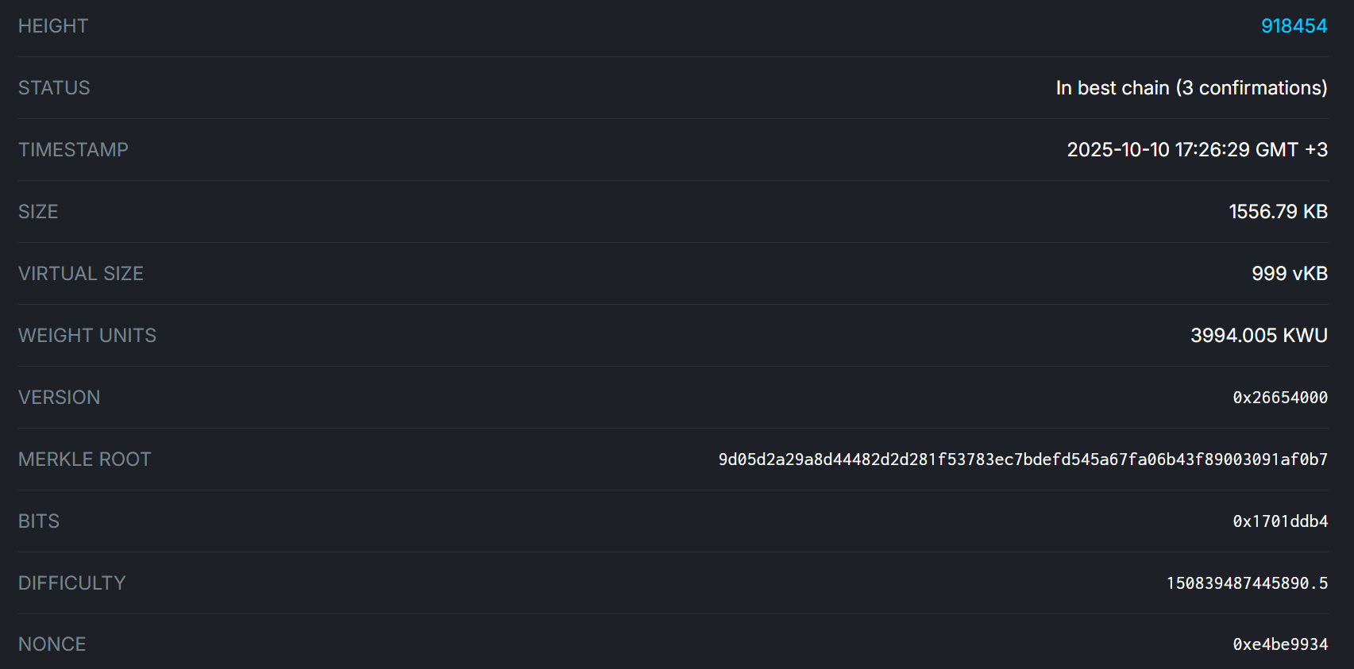

- Transaction Investigation (4 Marks)
- • Pick any transaction from the latest block and provide:
- Transaction ID (TXID) (0.5 marks)
05d3220540d7ab87077bf0043c577c3dad9dcd1d8398f6e9cf259636a3c96efc
- Total Input Value (in BTC) (0.5 marks)
27,952.79 BTC
- Total Output Value (in BTC) (0.5 marks)
27,955.92 BTC
- Transaction Fee (in BTC & USD) (1 mark)
27,952.79 BTC-27,955.92 BTC=-3.13 BTC
- Number of Confirmations (0.5 marks
18
- List one input address and one output address (1 mark)
input address =1CYMcajot9sABWmFuJMSRQRqHQNTY4wLzn
output address = bc1qd7nwstpss3f264hhaw29np7zc07uevhcv6fuju

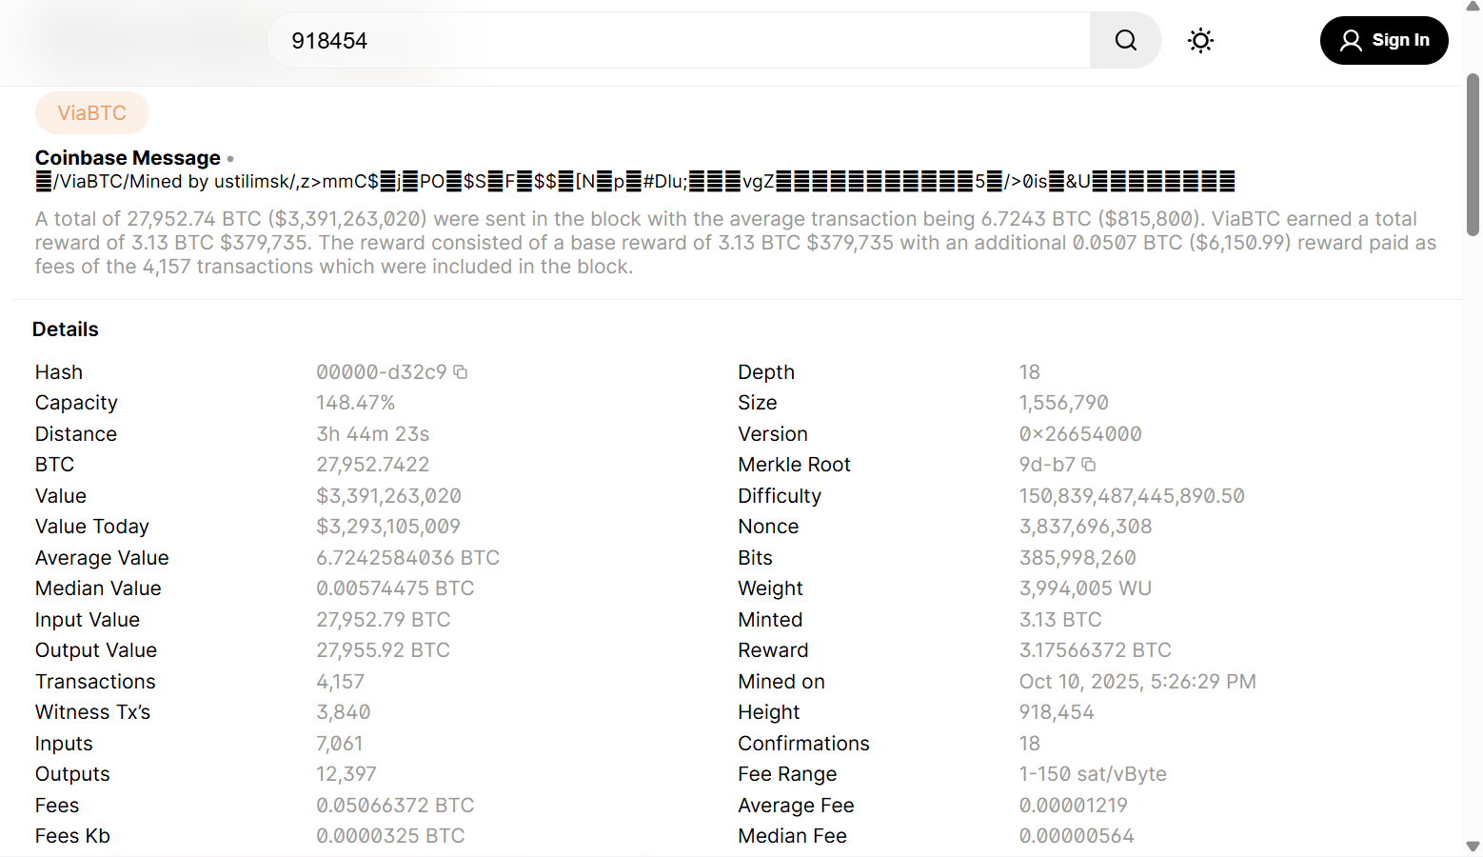

- Mempool & Fee Analysis (3 Marks)
- • Go to the mempool (unconfirmed transactions) section:
- What is the current average transaction fee (in sat/vByte)? (1 mark)
0.10 sat/vB
- How many unconfirmed transactions are pending? (1 mark)
75,151 TXs
- Explain why some transactions have higher fees than others. (1 mark) (Answer in 2-3 sentences)
Transactions have higher fees to incentivize miners to include them in the next block, as miners prioritize based on fee rate (sat/vByte) to maximize revenue within the block size limit. During high network congestion, users pay more for faster confirmation. Lower-fee transactions may wait longer or risk being dropped from the mempool.
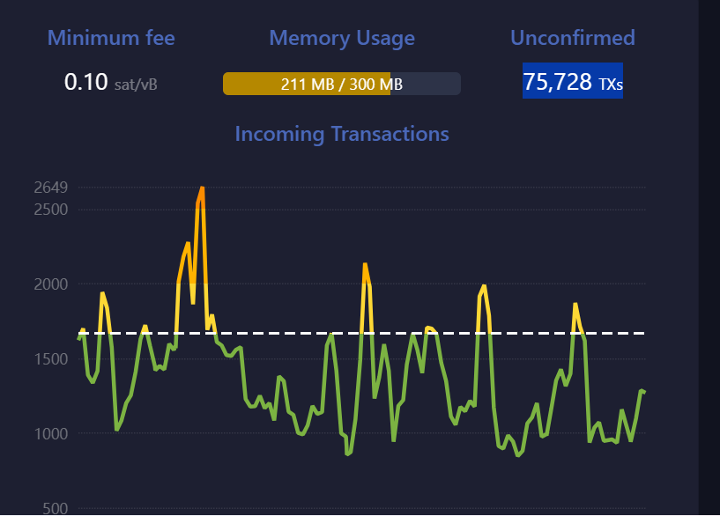

- Smart Contract Analogy (2 Marks)
• Bitcoin does not support smart contracts like Ethereum, but it has basic scripting.
- Find a Pay-to-Script-Hash (P2SH) transaction in any block.
000000000000000000014066dd091d78e3dbddc5495a8bec54f6028c724d32c9
- Provide its TXID (1 mark)
3303fd1c7deb53caaedc9ef40087c270603cfaac04d65da9c04c0fc55e7fd7e8
- Explain how P2SH differs from a standard P2PKH transaction (1 mark)
P2PKH (Pay-to-Public-Key-Hash) locks funds directly to a public key hash, requiring only a signature and public key to spend, making it simple for single-owner addresses. P2SH (Pay-to-Script-Hash) locks funds to the hash of a redeem script (which can be complex, like multi-sig or time-locks), allowing the recipient to reveal the full script only when spending, enhancing privacy and flexibility for advanced conditions without bloating the UTXO set.
- Critical Thinking (3 Marks)
- Suppose a block has only 1 transaction (the coinbase transaction).
- Why might this happen? (1 mark)
This could happen if the mempool is empty due to extremely low network activity, or if miners choose to mine an "empty" block to claim the block reward without including fee-paying transactions, perhaps to test the network or in early blockchain days with few users.
- How does this affect miner profitability? (1 mark
Profitability decreases because the miner forgoes transaction fees, relying solely on the block subsidy (currently 3.125 BTC). In high-fee environments, this could mean missing out on thousands in extra revenue, but in low-activity periods, it's negligible.
- Would this scenario be common? Justify. (1 mark)
This scenario is uncommon in practice because the Bitcoin network usually has many pending transactions, but it can occur during periods of low activity

