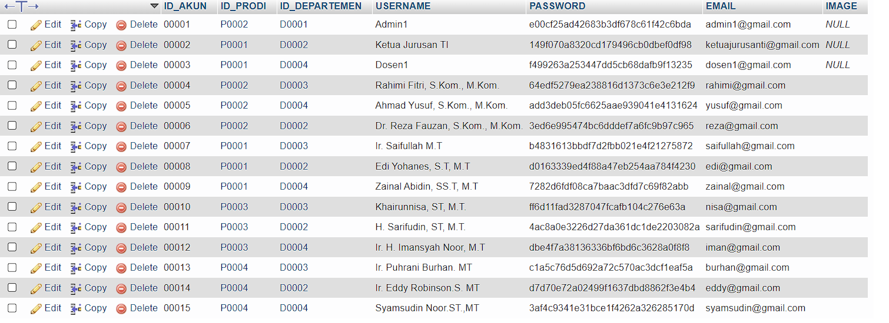

TI dan SIKC

Kaprodi = rahimi@gmail.com rahimi123 (2)

Dosen = yusuf@gmail.com yusuf123

Kajur = reza@gmail.com reza123

LISTRIK

Kaprodi = saifullah@gmail.com saifullah123

Kajur = edi@gmail.com edi123

Dosen = zainal@gmail.com zainal123

Elektro

Kaprodi = nisa@gmail.com nisa123

Kajur = sarifudin@gmail.com sarifudin123

Dosen = iman@gmail.com iman123

RPL

Kaprodi = burhan@gmail.com burhan123

Kajur = eddy@gmail.com eddy123

Dosen = syamsudin@gmail.com udin123

PAB

Kaprodi =

Kajur =

Dosen =

