

Marios Anastasopoulos

Optimization of satellite operations scheduling using an AI-based tool

School of Aerospace, Transport and Manufacturing

MSc in Astronautics and Space Engineering

MSc

Academic Year: 2022 - 2023

Supervisor: Dr. Nicola Garzaniti

September 2023



School of Aerospace, Transport and Manufacturing

MSc in Astronautics and Space Engineering

MSc

Academic Year 2022 - 2023

Marios Anastasopoulos

Optimization of satellite operations scheduling using an AI-based tool

Supervisor:  Dr. Nicola Garzaniti

September 2023

This thesis is submitted in partial fulfilment of the requirements for the degree of MSc in Astronautics and Space Engineering

© Cranfield University 2023. All rights reserved. No part of this publication may be reproduced without the written permission of the copyright owner.

Academic integrity declaration

I declare that:

* the thesis submitted has been written by me alone.
* the thesis submitted has not been previously submitted to this university or any other.
* that all content, including primary and/or secondary data, is true to the best of my knowledge.
* that all quotations and references have been duly acknowledged according to the requirements of academic research.

I understand that to knowingly submit work in violation of the above statement will be considered by examiners as academic misconduct.

Abstract

1) Introduction: introduce the problem and explain why you're doing what you are doing and what are the research question. The aim, the objective, the structure of the thesis. 2) Literature review: background information, what has been done in the field? How is the problem tackled today? Some information about the satellite subsystems that are relevant to the problem 3) Methodology 4) Results: could compare the way I solved the problem with the traditional solution and explain why my way is better( Verification & Validation) 5) Conclusion: summarize what I have done, the contribution, acknowledge the limitations, future work

Click here to enter abstract text of not more than 300 words.

Keywords:

Click here to enter at least 6 keywords (not contained within the thesis title) – this makes the thesis searchable.

Acknowledgements

Click here to enter acknowledgement text.

Table of Contents

Academic integrity declaration i

Abstract ii

Acknowledgements iii

List of Figures vi

List of Tables vii

List of Equations viii

List of Abbreviations ix

1 Guidance (Chapter title (use heading 1)) 1

1.1 Section heading (use Heading 2) 1

1.1.1 Subsection heading (use Heading 3) 1

1.2 Section Breaks 1

1.3 The Cranfield University logo and co-branding 2

1.3.1 Using Cranfield University text in place of a logo 2

1.3.2 Adding a partner logo 2

1.4 Inserting captions in the main document 3

1.4.1 Referring to captions for figures, tables etc 4

1.5 Updating Tables of Contents, Lists of Figures and captions 4

1.6 Inserting landscape pages 4

2 Chapter title (use Heading 1) 6

2.1 Section heading (use Heading 2) 6

2.1.1 Subsection heading (use Heading 3) 6

3 Chapter title (use Heading 1) 7

3.1 Section heading (use Heading 2) 7

3.1.1 Subsection heading (use Heading 3) 7

4 Chapter title (use Heading 1) 8

4.1 Section heading (use Heading 2) 8

4.1.1 Subsection heading (use Heading 3) 8

5 Chapter title (use Heading 1) 9

5.1 Section heading (use Heading 2) 9

5.1.1 Subsection heading (use Heading 3) 9

6 Chapter title (use Heading 1) 10

6.1 Section heading (use Heading 2) 10

6.1.1 Subsection heading (use Heading 3) 10

7 Chapter title (use Heading 1) 11

7.1 Section heading (use Heading 2) 11

7.1.1 Subsection heading (use Heading 3) 11

8 Chapter title (use Heading 1) 12

8.1 Section heading (use Heading 2) 12

8.1.1 Subsection heading (use Heading 3) 12

9 Chapter title (use Heading 1) 13

9.1 Section heading (use Heading 2) 13

9.1.1 Subsection heading (use Heading 3) 13

References 14

Appendices 15

Appendix A Ethical approval letter 15

Appendix B Appendix guidance (Appendix title (use Heading 7)) 16

Appendix C Appendix title (use Heading 7) 18

# List of Figures

Figure 1‑1 A figure caption 2

List of Tables

Table 1‑1 A table caption 2

List of Equations

(1‑1) 2

List of Abbreviations

|  |  |
| --- | --- |
| IT | Information Technology |
|  |  |
|  |  |
|  |  |
|  |  |

# Guidance (Chapter title (use heading 1))

## Section heading (use Heading 2)

### Subsection heading (use Heading 3)

Heading styles 1-6 should be applied to the headings throughout the main body of your thesis as they are the basis for the Table of Contents and caption numbering. Headings 7-9 have been modified specifically for use in the Appendices. The appearance of the headings can be changed by modifying the relevant Heading styles.

There is no need to leave blank lines between paragraphs as the Normal style (in addition to 1.5 line spacing) automatically incorporates spacing between paragraphs. The style Table Text can be applied to tables to reduce the line spacing.

#### Referring to Headings

**To create a cross-reference to a heading:**

1. Click on the **References** tab on the Ribbon
2. Select the **Cross-reference** command to open the Cross-reference window
3. Under **Reference Type** choose **Heading**
4. Under **For which heading** choose your heading
5. Under **Insert Reference To** choose **Heading Number** and click **Insert**. Repeat to insert the **Heading Text**
6. Click **Close**

## Section Breaks

This document relies on section breaks to control page layout, page numbering and so on. It is recommended that you work with the non-printing characters visible at all times to minimise the risk of accidentally deleting the section breaks. The **Show/Hide** button is located in **Paragraph** group on the **Home** tab of the Ribbon.

## The Cranfield University logo and co-branding

It is preferred that the Cranfield University logo is positioned at the top of the cover and title pages of the thesis document. However, if it is not appropriate to show the Cranfield University logo, then it can be removed and replaced by the text as described below.

If you are working with a partner on the research included in this thesis document, you may, subject to their approval, also include their official logo as co-branding on the cover and title pages. Guidance is provided below.

### Using Cranfield University text in place of a logo

If appropriate you may remove the Cranfield University logo from the cover and title pages of the thesis and in its place use the text “Cranfield University”.

To remove the Cranfield logo:

1. at the top of the cover/title page, delete the logo.
2. at the same position, type the text Cranfield University, ensuring it is centrally positioned and formatted as Arial 14pt.

### Adding a partner logo

Before using a partner logo in this document you must:

* obtain permission from the partner to use their logo in this document.
* obtain a high-resolution logo from the organisation – do not take a screen-shot from the website.

To add the partner logo as co-branding:

1. copy the table below.

|  |  |  |
| --- | --- | --- |
| Cranfield University mark with blue text on a white background. |  |  |

1. at the top of the cover and title page, delete the existing Cranfield University logo.
2. at the same position paste the table from above, ensuring that:
   1. the logo Cranfield University logo size is maintained as 4.4 cm x 4.4 cm, and
   2. the centre column width is no less than 4.4 cm.
3. In the right-hand column of the table, insert the high-resolution partner logo.

## Inserting captions in the main document

Captions should be used whenever you insert a graphic, table or equation – to add a caption choose **Insert Caption** from the **References** tab on the Ribbon. Specify whether the label should be Figure, Table or Equation or create a new caption of your own.

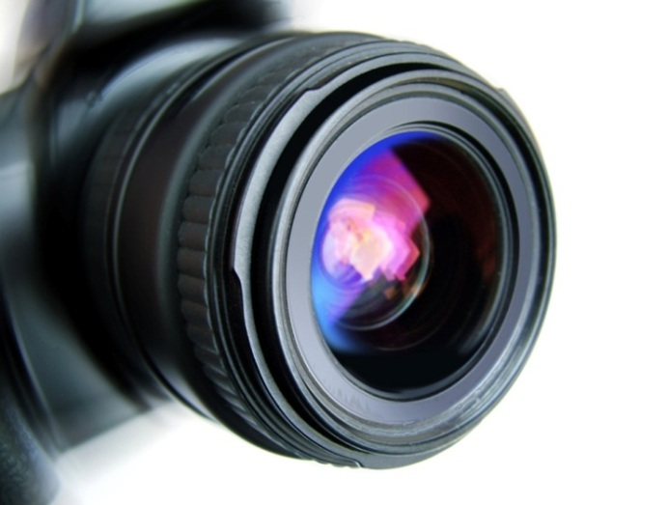

Figure ‑ A figure caption

Table ‑ A table caption

|  |  |  |
| --- | --- | --- |
|  | Heading | Heading |
| Label | Detail | Detail |
| Label | Detail | Detail |

Equations and their captions can be placed ‘side-by-side’ by moving the equation and the caption into the cells of a borderless, 2 column x 1 row table as shown below. Simply copy and paste this table as many times as you need to for all subsequent equations, but remember to periodically highlight and update the equation captions by pressing the **F9** key (or right-click and select **Update Field** from the shortcut menu).

|  |  |
| --- | --- |
|  | (‑) |

For information on inserting captions in appendices see Appendix A.

### Referring to captions for figures, tables etc

Use a cross-reference when you want to insert text similar to ‘… as shown in Figure 5.1, below’

1. Click on the **References** tab on the Ribbon
2. Select the **Cross-reference** command to open the Cross-reference window
3. In the **Reference Type** drop-down list choose the appropriate label
4. Under **For which heading** choose your figure
5. Under **Insert Reference To** choose **Only label and number** and click **Insert**. Repeat to insert either **above/below** or **page number** if required
6. Click **Close**

## Updating Tables of Contents, Lists of Figures and captions

Your table of contents, lists of figures and caption numbers will update automatically whenever you re-open the document, however you can ‘force’ an update at any time by highlighting the table or text and pressing the **F9** key (or right-click and select **Update Field** from the shortcut menu). To update all fields in a document press **Ctrl+A** then **F9**.

## Inserting landscape pages

It is often preferable to use a landscape page to display tables of data, charts or diagrams. Before changing an existing page from portrait to landscape it is necessary to enclose the page within a pair of next page section breaks. It may also be necessary to modify the page number format to ensure that page numbering continues from the previous section.

**To insert a Next Page Section Break:**

1. Click to place the insertion point where you would like to switch from portrait to landscape page orientation.
2. Go to the **Page Layout** tab on the Ribbon
3. Select the **Breaks** command and choose **Next Page** from the drop down list
4. Repeat steps 1-3 to insert a second **Next Page Section Break** at the point where you wish to switch back to portrait orientation
5. Click somewhere between the 2 new section breaks and use the **Orientation** command on the **Page Layout** tab to change page orientation from portrait to landscape.

# Chapter title (use Heading 1)

## Section heading (use Heading 2)

### Subsection heading (use Heading 3)

# Methodology

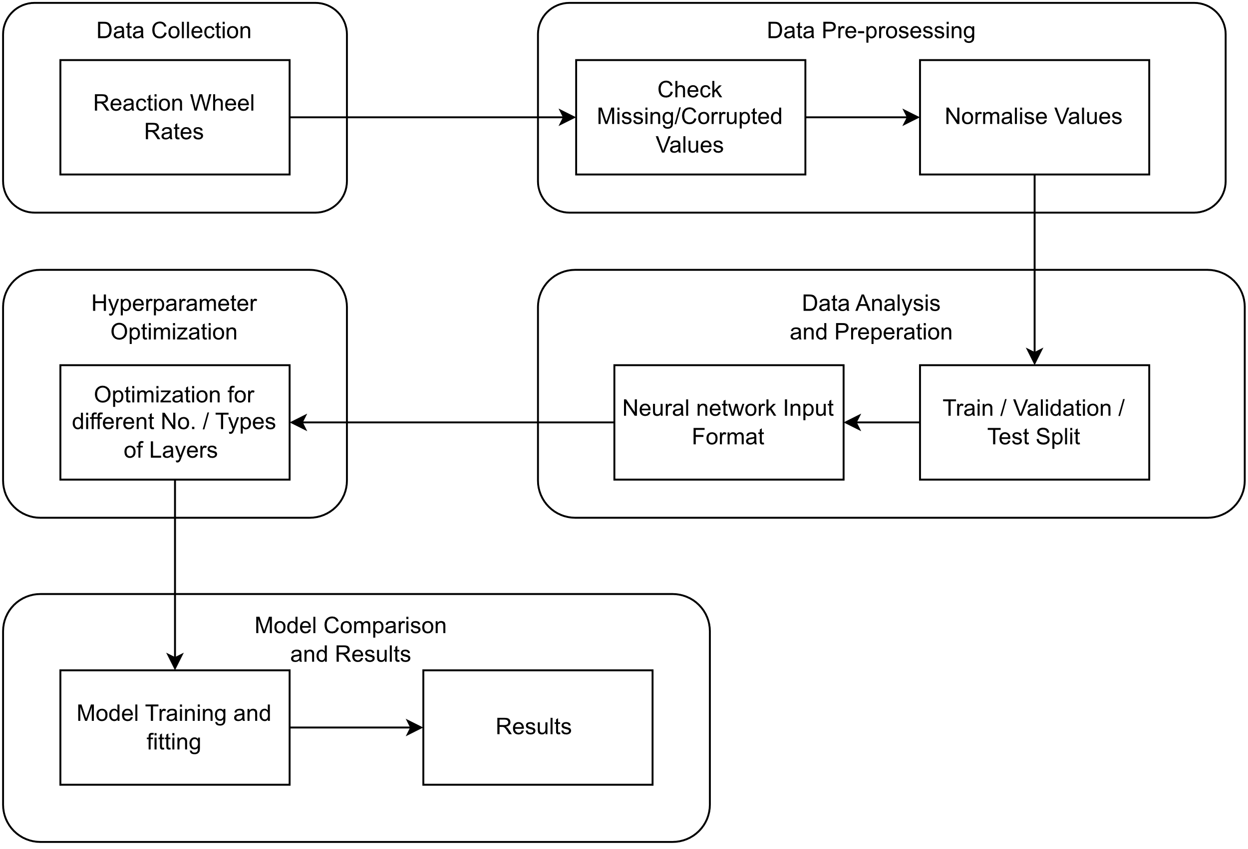In this chapter we will discuss the dataset that was used and how they were processed in order to be fit to use for training the models. Afterwards the process flow of how the models were built and assessed will be demonstrated.

## Dataset

The data that were used were provided by Hellas-Sat and collected through their telemetry system for Hellas-Sat 3. The rates of all four reaction wheels were provided for a timespan of one year, from 1-1-2022 01:00 UTC to 31-12-2023 23:00 UTC. The measurements that were provided were the hourly rpm of each wheel, which was calculated by taking the mean of the minimum and the maximum value in a 60 minute window. For each wheel the dataset that was used contained 8749 measurements. Each reaction wheel has each own telemetry: AW1010R is RW 1, AW2010R is RW 2, AW3010R is RW3 and AW4010R is RW4.

|  |  |
| --- | --- |
|  |  |
|  |  |

Some noticeable features on the plots of the reaction wheel rates are the following:

* All reaction wheels follow a similar pattern across the year.
* The amplitude of the range in each season varies. The maximum value is smaller around April and September, while it is larger around January, July and November.
* In November all reaction wheels are being forced to rotate in the opposite direction from their prior direction. This is done on purpose by the operators for maintenance purposes.
* The sudden decrease in the rates of the wheels is either because a stationkeeping maneuver is performed, or because of a manual wheel unloading. When a stationkeeping maneuver is performed, automatically a wheel unloading is performed, so that the satellite can take advantage of the thrust and the torques that are applied on it and become more fuel efficient.

Additionally, all data were scanned for any missing or corrupted values and an additional step that had to be taken is that we took the absolute values of the measurements. This is related to the fact that the reaction wheels have the ability to rotate both clockwise and counter-clockwise and at all times two of the wheels are spinning CW and two CCW. For purposes of maintenance, once per year the satellite operators make each wheel spin in the opposite direction and therefore we had to filter out of the dataset this transition, in order to avoid confusing the model during the training, because this is not a normal behavior of the wheel that the model needs to be able to predict.

Moreover, before the data was fed to the models they had to be split into three subsets: Training, Validation and Testing. For training purposes 70% of the original dataset was used, for validation 20% and for testing 10%. The resulting subsets contained 6124 datapoints for training, 1750 for validation and 802 for testing.

Finally, during the process of training, experimenting and building the models we came to the conclusion that all values needed to be normalized with respect to the maximum value that the rate of the wheel is allowed to reach, as advised by the constructor and Hellas-Sat. In this way better performance of the models was achieved.

The necessity for normalization can be demonstrated with the following example. The same model was used for training and validation two times. It included 1 LSTM layer with 64 units, 2 Dense layers with 128 units each and a Dense layer with 1 unit which is the output and a learning rate of 0.001 with Adam optimizer. On the first iteration the values were not normalized, while on the second they were. In the following figures, the results of the training on the validation can be seen. We notice that on the non-normalized predictions in the first figure, the predictions are cut-off when they reach higher values, while in the normalized model in the second figure we see patterns in the predictions in the higher values, that mimic those of the actual data, that are being plotted below them.

## Model Building

To create a model for timeseries forecasting, there are several parameters that need to be taken into account and combined result into many different architectures that have to be explored.

Those parameters are the number of layers within the model, as well as the type of layers and the number of neurons in each layer. For our case, Long Short Term Memory layers were used. They are a type of Recurrent Neural Network layer and they are widely used for speech recognition, text predictions and more importantly for timeseries forecasting. Another type of layer that was used is the Dense layer, which is the basic type of layer in machine learning.

The following figure displays a straightforward representation of the long short-term memory network. Typically, an LSTM network refers to an RNN with long short-term memory blocks. These blocks are interconnected recurrently and are responsible for maintaining memory. Each memory block contains memory cells that store the state, an input gate for determining what to learn, a forget gate for deciding what to discard, and an output gate for regulating modifications to the content. The critical distinction between LSTM and traditional RNN lies in the inclusion of these gates. The LSTM network utilizes these gates to make informed decisions about preserving relevant information, whereas the traditional RNN merely overwrites its contents at each time step during the modeling process.

The standard expression of the LSTM is provided in the following equations:

𝑖𝑡 = 𝜎𝑔(𝑊𝑖𝑠𝑡−1 + 𝑈𝑖𝑥𝑡 + 𝑏𝑖)

𝑜𝑡 = 𝜎𝑔(𝑊𝑜𝑠𝑡−1 + 𝑈𝑜𝑥𝑡 + 𝑏𝑜)

𝑓𝑡 = 𝜎𝑔(𝑊𝑓𝑠𝑡−1 + 𝑈𝑓 𝑥𝑡 + 𝑏𝑓)

̃𝑠𝑡 = 𝜙(𝑊 (𝑜𝑡 ⊙ 𝑠𝑡−1) + 𝑈 𝑥𝑡 + 𝑏)

𝑠𝑡 = 𝑓𝑡 ⊙ 𝑠𝑡−1 + 𝑖

𝑡 ⊙ ̃𝑠𝑡

𝑦𝑡 = 𝑜𝑡 ⊙ 𝜎𝑦(𝑠𝑡)

where 𝑠𝑡 and 𝑠𝑡−1 are the current and previous states; 𝑊 , 𝑈 are the weights in the networks; 𝑏 is the bias; 𝜎𝑔, 𝜙, 𝜎𝑦 are activation functions; and ⊙ denotes the element-wise multiplication.

Other parameters that affect the performance of the model are the learning rate and the optimizer that is used and the input window.

The window size of the input data for an LSTM network refers to the number of time steps or observations that the LSTM considers as a single input sequence. In other words, it determines how much historical information the LSTM can utilize to make predictions or learn patterns in the data. The window size is a crucial hyperparameter in LSTM networks, and selecting an appropriate value depends on the nature of the data and the specific task at hand. A smaller window size may be suitable for tasks with rapid changes, while a larger window size might be more appropriate for tasks with long-term dependencies. In our case, we experimented with window sizes of 24, 48 and 72, which translates to using one, two or three days of data as input, since our data are hourly measurements.

The learning rate is a hyperparameter that controls the step size at which the optimizer adjusts the model's parameters during training. It determines how much the model should update its weights in response to the calculated gradients. A larger learning rate allows for faster convergence during training but may also lead to overshooting and instability. On the other hand, a smaller learning rate leads to slower convergence but provides more stable updates.

The optimizer that was used is Adam (Adaptive Moment Estimation). It has the ability to adapt the learning rate for each parameter in the model. Instead of using a fixed learning rate, it maintains separate adaptive learning rates based on the historical gradients. In this way it allows the model to converge faster and more efficiently.

In the following table all hyperparameters are listed, as well as the range of their values that were explored.

|  |  |
| --- | --- |
| Hyperparameter | Range |
| No. Layers | [1, 2, 3, 4, 5, 6] |
| Type of Layers | [Dense, LSTM] |
| No. LSTM units | [32, 64, 128, 192, 256] |
| No. Dense neurons | [32, 64, 128, 192, 256] |
| Learning Rate | [0.1, 0.01, 0.001] |
| Optimizer | [Adam] |
| Window Size | [24, 48, 72] |

For a more complete exploration of the possible architectures, a tool for hyperparameter optimization was created that utilized Hyperband optimization, so that our research would be more extensive and would include as many candidate architectures as possible.

Hyperband's key idea is to quickly identify and eliminate poorly performing configurations, focusing resources on the most promising ones. This approach allows Hyperband to explore a wide range of hyperparameter configurations more efficiently than traditional grid search.

It starts by sampling a large number of random hyperparameter configurations and evaluates them for a small number of epochs, which is referred to as the "initial" number of epochs. After each epoch, it discards the poorly performing configurations and retains the top-performing configurations. The retained configurations are then allocated more resources (epochs) and trained further.

The process continues, progressively reducing the number of configurations but increasing the number of epochs allocated to each configuration at each round. Eventually, only the best configuration remains and is trained for a large number of epochs.

In summary, Hyperband does not exhaustively test all possible combinations of parameters. Instead, it combines random sampling with early elimination of underperforming configurations to find the best hyperparameter configuration within a specified resource budget.

In Hyperband, the number of configurations tested at each round is determined by a formula:

n = ceil((R / eta^s) * B), where:

n is the number of configurations at the current round,

R is the maximum number of epochs (max_epochs) specified for the search,

eta is the factor parameter, and

s is the round number (starting from 0).

The factor parameter in the Hyperband tuner controls the resource allocation and termination rate of the hyperparameter search. It determines the ratio between the number of configurations to evaluate at each round of successive halving. Its purpose is to control the aggressive elimination of poorly performing configurations and the allocation of more resources to promising configurations.

Although the reaction wheels are similar to their characteristics a model for each one had to be created, because they are positioned in different spots within the spacecraft and therefore they experience and are affected by the perturbations in a unique manner each. In the following tables we can see the results of hyperparameter optimization of different architectures for each reaction wheel. As we can see, the results vary among the reaction wheels for similar architectures.

The architecture that was chosen was a multi-layered LSTM or “stacked” LSTM. In a “stacked” LSTM network all input data are inserted in the first LSTM layer to generate hidden states, which are then used as inputs in the next LSTM layer and so on, unlit we get to the output layer. By adding more hidden layers, we add greater model depth and can observe the problem in different time scales. After analyzing the data for the reaction wheel rates, it was observed that there are some patterns emerging with different frequencies. A weekly, monthly and tri-monthly periodicity are observable as well as a fluctuation in the maximum value that is reached in each epoch throughout the year. Therefore, with the aim to capture these dependencies in the model, several “stacked” architectures were tested with different number of hidden layers.

Reaction Wheel 1 architecture results of hyperparameter optimization

|  |  |  |  |  |  |  |
| --- | --- | --- | --- | --- | --- | --- |
| Network | Window Size | Layers | Output Shape | No. of Parameters | Total Parameters | Trainable Parameters |
| RNN | (24, 1) | LSTM | (None, 32) | 7296 | 7329 | 7329 |
|  |  | Dense | (None, 1) | 33 |  |  |
| RNN | (48, 1) | LSTM | (None, 256) | 312320 | 312577 | 312577 |
|  |  | Dense | (None, 1) | 257 |  |  |
| RNN | (48, 1) | LSTM | (None, 64) | 28928 | 45825 | 45825 |
|  |  | Dense | (None, 256) | 16640 |  |  |
|  |  | Dense | (None, 1) | 257 |  |  |
| RNN | (24, 1) | LSTM | (None, 64) | 16896 | 41857 | 41857 |
|  |  | Dense | (None, 128) | 8320 |  |  |
|  |  | Dense | (None, 128) | 16512 |  |  |
|  |  | Dense | (None, 1) | 129 |  |  |
| RNN | (48, 1) | LSTM | (None, None, 128) | 90624 | 119937 | 119937 |
|  |  | LSTM | (None, 32) | 20608 |  |  |
|  |  | Dense | (None, 256) | 8448 |  |  |
|  |  | Dense | (None, 1) | 257 |  |  |
| RNN | (72, 1) | LSTM | (None, None, 192) | 203520 | 273537 | 273537 |
|  |  | LSTM | (None, 64) | 65792 |  |  |
|  |  | Dense | (None, 64) | 4160 |  |  |
|  |  | Dense | (None, 1) | 65 |  |  |
| RNN | (72, 1) | LSTM | (None, None, 64) | 35072 | 245121 | 245121 |
|  |  | LSTM | (None, None, 32) | 12416 |  |  |
|  |  | LSTM | (None, 192) | 172800 |  |  |
|  |  | Dense | (None, 128) | 24704 |  |  |
|  |  | Dense | (None, 1) | 129 |  |  |
| RNN | (72, 1) | LSTM | (None, None, 64) | 35072 | 267585 | 267585 |
|  |  | LSTM | (None, None, 192) | 197376 |  |  |
|  |  | LSTM | (None, 32) | 28800 |  |  |
|  |  | Dense | (None, 64) | 2112 |  |  |
|  |  | Dense | (None, 64) | 4160 |  |  |
|  |  | Dense | (None, 1) | 65 |  |  |

Reaction Wheel 2 architecture results of hyperparameter optimization

|  |  |  |  |  |  |  |
| --- | --- | --- | --- | --- | --- | --- |
| Network | Window Size | Layers | Output Shape | No. of Parameters | Total Parameters | Trainable Parameters |
| RNN | (24, 1) | LSTM | (None, 256) | 287744 | 288001 | 288001 |
|  |  | Dense | (None, 1) | 257 |  |  |
| RNN | (48, 1) | LSTM | (None, 64) | 28928 | 28993 | 28993 |
|  |  | Dense | (None, 1) | 65 |  |  |
| RNN | (48, 1) | LSTM | (None, 128) | 90624 | 94785 | 94785 |
|  |  | Dense | (None, 32) | 4128 |  |  |
|  |  | Dense | (None, 1) | 33 |  |  |
| RNN | (24, 1) | LTSM | (None, 64) | 16896 | 50049 | 50049 |
|  |  | Dense | (None, 256) | 16640 |  |  |
|  |  | Dense | (None, 64) | 16448 |  |  |
|  |  | Dense | (None, 1) | 65 |  |  |
| RNN | (48, 1) | LTSM | (None, None, 192) | 185088 | 382721 | 382721 |
|  |  | LTSM | (None, 128) | 164352 |  |  |
|  |  | Dense | (None, 256) | 33027 |  |  |
|  |  | Dense | (None, 1) | 257 |  |  |
| RNN | (72, 1) | LTSM | (None, None , 192) | 203520 | 233409 | 233409 |
|  |  | LTSM | (None, 32) | 28800 |  |  |
|  |  | Dense | (None, 32) | 1056 |  |  |
|  |  | Dense | (None, 1) | 33 |  |  |
| RNN | (72, 1) | LSTM | (None, None, 32) | 13440 | 217217 | 217217 |
|  |  | LSTM | (None, None, 192) | 172800 |  |  |
|  |  | LSTM | (None, 32) | 28800 |  |  |
|  |  | Dense | (None, 64) | 2112 |  |  |
|  |  | Dense | (None, 1) | 65 |  |  |
| RNN | (72, 1) | LSTM | (None, None, 128) | 102912 | 538625 | 538625 |
|  |  | LSTM | (None, None, 192) | 246528 |  |  |
|  |  | LSTM | (None, 128) | 164352 |  |  |
|  |  | Dense | (None, 128) | 16512 |  |  |
|  |  | Dense | (None, 64) | 8256 |  |  |
|  |  | Dense | (None, 1) | 65 |  |  |

Reaction Wheel 3 architecture results of hyperparameter optimization

|  |  |  |  |  |  |  |
| --- | --- | --- | --- | --- | --- | --- |
| Network | Window Size | Layers | Output Shape | No. of Parameters | Total Parameters | Trainable Parameters |
| RNN | (24, 1) | LSTM | (None, 32) | 7296 | 7329 | 7329 |
|  |  | Dense | (None, 1) | 33 |  |  |
| RNN | (48, 1) | LSTM | (None, 256) | 312320 | 312577 | 312577 |
|  |  | Dense | (None, 1) | 257 |  |  |
| RNN | (48, 1) | LSTM | (None, 128) | 90624 | 107265 | 107265 |
|  |  | Dense | (None, 128) | 16512 |  |  |
|  |  | Dense | (None, 1) | 129 |  |  |
| RNN | (24, 1) | LSTM | (None, 128) | 66560 | 149121 | 149121 |
|  |  | Dense | (None, 256) | 33024 |  |  |
|  |  | Dense | (None, 192) | 49344 |  |  |
|  |  | Dense | (None, 1) | 193 |  |  |
| RNN | (48, 1) | LSTM | (None, None, 256) | 312320 | 706817 | 706817 |
|  |  | LSTM | (None, 192) | 344832 |  |  |
|  |  | Dense | (None, 256) | 49408 |  |  |
|  |  | Dense | (None, 1) | 257 |  |  |
| RNN | (72, 1) | LSTM | (None, None, 192) | 203520 | 536449 | 536449 |
|  |  | LSTM | (None, 192) | 295680 |  |  |
|  |  | Dense | (None, 192) | 37056 |  |  |
|  |  | Dense | (None, 1) | 193 |  |  |
| RNN | (72, 1) | LSTM | (None, None, 192) | 203520 | 417537 | 417537 |
|  |  | LSTM | (None, None, 32) | 28800 |  |  |
|  |  | LSTM | (None, 192) | 172800 |  |  |
|  |  | Dense | (None, 64) | 12352 |  |  |
|  |  | Dense | (None, 1) | 65 |  |  |
| RNN | (72, 1) | LSTM | (None, None, 64) | 35072 | 353825 | 353825 |
|  |  | LSTM | (None, None, 32) | 12416 |  |  |
|  |  | LSTM | (None, 256) | 295936 |  |  |
|  |  | Dense | (None, 32) | 8224 |  |  |
|  |  | Dense | (None, 64) | 2112 |  |  |
|  |  | Dense | (None, 1) | 65 |  |  |

Reaction Wheel 4 architecture results of hyperparameter optimization

|  |  |  |  |  |  |  |
| --- | --- | --- | --- | --- | --- | --- |
| Network | Window Size | Layers | Output Shape | No. of Parameters | Total Parameters | Trainable Parameters |
| RNN | (24, 1) | LSTM | (None, 192) | 166656 | 166849 | 166849 |
|  |  | Dense | (None, 1) | 193 |  |  |
| RNN | (48, 1) | LSTM | (None, 32) | 10368 | 10401 | 10401 |
|  |  | Dense | (None, 1) | 33 |  |  |
| RNN | (48, 1) | LSTM | (None, 256) | 312320 | 328833 | 328833 |
|  |  | Dense | (None, 64) | 16448 |  |  |
|  |  | Dense | (None, 1) | 65 |  |  |
| RNN | (24, 1) | LSTM | (None, 128) | 66560 | 79393 | 79393 |
|  |  | Dense | (None, 32) | 4128 |  |  |
|  |  | Dense | (None, 256) | 8448 |  |  |
|  |  | Dense | (None,1) | 257 |  |  |
| RNN | (48, 1) | LSTM | (None, None, 128) | 90624 | 148481 | 148481 |
|  |  | LSTM | (None, 64) | 49408 |  |  |
|  |  | Dense | (None, 128) | 8320 |  |  |
|  |  | Dense | (None, 1) | 129 |  |  |
| RNN | (72, 1) | LSTM | (None, None, 192) | 203520 | 281985 | 281985 |
|  |  | LSTM | (None, 64) | 65792 |  |  |
|  |  | Dense | (None, 192) | 12480 |  |  |
|  |  | Dense | (None, 1) | 193 |  |  |
| RNN | (72, 1) | LSTM | (None, None, 256) | 336896 | 764289 | 764289 |
|  |  | LSTM | (None, None, 64) | 82176 |  |  |
|  |  | LSTM | (None, 256) | 328704 |  |  |
|  |  | Dense | (None, 64) | 16448 |  |  |
|  |  | Dense | (None, 1) | 65 |  |  |
| RNN | (72, 1) | LSTM | (None, None, 192) | 203520 | 396865 | 396865 |
|  |  | LSTM | (None, None, 128) | 164352 |  |  |
|  |  | LSTM | (None, 32) | 20608 |  |  |
|  |  | Dense | (None, 128) | 4224 |  |  |
|  |  | Dense | (None, 32) | 4128 |  |  |
|  |  | Dense | (None, 1) | 33 |  |  |

## Model Assessment

The next step from hyperparameter optimization was to assess the resulting models for each type of architecture. Assessing machine learning models is an important step in evaluating their performance and to determine whether they are suitable for our project. The metrics that were used for the evaluation are Root Mean Squared Error, Loss and Validation Loss.

Root Mean Squared Error (RMSE) is a metric used to measure the accuracy of a model’s predictions compared to the actual values. It calculates the square root of the average of squared differences between predicted values and actual values. A lower RMSE indicates better performance of the model.

Loss refers to the objective function used during the training process. In LSTM models it is usually Mean Squared Error. During training the model tries to minimize this loss, making the predictions closer to the actual values. Monitoring the loss during training allows you to understand how well the model is learning from the data.

Validation loss is computed using the same loss function as during training, but it is calculated on the validation dataset. This dataset is not used for training the model, and its purpose is to evaluate how well the model generalizes to unseen data. The validation loss helps you detect overfitting, when the model performs well on the training data but poorly on new data.

## Ticket Creation

Once the models for each reaction wheel are built and trained, we can make predictions for each one, to detect if their rate is going to exceed a specific threshold and then create a ticket in the Spacecraft Control Centre with the necessary information, so that the engineers, operators and flight dynamics team can act accordingly. The following flow diagram explains the procedure in which the ticket will be created and the steps that need to take place.

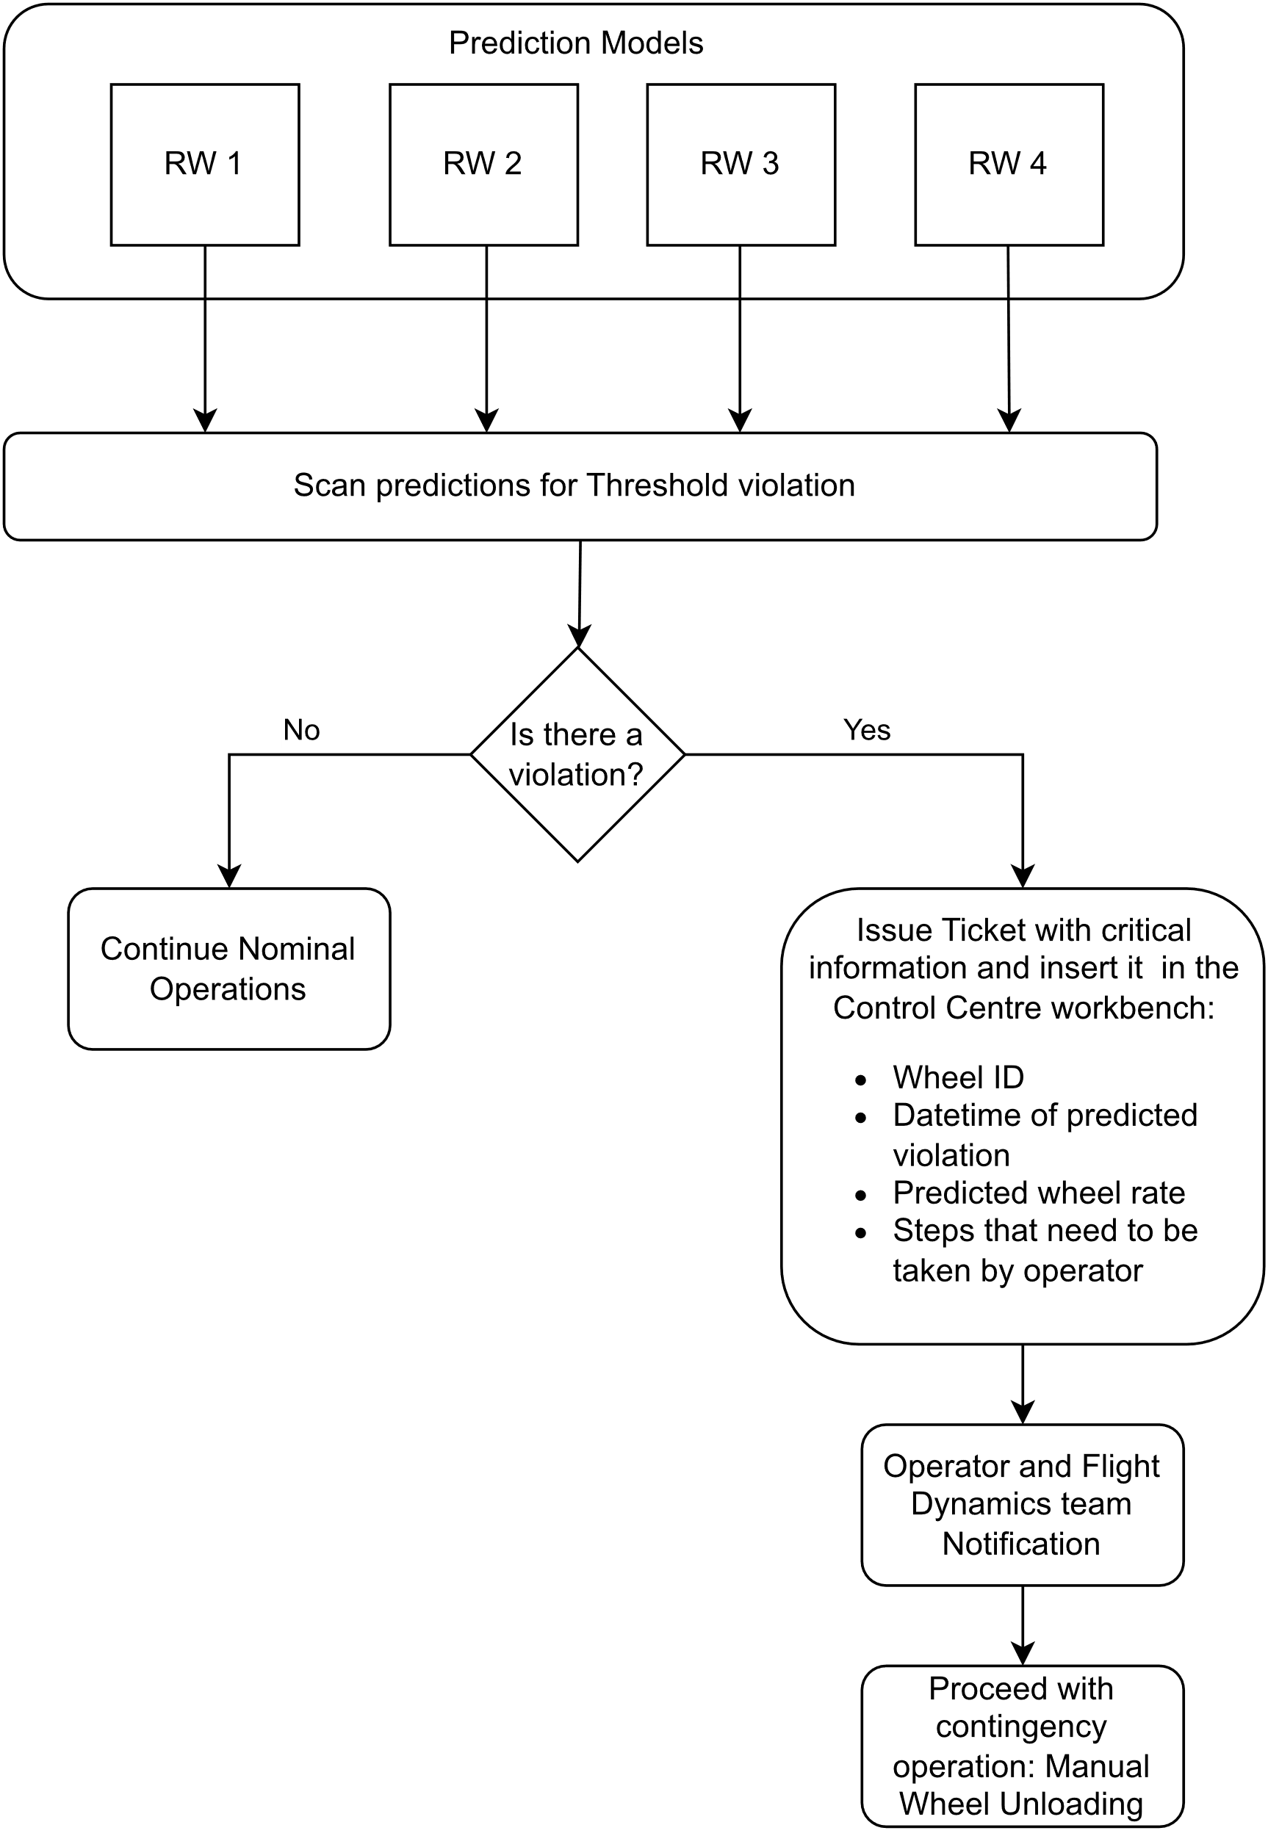

Firstly, the predictions are created for each Reaction Wheel for a certain period. Then the results need to be examined, in order to assess if any of the predictions exceed a set threshold.

To make predictions, the hourly Reaction Wheel rates from the last 72 hours are needed. Then using these data a prediction is made for the next hour, which can be then used along side with the last 71 hours, with the aim to predict the next hour. This procedure can be followed another 70 times, 71 in total, so that we can get a prediction in total for the next 71 hours, approximately 3 days. No further predictions should be made, because they would be based only on already 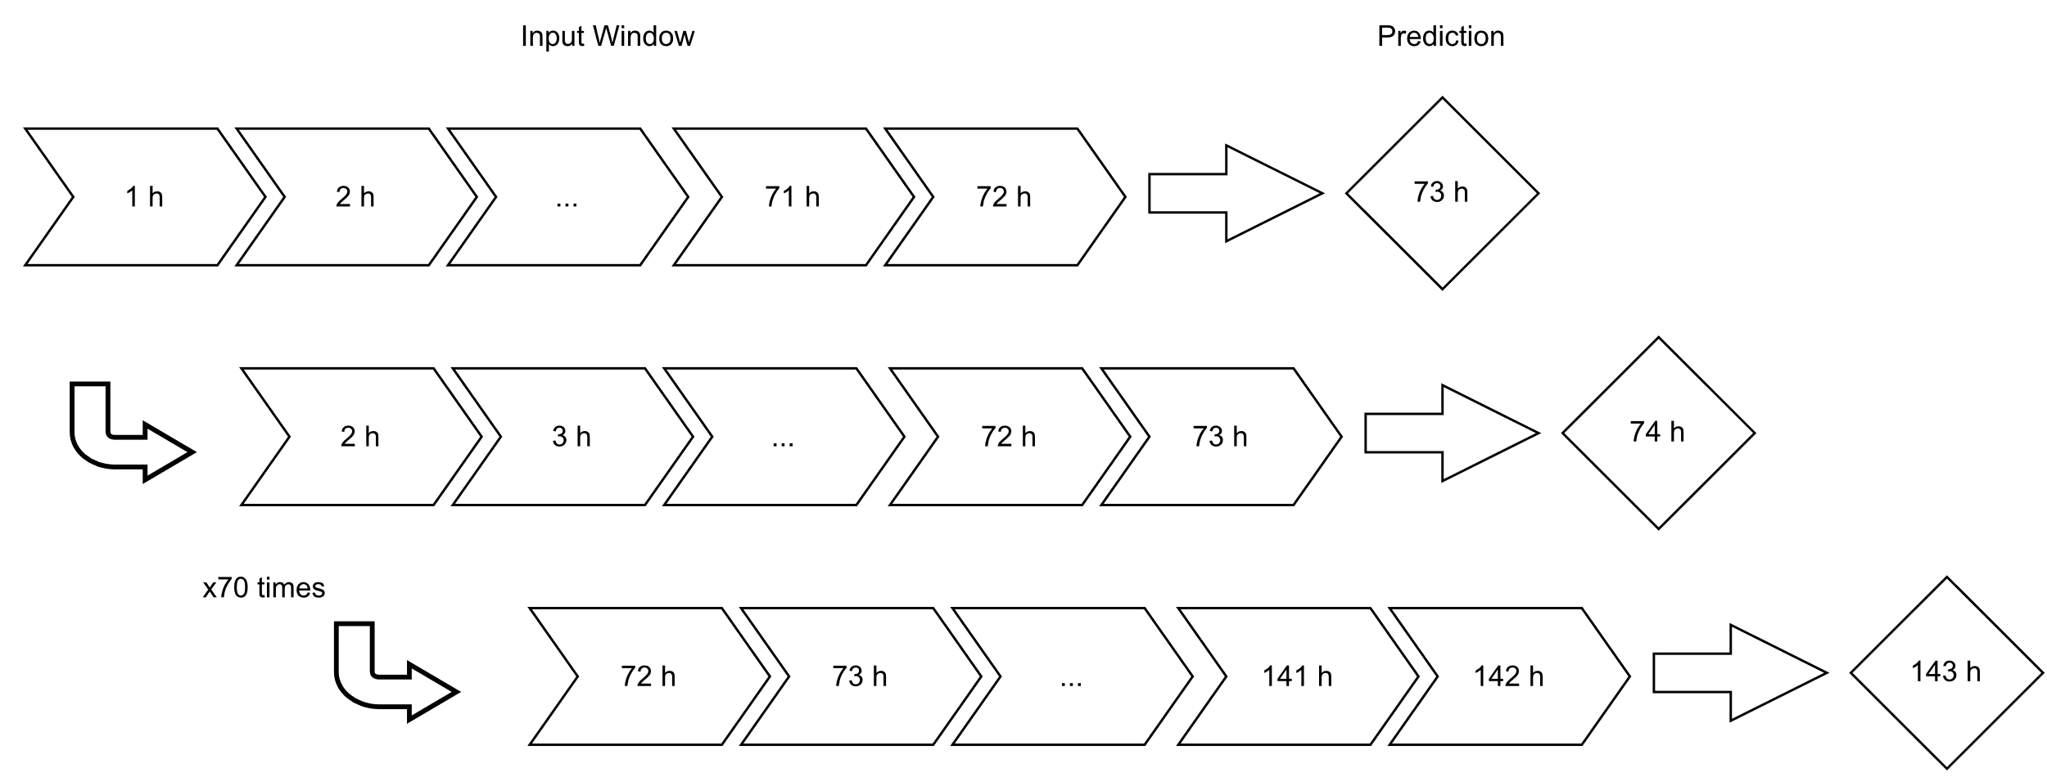predicted values and no real data.

If none of the wheels exceed the set limit, then no action needs to be taken and operations can proceed nominally. However, if the predictions indicate that one of the wheels will surpass the limit at a specific time, a ticket needs to be created in the operation center workbench, so that the operators can be notified that a manual wheel unloading will need to take place.

To achieve that a process of scanning the prediction results was created, which identifies which wheel will exceed the limit and when, and then creates a ticket with the appropriate information on the workbench, by creating an entry in the right tables in its database.

A ticket is produced only for the most imminent threshold violation in one of the reaction wheels. This is due to the fact that when a wheel unloading takes place on the spacecraft, all four wheels are being unloaded at the same time. Therefore, if the procedure is executed for the most imminent limit violation chronologically, then afterwards the rates of all the wheels are being affected and the predictions that were made before become invalid, as well as any alarms that the threshold will be reached.

The information that is input is the date of the procedure, which is the date that the rate will pass the threshold, the predicted rate of the wheel, which wheel will it be and the steps of the procedure that will need to be followed.

The ticket shall be marked as unverified, so that the flight dynamics team can process the information that is given and decide in what direction the unloading will be performed and if there is a more efficient time to execute the procedure than the one that is predicted.

The procedure that the operator will have to execute, includes 11 steps which are also included in the ticket that is produced and displayed on the workbench:

• Step 1: Initialize procedure 4000CA02.

• Step 2: Verify Observability. Verification of the housekeeping packet that is needed for the operation. This is done to ensure that all telemetry that is needed for the operation are downlinked. Need to activate the table DUMP NM_DMP for the operation follow-up and in particular the duty cycle parameters checking.

• Step 3: Deactivate automatic wheel unloading. The automatic wheel unloading is disabled to avoid the random execution of the wheel unloading during the procedure.

• Step 4: Configure wheels unloading in the direction (East, West, North , South) that has been decided by the flight dynamics team. The maneuver direction shall be set to select the thruster set used during the wheel unloading. If it is not provided, the procedure will be rejected

• Step 5: Activate wheels unloading. Wheel unloading starts as soon as telecommand 3002FHA is received on board. While wheel unloading has started, procedure execution has to be continued in order to monitor wheel unloading behavior.

• Step 6: Monitor wheels unloading. The wheel unloading is check thanks to specific telemetry: spacecraft attitude, wheel angular momentum, on-control thruster valves status and temperature. If these telemetry are not correct during the wheel unloading the operator has to abort the procedure.

• Step 7: Verify end of wheels unloading. The thrusters history is recorded to know wheel unloading fuel consumption.

• Step 8: Reset boost parameters. The boost parameters must be reset after the boost to avoid performing any operational mistake.

• Step 9: Re-activate automatic wheels unloading. Set back on automatic wheel unloading, which was deactivated in the beginning of the procedure.

• Step 10: Deactivate observability. Come back to the default spacecraft telemetry plan by stopping NM_DM table DUMP.

• Step 11: End procedure.

# Chapter title (use Heading 1)

## Section heading (use Heading 2)

### Subsection heading (use Heading 3)

# Chapter title (use Heading 1)

## Section heading (use Heading 2)

### Subsection heading (use Heading 3)

# Chapter title (use Heading 1)

## Section heading (use Heading 2)

### Subsection heading (use Heading 3)

# 

# Chapter title (use Heading 1)

## Section heading (use Heading 2)

### Subsection heading (use Heading 3)

# Chapter title (use Heading 1)

## Section heading (use Heading 2)

### Subsection heading (use Heading 3)

# Chapter title (use Heading 1)

## Section heading (use Heading 2)

### Subsection heading (use Heading 3)

References

Click here to enter reference list.

Appendices

Whilst Heading 1 to Heading 6 can be used to number headings in the main body of the thesis, Heading styles 7–9 have been modified specifically for lettered appendix headings with Heading 7 having the ‘Appendix’ prefix as shown below.

Ethical approval letter

Click here to insert your ethical approval letter as the first appendix, i.e. Appendix A.

Appendix guidance (Appendix title (use Heading 7))

Appendix section (use Heading 8)

Appendix subsection (use Heading 9)

Creating captions in appendices

If you have chosen to include chapter numbers in your captions, then follow the instructions given here to apply the same format to the captions in your appendices. This section explains how to caption the figures and tables in your Appendices, assuming that Heading 7 is numbered “Appendix A” and that the Figures and Tables are going to be labelled ‘Figure A-1’, ‘Figure A-2’, ‘Table B-1’ etc.

You will have to create new, separate labels that look like the ‘Figure’ and ‘Table’ labels you used in the main body of your thesis.

1. Select the **References** tab on the Ribbon then click on **Insert Caption**
2. Click **New Label**. Type **Figure_Apx** then click **OK**
3. You now have two labels for figures, called **Figure** and **Figure_Apx**  
   Repeat for table captions.
4. In the **Caption** box, type your caption text
5. Click **Numbering**. Tick **Include chapter numbering** and choose **Heading 7** from the drop-down list of styles and click **OK** twice
6. Your caption should look something like this:

**Figure_Apx A‑1 This is the caption text for a Figure in the Appendix**

1. Delete the extraneous ‘_Apx’ from the caption label so it reads:  
   **Figure A‑1 This is the caption text for a figure in the appendix**.  
   **TIP:** Instead of deleting each ‘_Apx’ individually use **Find & Replace** to modify all the labels at once.

Creating Lists of Figures and Tables for Appendices

This template already includes a List of Figures and a List of Tables, however you will have to create two new lists for the ‘Figure_Apx’ and the ‘Table_Apx’ labels.

1. Place the insertion point on a blank row after the existing List of Figures
2. Select the **Insert Table of Figures** command on the **References** tab of the Ribbon
3. Set the **Caption Label** box to ‘**Figure_Apx**’ and click **OK**  
   **Note:** Word will put a single blank line between the original list and the new list preventing it from appearing as one seamless list. However, if you select the blank paragraph between the tables you can hide it by opening the Font dialog box from the Home tab and selecting **Hidden**.
4. Click after the List of Tables and repeat for the Caption Label ‘Table_Apx’.

Appendix title (use Heading 7)

Appendix section (use Heading 8)

Appendix subsection (use Heading 9)