1 Design and User Interface

The user interface is designed to accommodate the user requirements. The introduction page contains some information about the project, what it does, and how to use the tool. The navigation bar, available on all pages of the site, contains links back to the introduction page, as well as to a page where users can see a list of datasets and analysis of a dataset (See Figure 1). From the introduction page, the user can choose to log in or see a list of the datasets in the system (See Figure 2). Users will need an account to log in if they are willing to keep datasets private or delete datasets they have uploaded(See Figure 3). 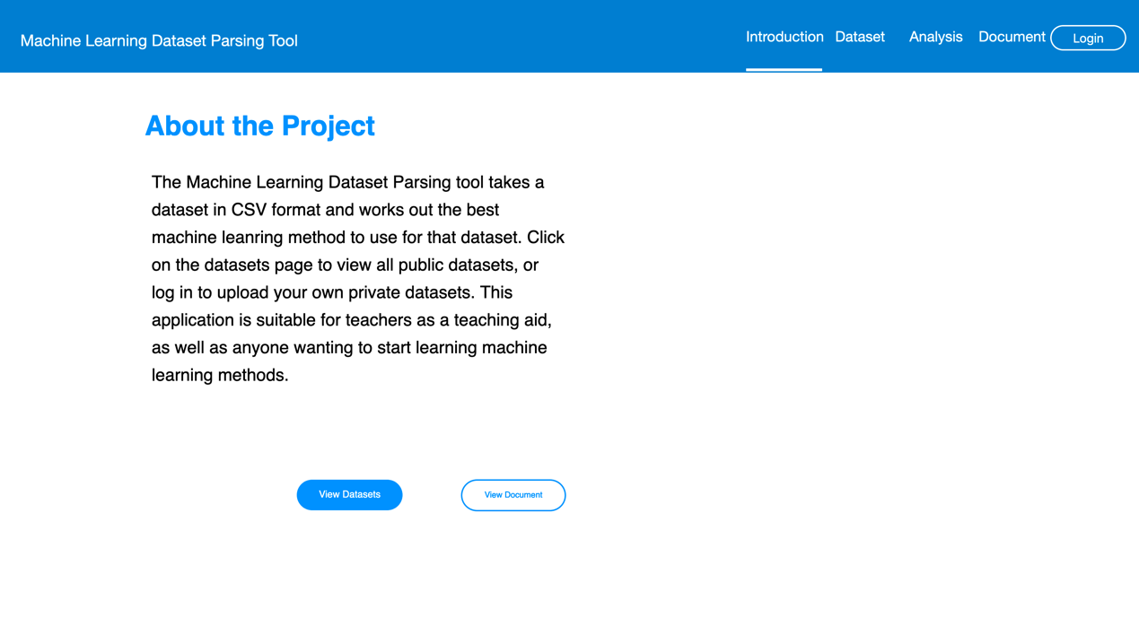

Figure 1: The Introduction Page of the system

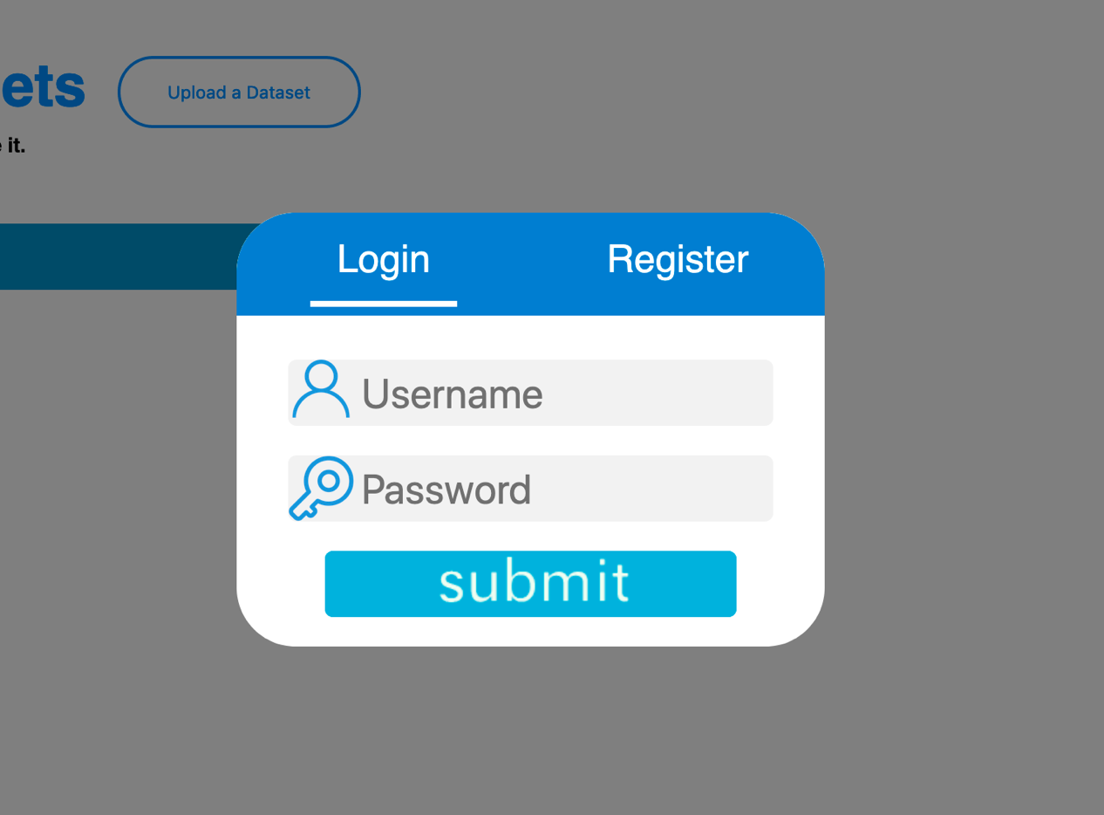

Figure 2: The Login table of the system

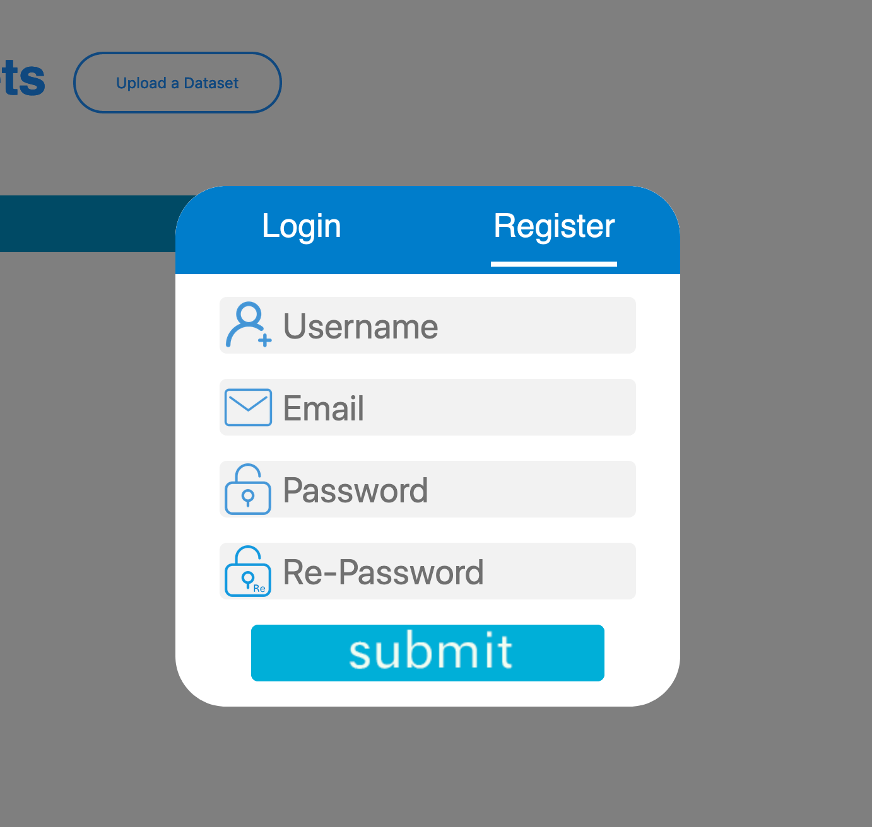

Figure 3: The Register table of the system

Clicking on the datasets link takes the user to the datasets page. In the left part of the page, after loading all files (See Figure 4), files in the database list can be seen (See Figure 5). When users log in with own account, the own datasets will be shown with account name. Double clicking on a dataset takes the user to the analysis page for that dataset (See Figure 6). From the datasets page, the user may also choose to upload a new dataset for analysis. Although it was planned that there would be a search bar for datasets, this feature was never implemented. Instead, the only way to find a dataset is to scroll through the list of all datasets (or private datasets if the user is logged in). Each dataset in the list also displays a download button when the user hovers over its name. Clicking the download button will download the raw data, in CSV format. When users double click on button Upload a Dataset, they are allowed to choose a CSV file, as well as choose if the file is time series or image (See Figure 7). Also, users can write down a description for new dataset (See Figure 8). Then, clicking on button confirm, the user can go to the analysis page.

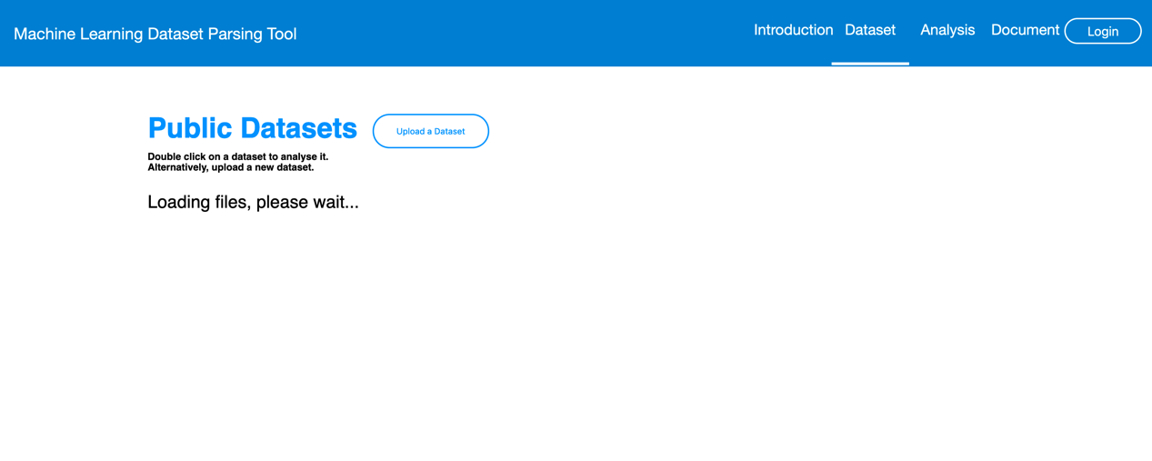

Figure 4: The Loading process

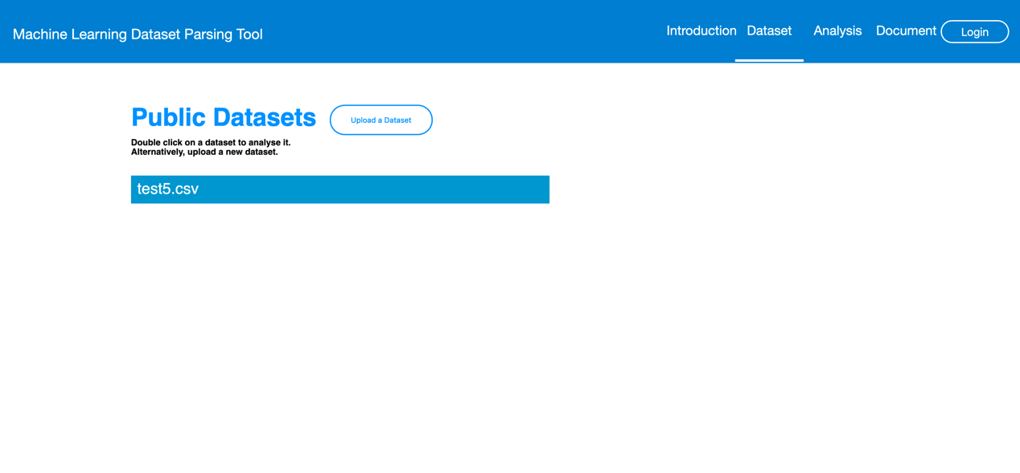

Figure 5: The Datasets Page of the system

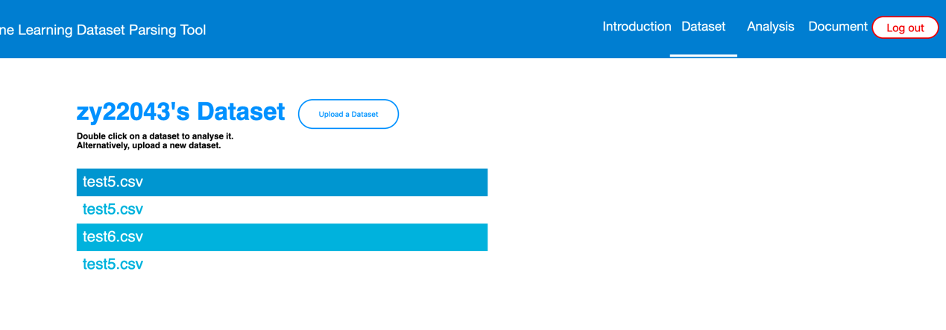

Figure 6: The Users Datasets

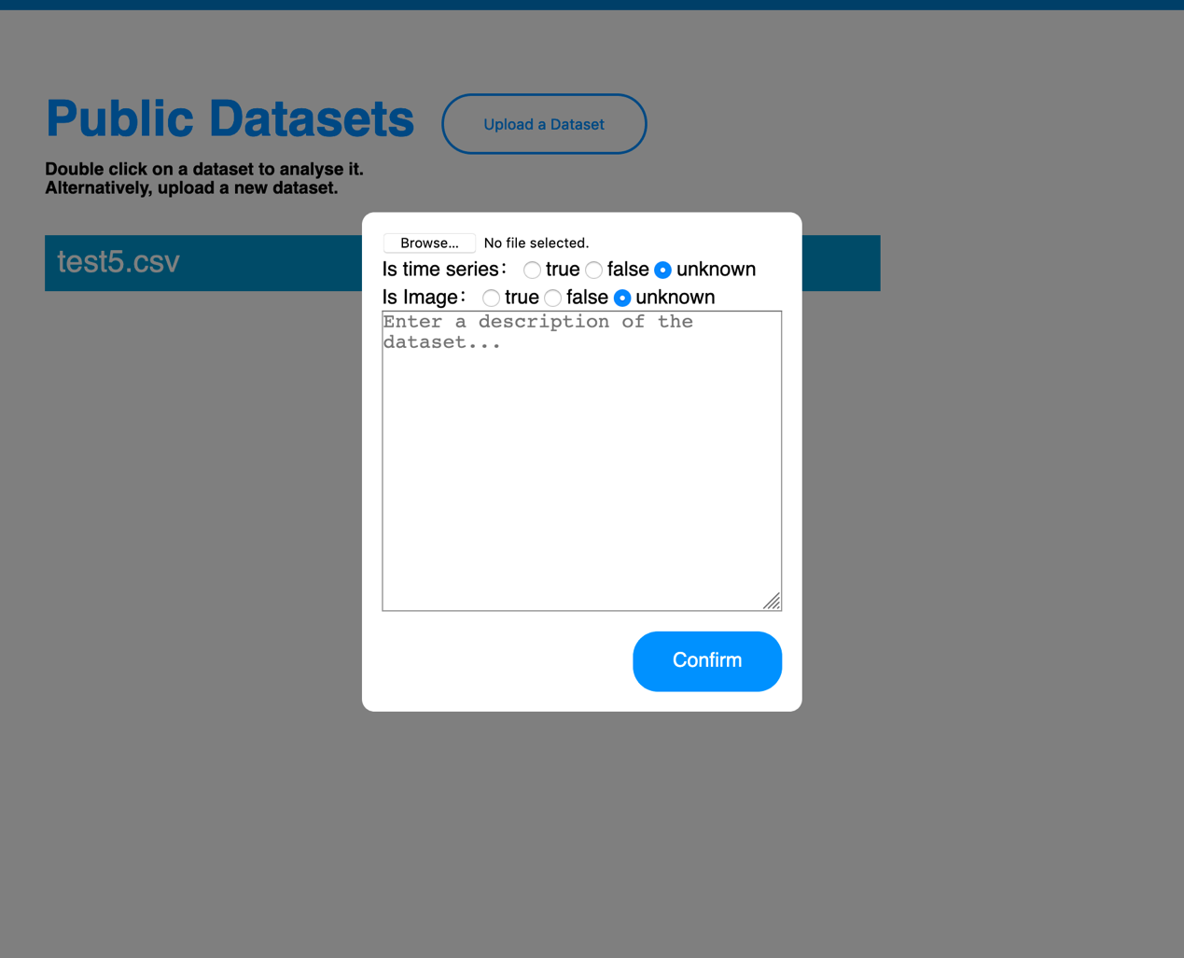

Figure 7: The upload table

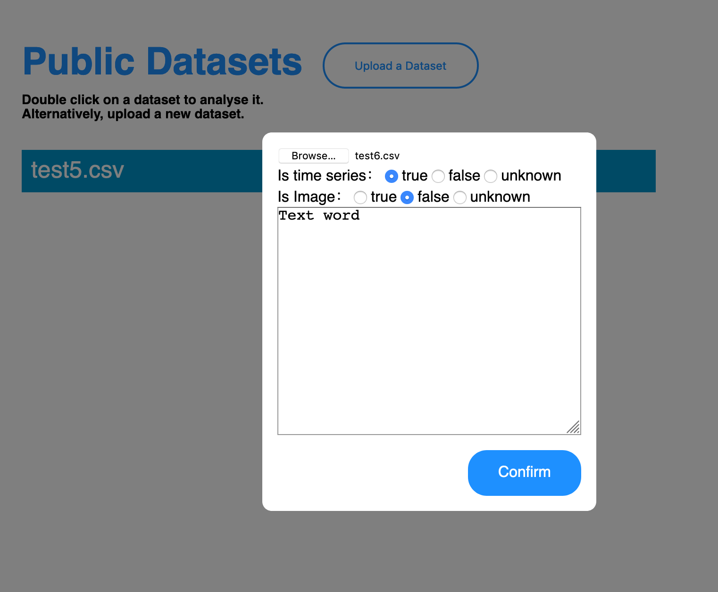

Figure 8: The description for new dataset

When a user double clicks on a dataset, they are taken to a page where the dataset is analyzed. The main function of the analysis page for a dataset is to show the best machine learning algorithm for that dataset. The dataset’s name can clearly be seen at the top of the page (See Figure 9). More information about the dataset is available on the page, such as the features extracted by the data pre-processing routines outlined in section 2.2. Moreover, the user can see the decision tree and the route taken through the decision tree to get to the machine learning algorithm that was chosen. This is helpful for when the system is being used as a teaching aid, as it shows how the machine learning algorithm was decided. A download and delete button were also planned to be available, however the download button was moved to the page with the list of datasets, and the delete feature was never implmented. From the analysis page, it was planned that the user can go to a page where the datasets are visualized. However, the visualisation feature was also abandoned (see section 5.3). Instead, users can go to document page.

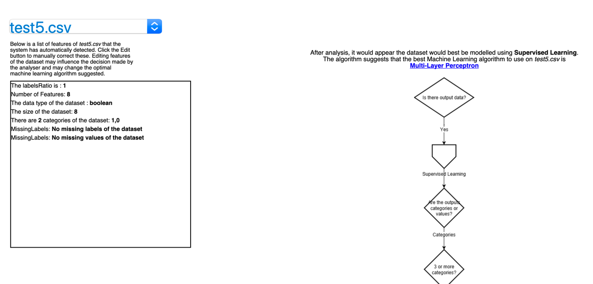

Figure 9: The Analysis Page of the system

In the document page, the name of the machine learning algorithm being shown at the left column, which is a list of all names of machine learning algorithm. The user can acquire definition and decision tree of different types of machine learning algorithms (See Figure 10). The user can see the process how to generate a best machine learning algorithm for datasets as a teaching aid.

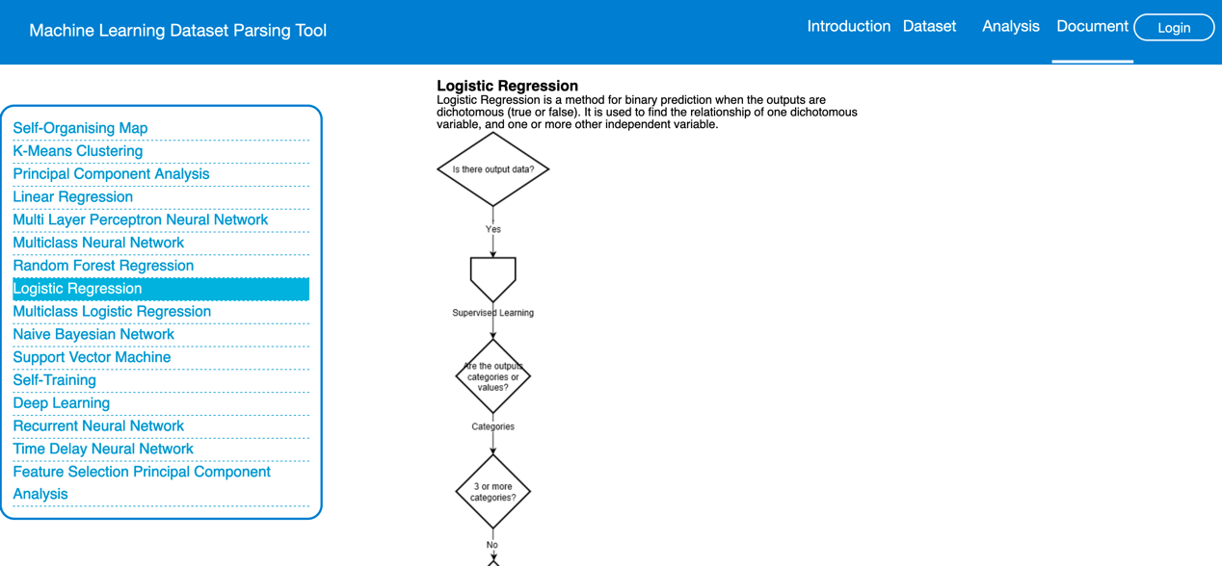

Figure 10: The Document Page of the system

1. Reason that choose these language
   1. HTML

HTML or Hyper-text Mark-up Language is a globally accepted programming language for formatting web pages. Nowadays, it is commonly used along with JavaScript and Cascading Style Sheets (CSS) to give web pages the look and feel.

Through HTML, the look and appearance of images, links, headings, text, page layout and just about every element of a web page can be formatted. Below are some of the advantages of using HTML while creating the website. Firstly, HTML is easy to use and understand. Secondly, all browsers support HTML. Thirdly, HTML is most search engine friendly. At the end, HTML is free. [1] According to these advantages, HTML is used to show all the website information.

* 1. CSS

CSS stands for Cascading Style Sheets. CSS is the standard language for defining styles on web pages. Although CSS is more widely known for its application in HTML documents, it can be used for defining styles for any structured document format. below are some of the advantages of designing web pages with HTML. Firstly, CSS saves time. With CSS, people only have to specify these details once for any elements. CSS will automatically apply the specified styles whenever that element occurs. Secondly, pages load faster. Less code means faster download times. Thirdly, CSS is easy to maintenance. To change the style of an element looks across the whole site, people only have to make an edit in one place. At the end, CSS is superior styles to HTML. CSS is built for styles. HTML is not. While browsers usually display HTML elements in a certain way, people can override this with CSS [2]. According to these advantages, CSS is used to set basic layout and size for different parts.

* 1. JavaScript

JavaScript is used for implementing the functionality because the benefits below. Firstly, client-side JavaScript is very fast because it can be run immediately within the client-side browser. Unless outside resources are required, JavaScript is unhindered by network calls to a backend server. It also has no need to be compiled on the client side which gives it certain speed advantages (granted, adding some risk dependent on that quality of the code developed). Secondly, JavaScript is relatively simple to learn and implement. Thirdly, considering about the sever load. Being client-side reduces the demand on the website server. Fourthly, drag and drop components or slider may give a rich interface to the website. Then, extended functionality is always used in JavaScript. Third party add-ons like Greasemonkey enable JavaScript developers to write snippets of JavaScript which can execute on desired web pages to extend its functionality. At the end, most important advantage is versatility. Nowadays, there are many ways to use JavaScript through Node.js servers. If people were to bootstrap node.js with Express, use a document database like mongodb, and use JavaScript on the front-end for clients, it is possible to develop an entire JavaScript app from front to back using only JavaScript [3].

1. Problem encountered

3.1 website size

In the previous design, using relative localization to implement layout for the different parts, however, it is not adaptive for all kinds of browsers. Thus, method relative localization has been changed to responsive design to adapt different browsers when users are using project website. Below showing the benefits of responsive design. Firstly, using responsive web design improved user experience, a responsive website leads to a better user experience. A major factor indicating the quality of user experience is the time people spend on the site. If users find it hard to navigate or use because of constantly pinch and zoom, users won’t stay on the website. Nevertheless, if the website scales and responds to the change in screen size, then visitors won’t have problems accessing menus, links, buttons or filling out forms. As a result, the user experience will be better and more time will be spent on the site.

1. References

[1] *Advantages of an HTML-based website* [Online]. Available: <http://www.vtech-seo.com/web-design-articles/advantages-of-html.html>

[2] *CSS advantages* [Online]. Available: <https://www.quackit.com/css/tutorial/css_advantages.cfm>

# [3] *12 Important Advantages of Responsive Web Design* [Online]. Available: <https://guide.freecodecamp.org/javascript/advantages-and-disadvantages-of-javascript/>