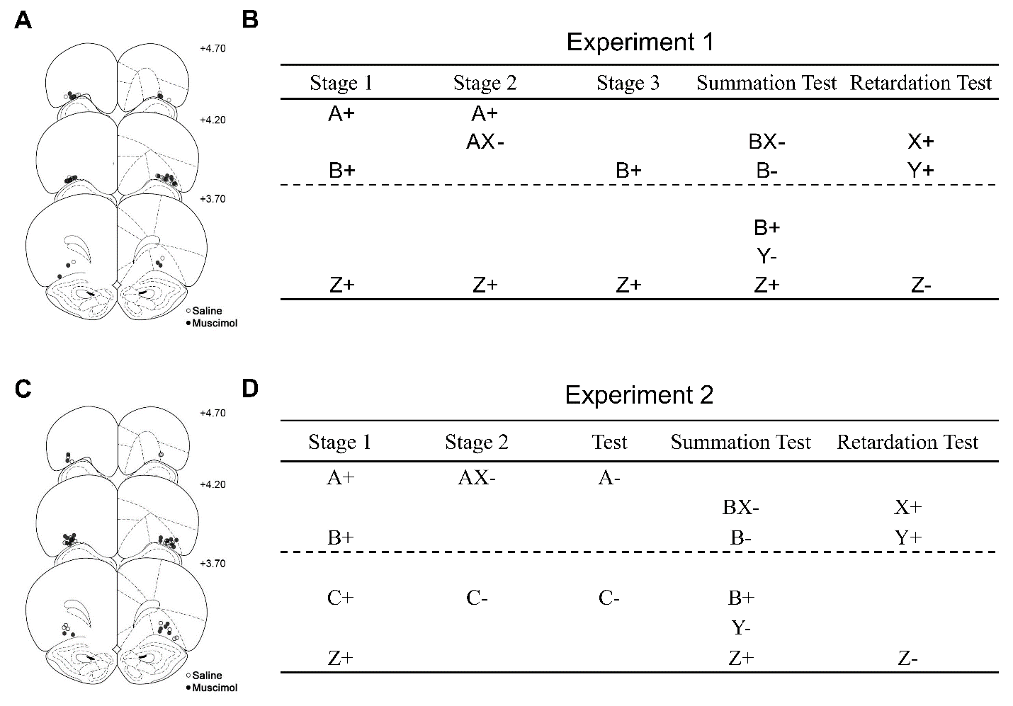

Figure 1. Experiment 1 **(A)** Schematic representation of cannulae tip placements in the OFC. Coronal sections are identified in mm relative to bregma (Paxinos and Watson, 1997). **(B)** The design of experiment 1 intended to establish cue X was a conditioned inhibitor. This is achieved by training cue A as a reliable predictor of reward unless it is simultaneously presented in compound with cue X. The main design is depicted above the dashed line, whereas additional control cues are depicted below the dashed line. A and B are auditory cues (white noise and click), C was always a tone, X and Y are visual cues (house light off and panel lights on), Z was always a flashing magazine light and the symbols "+" and "-" denote reward and non-reward respectively. Infusion of saline or muscimol occurred during stage 2. Experiment 2 **(D) (C)** Schematic representation of cannulae tip placements in the OFC. The design of experiment 2 intended to establish cue X as a conditioned inhibitor. This is achieved by training cue A as a reliable predictor of reward unless it is simultaneously presented in compound with cue X. The key aspects of the procedure are highlighted above the dashed line and additional control cues are presented below the dashed line. A and B are auditory cues (white noise and click), X and Y are visual cues (house light off and panel lights on), Z was always a flashing magazine light and the symbols "+" and "-" denote reward and non-reward respectively. Infusion of saline or muscimol occurred during stage 2.

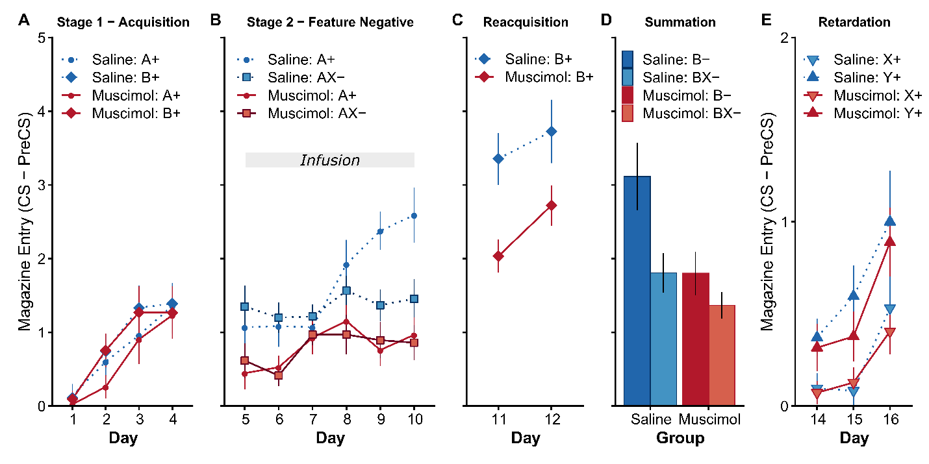

Figure 2. OFC is necessary for the expression but not the learning of conditioned inhibition. Rates of discriminative magazine responding in Experiment 1 presented as CS-PreCS difference scores in 10s. **(A)** Acquisition of responding to cues A+ and B+ in Stage 1. **(B)** Acquisition of the A+/AX- discrimination following saline or muscimol infusions. Following saline infusions, responding to A+ was greater than AX- whereas muscimol infusions abolished differences in responding to A+ and AX-. **(C)** Reacquisition to control cue B+ in stage 3 in the absence of infusions revealed significantly lower responding in the muscimol group. **(D)** A summation test revealed lower responding to BX- than B- in both the saline and muscimol groups (see Supplemental Figure S2 for first 2 trials of the summation test). **(E)** A retardation test revealed significantly lower responding to X+ than to the novel control cue Y+ in both the saline and muscimol groups. Error bars depict ±SEM.

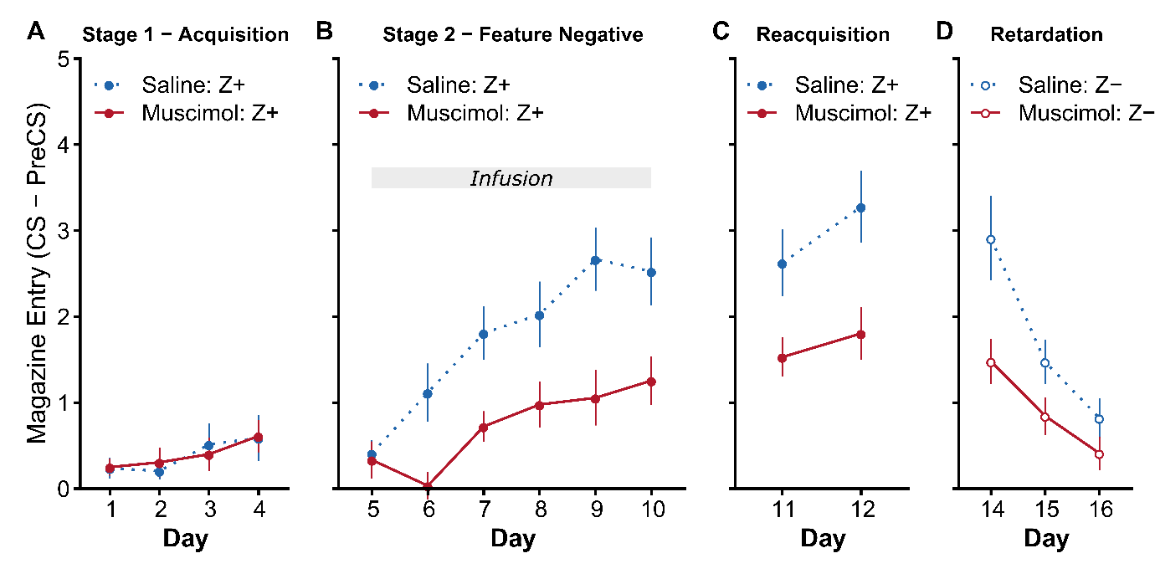

Figure 3. OFC inactivation disrupts Pavlovian acquisition. Responding to control cue Z in Experiment 1 in the test phases described in Figure 2. **(A)** There were no significant group differences in stage 1 acquisition prior to drug infusions. **(B)** The muscimol group responded significantly lower than the saline group in stage 2 and this difference persisted when tested drug free in **(C)** stage 3 and during **(D)** extinction of cue Z in the retardation test. Rates of discriminative magazine responding are presented as CS-PreCS difference scores in 10s. Error bars depict +SEM.

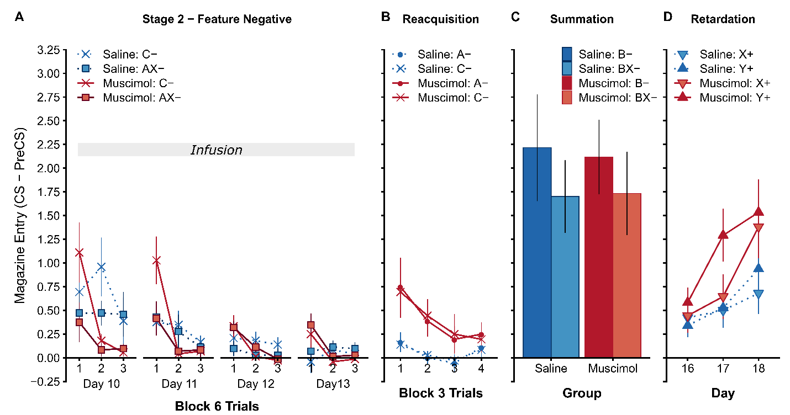

Figure 4. OFC inactivation disrupts between-session extinction and enhances within-session extinction and does not depend on the acquisition of conditioned inhibtion. Experiment 2 **(A)** Extinction of AX- and C- during stage 2 of the conditioned inhibition procedure depicted in blocks of 6 trials within each session. Following saline infusions, responding to AX- and C- declined within- and between-sessions whereas muscimol infusions into LO impaired the retention of extinction between-session extinction. **(B)** Test of the responding to A- and C- drug-free depicted in blocks of 3 trials within the session. Responding in the muscimol group was significantly higher than the saline group but responding did not differ between cues. **(E)** A summation test revealed lower responding to BX- than B- in both the saline and muscimol groups. **(F)** A retardation test revealed similar rats of acquisition to X+ and control cue Y+ in muscimol and saline group. Rates of discriminative magazine responding presented as CS-PreCS difference scores in 10s. Error bars depict +SEM.

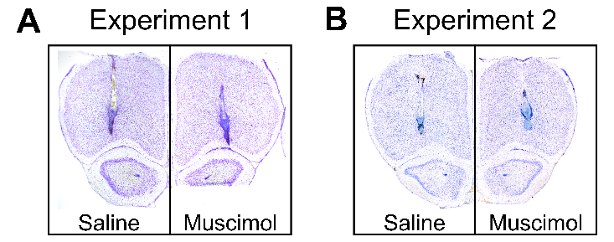

Supplemental Figure S1. Representative photomicrographs of Nissl stained coronal sections depicting cannulae placement in the lateral OFC in the saline (left) and muscimol (right) groups in **(A)** Experiment 1, and **(B)** Experiment 2. Placements estimated at 4.20 mm relative to bregma (Paxinos and Watson, 1997).

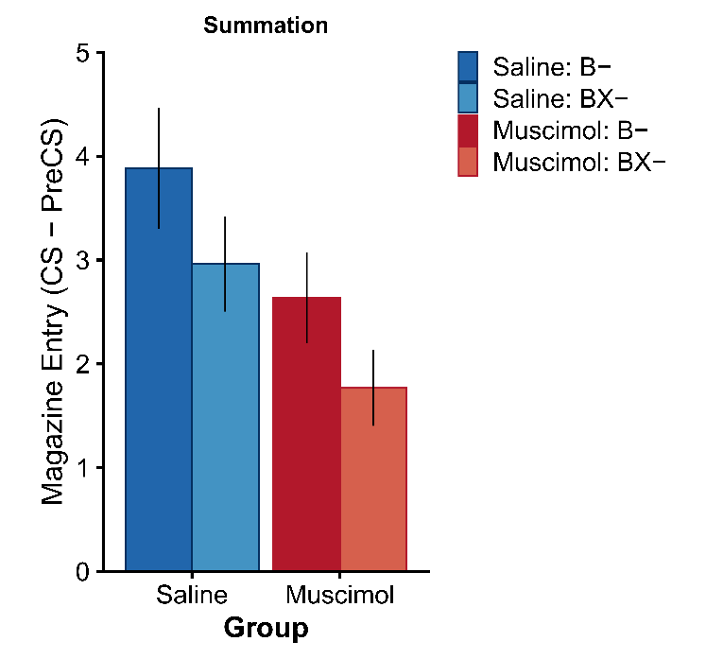

Supplemental Figure S2. The first block of two trials from the summation test in Experiment 1 (full test data shown in Figure 2D). Rates of discriminative magazine responding in presented as CS-PreCS difference scores in 10s. Error bars depict ±SEM.

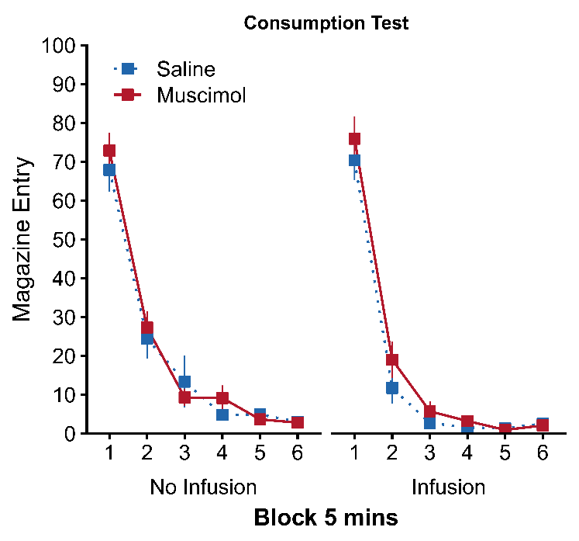

Supplemental Figure S3. OFC inactivation does not affect appetite or vigour of reward approach when rewards are freely available. Magazine frequency in 5-minute blocks following a dummy infusion (No Infusion; Left) and intra- OFC drug infusion (Infusion; Right). All animals ate the 40 reward pellets that were placed in the magazine and freely available from the start of the 30-minute test sessions.

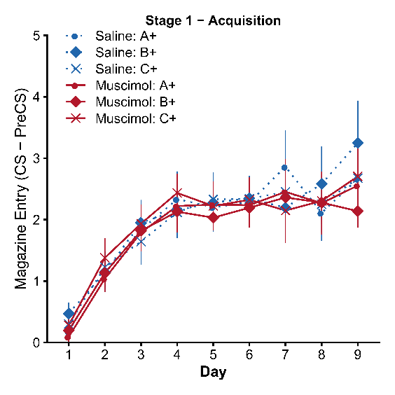

Supplemental Figure S4. Acquisition of conditioned responding to cues A+, B+, and C+ before (days 1-6) and after surgery and post-operative recovery (days 7-9). Rates of discriminative magazine responding presented as CS-PreCS difference scores in 10s. Error bars depict +SEM.

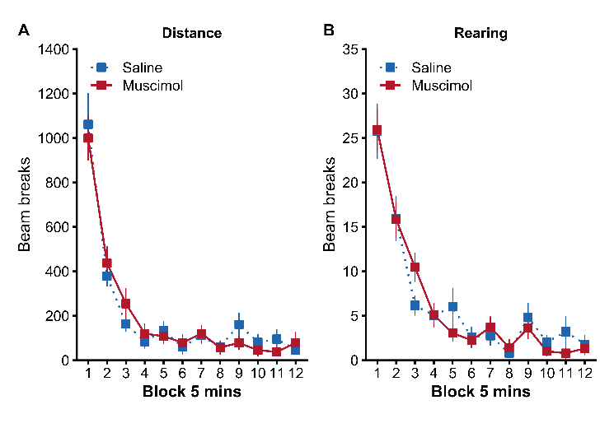

Supplemental Figure S5. OFC inactivation does not disrupt locomotor activity and novelty exploration in a locomotor assay. **(A)** Total distance travelled in blocks of 5 minutes as measured by the total number of infra-red beam breaks. **(B)** Frequency of rearing behaviour travelled in blocks of 5 minutes as measured by the total number of infra-red beam breaks located 14 cm above the floor. Error bars depict +SEM.

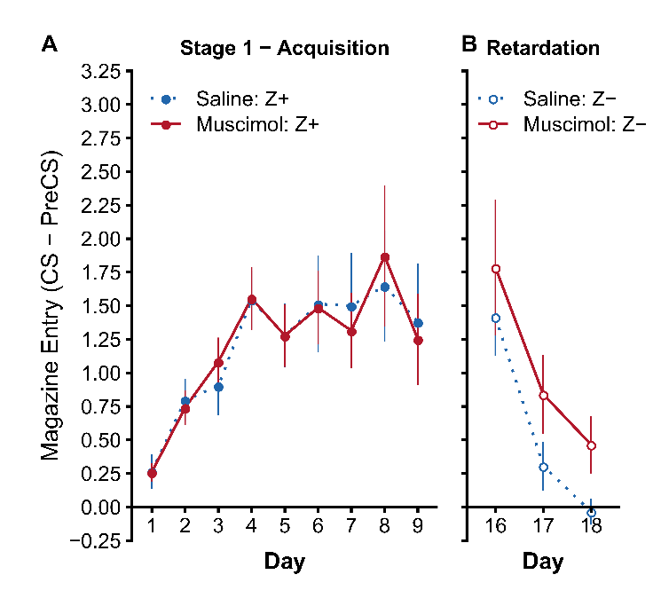

Supplemental Figure S6. Responding to control cue Z in Experiment 2 during **(A)** Stage 1 acquisition, and (B) non-reinforcement during the retardation test. Rats in both groups acquired responding to Z+ in Stage 1 at a similar rate (significant main effect of Day $F(8,176)=8.80$, $p<.001$, but no effect of Group $F(1,22)=0.00$, $p=.997$, or Group*Day interaction $F(8,176)=0.18$, $p=.994$). During the retardation test, responding to non-reinforced cue Z- also decreased at a similar rate in both groups (significant main effect of Day $F(2,44)=20.78$, $p<.001$, but no effect of Group $F(1,22)=2.07$, $p=.164$, or Group*Day interaction $F(2,44)=0.08$, $p=.925$). Rates of discriminative magazine responding presented as CS-PreCS difference scores in 10s. Error bars depict +SEM.