LY354740_Expt3_4_Locomotor_FoodDep_AdLib

Marios Panayi

4/22/2020

# Experiment 3. Locomotor Activity Food Dep LY & Amph

Following injections, Amphetamine significantly increased locomotor activity (Amph $F(1,24)=159.81$, $p<.001$, Amph x Time $F(11,264)=2.29$, $p=.011$). However, in contrast to previous reports, LY354740 significantly enhanced this hyperactivity over time rather than reduce it (Amph x LY354740 x Time $F(11,264)=1.99$, $p=.029$, Amph x LY354740 $F(11,264)=1.99$, $p=.029$). LY354740 significantly increased Amph induced hyperactivity 61-120 mins post injection (Amph/LY354740 vs Amph/Veh $t(24)=3.00$, $p=.006$) but not 1-60 mins post injection ($t(24)=1.18$, $p=.250$). In contrast, LY354740 alone did not affect locomotor activity (Veh/LY354740 vs Veh/Veh, 1-60 mins $t(24)=−0.88$, $p=.389$, 61-120 mins $t(24)=−0.63$, $p=.534$).

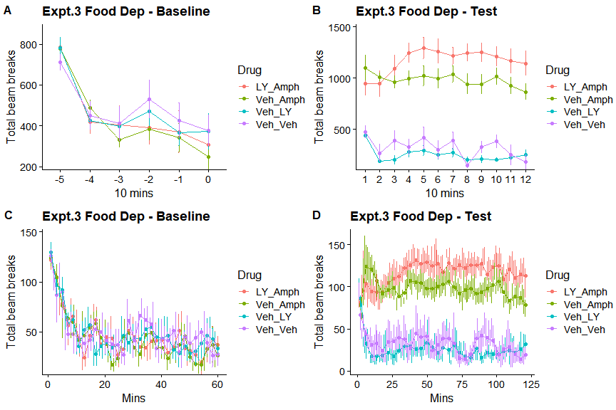

# Experiment 4. Locomotor Activity Food Dep LY & Amph

Following injections, Amphetamine significantly increased locomotor activity (Amph $F(1,32)=169.74$, $p<.001$, Amph x Time $F(11,352)=5.22$, $p<.001$).Furthermore, LY354740 significantly enhanced this reduced this hyperactivity (Amph x LY354740 x Time $F(11,352)=2.86$, $p=.001$, Amph x LY354740 $F(11,352)=2.86$, $p=.001$). LY354740 significantly reduced Amph induced hyperactivity 1-60 mins post injection (Amph/LY354740 vs Amph/Veh $t(32)=−5.00$, $p<.001$) but not 61-120 mins post injection ($t(32)=−0.78$, $p=.440$). In contrast, LY354740 alone did not affect locomotor activity (Veh/LY354740 vs Veh/Veh, 1-60 mins $t(32)=−0.51$, $p=.615$, 61-120 mins $t(32)=−0.01$, $p=.990$).

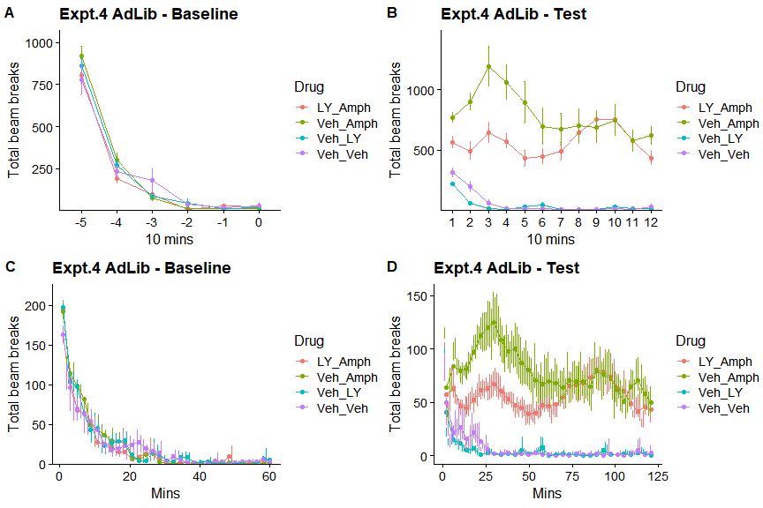

##### 

# Eperiment 5 Locomotor Activity Dose Amphetamine Feeding Manipulation

Prior to Amph administration, locomotor activity was significantly lower following food restriction than Ad libitum food access (Feeding $F(1,82)=5.19$, $p=.025$, Feeding x Time $F(5,410)=5.45$, $p<.001$).

Following injections, both food restriction (Feeding $F(1,67)=2.22$, $p=.141$, Feeding x Time $F(11,737)=3.13$, $p<.001$) and amphetamine (Amph $F(3,67)=21.64$, $p<.001$, Amph x Time $F(33,737)=7.91$, $p<.001$) independently enhanced locomotor activity, however they did not significantly interact with each other (Amph x Feeding x Time $F(33,737)=0.62$, $p=.954$, Amph x Feeding $F(3,67)=0.54$, $p=.656$, ). Varying doses of amphetamine produced a dose response curve such that all doses of amphetamine increased activity relative to vehicle injections (0 vs 1.0 mg/kg $t(67)=−3.77$, $p=.002$, 0 vs 2.5 mg/kg $t(67)=−7.73$, $p<.001$, 0 vs 5.0 mg/kg $t(67)=−5.80$, $p<.001$), and 2.5 mg/kg produced the highest response (1.0 vs 2.5 mg/kg $t(67)=−4.28$, $p<.001$, 2.5 vs 5.0 mg/kg $t(67)=2.09$, $p=.167$, 1.0 vs 5.0 mg/kg $t(67)=−2.19$, $p=.136$).

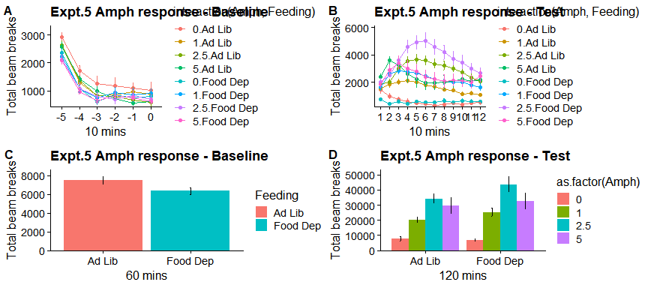

# Blood Serum levels of Amph

One potential account for the differential effects of feeding state on amphetamine-induced locomotor activity could be differential metabolism resulting in different blood levels of amphetamine. This was tested by sampling blood amphetamine levels in ad libitum and food deprived rats injected with either 1.0, 2.5, or 5.0 mg/kg of amphetamine. During the first our after injection (15 & 30 mins), blood levels of amphetamine increased with injection dose (Amph $F(2,18)=7.84$, $p=.004$, 1.0 vs 2.5 mg/kg $t(18)=−0.97$, $p=.606$, 1.0 vs 5.0 mg/kg $t(18)=−3.80$, $p=.004$, 2.5 vs 5.0 mg/kg $t(18)=−2.89$, $p=.025$), and reduced over time (Time $F(1,18)=16.18$, $p=.001$, Amph x Time $F(2,18)=1.41$, $p=.271$). However, feeding state did not signficantly affect blood levels of amphetamine (Feeding $F(1,18)=0.15$, $p=.701$, Feeding x Time $F(1,18)=0.56$, $p=.463$), or interact with amphetamine dose (Amph x Feeding $F(2,18)=0.18$, $p=.834$, Feeding x Amph x Time $F(2,18)=1.23$, $p=.316$).

