LY354740_WM_TMaze_Expts12

Marios Panayi

4/28/2020

# Experiment 1 - LY354740 impairs spatial working memory

Accuracy and latency during the sample and choice phase were significantly affected by LY354740 injections (Accuracy $F(3,81)=4.10$, $p=.009$, Sample Latency $F(3,81)=6.42$, $p=.001$, Choice Latency $F(3,81)=6.21$, $p=.001$). This was mainly due to a significant reduction in accuracy at the 10 mg/kg dose (No Inj vs 10 mg/kg $t(27)=2.76$, $p=.047$, Veh vs 10 mg/kg $t(27)=3.54$, $p=.007$), and an increase in latency at the 10 mg/kg dose during the sample (No Inj vs 10 mg/kg $t(27)=−4.04$, $p=.002$, Veh vs 10 mg/kg $t(27)=−3.01$, $p=.027$, 1 vs 10 mg/kg ) and choice phases (No Inj vs 10 mg/kg $t(27)=−3.40$, $p=.011$).

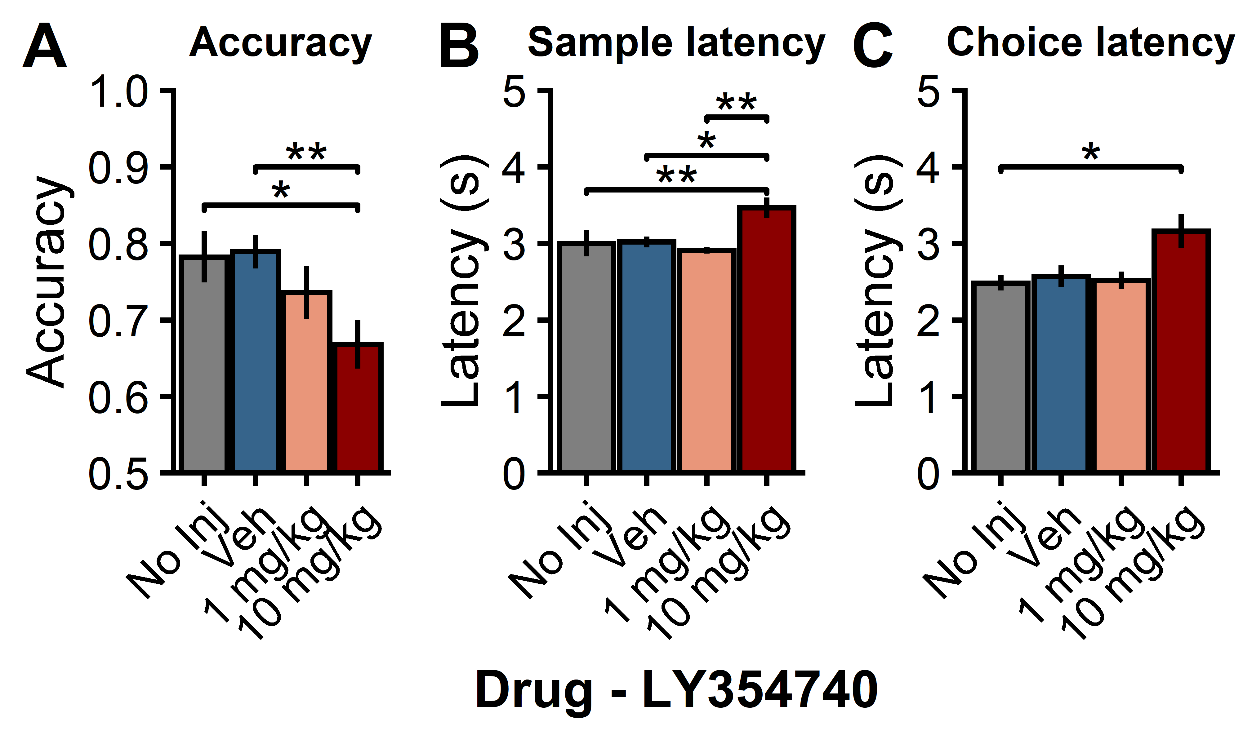

Figure 1. Title and Caption

# Experiment 2 - LY354740 exacerbates amphetamine-induced working memeory deficits

Drug injections significantly disrupted all three performance measures on the spatial working memory task (Drug: accuracy $F(2,52)=8.15$, $p=.001$, sample latency $F(2,52)=8.83$, $p<.001$, choice latency $F(2,52)=21.17$, $p<.001$). Compared to vehicle injections, amphetamine disrupted performance on the spatial working memory task, surprisingly this effect was only statistically robust for response latencies during the choice period (veh/veh vs Amph/veh: accuracy $t(26)=1.64$, $p=.249$), sample latency $t(26)=−2.45$, $p=.054$, choice latency $t(26)=−3.15$, $p=.011$). However, combining LY354740 and amphetamine significantly impaired accuracy (veh/veh vs Amph/LY354740 $t(26)=4.03$, $p=.001$, Amph/veh vs Amph/LY354740 $t(26)=2.82$, $p=.024$), and increased response latencies during both the sample (veh/veh vs Amph/LY354740 $t(26)=−5.27$, $p<.001$, Amph/veh vs Amph/LY354740 $t(26)=−1.54$, $p=.291$) and choice periods veh/veh vs Amph/LY354740 $t(26)=−7.42$, $p<.001$, Amph/veh vs Amph/LY354740 $t(26)=−3.00$, $p=.016$).

