Reversal learning procedures have significant potential to further understanding and treatment of disorders of compulsivity (DOC) such as obsessive-compulsive disorder and cocaine addiction. Reversal learning tasks measure behavioural flexibility by changing the meaning of cues guiding when to act and when to withhold behaviour. Impairments in reversal learning are a reliable feature of both clinical and translational models of DOC. Reversal learning provides an important method to understand and test pharmacological treatments of DOC. A key neuropathology underlying DOC and causing reversal learning deficits is Orbitofrontal cortex (OFC) dysfunction. In reversal learning, distinct subpopulations of OFC neurons respond to cues that signal when to perform or withhold behaviour, and flexibly update firing when cue contingencies change. A history of cocaine use significantly impairs both flexible updating of behaviour and OFC activity in reversal learning.

More generally, OFC activity is thought to reflect an internal cognitive model of a task/our environment. Prior history of cocaine use has been found to disrupt the flexible use and updating of these OFC representations, and optogenetic stimulation of OFC during learning effectively treats this impairment in rodents. This suggests that cocaine use impairs flexible updating of an internal model of the task within the OFC, leading to inflexible and persistent behaviour in reversal learning. However, in the reversal learning tasks commonly used, representations of internal cognitive maps cannot be disentangled from simple task features such as the presence or absence of reward. This is because the implementation designed to enforce the introduction of alternative maps utilizes the reward associations themselves. That is, the reversal is signaled to the subject by a change in cue-reward associations. Further, this approach confounds time and recognition of its passage, and leaves the decision whether to even create alternative maps up to the subject. The argument is that OFC function is necessary for rapid reversal learning because it facilitates the creation, maintenance or use of these alternative maps; however it could equally well be argued (and in fact has) that this deficit, viewed in isolation, is simply due to slower learning or deficits in response inhibition. To resolve these issues, it is necessary to use a behavioral approach that dissociates the cue that triggers changes in the map being used from these other features and requires mapping for successful performance. One such task that still shares many of the features of reversal learning that makes it so popular is an occasion setting task.

(EXPLAIN OS HERE I THINK And WHY IT IS GREAT)

Here I will use occasion setting to test how OFC function and dysfunction relate to flexible behavioural control. OFC dysfunction and its relation to impaired behaviour relevant to DOC will be manipulated by comparing behaviour and electrophysiology in rats with and without a history of cocaine use, focusing on the hypothesis that OFC’s processing of the occasion setter is the critical contribution. Further, I assess whether the loss of control caused by a history of cocaine use relates to changes in the underlying function we identify and whether this loss of control and associated neural measures in OFC can be restored using a promising novel drug compound. These experiments will help bridge the gap in understanding how OFC function plays a fundamental role in both reversal learning and neuropathology of DOC.

**Aims**

**Aim 1. I will determine whether representations of task space formed during reversal learning are disrupted in OFC in rats with a history of cocaine use.**

Rats will be trained to self-administer sucrose or cocaine followed by 3 weeks of abstinence to generate a model of impaired OFC dependent reversal learning that has been established in the lab. I will then record neural activity in these rats from OFC in a modified reversal learning task that dissociates neural activity related to observable task features (e.g. cue identity) from general task structure (e.g. cue meaning). This will test the hypothesis that reversal learning deficits are related to impaired representations of abstract task space in OFC.

**Significance.**

Disorders of compulsion, such as OCD, addiction, depression, attention-deficit hyperactivity disorder, and schizophrenia, are characterized by deficits in reversal learning and altered OFC function, a key region in the fronto-striatal neuropathology of these disorders.

Compulsive and neurotypical behaviours do not occur in a vacuum, but instead are elicited and informed by informative cues in our environment. Reversal learning procedures model this with discrete cues (e.g. odors) that indicate whether a behaviour (e.g. checking a location) will lead to a biologically meaningful outcome (e.g. food). In a typical procedure, subjects first learn to discriminate responding to a rewarded (A+) and non-rewarded (B-) cue, and then these cue-outcome relationships are reversed i.e. A- and B+. A reversal deficit is characterized by subject’s taking significantly longer to reach a threshold of behavioural accuracy following reversal. Distinct populations of neurons in OFC increase firing to rewarded and non-rewarded cues before and after reversal. This is consistent with a mental representation of task structure being updated in OFC, which is the general function proposed by current computational reinforcement learning models of OFC. Prior use of cocaine significantly impairs reversal learning behaviour and the flexibility of OFC activity to adapt to the new contingencies, suggesting that cocaine use impairs flexible updating of task representations in OFC. However, in this simple task the identity and value (average reward history) of each cue are significantly correlated. The meaning and identity of cues in the task can be separated by making cue-reward relationships conditional on other information/cues i.e. A is rewarded when preceded by cue X, but not cue Y (X->A+, Y -> A-), and B is rewarded when preceded by cue Y, but not X (X->B-, Y -> B+). Neural activity to cues A and B are now meaningful only in the context of preceding cues X and Y. A reversal of these contingencies (i.e. X->A- / Y -> A+ and X->B+ / Y -> B-), allows for an analysis of updating neural representations of task structure that can be dissociated from cue identity and value.

Are reversal learning deficits following a history of cocaine related to impaired flexibility of task representation in OFC? **I will use a combination of single unit recording, manipulated history of cocaine use, and a conditional reversal procedure to address this question. If this is true, then the neural ensembles in OFC will show flexible updating of task structure in control animals that is impaired in animals with a history of cocaine use. These results will then be computationally modeled within the reinforcement learning framework currently used to understand OFC function.** The present study will further our understanding of how broader theories of OFC function relate to behavioural flexibility in reversal learning, a neural substrate and procedure with significant translational relevance to disorders of compulsivity.

**Aim 2. I will test the efficacy of a novel D3 antagonist to treat reversal learning deficits in rats with a history of cocaine use.**

Cocaine experienced and naïve rats will be tested on reversal learning (as described in Aim 1) in combination with an injection of a novel D3 antagonist or vehicle prior to the reversal learning stage. This will test the translational potential of a novel class of pharmacological treatments for addiction to treat compulsive and inflexible behaviours that persist in drug users long after drug use has stopped.

**Significance.**

A history of drug use can significantly increase compulsive and inflexible behaviour and learning even long after drug taking has ended. Reversal learning deficits are sensitive to these long-term behavioural issues, and have been demonstrated in rodents, non-human primates, and human clinical populations. A novel class of highly selective dopamine receptor D3-antagonists developed at NIDA have shown significant potential to treat drug seeking and taking behaviours. However, it is unknown whether they have the potential to treat compulsive and inflexible non-drug behaviours caused by a prior history of drug use.

Here, I will assess whether reversal deficits caused by a history of cocaine use can be treated by administration of a selective D3-antagonist prior to reversal learning. I will test this by manipulating prior cocaine history and using the reversal learning task described in Aim 1, and inject rats with the D3-antagonist or vehicle immediately prior to reversal learning. If the D3-antagonist is effective at treating reversal deficits, I expect to see that cocaine-treated animals injected with the D3-antagonist to take fewer trials to learn the reversal than cocaine-treated animals injected with vehicle. The present study will provide an important translational step in drug development for the treatment of the acute and long-term consequences of addiction, a disorder associated with increased compulsivity. An effective pharmacological treatment targeting D3 receptors has the potential to treat behavioural inflexibility in other disorders of compulsivity.

**Approach**

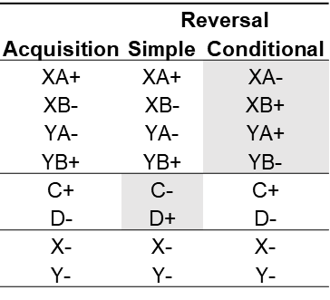**Expt 1.**

*Experimental design. X and Y are auditory cues, cues A-D are odors, and pairs of cues reflect sequential presentation of an auditory cue followed by an odor. Rewarded Go trials are indicated by “+”, and non-rewarded NoGo trials are indicated by “-”.*

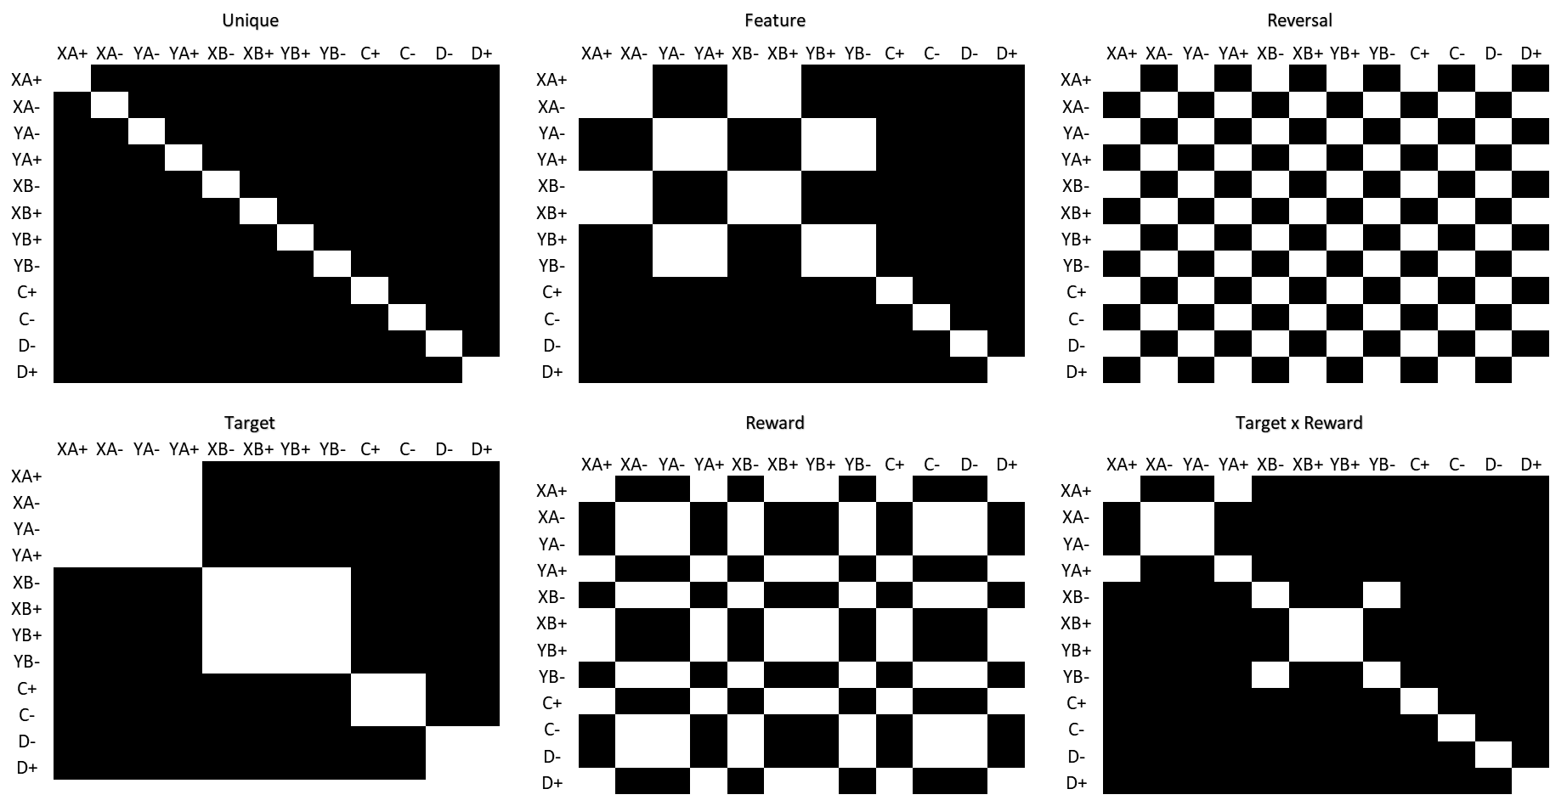

Hypothesized results in sucrose control rats. Colors represent proportion of correctly classified trials from zero (black) to a high proportion (white). White indicates that the representation of these trial types is more similar.

-----

Expt 2.



*Predicted behaviour if the drug is effective. Trials to criterion levels of accuracy during reversal (performance levels adapted from results published in the lab).*

*-----*

*Alternative strategies, pitfalls and future directions.* Cocaine history is expected to cause a significant reversal deficit to the simple reversal control cues in Expt 1, but this might not be true for the more complex conditional cues. This scenario will still provide interesting and meaningful behavioural and neural information addressing Aim 1 but would suggest that the experimental design is inappropriate for Expt 2. If this is the case, a simple reversal design will be employed in Expt 2 to test the efficacy of the D3-antagonist without losing any translational relevance. Cocaine history has been shown to disrupt both OFC function and behaviour in the simple reversal design commonly used in this lab.