**Methods**

*Animals.* Rats were housed four per cage in ventilated Plexiglass cages in a temperature regulated (22 ± 1­°C) and light regulated (12h light/dark cycle, lights on at 7:00 AM) colony room. At least one week prior to behavioural testing, feeding was restricted to ensure that weight was approximately 95% of ad libitum feeding weight, and never dropped below 85%. All animal research was carried out in accordance with the National Institute of Health Guide for the Care and Use of Laboratories Animals (NIH publications No. 80-23, revised 1996) and approved by the University of New South Wales Animal Care and Ethics Committee. Subjects were and one hundred and twelve male Wistar rats (BRC Laboratory Animal Service, University of Adelaide, South Australia, Australia) approximately 4 months old (Experiment 1, N = 32, weighing between 343-452 g, M = 403.6 g; Experiment 2, N = 64, weighing between 343-452 g, M = 403.6 g).

*Apparatus.* Behavioural testing was conducted in eight identical operant chambers (30.5 x 32.5 x 29.5 cm; Med Associates) individually housed within ventilated sound attenuating cabinets. Each chamber was fitted with a 3-W house light that was centrally located at the top of the left-hand wall. Food pellets could be delivered into a recessed magazine, centrally located at the bottom of the right-hand wall. Delivery of up to two separate liquid rewards via rubber tubing into the magazine was achieved using peristaltic pumps located above the testing chamber. The top of the magazine contained a white LED light that could serve as a visual stimulus. Access to the magazine was measured by infrared detectors at the mouth of the recess. Two retractable levers were located on either side of the magazine on the right-hand wall. A speaker located to the right of the house light could provide auditory stimuli to the chamber. In addition, a 5-Hz train of clicks produced by a heavy-duty relay placed outside the chamber at the back right corner of the cabinet was used as an auditory stimulus. The chambers were wiped down with ethanol (80% v/v) between each session. A computer equipped with Med-PC software (Med Associates Inc., St. Albans, VT, USA) was used to control the experimental procedures and record data.

*Devaluation chambers.* To provide individual access to reinforcers during the devaluation procedure, rats were individually placed into a mouse cage (33 x 18 x 14 cm clear Perspex cage with a wireframe top). Pellet reinforcers were presented in small glass ramekins inside the box and liquid reinforcers were presented in water bottles with a sipper tube. 1 day prior to the start of the devaluation period, all rats were exposed to the mouse cages and given 30 mins of free access to home cage food and water to reduce novelty to the context and consuming from the ramekin and water bottles.

*Reinforcers***.** The reinforcers used were a single grain pellet (45 mg dustless precision grain-based pellets; Bio-serv, Frenchtown, NJ, USA), 20% w/v sucrose solution and 20% w/v maltodextrin solution (Myopure, Petersham, NSW, Australia). Liquid reinforcers were flavoured with either 0.4% v/v concentrated lemon juice (Berri, Melbourne, Victoria, Australia) or 0.2% v/v peppermint extract (Queen Fine Foods, Alderley, QLD, Australia) to provide unique sensory properties to each reinforcer. Liquids were delivered over a period of 0.33 s via a peristaltic pump corresponding to a volume of 0.2 mL. The volume and concentration of liquid reinforcers was chosen to match the calorific value of the corresponding grain pellet reward, and have been found to elicit similar rates of Pavlovian and instrumental responding as a pellet reward in other experiments conducted in this lab. In all experiments involving liquids, the magazine was scrubbed with warm water and thoroughly dried between sessions to remove residual traces of the liquid reinforcer. To reduce neophobia to the reinforcers, one day prior to magazine training sessions all animals were pre-exposed to the reinforcers (10 g of pellets per animal and 25 ml of liquid reinforcer per animal) in their home cage.

*Magazine training.* In all experiments, animals received two sessions of magazine training, one for each reinforcer with the following parameters: reward delivery was on an RT60 s schedule for 16 rewards with the house light and fan kept on throughout the session. Sessions were separated by at least 2 hours.

Experiment 2. Sensory Specific Satiety and Pavlovian to Instrumental Transfer Single Lever

Acquisition Training

On each day all animals received either a single Pavlovian training session, or two instrumental training sessions. The order of Pavlovian and instrumental sessions alternated each day.

Pavlovian Training

All animals received a total of 6 days of Pavlovian training. Pavlovian training sessions consisted of 3 CSs, a 2800 Hz, 80 dB tone, 78 dB white noise and a 5 Hz train of clicks. There were 4 presentations of each cue (i.e. a total of 12 cues presented within a session) each lasting 2 mins with a variable ITI of 300s. Reward was delivered throughout the cue period on a RT 30s schedule. Each cue was paired with a unique outcome (grain pellet, lemon sucrose, and peppermint maltodextrin) and the identity of that outcome remained constant. All unique cue-outcome combinations were counterbalanced across animals and within groups.

Instrumental Training

Prior to Pavlovian and instrumental acquisition training all animals were given 2 days of lever training on a continuous reinforcement schedule (each lever press was rewarded) using the same parameters as the instrumental training sessions.

All animals received a total of 6 days of instrumental training. Instrumental training involved two sessions per day, separated by at least one hour. During the session a single lever was extended and lever pressing was rewarded with a unique liquid outcome, either lemon sucrose or peppermint maltodextrin. During the second instrumental session of the day, a different lever was extended and lever pressing was rewarded with the unique liquid outcome that was not paired with the earlier lever. The identity of the lever outcome pairings was kept constant throughout training and was counterbalanced between subjects and within groups. Training sessions lasted until a maximum of 20 rewards was earned or until 30 mins had elapsed. On the first two days, reinforcement was delivered on a random ratio 5 schedule (RR5) such that on average a reward was delivered every 5 lever presses, followed by four days of RR10.

Devaluation

Satiety devaluation was achieved by providing rats with 1 hour of free access to one of the liquid reinforcers in the devaluation chamber. At the end of the 1 hour period animals were removed from the devaluation chamber and put back in their home cage and immediately transferred to the test chambers. One of the liquid reinforcers was devalued using this method on two consecutive days to allow a test on each lever. Following 2 further days of Pavlovian and instrumental training, the alternative liquid reinforcer was devalued for two days. This resulted in both liquid reinforcers being devalued and tested with each lever.

PIT Test

The PIT test involved a single lever presented at the start of the session for 10 mins with no programmed consequences to extinguish lever pressing behavior to a low baseline rate (this allows for clearer demonstration of the potential rate-enhancing effect of CS presentations). Then the CSs were played for 2 min with a fixed 2 min inter-stimulus interval. Each CS was played three times (a total of 9 CS presentations) and the order of CS presentation was randomized. Throughout the session no rewards were delivered and lever pressing and magazine entry were recorded with no programmed consequences. A second identical test session was conducted on the following day using the lever that had yet to be tested. Order of lever presentation was counterbalanced. This pattern of tests was repeated once after 4 days of retraining on Pavlovian and instrumental sessions.

**The effect of sensory specific satiety on Pavlovian cue representations**

The rodent OFC appears to be critical to updating cue-guided behaviour when the value of the outcome is devalued by taste aversion but not by specific satiety processes. Both methods of devaluation are used interchangeably to probe an organism’s ability to update behaviour the value of an outcome changes, and to establish learning about associations between cues and specific outcome identities (Balleine, Killcross, & Dickinson, 2003; Killcross & Blundell, 2002). However, while these two devaluation methods are often used interchangeably, it is unclear whether they engage the same or different associative mechanisms. It is possible that sensory specific satiety procedures provide multiple mechanisms for reducing behaviour to the devalued cue which are not available in taste aversion procedures. One difference between these two methods of devaluation is that sensory specific satiety involves the reduction of value by satiation, but also by habituation of the sensory representation of the outcome i.e. specific satiety not only reduces the value of the expected outcome but also the ability to excite the representation of an outcome’s sensory properties. In contrast taste aversion has been argued to leave the sensory identity of the predicted outcome intact, and only modifies its associated value (Colwill & Rescorla, 1988, 1990; Holland, 2004).

Taste aversion devaluation mechanisms have been successfully explored using Pavlovian-to-instrumental transfer procedures (PIT) (Colwill & Rescorla, 1988, 1990; Holland, 2004), in which Pavlovian cues selectively increase instrumental responding when both cue and response predict the same outcome, i.e. the specific PIT effect. In conditioning, cues and instrumental responses can form independent associations with both the sensory and the general motivational properties of an outcome (Gilroy, Everett, & Delamater, 2014), and in specific PIT it is the predicted sensory properties of the Pavlovian cue that appear to drive instrumental responding for the same outcome. This mechanism is supported by the finding that taste aversion devaluation does not disrupt specific PIT because the taste aversion does not change the sensory properties of predicted outcomes, only their associated motivational value. If the effects of specific satiety differ from taste aversion by virtue of habituating the sensory properties of an expected outcome, then it would be predicted that the expected outcome would lose its specific signalling properties in a specific PIT procedure. This hypothesis was assessed directly by testing the effect of specific satiety on specific PIT.

First, rats were trained on two unique lever-outcome relationships and three unique Pavlovian cue-outcome relationships. Instrumental training was for liquid sucrose and maltodextrin rewards, whereas Pavlovian cues predicted either liquid sucrose, maltodextrin, or food pellet rewards (supplementary results).

Prior to PIT testing, one of the two instrumental outcomes was devalued by specific satiety (supplementary results). Instrumental responding was sensitive to the selective reduction in outcome value (Figure 3A) during a pre-test instrumental extinction session. Responding was significantly reduced on the lever associated with the devalued outcome compared to the non-devalued outcome. This significant devaluation effect was observed at the start of extinction but disappeared when responding on both levers had extinguished by the end of extinction. This was supported by a significant main effect of Block (*F*(3, 39) = 25.60,  *p* < .001) and Devaluation x Block interaction(*F*(3, 39) = 4.43,  *p* = .009), but no effect of Devaluation (*F*(1, 13) = 3.40,  *p* = .09). Specifically, non-devalued was significantly higher than devalued lever responding in block 1 (*F*(1, 13) = 13.70,  *p* = .003) and block 2 (*F*(1, 13) = 8.84,  *p* = .02), but not blocks 3 and 4 (*F’s* < 1.0, *p’s* > .84). In contrast to lever pressing, magazine behaviour (Figure 3B) did not differ between devaluation conditions during the lever extinction period (Devaluation x Block ANOVA, all *F’*s < 2.58*, p’s* > .07).

During the PIT test, the sensory specific PIT effect was observed on the non-devalued lever, but this effect was selectively abolished on the devalued lever (Figure 3C). Specifically, responding on the non-devalued lever was greatest in the presence of the Cue that predicted the same outcome (Same vs. Different, *F*(1, 13) = 5.98,  *p* = .04; Same vs. General, *F*(1, 13) = 20.37,  *p* < .001), and responding during the different cue was greater than during the general cue (*F*(1, 13) = 4.28,  *p* = .049). Responding on the devalued lever did not differ in the presence of the different cues (all *F’*s < 3.19*, p’s* > .2). This pattern of simple effects was supported by a Devaluation (Non-Devalued, Devalued) x Cue (Same, Different, General) ANOVA which revealed a significant main effect of Cue (*F*(2, 26) = 5.93,  *p* = .01), and a Devaluation x Cue interaction (*F*(2, 26) = 4.38,  *p* = .02), but no main effect of Devaluation (*F*(1, 13) = 3.934,  *p* = .07). An additional planned comparison of responding during the Same cue revealed a significant decrease in responding on the devalued lever compared to the non-devalued lever (*F*(1, 13) = 11.87,  *p* = .007). In contrast to lever pressing, magazine behaviour (Figure 3D) did not differ between devaluation or cue conditions during the test (Devaluation x Cue ANOVA, all *F’*s < 1*, p’s* > .51), suggesting that the effects on lever pressing were not confounded by differences in competing magazine responding to the cues.

These findings suggest that one associative pathway that might contribute to behavioural control in Pavlovian devaluation tasks using specific satiety is habituation or a reduction in the signalling efficacy of the sensory specific properties of expected outcomes. In contrast, devaluation using taste aversion leaves the signalling properties of expected outcomes intact (Holland, 2004; Rescorla, 1992). Given that lesions of the rodent OFC disrupt devaluation by taste aversion (Gallagher et al., 1999; Pickens et al., 2003, 2005), the intact devaluation we observe following specific satiety in OFC lesioned animals can be accounted for by this alternative pathway. Specifically, OFC lesions disrupt the use of specific outcome properties to access the current motivational value of an expected outcome (as required by taste aversion devaluation), but do not disrupt the representation of the sensory specific properties of expected outcomes per se. In fact, pre-training OFC lesions do not disrupt specific Pavlovian to instrumental transfer (Ostlund & Balleine, 2007), an effect we have confirmed with our lesion and behavioural parameters (supplementary Figure S1).

**Supplementary Results –** **Effect of sensory specific satiety on specific Pavlovian to instrumental transfer**

*Exclusions*

Two rats were excluded based on a substantial response bias to one cue. Responding was over 4x higher to one CS suggesting substantial cue or outcome preference.

*Behavioural results*

Instrumental

Acquisition of instrumental responding for the sucrose and maltodextrin rewards occurred at a similar rate, and did not differ on the final day of acquisition (lever presses per min; Sucrose, *M* = 28.87, *SD* = 9.97; Maltodextrin, *M* = 27.53, *SD* = 7.68). A Reward (Sucrose, Maltodextrin) x Session (1-6) ANOVA revealed that lever pressing significantly increased across sessions (main effect of *F*(5, 65) = 129.71,  *p* < .001, positive linear trend *F*(1, 13) = 92.91,  *p* < .001 ) but did not significantly differ between reward type (all remaining *Fs* < 1.00, *p* > .84).

Pavlovian

The rate of acquisition was greater for the cues predicting sucrose and maltodextrin than for the cue predicting pellets, however there were no differences in responding by the final day of acquisition (time spent in magazine during 2 minute cue above 2 minute baseline; Sucrose, *M* = 46.32 s, *SD* = 17.57; Maltodextrin, *M* = 52.60 s, *SD* = 15.06; Pellet, *M* = 39.22 s, *SD* = 19.89). A Reward (Sucrose, Maltodextrin, Pellet) x Session (1-6) ANOVA revealed significant main effects of Session (*F*(5, 65) = 11.24,  *p* < .001, positive linear trend *F*(1, 13) = 27.66,  *p* < .001) and Reward (*F*(2, 26) = 22.28,  *p* < .001; Session x Reward interaction did not reach significance *F*(10, 130) = 1.41,  *p* = .18). During acquisition responding did not differ between Sucrose and Maltodextrin rewards (*F*(1, 13) = 1.62, *p* = .54), whereas responding for Pellet reward was significantly lower than Sucrose (*F*(1, 13) = 27.55, *p* < .001) and Maltodextrin (*F*(1, 13) = 26.07, *p* = .001) rewards. Additional analysis of responding for each Reward on the final day of acquisition suggested that there were no significant differences between reward types (*F*(2,26) = 2.26,  *p* = .13).

Satiety Devaluation

Prior to each of the 4 test sessions, rats consumed *M*1 = 21.09 (*SD* = 3.29), *M*2 = 23.16 (*SD* = 4.85), *M*3 = 22.45 (*SD* = 5.15), *M*4 = 23.36 (*SD* = 2.97) grams of the to-be devalued liquid reinforcer. Total reward consumption did not differ between test sessions (main effect of session *F*(3, 39) = 2.52,  *p* = .07).

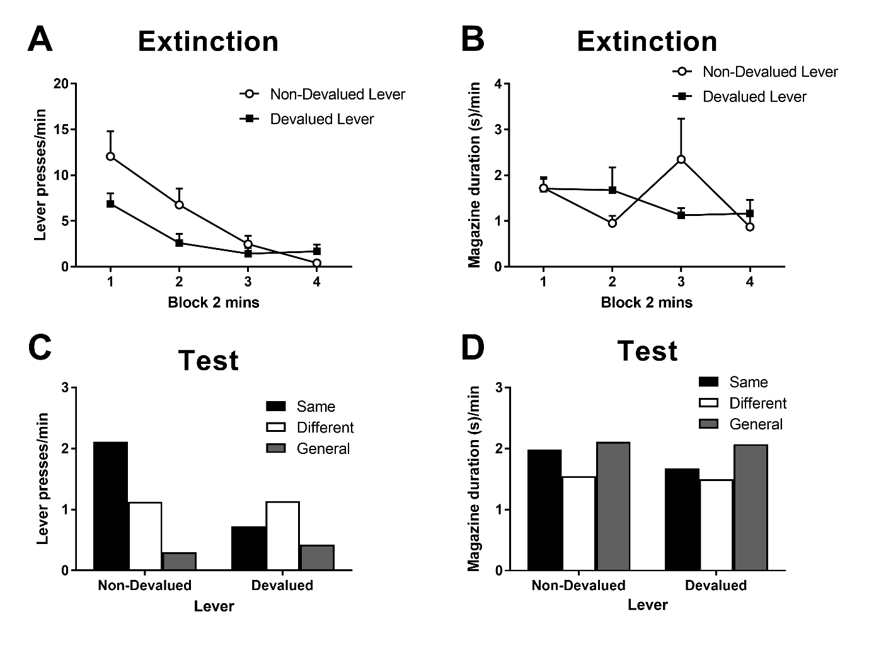

Figure 3. The effects of specific satiety on specific PIT. Rate of lever pressing (A) and magazine duration (B) responding during instrumental extinction in two minute blocks following devaluation by sensory specific satiety. Error bars depict +SEM. Rate of lever pressing (C) and magazine duration (D) responding during the specific PIT test in extinction following outcome devaluation by sensory specific satiety. Responding plotted as the mean response rate per minute during each cue minus the preceding baseline no-cue period. Same and different conditions indicate whether the Pavlovian CS predicted the same or different liquid reinforcer to the instrumental response, and the general condition indicates responding during the CS that predicted pellets which were never an instrumental reinforcer. Non-devalued (left) and devalued (right) indicate whether the lever outcome was devalued by specific satiety.