ChartVolt
Trade. Compete. Win.
Business Plan & Company Overview
Confidential · Prepared for internal and investor review

A quick note before the detail
We built ChartVolt because we kept seeing the same thing happen to people who get into trading: they arrive excited, lose money fast, and quietly disappear. The markets are unforgiving, and most newcomers never get past that first painful month. We thought there had to be a better way to give people the thrill and the skill of trading without handing the markets their savings.
So we made trading a competition. You trade real live prices, but with virtual capital, and you compete for real prize pools. The most you can ever lose is a small entry fee you decide on up front. Everything that follows in this document explains how that idea works as a product, how it makes money, how we keep everyone safe, and where we plan to take it.
1. What we are
ChartVolt is a gamified trading competition platform. The simplest way to describe it is "fantasy sports for traders." People trade against real, live market prices, but the capital is virtual, so nobody is exposed to runaway losses. Instead they enter tournaments and one-on-one duels, climb leaderboards, and compete for prize pools funded by entry fees.
Underneath the game sits a genuine trading engine. Prices stream in real time, and players work with leverage, margin, stop-loss and take-profit orders, and liquidation, exactly as they would on a live platform. Today that engine is focused on forex, which is where the experience is sharpest and most reliable. Other asset classes are on the roadmap, and we are honest about that distinction throughout this document.
What players actually do on the platform:
- Trade a realistic forex simulator driven by live market prices.
- Enter competitions: multi-player tournaments with a prize pool and a live leaderboard.
- Play 1v1 challenges: head-to-head duels where the winner takes the pot.
- Spend Volt Credits in a marketplace for indicators, strategies, cosmetics, and creator packages.
- Become a Game Master: host their own competitions and earn referral income.
- Progress through levels, titles, badges, and a journey map that rewards them for sticking around.
A single wallet ties it together. Players deposit money, receive Volt Credits (our in-app currency, where 100 credits equals one euro), and use those credits to play, buy, and cash out.
2. Who it's for
Our core players are aspiring and retail traders who want to get better and compete, but are understandably nervous about risking real money on the markets. Right alongside them are competitive gamers who are drawn to ranks, prizes, and head-to-head play as much as to trading itself. The two groups overlap more than people expect.
Then there are the creators. Trading educators and community leaders are always looking for ways to engage their audiences, and our Game Master program lets them run branded contests and earn from the activity they generate. They are both customers and a distribution channel.
Finally, there is the business-to-business side. Because the whole platform is white-label, brokers, educators, and fintech brands can run ChartVolt under their own name. That turns a single consumer app into a product other companies pay to operate.
3. Why now
Three things are happening at once, and ChartVolt sits right where they meet. Retail trading has exploded, but the dropout rate is brutal because most people lose money early. At the same time, competitive and prize-based gaming has gone fully mainstream and proven that people will happily pay to compete. And there is a clear, unmet appetite for a way to enjoy trading without the open-ended financial risk.
Our angle is simple. We take an activity that normally costs people money and trust, and we turn it into something fun, social, repeatable, and capped in risk. That is better for the player and better for the business, because people stay longer and come back more often. And because the trading is simulated, we avoid much of the regulatory weight that comes with executing real trades.
4. How the money flows
Money moves through the platform in a clean loop, and every step is recorded. A player deposits by card, receives credits, spends them on contests and items, wins prizes, and withdraws what they cash out. We earn a transparent fee at the deposit, the contest, and the withdrawal, never from a player's trading losses.
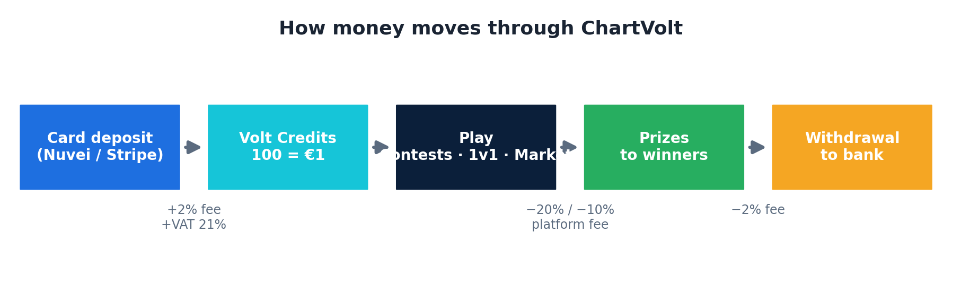
Figure 1. The flow of funds, from card deposit to bank payout.
The fees behind that flow (these are our current defaults and are configurable per brand):
Revenue source | Default
Deposit fee | 2% on deposits
Withdrawal fee | 2% on withdrawals
Competition fee | 20% of the prize pool
1v1 challenge fee | 10% of the prize pool
Marketplace & Game Master sales | the item / package price
Unclaimed pools & lapsed creator fees | retained by the platform
Key figures, for reference: 100 Volt Credits equal one euro, the minimum deposit is €10, the minimum withdrawal is €20, VAT of 21% is applied where it is due, and Game Masters earn a 5% referral share by default. Behind the scenes we keep the player's wallet and the company's revenue on separate ledgers and reconcile them automatically, so the books always agree.
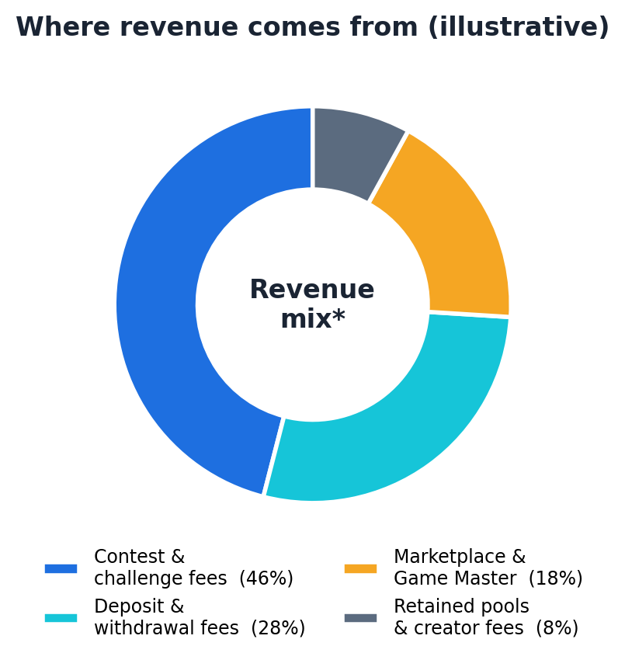
Figure 2. Illustrative split of where revenue comes from. Actual mix depends on player behavior.
5. How we protect everyone
We treat safety as a feature, not a checkbox, and we think about it in three directions: protecting the company, protecting the payment channel and the bank, and protecting the customer. Each one has real machinery behind it.
Protecting the company
We detect fraud and abuse with device fingerprinting, suspicion scoring, and multi-account and same-network checks that catch collusion and bonus abuse. Inside contests, anti-cheat rules guard against mirror-trading and abnormal drawdown, and we keep price snapshots so results can always be settled fairly. Every sensitive admin action is logged with its IP and device, and an automated reconciliation service constantly checks that every balance matches its transaction history.
Protecting the bank and the payment channel
Every payment confirmation is cryptographically verified before we grant a single credit, so forged messages are rejected and logged. Deposits are processed in a way that can never double-count, even if the provider sends the same callback twice. When a chargeback comes in, the platform automatically assembles a professional evidence report, suspends the account, and reclaims the disputed credits. Deposits and withdrawals are rate-limited to shut down automated attacks.
Protecting the customer
The biggest protection is the design itself: a player can only ever lose the small entry fee they chose, never an uncapped market loss. On top of that we run identity verification for withdrawals, enforce sensible withdrawal limits and hold periods, support two-factor authentication, and give every player a clear, itemized record of every euro and every credit, complete with proper invoices and VAT.
6. Built to scale
None of this matters if the platform falls over when it gets busy, so we built it to grow. A primary server handles the live price feed, candle aggregation, and the heavy background work. Secondary servers handle the web traffic and push real-time updates to players, and they talk to the primary through a fast relay. When we need more capacity, we add another secondary server. There is no re-architecture required to scale up.
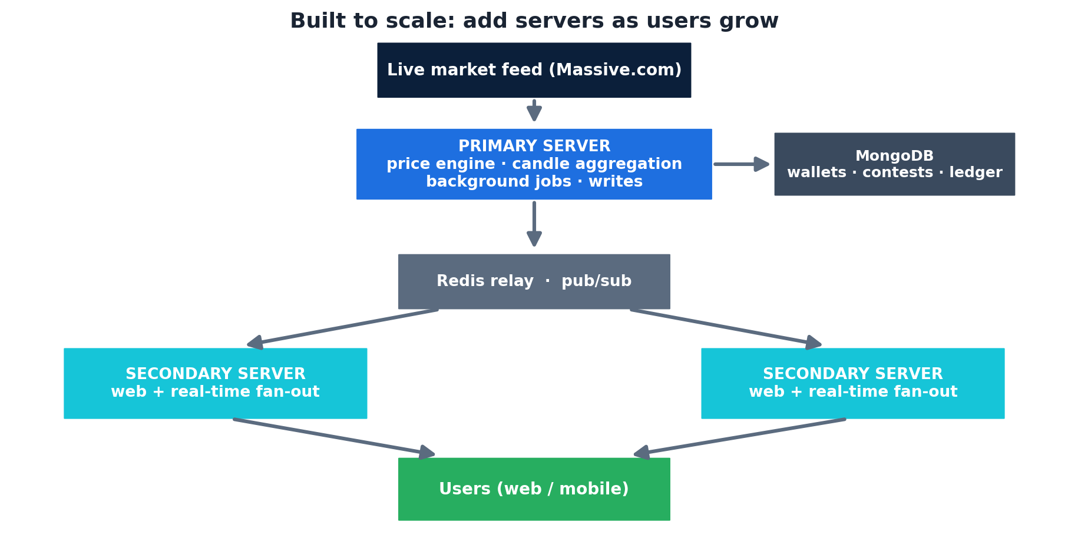
Figure 3. The platform's multi-server design. Capacity grows by adding servers.
In plain terms: a couple of servers comfortably handle roughly a thousand active traders today, and the streaming side of the product scales horizontally well beyond that. The main thing we watch as we grow is the database write load on the primary, which is the natural ceiling and the first thing we would reinforce.
7. How we grow
Our cheapest and most trustworthy growth comes from creators. The Game Master program turns influencers and community leaders into a distribution network: they host competitions for their followers and earn a referral share, so they bring the audience while we provide the platform. We complement that with focused performance marketing aimed at retail-trading and competitive-gaming audiences, and with flagship tournaments whose headline prize pools create their own publicity and viral leaderboards.
Keeping players is just as important as winning them. A low €10 entry point removes the barrier to trying, the progression systems give people a reason to come back daily, the leaderboards and duels create rivalry, and the built-in tutorials reduce the early confusion that usually drives newcomers away.
We grow in three phases:
- Launch and prove it in one core market with forex contests and our first Game Masters.
- Scale with creator-led and paid acquisition, more regions and languages, and a deeper marketplace.
- Become a platform: sign white-label partners who each bring their own audience.
8. The numbers
What follows is a planning model, not a promise. It shows how turnover behaves on a sensible set of assumptions, and the assumptions are meant to be argued with and replaced as we learn. The headline driver is the number of active players; everything else follows from that. We assume a blended revenue of roughly €8 per active player per month, drawn from the deposit, contest, and withdrawal fees described earlier.
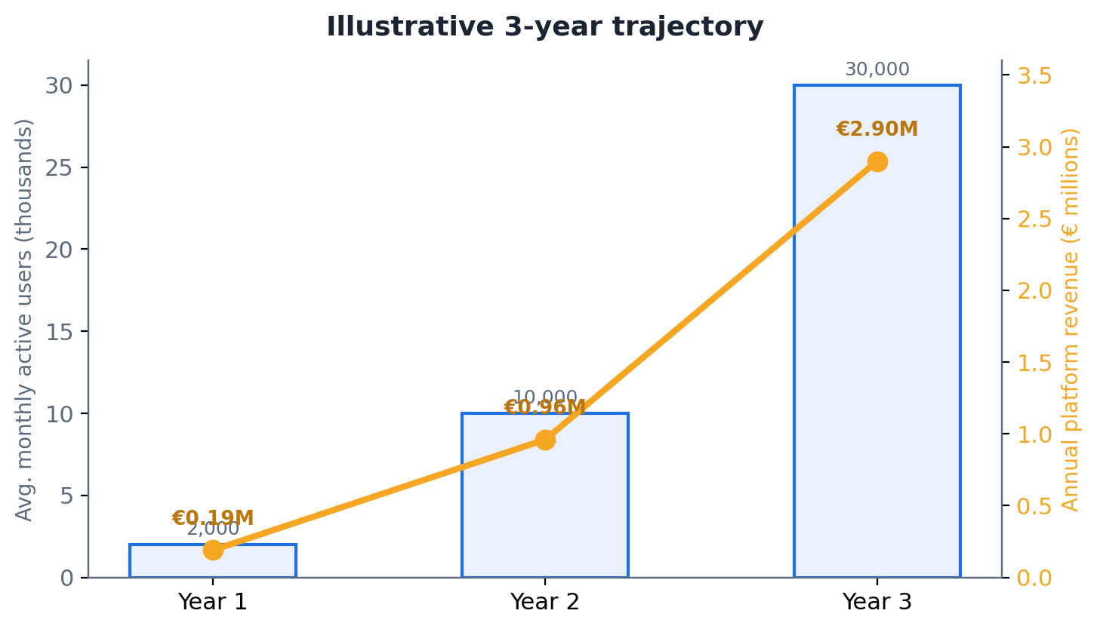
Figure 4. Illustrative three-year trajectory of active players and annual revenue.
Stage | Avg. monthly active players | Annual platform revenue
Year 1 (ramp) | 2,000 | ~€190K
Year 2 (scale) | 10,000 | ~€960K
Year 3 (platform + white-label) | 30,000 | ~€2.9M
A note on what these figures mean: turnover here is the platform's own revenue from fees and sales, not the gross volume of money moving through player wallets, which is several times larger. The levers that move the model most are the number of active players, how much each one plays, how often they deposit, and how many white-label partners we sign. Our main variable cost is payment processing, which runs in the region of 2.9% plus a small fixed fee per deposit and is partly offset by our own deposit and withdrawal fees.
In one breath
ChartVolt makes trading a fair, fun, capped-risk competition. Players trade live markets with virtual capital and compete for real prizes; we earn from transparent fees rather than from anyone's losses; we protect the company, the bank, and the customer at every layer; and we are built white-label on infrastructure that scales, so we can grow from a focused launch into the engine behind many branded trading-competition products.

