### EEEN 3449

### Microprocessor Systems

# Bit Testing

Tyler Hurson

Spring 2017

**I. INTRODUCTION**

* 1. **Purpose**

The purpose of this experiment is explore the AND, OR, and XOR operations and how they affect the bits in particular numbers using the Assembly language.

* 1. **Problem**

Often, individual bits must be set, cleared, or toggled. This can be achieved by using the AND, OR, and XOR operations. AND has the effect of clearing bits; the 0 bits in the operand indicate which bits will be cleared. OR has the effect of setting bits; the 1 bits in the operand indicate which bits will be set. XOR has the effect of toggling bits; the 1 bits in the operand indicate which bits will be toggled.

Five variations of a program were created. Initially, $5A was loaded to accumulator A from memory address $1500. A set of 1-2 bitwise operations were performed, and then the number was stored back into $1500. Program A (Appendix A) toggled bits 0-3 and cleared bits 4-7. Program B (Appendix B) toggled bits 4-7. Program C (Appendix C) toggled bits 4-7 and set bits 0-3. Program D (Appendix D) toggled bits 0-3 and set bits 4-7. Program E (Appendix E) set bits 7, 5, 3, 1 and cleared bits 6, 4, 2, 0.

Two additional variation of a program were created. Program F (Appendix) loaded $5A into accumulator B. B was then rotated 4 times to the right, effectively swapping the two nibbles in the byte. The number was then stored back into $1500. Program G (Appendix) is similar to program F, but used accumulator A instead of accumulator B to store $5A.

* 1. **Scope**

The scope of this experiment is limited to the HCS12 microcontroller. Several instructions will be used from the HCS12 instruction set.

**II. TEST AND EVALUATION**

**2.1 Apparatus**

The equipment used in this test includes: Dragon12-Junior development board, USB power cord, and laptop PC with AsmIDE.

**2.2 Procedure**

1. The development board was connected to the computer.
2. The COM port number was determined under Device Manager on PC. AsmIDE was launched. Under View -> Options -> COM Port, the COM port was set to the device’s number. The Terminal Window was enabled. Under Set COM Options, the default values were restored.
3. Program A was opened, and then assembled. After no errors were recorded, program A was downloaded into the development board, by typing load in the Terminal Window in AsmIDE, then downloading the program.
4. g 2000 was typed to execute the program. At the end of the program, md 1500 was typed to confirm that the number stored at $1500 was correct.
5. Program B was opened, and then assembled. After no errors were recorded, program B was downloaded into the development board.
6. g 2000 was typed to execute the program. At the end of the program, md 1500 was typed to confirm that the number stored at $1500 was correct.
7. Program C was opened, and then assembled. After no errors were recorded, program C was downloaded into the development board.
8. g 2000 was typed to execute the program. At the end of the program, md 1500 was typed to confirm that the number stored at $1500 was correct.
9. Program D was opened, and then assembled. After no errors were recorded, program D was downloaded into the development board.
10. g 2000 was typed to execute the program. At the end of the program, md 1500 was typed to confirm that the number stored at $1500 was correct.
11. Program E was opened, and then assembled. After no errors were recorded, program E was downloaded into the development board.
12. g 2000 was typed to execute the program. At the end of the program, md 1500 was typed to confirm that the number stored at $1500 was correct.
13. Program F was opened, and then assembled. After no errors were recorded, program F was downloaded into the development board.
14. g 2000 was typed to execute the program. At the end of the program, md 1500 was typed to confirm that the number stored at $1500 was correct.
15. Program G was opened, and then assembled. After no errors were recorded, program G was downloaded into the development board.
16. g 2000 was typed to execute the program. At the end of the program, md 1500 was typed to confirm that the number stored at $1500 was correct.

**III. RESULTS**

* 1. **Data**

Table 1 displays the final result (the number stored at $1500) of each of the seven programs.

Table 1: Final Results

|  |  |
| --- | --- |
| **Program** | **Result** |
| A | $05 |
| B | $AA |
| C | $AF |
| D | $F5 |
| E | $66 |
| F | $A5 |
| G | $A5 |

* 1. **Analysis**

The following flowcharts display the program flow for each of the seven programs executed.

Figure 2: Flowchart of Program A

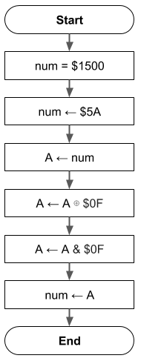

Figure 3: Flowchart of Program B

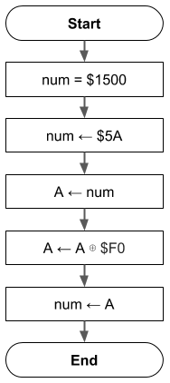

Figure 4: Flowchart of Program C

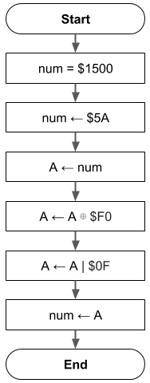

Figure 5: Flowchart of Program D

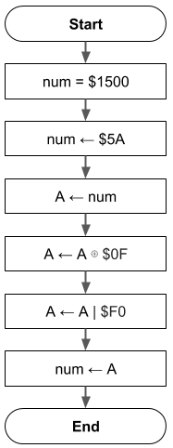

Figure 6: Flowchart of Program E

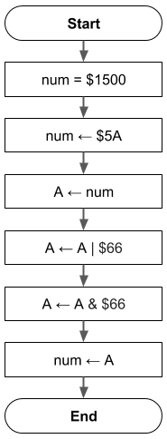

Figure 7: Flowchart of Program F

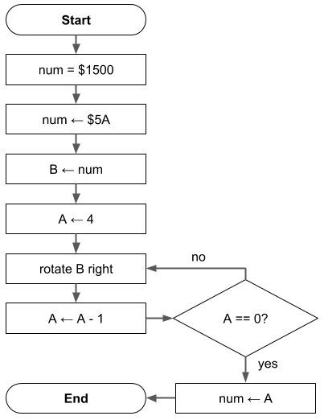

Figure 8: Flowchart of Program G

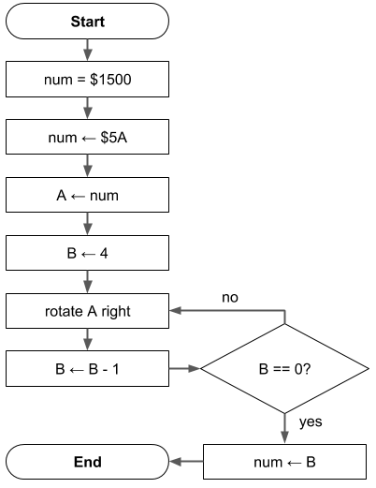

1. **CONCLUSION**

**4.1 Assessment**

This experiment served as an introduction to bit setting/clearing/toggling. Bitwise manipulation is useful when working with boolean values, which may be represented as a single flag (bit) in a 8-bit value.

**APPENDIX A**

**ASSEMBLY PROGRAM A**

org $1500

num rmb 1

org $2000

movb #$5A,num ; load $5A into $1500

ldaa num ; A = $5A

eora #$0f ; toggle bits 3,2,1,0 in A

anda #$0f ; clear bits 7,6,5,4 in A

staa num ; $1500 = A

swi

end

**APPENDIX B**

**ASSEMBLY PROGRAM B**

org $1500

num rmb 1

org $2000

movb #$5A,num ; load $5A into $1500

ldaa num ; A = $5A

eora #$f0 ; toggle bits 7,6,5,4 in A

staa num ; $1500 = A

swi

end

**APPENDIX C**

**ASSEMBLY PROGRAM C**

org $1500

num rmb 1

org $2000

movb #$5A,num ; load $5A into $1500

ldaa num ; A = $5A

eora #$f0 ; toggle bits 7,6,5,4 in A

oraa #$0f ; set bits 0,1,2,3 in A

staa num ; $1500 = A

swi

end

**APPENDIX D**

**ASSEMBLY PROGRAM D**

org $1500

num rmb 1

org $2000

movb #$5A,num ; load $5A into $1500

ldaa num ; A = $5A

eora #$0f ; toggle bits 0,1,2,3 in A

oraa #$f0 ; set bits 7,6,5,4 in A

staa num ; $1500 = A

swi

end

**APPENDIX E**

**ASSEMBLY PROGRAM E**

org $1500

num rmb 1

org $2000

movb #$5A,num ; load $5A into $1500

ldaa num ; A = $5A

oraa #$66 ; set bits 7,5,3,1 in A

anda #$66 ; clear bits 6,4,2,0 in A

staa num ; $1500 = A

swi

end

**APPENDIX F**

**ASSEMBLY PROGRAM F**

N equ 4

org $1500

num rmb 1

org $2000

movb #$5A,num ; load $5A into $1500

ldab num ; B = $5A

ldaa #N ; A = 4

loop rorb ; rotate B to right

dbne A,loop ; decrement A, branch if A != 0

stab num ; $1500 = B

swi

end

**APPENDIX G**

**ASSEMBLY PROGRAM G**

N equ 4

org $1500

num rmb 1

org $2000

movb #$5A,num ; load $5A into $1500

ldaa num ; A = $5A

ldab #N ; B = 4

loop rora ; rotate A to right

dbne B,loop ; decrement B, branch if B != 0

staa num ; $1500 = A

swi

end