**Introduction**

Students at Texas A&M University-Kingsville (TAMUK) face a great number of challenges before they may graduate. They have grades to maintain, deadlines to meet, extracurricular activities, and vast amounts of studying to contend with on a daily basis. Unfortunately, we have to add parking to the list of headaches that students and, indeed, faculty must deal with on a daily basis. When asked, many students relayed to our group their dissatisfaction and , sometimes, downright loathing for the parking situation on campus. For now, there exists four viable options to each student and faculty member at TAMUK:

1. Arrive to campus extremely early and hope that there is an available parking space, but probably still have to drive around searching for said space.
2. Park off-campus and walk to wherever it is they were headed. This option might make them late depending on how far away they have parked. This might be a few blocks because it is illegal to park in the surrounding neighborhoods on the weekdays.
3. Arrive on time to campus with everyone else and definitely have to drive around looking for an open space. This option will, most likely, also cause the student or faculty member to be late. There is an inherent flaw in this method as well. A person can only see the spaces they are driving past. If a space becomes available after they had left the area, they would not know until they had completed a full circuit around campus. By then that space would be occupied by any number of people that were also searching for a place to park.
4. Ride a bike.

With the right planning, of course, anybody might avoid being late. But why should someone have to leave their home an half hour to an hour early just to find a parking space and then sit and wait until their class or meeting starts?

Our team, *Insert Team Name Here*, believes we can add a fifth option. It would be an option that allows the students and faculty of TAMUK to monitor the parking situation on campus in real time and avoid the “drive-around”. By using vehicle recognition software and a network of internet protocol (IP) security cameras, we will be able to monitor the designated parking lots across the campus, then provide up-to-the-minute information on the availability of parking in that area. All this information would be accessible via our free mobile app (See: figures 1.1 and 1.2 ). To avoid any damage or liabilities, this app would include G.P.S. recognition and a speech component to relay the location of the parking spot to the user without the user having to look at their phone.

Once we have succeeded, a student may choose a new fifth option of leaving early if they need to, or just in time because they are confident in their ability to find a parking spot thanks to their new mobile app. I thank you for reading this far, and hope that, in the future, we can make this a reality.

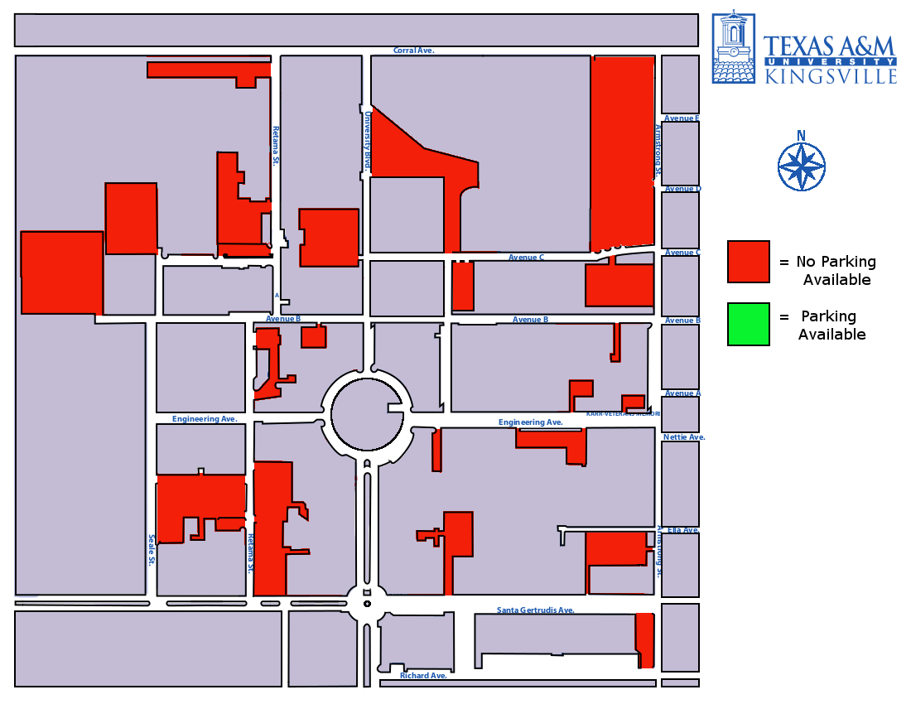

Fig. 1.1 - There is no parking available.

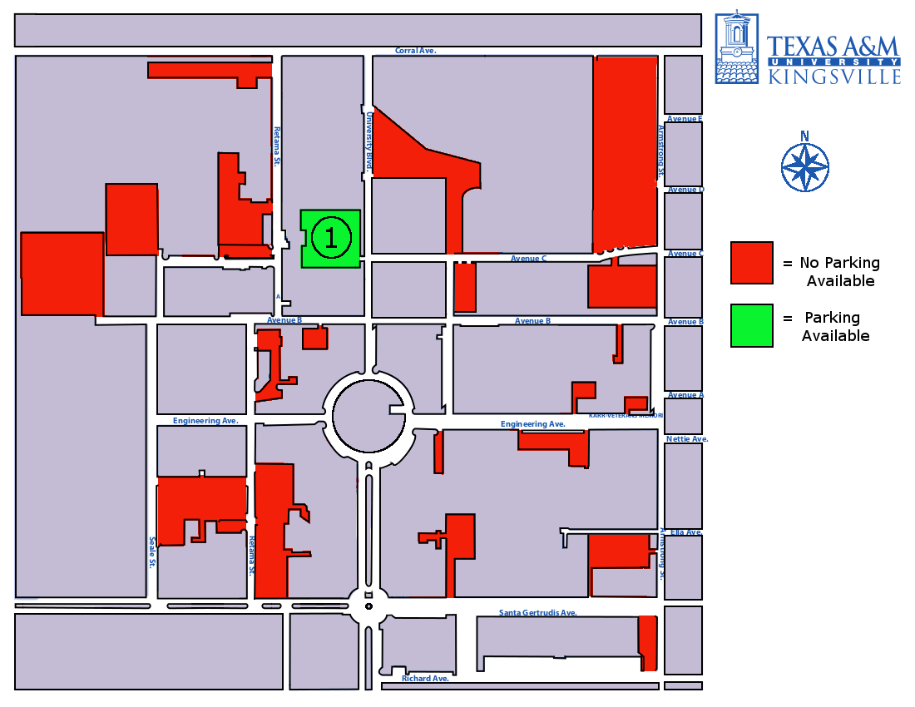

Fig. 1.2 - A spot has opened up!

**Our Purpose**

The purpose of *Insert Team Name Here* is to address and eliminate the problems that have arisen due to the current parking situation at Texas A&M University-Kingsville by providing up-to-the-minute information on the location and availability of parking spaces in designated lots across campus via a free mobile application.