**SeeSpotPark**

Tyler Hurson

David Rodriguez

Koltan Weaks

Thomas Wurdinger

**Table of Contents**

|  |  |
| --- | --- |
| Introduction | 1 |
| Project Objectives | 2 |
| Design Strategy | 3 |
| Project Plan | 4 |
| Evaluation Criteria | 5 |
| Schedule | 6 |
| References | 7 |
| Glossary | 8 |

**1. Introduction**

1.1 Background

Students at Texas A&M University-Kingsville (TAMUK) face a great number of challenges before they may graduate. They have grades to maintain, deadlines to meet, extracurricular activities, and vast amounts of studying to contend with on a daily basis. Unfortunately, parking can be added to the list of headaches that students and, indeed, faculty must deal with on a daily basis. When asked, many students relayed to our group their dissatisfaction and , sometimes, downright loathing for the parking situation on campus. For now, there exists four viable options to each student and faculty member at TAMUK:

* Arrive to campus extremely early and hope that there is an available parking space, but probably still have to drive around searching for said space.
* Park off-campus and walk to wherever it is they were headed. This option might make them late depending on how far away they have parked. This might be a few blocks because it is illegal to park in the surrounding neighborhoods on the weekdays.
* Arrive on time to campus with everyone else and definitely have to drive around looking for an open space. This option will, most likely, also cause the student or faculty member to be late. There is an inherent flaw in this method as well. A person can only see the spaces they are driving past. If a space becomes available after they had left the area, they would not know until they had completed a full circuit around campus. By then that space would be occupied by any number of people that were also searching for a place to park.
* Ride a bike.

With the right planning, of course, anybody might avoid being late. But why should someone have to leave their home an half hour to an hour early just to find a parking space and then sit and wait until their class or meeting starts?

Our team, <team name>, believes we can add a fifth option. It would be an option that allows the students and faculty of TAMUK to monitor the parking situation on campus in real time and avoid the “drive-around”. By using vehicle recognition software and a network of internet protocol (IP) security camera modules, we will be able to monitor the designated parking lots across the campus, then provide up-to-the-minute information on the availability of parking in that area. All this information would be accessible via our free mobile app (See: figures 1.1 and 1.2 ). To avoid any damage or liabilities, this app would include G.P.S. recognition and a speech component to relay the location of the parking spot to the user without the user having to look at their phone.

Image recognition software is becoming more and more prevalent in today’s connected world. The most visible aspect being the facial recognition aspect of the software. On the high end of things, we have IBM’s deep learning and its massive neural net. This software basically uses the entirety of the internet as its basis for information retrieval. This allows for a much broader spectrum of objects that can be identified. This option, however, has its time limitations. Any information would have to be sent to them, placed in a queue, processed in turn, then returned to us. To provide the most recent data to our users, the vehicle recognition software will be created by our team. Using a method called Viola-Jones feature detection, our software will be able to accurately recognize and count vehicles that enter or exit a parking area. The software will recognize the features of vehicles only, ensuring that students on foot or cyclists do not render a false positive.

Once we have succeeded, a student may choose a new fifth option of leaving early if they need to, or just in time because they are confident in their ability to find a parking spot thanks to their new mobile app.

1.2 Purpose

The purpose of this project is to alleviate the parking problem on the TAMUK campus by providing students and faculty with live information on the availability of designated parking spaces around campus via an easy-to-use mobile application.

1.3 Overview

Several parking lots around campus will be chosen as designated parking lots. Each designated parking lot will have a total capacity and a counter. The capacity will represent the maximum amount of vehicles that the parking lot can hold. The counter will represent the total amount of vehicles in the parking lot at any given time.

Each parking lot will include two cameras mounted at each entrance placed at mid-car level. Several laser break devices will also be mounted to each entrance. When the lasers are tripped, the cameras will capture a video of the passing object. These images will be transmitted to a central server and processed through an image recognition algorithm to determine whether or not the candidate object is a valid vehicle based upon some predetermined criteria. If the passing object is a valid vehicle, the counter associated with the parking lot will be incremented or decremented, depending on the direction of the vehicle.

Customers access the system through a free, downloadable mobile application. The application consists of a map of the TAMUK campus containing each designated parking lot (Fig. 1.1, 1.2). A large number above each parking lot will represent the total number of free parking spaces available per lot.

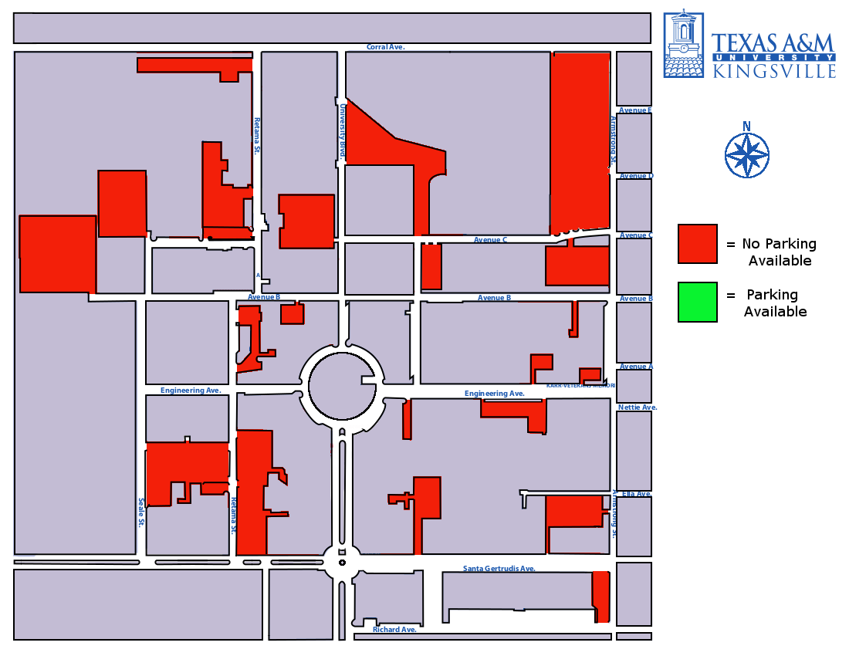

Fig. 1.1 - There is no parking available.

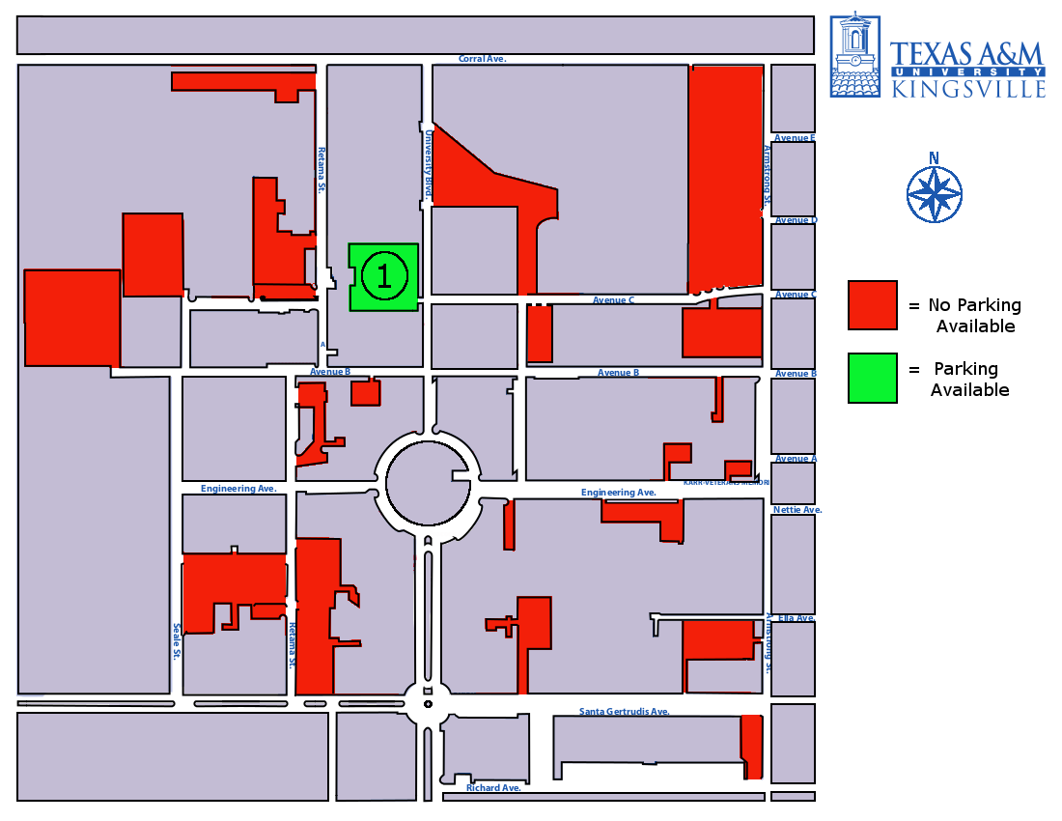

Fig 1.2 - A spot has opened up!

Due to inherent problems with long-term accuracy, the counter of each parking lot will have to be periodically reset. During the after-school hours (midnight - 6 AM), a set of overhead cameras will capture an image of the entire parking lot and use this image to determine the actual number of vehicles in the parking lot. The counter will be reset to this value.

1.4 Contextualization

This technology is currently most used in parking garages. There is no single solution, though. For each different garage,

**2. Project Objectives**

2.1 Scope

Initially, the application will provide data for designated parking areas only. The scope is further refined to those parking areas designated for student, faculty and commuters only. All parking areas designated for residential use will be omitted.

The camera modules will be constructed and programmed as such that any enclosed parking area may be included in the overall system without any special considerations.

2.2 Goals

Our first goal will be the creation of accurate vehicle recognition software. Concurrently, we will be designing, building, and distributing weather/tamper resistant camera modules to parking areas around campus. Once we have modules at every entrance and exit we will be able to use the data we gather to provide an easy to use application for students and faculty that has an accuracy of 1-2 vehicles.

**3. Design Strategy**

3.1 Approach

3.1 Technical Overview

The overall system will consist of four components: a central server, the camera system, the laser-break system, a number of mobile applications.

3.1.1 Server

The server contains the database and the main application. It is responsible for storing system data, receiving data from the camera system, and sending data to mobile applications.

Static data on the server will include programming source files and libraries. Dynamic data will include the capacity and counter for each parking lot. Dynamic data will be stored on a database.

The main application implements the domain logic and interfaces with the database. It handles data requests and responses and updates the database accordingly.

3.1.2 Camera System

The camera system consists of a set of cameras physically mounted around designated parking lots. The cameras will be outdoor cameras with a built-in WiFi capabilities. The camera system consists of two subsystems: the entrance camera system and the overhead camera system.

The entrance cameras are responsible for capturing images of vehicles as they enter and exit each parking lot and sending the images to the server. The cameras will be placed 10 cm-2 m from the curb of the parking lot entrance on either side of the entrance, facing each other, centered between the laser break devices. They will be attached to a metal pole that will rise 0.75 m from the ground. As an object trips a laser-break device, the two entrance cameras capture the passing object as a series of images and send the images to the server to be processed.

Overhead cameras are responsible for capturing images of entire parking lots and sending the images to the central server. The cameras will be placed several meters above the parking lot on a nearby pole or building. The number of overhead cameras will differ per parking lot depending on the geometry of the lot and the placement of nearby poles and buildings. Larger parking lots and non-rectangular shaped parking lots may require more than one overhead camera.

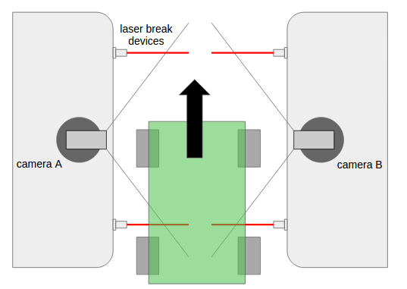

3.1.3 Laser Break System

The laser break system will consist of several laser break devices mounted at the entrance of designated parking lots. Each entrance will contain two rows of laser break devices. When a device is tripped, it will send a signal to the entrance cameras indicating that they should begin to record and transmit images to the central server for processing.

3.1.4 Mobile Application

The mobile application is the customer-facing portion of the system. The mobile application consists of a map of the TAMUK campus containing each designated parking lot. It is responsible for sending data requests to, and receiving data responses from the central server, and updating the map with the appropriate information.

3.2 Design Alternatives

In the event that the camera system fails, or the image recognition algorithm does not meet our accuracy requirements, we will fall back upon an alternative counting system.

In this system, the entrance cameras are done away with entirely, and the counting of vehicles is done exclusively by the laser break system. There are three rows of laser break devices instead of two. The counter for each parking lot is incremented or decremented depending on the order in which the rows of devices are tripped. Figure 3.1 illustrates the system.

Figure 3.2 is a state diagram modeling the logic of the system. The system begins at state 0, and waits for either row A, B, or C to be tripped. As the lasers are tripped, the system enters a new state depending on which row was tripped. For example, a vehicle tripping C, followed by B, followed by A would indicate that a vehicle has left the parking lot (prompting the system to decrement the counter by one). Likewise, a vehicle tripping A, followed by B, followed by C would indicate that a vehicle has entered the parking lot.

The logic also handles two vehicles entering and exiting at the same time. However, a major flaw of the system is that one vehicle may “mask” another vehicle by blocking the lasers that would otherwise detect it.

Due to this problem, we decided to settle upon a camera-based system. Though a camera-based system is more expensive and sophisticated, it will prove much more accurate.

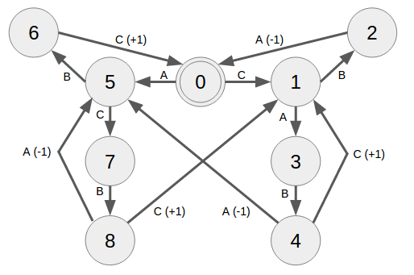

**4. Project Plan**

4.1 Overview

The project consists of four major tasks: the central server, the camera system, the laser-break system, and the mobile application. In general, each of these major tasks may be completed independently, with few dependencies between each major task. Each major task may be broken down into several minor tasks. Each minor task may be broken down into one or more steps.

Each minor task will be assigned a complexity level, an integer value (0-10). This value is an estimation of how much time the particular minor task will take. The complexity level will be used to determine an accurate schedule for the project.

**Project**

Setting up the project.

1. Establish problem and solution
   1. Establish problem - Clearly define the problem. Is it a real problem?
   2. Establish solution - Generate a rough idea of a solution to the established problem. Determine if the solution would
2. Determine feasibility
3. Gather requirements
4. Obtain Permission
5. Putting it all together

4.2 Server Tasks

|  |  |
| --- | --- |
| **Task** | **Complexity** |
| **Requirements Gathering**  Establish budget, determine hardware, environment, and technology requirements, as well as any other requirements (reliability of server, customer support, etc.). |  |
| **Research**  Investigate available academic and commercial servers and compare them against the established requirements. Calculate the monthly cost of each server and determine if it fits within the budget. |  |
| **Acquisition**  Purchase/rent the chosen server. Document the server specs and the cost. Login to the server to confirm that we have access to it. Confirm that we can read/write to the server and that the server is connected to the internet. |  |
| **Initial Setup**  Put server files under version control. Install required technologies. Create database and configure schema. Establish static IP for server. Open up ports for outside access. |  |
| **Camera Communication**  Establish data communication between the camera system and the server. Ensure that the server is receiving images from the camera and can interpret them in the appropriate format. |  |
|  |  |

Retrain vehicle recognition algorithm with campus-specific information.

Gather still frames from incoming video.

Crop and label pictures as either containing a vehicle or not

Retrain algorithm with updated photos

Process video

Route incoming video through vehicle recognition algorithm

Determine , frame by frame, if video contains a vehicle

If it does, that vehicle is identified ,labeled and tracked

If it does not, nothing happens

Relay data to database

Testing

4.3 Laser Break System

Physically setting up the beam/laser system in the environment, sending information over WiFi, determining whether or not a car has passed in/out of the parking lot, running tests.

4.4 Camera System

Involves physically setting up the camera in the environment, sending an image over WiFi, determining the number of cars in the parking lot given an image (image recognition).

1. Determine requirements
   1. What type of camera(s) do we need?
      1. How are we going to communicate with the server?
      2. What are the minimum specs of the camera?
   2. What type of fastening equipment is needed?
      1. How will the equipment be placed?
      2. How will the camera be placed on the equipment?
      3. Environmental hazards
         1. People
         2. Vehicles
         3. Weather
   3. People/Obstacles
   4. What is the optimal camera configuration?
2. Deploy and enable camera modules
   1. Configure all cameras to send data to static IP
   2. Physically place camera modules at all ingress and egress locations for each parking lot on campus.
   3. Confirm video transmission

4.4 Mobile Application

Developing the accompanying mobile application that students/faculty will use to view open parking spaces.

1. Determine requirements
   1. What platform(s) are we targeting? (Android, Apple, etc.)
   2. What technologies will be required? (programming languages, libraries, etc.)
   3. Will the data have to be persistent?
      1. If so, how will we be storing our data?
2. Initial setup
   1. Create new mobile application project
   2. Put project under version control
   3. Download project onto test device and confirm it is working
3. Establish data communication between server
4. Download environment
5. Testing

4.5 Prerequisite Chart

<visual chart containing a list of all the subtasks, with arrows pointing to prerequisites>

**5. Evaluation Criteria**

5.1 Success

The success of this project can easily be measured by a student or faculty member’s ability to accurately monitor the parking situation on campus. Right now that ability is pretty much non-existent. By the time we are finished, there will be an interconnected network of web-enabled security cameras that will track cars as they enter and exit the parking areas. That info will be displayed to our users through our easy to use interface on our mobile app.

So, as outlined, there will be three major benchmarks to our success:

* The vehicle recognition software will be accurate to within a two car margin of error.
* .There will be a network of internet-connected camera modules installed at every entrance and exit to all designated parking lots.
* The data gathered by the cameras will be immediately available via an easy to use mobile application.

Once these three benchmarks are met, TAMUK students will have that ability to accurately monitor the parking situation on campus.

**6. Schedule**

6.1 Overview

1. October 14th -
   1. Determine Requirements
   2. Determine technology
      1. Pick and accurate device for the job
   3. Establish communication methods
      1. How to store the project efficiently for team members

6.2 Schedule

<table of tasks to be completed with expected completion date for each task>

**References**

<list of references used in this document>

**Glossary**

**Designated parking lot** – A parking lot on the TAMUK campus that has been chosen as a target of the system.

**Domain logic** - The portion of the program that implements the real-world rules of the application.

**TAMUK** - Texas A&M University-Kingsville