Biometric Data Purge
(Biometric Logs Removal Notification System)

USER MANUAL
2026

System Overview
Biometric Data Purge is a notification system that’ll remind the user to confirm removal of biometric logs every 20th of the month (last cutoff of the month). It utilizes local routing and permissions to send push notification to the desktop, ensuring consistent system alerts.

Installation and Deployment
The system is designed to be plug-and-play with a minor system task scheduling setup.

Initial System Setup:
- Server requirements: Ensure the target system has XAMPP (with Apache and MySQL installed) or something similar installed.
- File Placement: Copy the whole project folder to the system’s XAMPP htdocs folder.
- Database Setup: Database will be automatically setup upon the initial start of the system login page (http://localhost/biometric_data_purge/login.php). User can login using default account credentials (username: admin, password: adminpassword).

Task Scheduler Setup for System Notification:
- Open Microsoft Task Scheduler.
- Click Create Task.
- Enter desired task name (e.g. Biometric Data Purge Notification System).
- Select “Run whether user is logged in or not”
- Change “Configure for” to Windows 10 / 11.

-- Setting the Trigger--
- Go to Triggers tab and select New.
- Set “Begin the task” to On a Schedule.
- Make the task “Daily”, set the start time to 6:00 AM, and set “Recur every” to 1 day/s.
- In advance settings, enable “Repeat task every” and set it to 270 minutes (4.5 hours) for duration of 1 day.
- Enable “Stop all running tasks at the end of repetition duration.
- Make sure the Enabled checkbox is marked then click OK.

-- Adding the Action Script --
- Go to Actions tab and select New.
- Set Action to “Start a program”.
- Click browse and locate “runPurgeInv.vbs” inside the root project folder.
- Click OK.

-- Setting up Task Conditions --
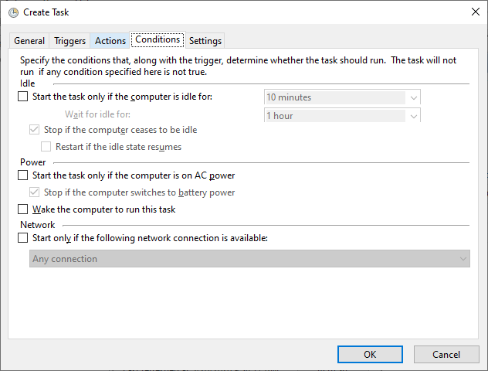
- Go to the Conditions Tab and copy these settings:

-- Adjusting Task Settings --
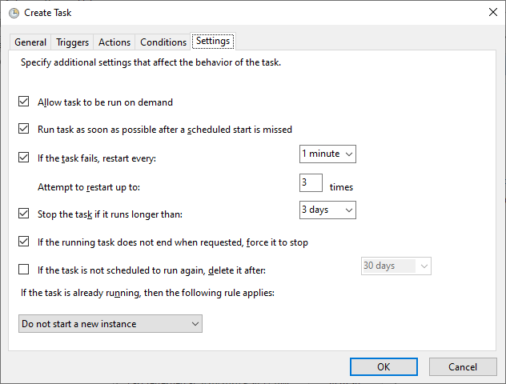
- Go to Settings Tab and copy these settings:
- Click OK.

Use of System
The Biometric Data Purge have three (3) main pages: Dashboard, History, and Edit Devices. Dashboard lists all devices with their corresponding cutoff date. History displays previous log deletion confirmations for each device which are group by section. Edit Devices enables the user to add, edit, or remove devices from the list as long as they follow the format of the data file.

Dashboard
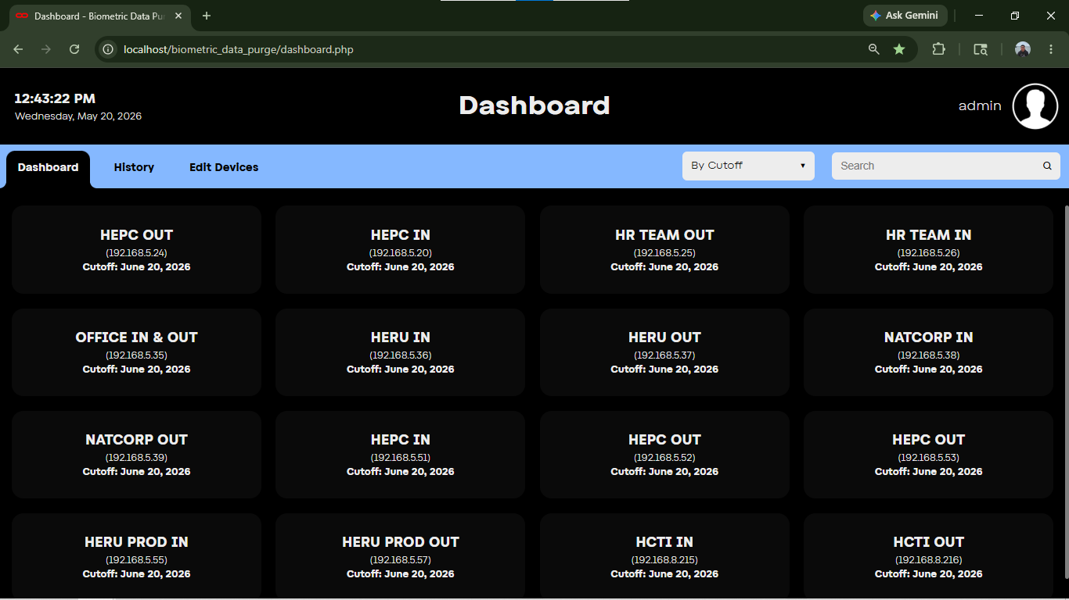
The Dashboard includes a sort menu and a search bar. The sort menu offers two (2) choices: By Cutoff and Alphabetical. The device display items will change colors depending on their cutoff date.

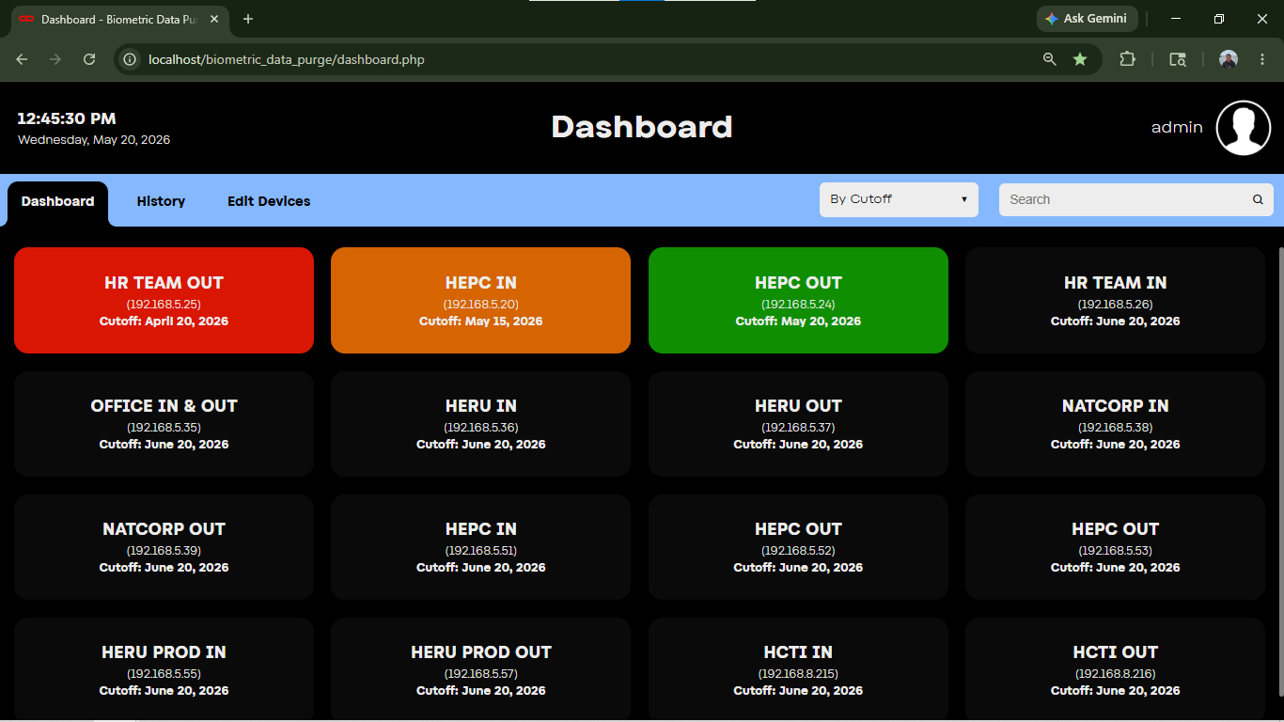
- Black / Gray: The default color, cutoff date is still in the future.
- Green: Cutoff date is today.
- Orange: Log removal is due but still inside the one week mercy window.
- Red: Log removal is overdue.

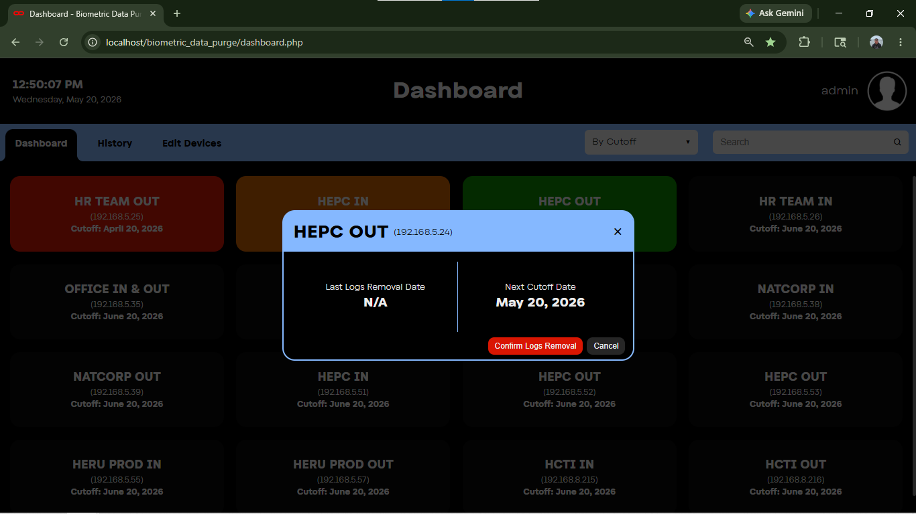
User will need to click on a device for the modal to pop up. This will give the user the option to confirm removal of biometric logs for that specific device.

Upon user’s confirmation, the system will record the date and save it on a history log, and will automatically set the cutoff date of that device to the 20th of next month.
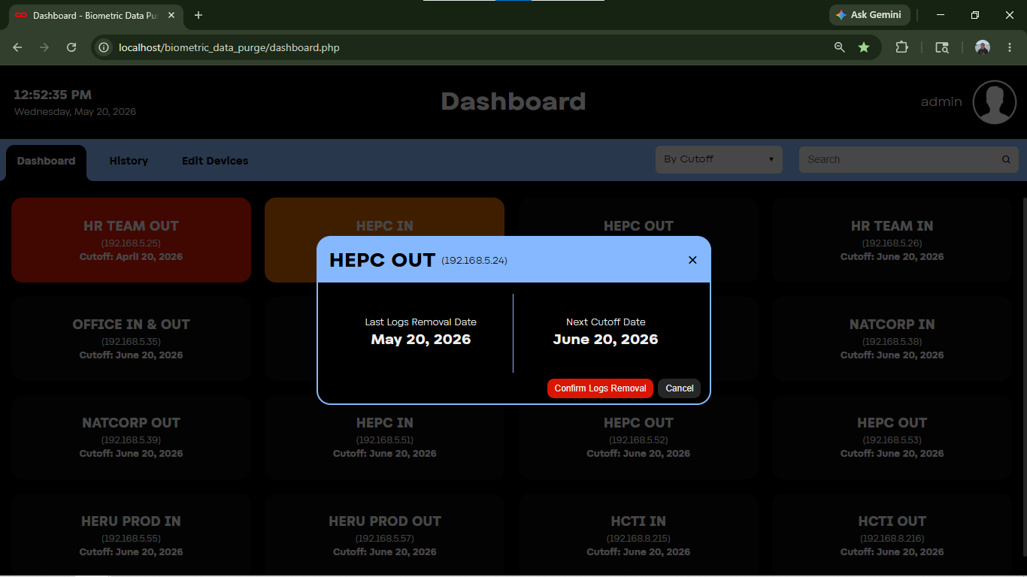
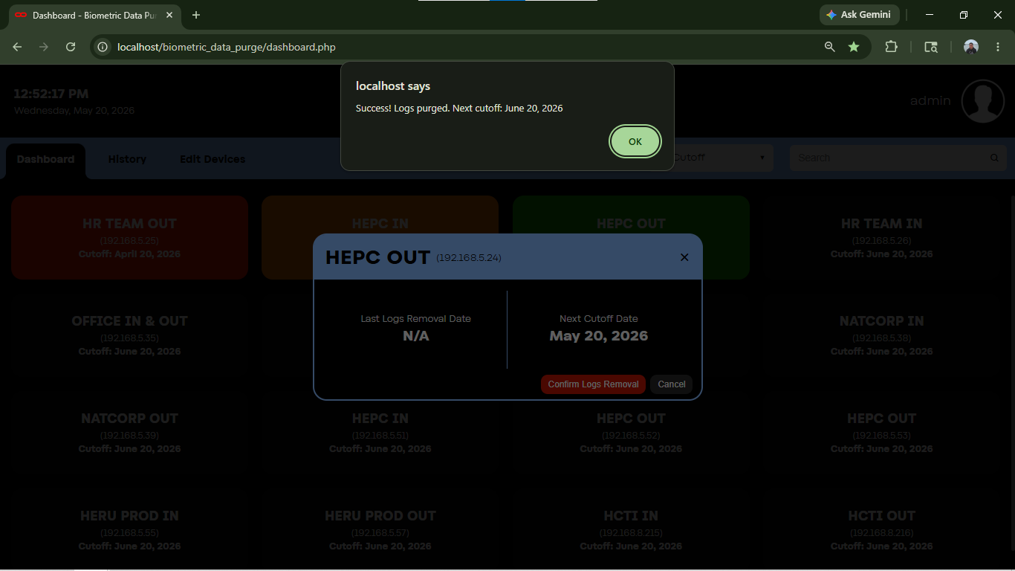

History
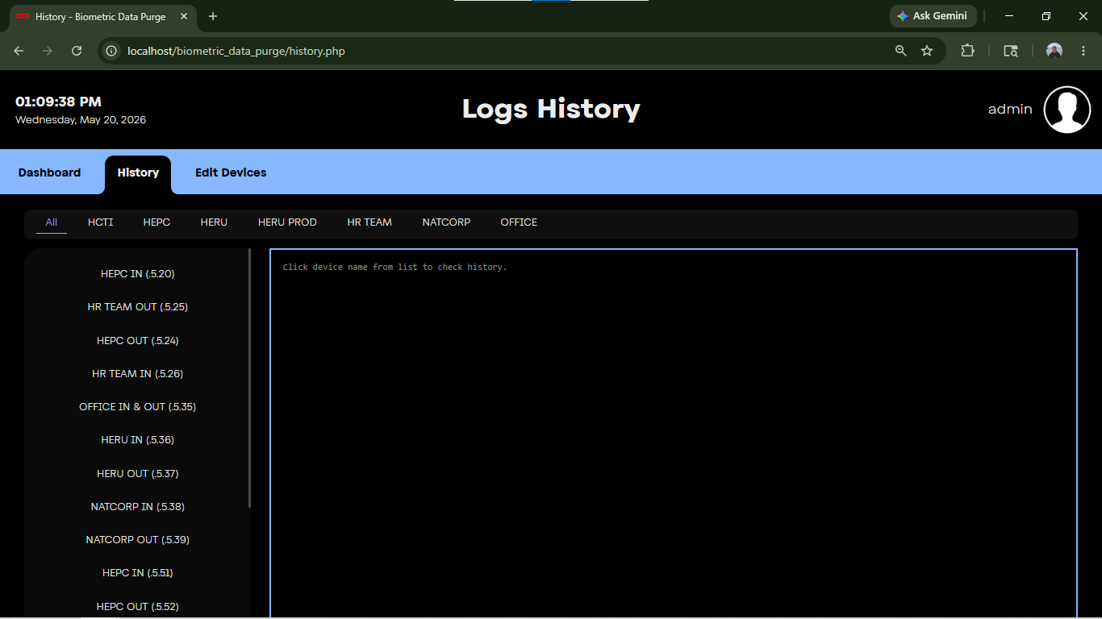
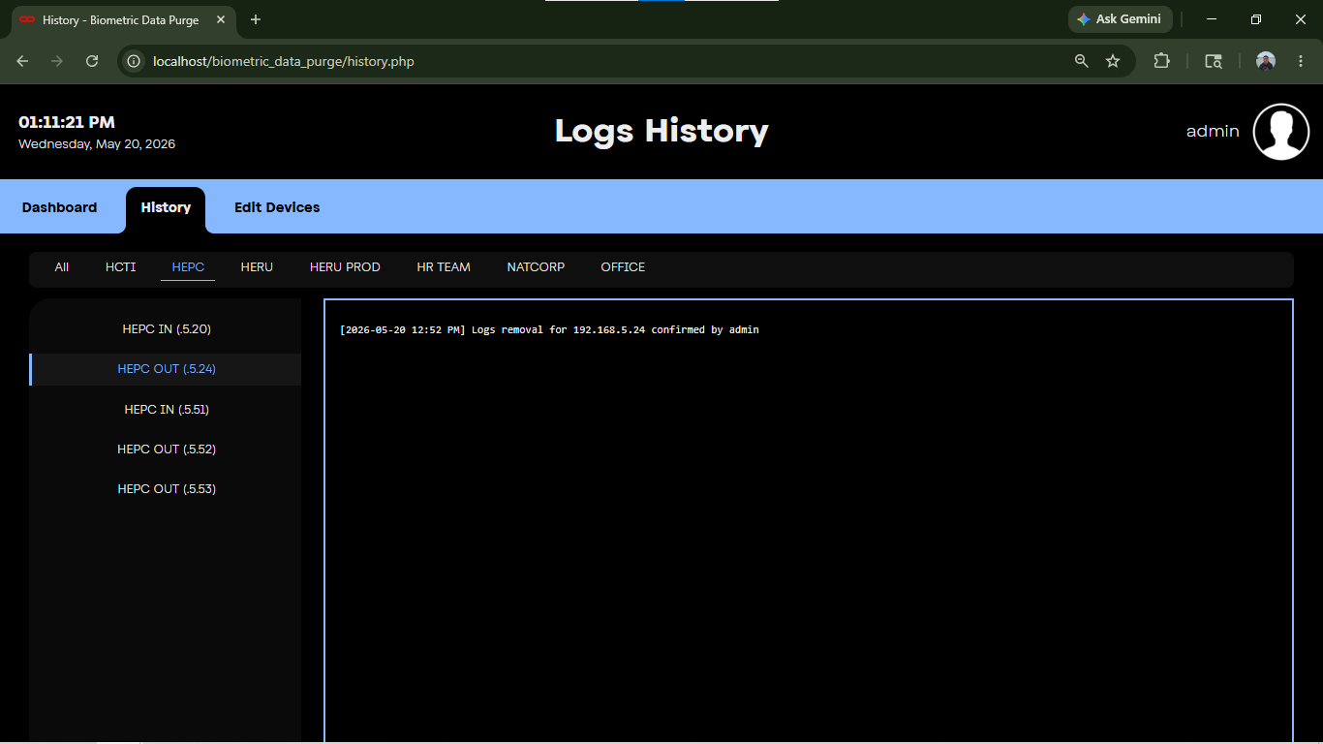
This tab displays all the previous confirmation of log removal for each device, grouped by section name.

Edit Devices
This section gives the user the ability to add new devices and edit or delete existing devices. This will only be the only way for the user to read and edit the devices file. The file is encrypted outside of the system for security reasons.

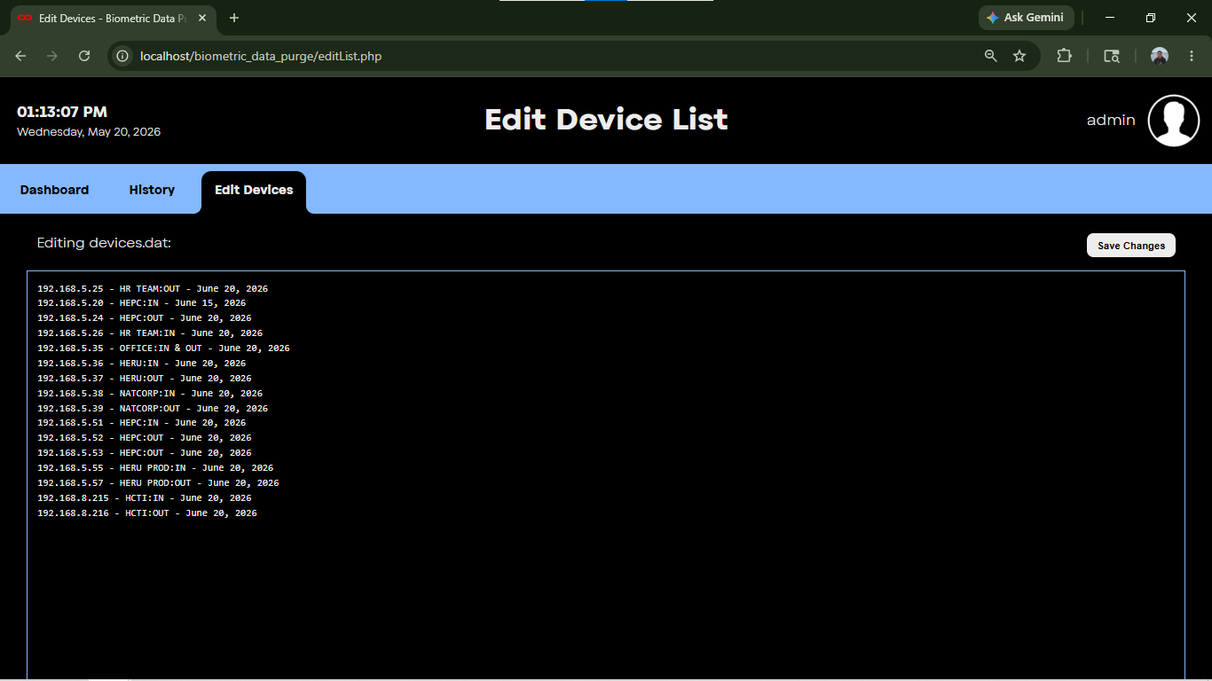
In adding or editing a device, keep this format in mind:
[IP Address] - [Section / Group]:[IN / OUT] - [month day, year]
e.g. 192.168.1.1 - GROUP:IN - JUNE 20, 2026

Technological Stack and Environment Specifications:

- Runtime Environment: PHP 8.2.12 or higher
- Database Management System: MariaDB 10.4.32 / MySQL v5.7+
- Web Server Compatibility: Apache HTTP Server / Nginx
- Core Backend Architecture: Procedural & Object-Oriented PHP leveraging PHP Data Objects (PDO) for secure database abstraction.
- Frontend Ecosystem: Native HTML5, modern vanilla CSS3 (utilizing root CSS variables for global states), and asynchronous client-side JavaScript (ES6+ Architecture).
- Client Monitoring Integration: Progressive Web App (PWA) capabilities via native Service Workers (sw.js) and modern Web Push Notification APIs.

