HEPC-NetPulse:
IT Administrator & User Manual

Prepared By:
Mariquit, Lance Joseph J.
IT OJT STAFF

System Overview
HEPC-NetPulse is a dedicated network monitoring system for Hayakawa Electronics (PHILS.) Corp. It provides real-time visibility into tracking latency (ms) and connectivity status for servers, switches, biometrics, and workstations.

Smart Installation & Deployment
The system is designed for a "Plug-and-Play" deployment. You do not need to manually create a database or import .sql files.
Deployment Steps:
- Server Requirements: Ensure the target server has XAMPP (or an Apache/MySQL stack) installed.
- File Placement: Copy the project folder into the htdocs directory of your XAMPP installation.
- Automatic Database Setup:
* Open your browser and navigate to the system url (e.g., localhost/net_pulse/ logIn.php or <server-ip>/ net_pulse /logIn.php).
  - The system will automatically detect if the net_pulse database exists.
  - If not found: It will instantly create the database, the users table, and the default admin account.
- Configuration: If your MySQL root user has a password, update the $pass variable in dbConfig.php before the first run.

Administrative Access
Once the auto-initialization is complete, you can log in immediately.
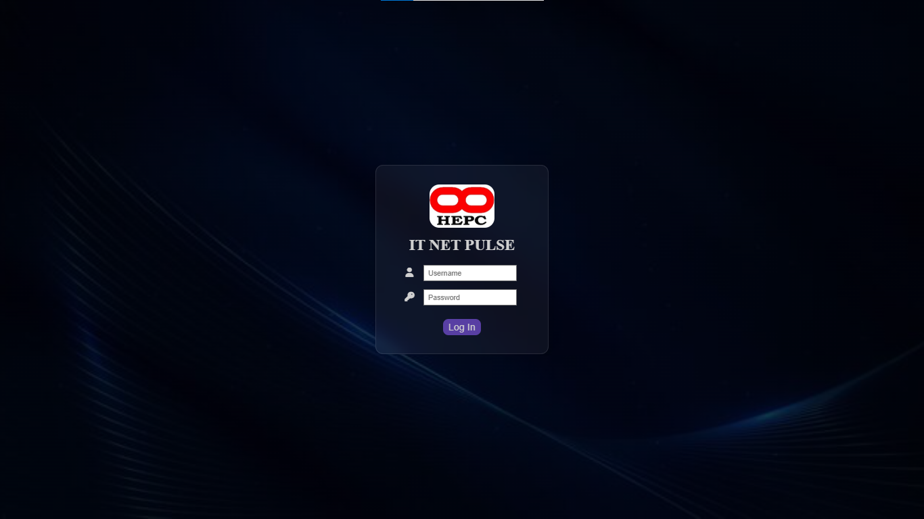
Net Pulse Login Page
- Default Credentials:
* Username: admin
* Password: adminpassword

(Note: You can change password directly in phpMyAdmin, just replace current password with a password_hashed version of your new password.)

Adding Additional Admins:
To maintain security, the system does not have a public registration page. To add more IT staff:
- Open phpMyAdmin.
- Go to the users table in the net_pulse database.
Select net_pulse database
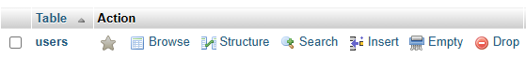
Click users table

- Click on the Insert tab.
- Fill in values for username and password (only insert a php hashed version of the password otherwise log in will fail).
- Leave the user_id and ping blank.
- Click Go. A new account has been registered and can be used for login.

Operational Guide
- The Dashboard: Provides a live "Pulse" of the network. The system uses latencyTracker.js to feed data into a Chart.js interface.
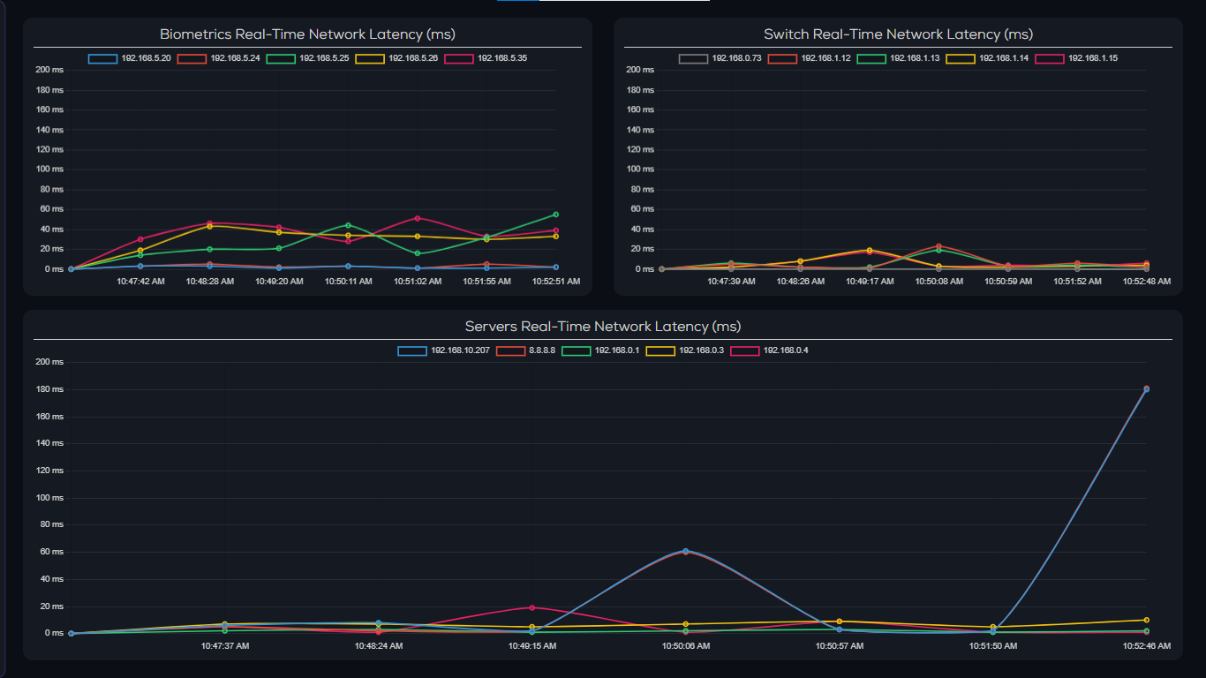
Latency charts in Dashboard

- Network Monitoring Pages: Illustrates network health of the corresponding devices or addresses of that web page:
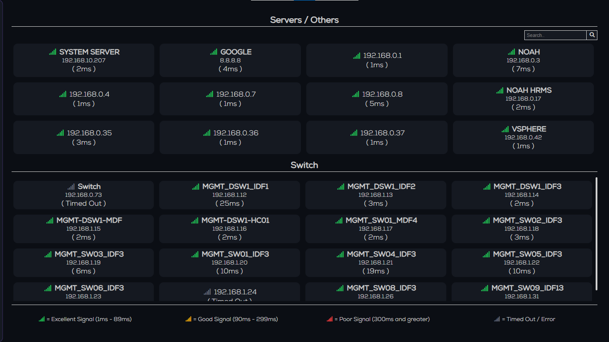IP Addresses Web Page displaying server and switch ips

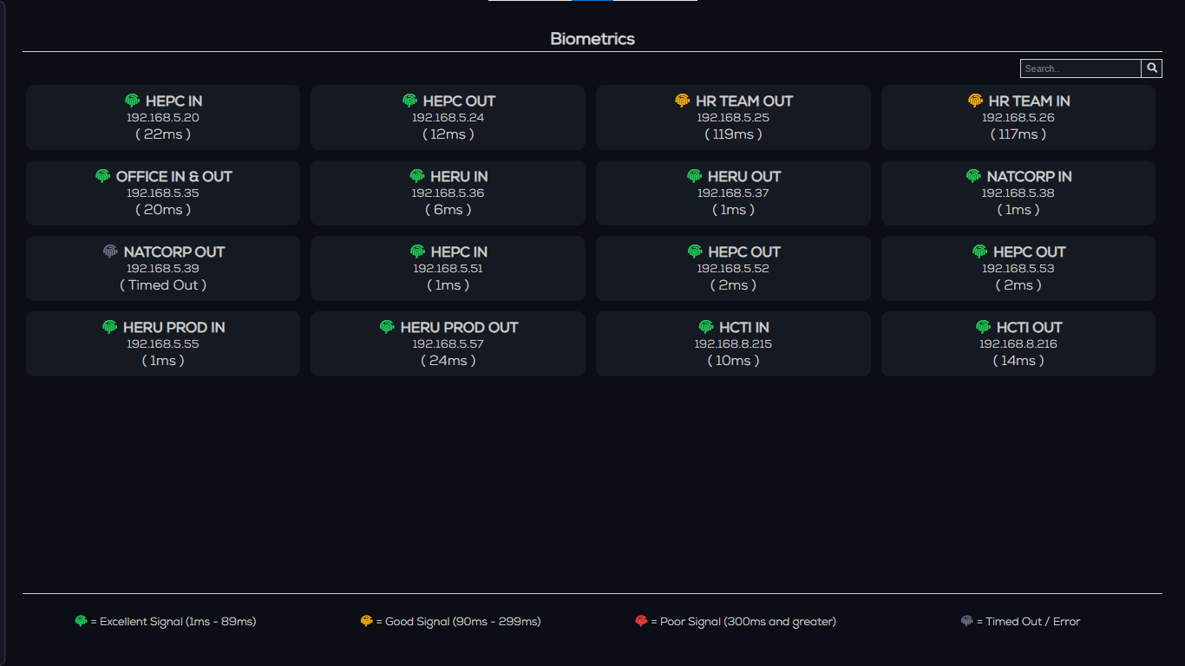
Biometrics page showing biometric devices

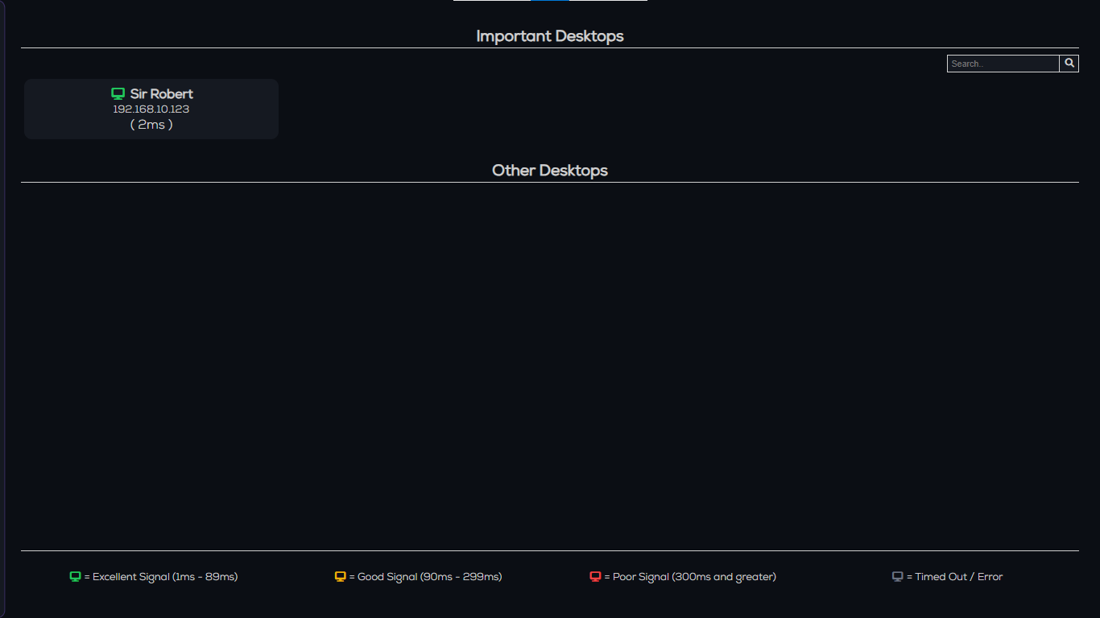
Desktops Page presenting connected desktops

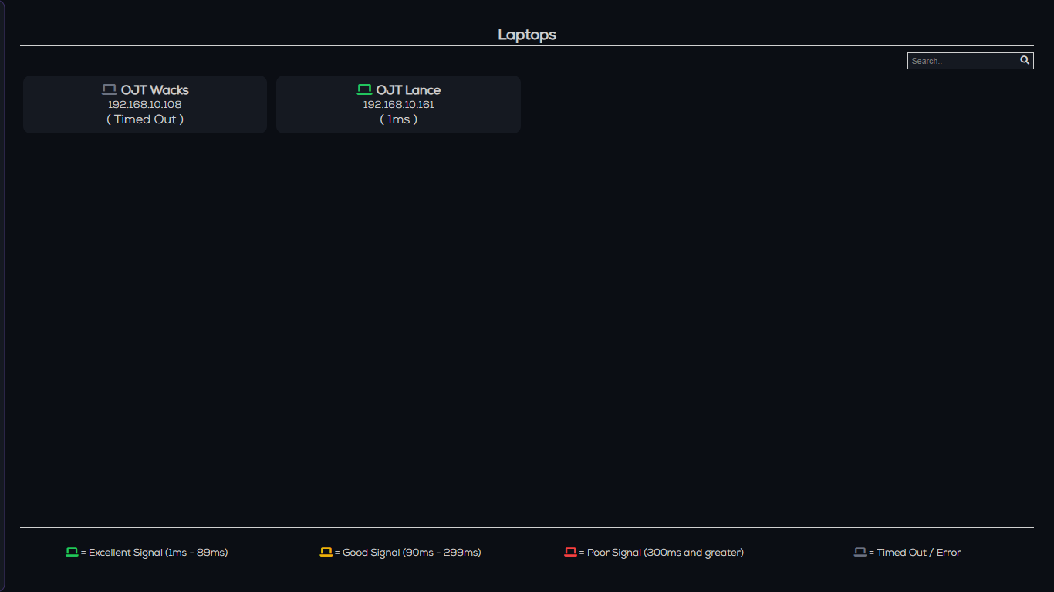
Laptops page showing connected laptops

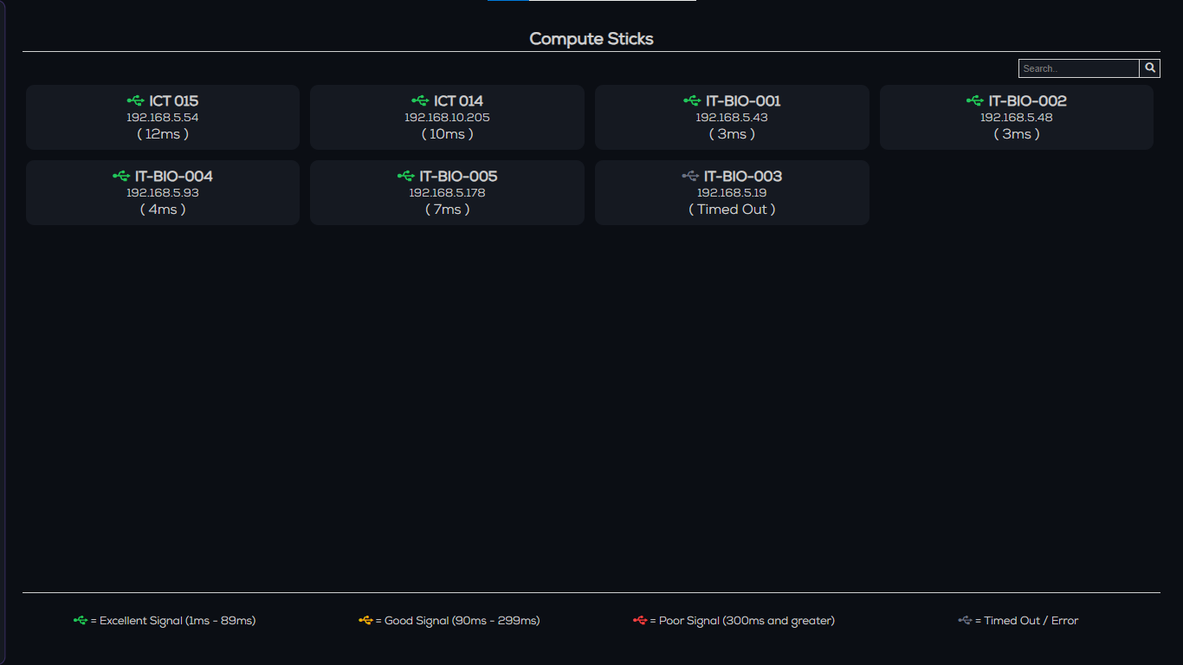
Compute Sticks page

- Asset Management: Use the Edit Addresses (click the hamburger menu on the bottom side of the navigation panel) page to modify the list of monitored hardware. The system reads from and writes to local .txt configuration files to keep the monitoring targets dynamic.
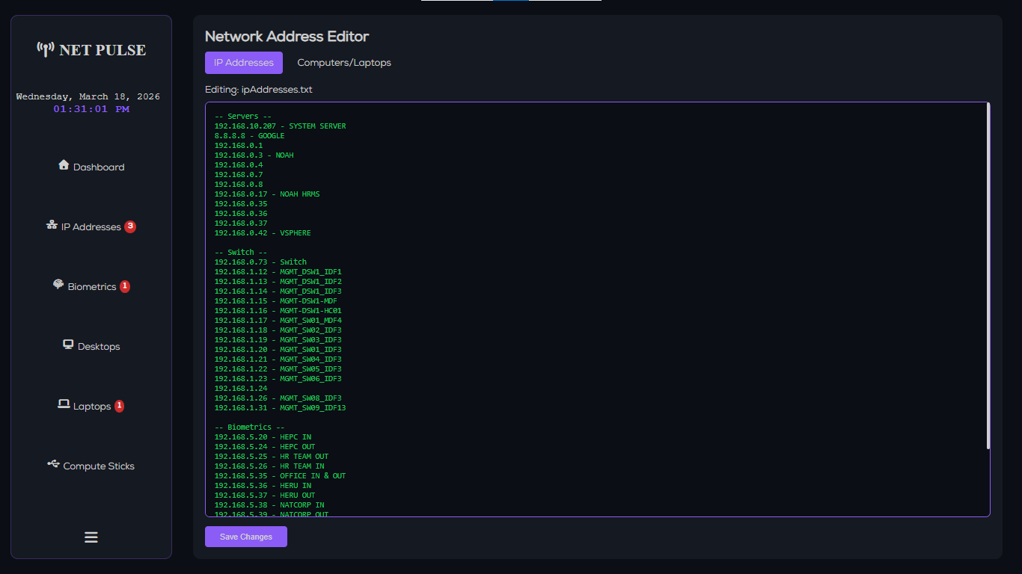
IP Address Network Editor page

- Log Auditing: Use Download Logs (click the hamburger menu on the bottom side of the navigation panel) to download and view historical connectivity logs to identify patterns in network downtime.
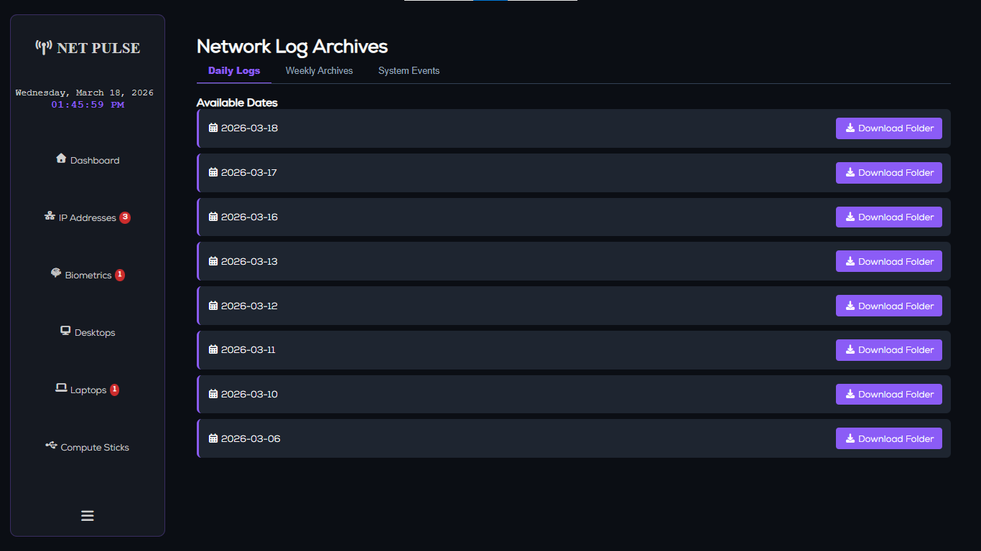
Daily logs download page

Alert System & Troubleshooting
The system includes an audio-visual alert mechanism (systemAlert.php) that triggers during critical failures.
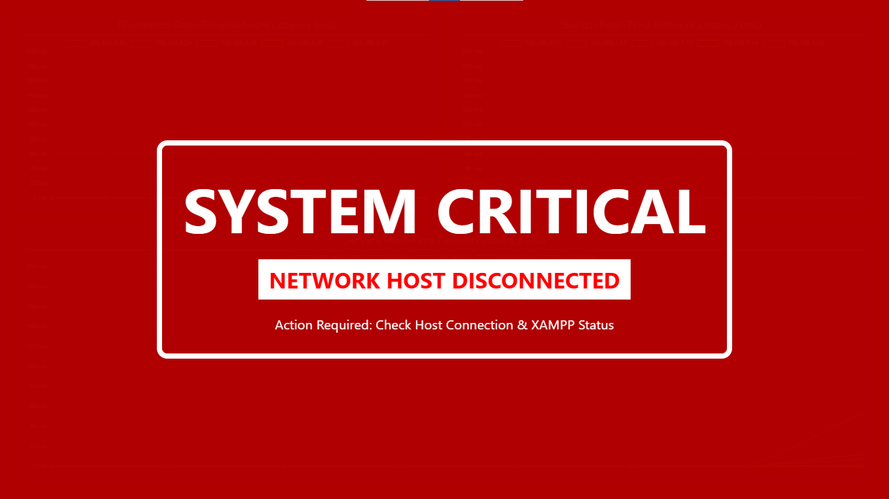
System Alert when host is offline

If the Alert Triggers:
- Check XAMPP Services: Ensure both Apache and MySQL are running.
- Verify exec() Permissions: The backend uses the PHP exec() command to run system pings. Ensure this is not disabled in your php.ini file.
- Network Scope: Ensure the server hosting the app is on a network segment that can "reach" the target IPs (Servers, Switches, Biometrics).
- Host Network Connectivity: Check if host device is connected to a valid network connection

The system also plays a short two-beep alarm when an ip returned as timed out or network status changed from online to offline. Number of offline devices is represented by a number badge
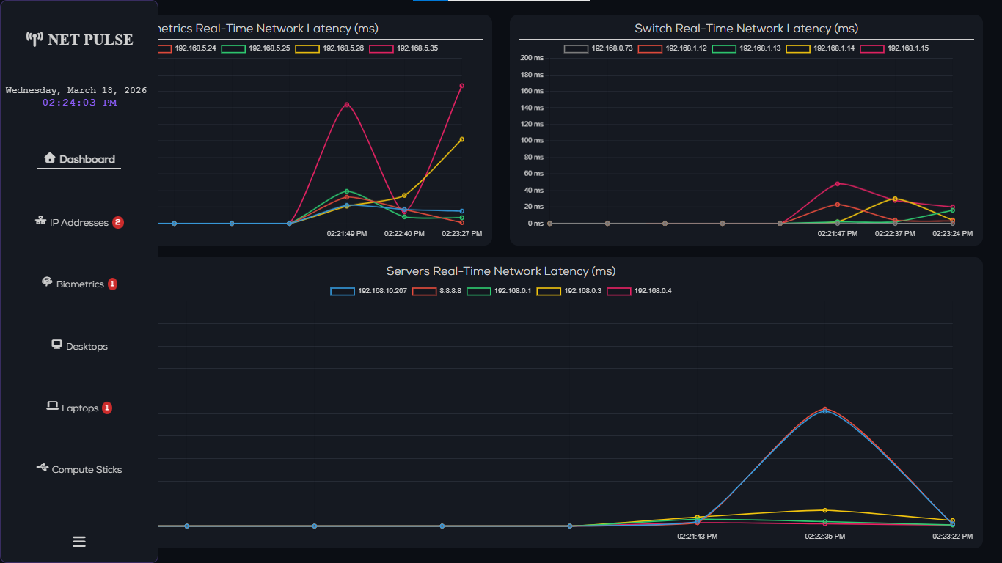
Navigation bar with number badges

Security & Stability
- Auto-Logout: A "Heartbeat" script (userHeartbeat.js) monitors admin activity. If the browser tab is closed and inactive for 15 seconds, the session is destroyed and user is automatically logged out for security.
- System Watchdog: A background script (systemWatchdog.js) ensures the application logic remains active and alerts the IT admin if the monitoring process stalls.

Note: When migrating to a permanent company server, ensure the folder permissions allow the web server (Apache) to write to the local text files and the database directory.

