**Unsupervised Machine Learning Homework – Cryptocurrency Clusters**

Marisa Kiger

University of Richmond

12/11/2021

**Conclusion/Recommendation:**

**The K-Means plot shows the elbow to be approximately at 4.**

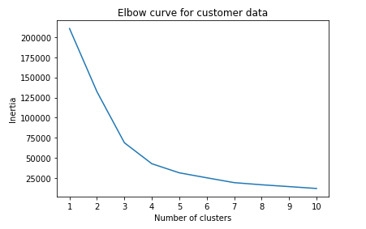

**Using 4 clusters for predictions and a learning rate of 250 the plot of TSNE features shows four distinct clusters. The client can reasonably cluster the cryptocurrencies using ideally 4 clusters.**

