Industrial Internship Report on
”Project Name” : Quiz Game
Prepared by
Mari Paramasivam S

Executive Summary
This report describes the Industrial Internship provided by upskill Campus and UniConverge Technologies Pvt Ltd (UCT).
During this internship, I developed a Quiz Game using Python. The project includes General Knowledge and Mathematics questions with scoring and feedback.
This internship helped me improve my programming skills, logical thinking, and understanding of real-world applications. Overall, it was a valuable learning experience.

TABLE OF CONTENTS
1 Preface 3
2 Introduction 4
2.1 About UniConverge Technologies Pvt Ltd 4
2.2 About upskill Campus 8
2.3 Objective 9
2.4 Reference 9
2.5 Glossary 10
3 Problem Statement 11
4 Existing and Proposed solution 12
5 Proposed Design/ Model 13
5.1 High Level Diagram (if applicable) 13
5.2 Low Level Diagram (if applicable) 13
5.3 Interfaces (if applicable) 13
6 Performance Test 14
6.1 Test Plan/ Test Cases 14
6.2 Test Procedure 14
6.3 Performance Outcome 14
7 My learnings 15
8 Future work scope 16

Preface

This internship helped me gain practical knowledge in Python programming. The project “Quiz Game” was developed to create an interactive system where users can answer questions and check their knowledge.
This program improved my logical thinking and coding skills. I thank upskill Campus and UCT for providing this opportunity.
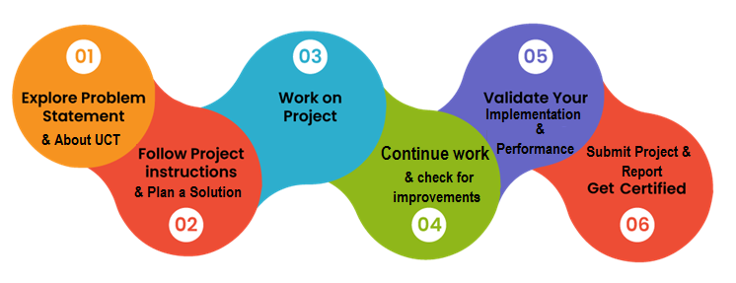

Introduction

About UniConverge Technologies Pvt Ltd
A company established in 2013 and working in Digital Transformation domain and providing Industrial solutions with prime focus on sustainability and RoI.
For developing its products and solutions it is leveraging various Cutting Edge Technologies e.g. Internet of Things (IoT), Cyber Security, Cloud computing (AWS, Azure), Machine Learning, Communication Technologies (4G/5G/LoRaWAN), Java Full Stack, Python, Front end etc.

- UCT IoT Platform ()
UCT Insight is an IOT platform designed for quick deployment of IOT applications on the same time providing valuable “insight” for your process/business. It has been built in Java for backend and ReactJS for Front end. It has support for MySQL and various NoSql Databases.
- It enables device connectivity via industry standard IoT protocols - MQTT, CoAP, HTTP, Modbus TCP, OPC UA
- It supports both cloud and on-premises deployments.
It has features to
• Build Your own dashboard
• Analytics and Reporting
• Alert and Notification
• Integration with third party application(Power BI, SAP, ERP)
• Rule Engine

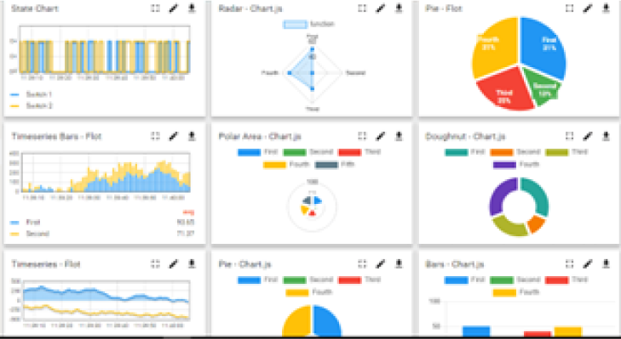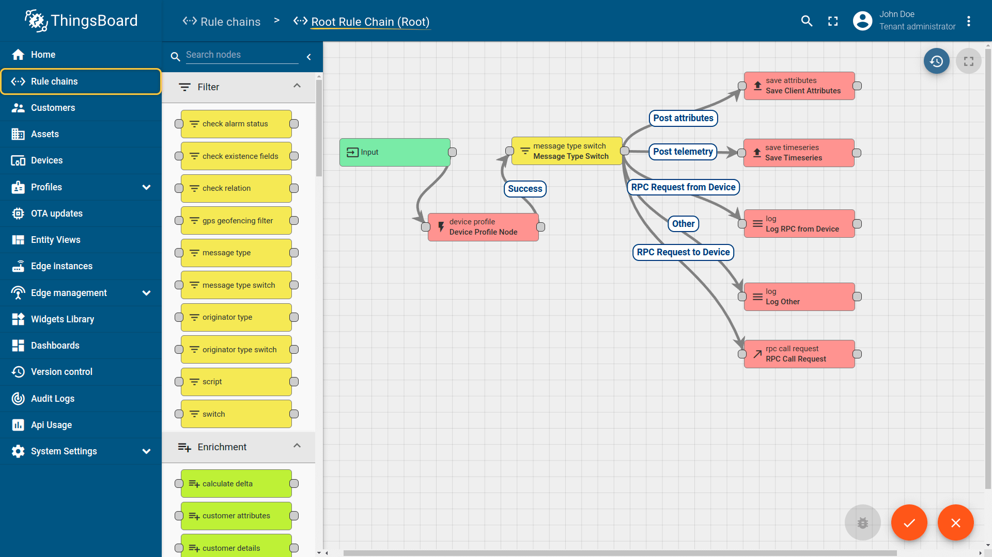

- Smart Factory Platform ()
Factory watch is a platform for smart factory needs.
It provides Users/ Factory
- with a scalable solution for their Production and asset monitoring
- OEE and predictive maintenance solution scaling up to digital twin for your assets.
- to unleased the true potential of the data that their machines are generating and helps to identify the KPIs and also improve them.
- A modular architecture that allows users to choose the service that they what to start and then can scale to more complex solutions as per their demands.
Its unique SaaS model helps users to save time, cost and money.
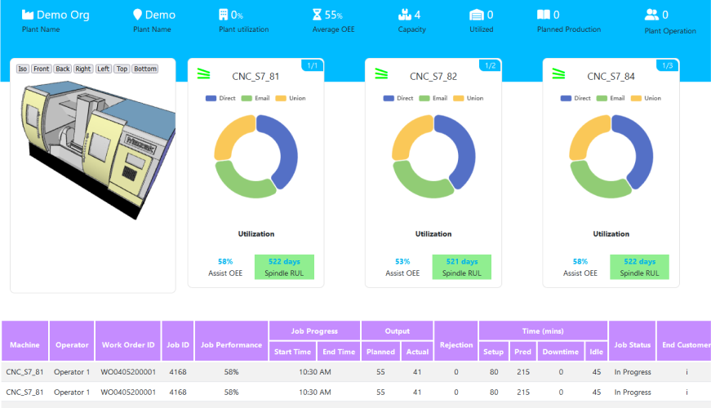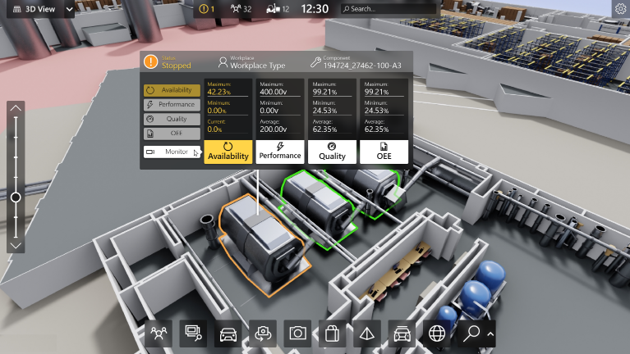

-  based Solution
UCT is one of the early adopters of LoRAWAN teschnology and providing solution in Agritech, Smart cities, Industrial Monitoring, Smart Street Light, Smart Water/ Gas/ Electricity metering solutions etc.
- Predictive Maintenance
UCT is providing Industrial Machine health monitoring and Predictive maintenance solution leveraging Embedded system, Industrial IoT and Machine Learning Technologies by finding Remaining useful life time of various Machines used in production process.
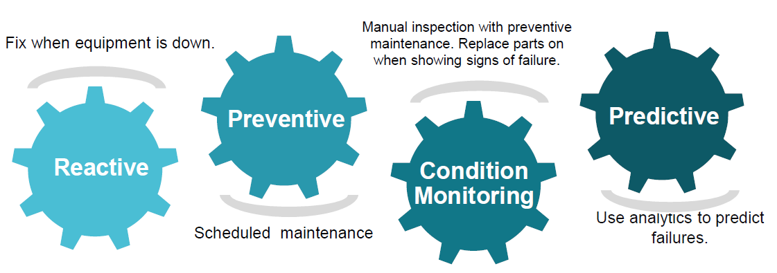

About upskill Campus (USC)
upskill Campus along with The IoT Academy and in association with Uniconverge technologies has facilitated the smooth execution of the complete internship process.
USC is a career development platform that delivers personalized executive coaching in a more affordable, scalable and measurable way.




Seeing need of upskilling in self paced manner along-with additional support services e.g. Internship, projects, interaction with Industry experts, Career growth Services
https://www.upskillcampus.com/
upSkill Campus aiming to upskill 1 million learners in next 5 year

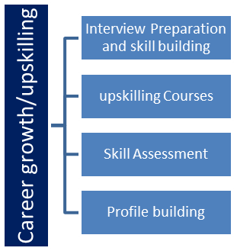
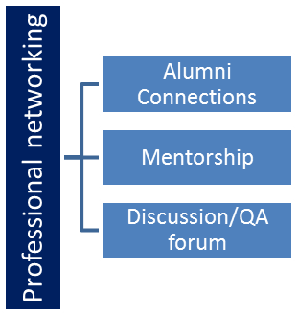
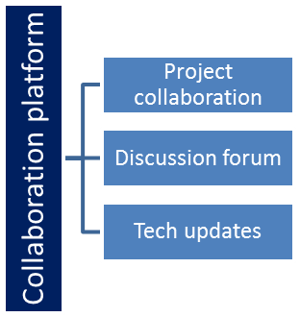
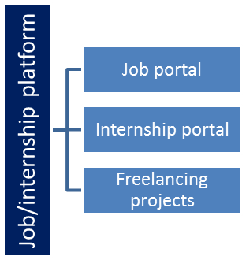

The IoT Academy
The IoT academy is EdTech Division of UCT that is running long executive certification programs in collaboration with EICT Academy, IITK, IITR and IITG in multiple domains.

Objectives of this Internship program
The objective for this internship program was to
☛ get practical experience of working in the industry.
☛ to solve real world problems.
☛ to have improved job prospects.
☛ to have Improved understanding of our field and its applications.
☛ to have Personal growth like better communication and problem solving.

Reference
[1] Python Official Website – https://www.python.org/⁠�
[2] GitHub – https://github.com/⁠�
[3] Colorama Library Documentation

Glossary
Terms | Acronym
Quiz Game | A program that asks questions and checks answers
Python | Programming language used in this project
Score | Marks obtained by user
Input | Data given by user
Output | Result shown by program

Problem Statement

In the assigned problem statement, the aim of this project is to develop a Quiz Game using Python. In today’s digital world, learning methods are changing from traditional methods to interactive systems. Many students find it difficult to learn through books alone, so there is a need for an engaging and interactive learning tool.
The Quiz Game helps users to test their knowledge in different areas such as General Knowledge and Mathematics. It provides a set of questions where users can answer and get immediate feedback. This makes learning more interesting and effective.
The main problem is to design a system that can take user input, check the answers, and calculate the score accurately. The system should be simple, user-friendly, and easy to use.
This project also focuses on improving logical thinking and programming skills. It helps in understanding how real-time applications work and how user interaction is handled in Python.
Thus, this Quiz Game is developed as a simple solution to make learning interactive, improve knowledge, and provide a better user experience.

Existing and Proposed solution

Provide summary of existing solutions provided by others, what are their limitations?
Many existing quiz systems are either manual or very basic programs. In manual methods, quizzes are conducted using paper, which takes more time to evaluate and does not provide instant results. Some simple digital quiz programs also exist, but they have limited features and are not very interactive.
The main limitations of existing systems are:
No instant feedback
Manual or slow score calculation
Less user interaction
Limited number of questions
No performance tracking

What is your proposed solution?
The proposed solution is to develop a Quiz Game using Python. This system allows users to answer questions from different categories such as General Knowledge and Mathematics.
It automatically checks answers, calculates scores, and provides immediate feedback. The system is designed to be simple, interactive, and easy to use.

What value addition are you planning?
The proposed system provides several improvements:
Automatic score calculation
Instant feedback to users
Large number of questions
Timer for each question
Performance tracking
User-friendly interface
This makes the quiz more engaging and useful for learning.

Code submission (Github link) :
https://github.com/MarishwaranOffice/UpskillCampus/blob/main/quiz_game.py

Report submission (Github link) :

https://github.com/MarishwaranOffice/UpskillCampus/blob/main/QuizGame_MariParamasivamS_USC_UCT.pdf

Proposed Design/ Model

The proposed system is designed as a Quiz Game using Python. The system follows a simple flow where the user selects a quiz category, answers questions, and receives a score at the end.
The program starts by displaying the quiz options such as General Knowledge and Mathematics. After selecting the category, questions are shown one by one. The user enters the answer, and the system checks whether it is correct or not.
The system keeps track of the score and displays the final result after all questions are completed. It also provides feedback based on the performance of the user.
The design of the system is simple, user-friendly, and easy to understand. It ensures smooth interaction between the user and the program.

High Level Diagram (if applicable)

User → Quiz Game System → Questions → User Input → Score → Result

Figure 1: HIGH LEVEL DIAGRAM OF THE SYSTEM

Low Level Diagram (if applicable)

Start → Select Quiz → Display Question → Get Answer → Check Answer → Update Score → Next Question → End

Performance Test

This section explains the performance of the Quiz Game system and how it works efficiently like a real-world application.
The main constraints considered in this project are accuracy, speed, memory usage, and user interaction. The system must correctly check answers, respond quickly, and handle user inputs without errors.
To handle these constraints, the program uses simple and efficient logic. It checks answers accurately using conditions and provides quick output without delay. The memory usage is low because only required data is stored. The system is designed to be user-friendly and easy to operate.
The testing shows that the system performs well under normal conditions. It gives correct results and runs smoothly. Even though advanced constraints like power consumption are not tested, they have minimal impact on this type of application.
Some improvements can be made in future, such as adding a database, improving interface, and increasing performance for large data.

Test Plan/ Test Cases
Verify question display
Verify user input handling
Check correct answer validation
Check wrong answer handling
Verify score calculation
Test program without errors

Test Procedure
The program was tested by running it multiple times with different inputs. Various test cases were used to check all functionalities like question display, answer checking, and score calculation. Both correct and incorrect inputs were tested.

Performance Outcome
The system performed successfully during testing. It displayed questions correctly, accepted inputs properly, and calculated scores accurately. The program runs smoothly without any major errors and provides correct output.

My learnings

During this internship, I learned many important concepts in Python programming. I understood how to take user input, process data, and display output correctly.
I improved my logical thinking and problem-solving skills while developing the Quiz Game project. I also learned how to design a simple application and test it properly.
This internship helped me gain practical knowledge and confidence in developing real-time projects.

Future work scope

The Quiz Game can be further improved by adding more advanced features. A graphical user interface (GUI) can be implemented to make the system more attractive and user-friendly.

A database can be added to store questions and user scores permanently. More categories and difficulty levels can also be included to enhance the user experience.
Additionally, the system can be developed as a web or mobile application for better accessibility.

