**Vanier College**

**Computer Science Department**

**420-320-VA Database I**

**Fall 2018**

**Lab/Assignment Number and Title:** Lab 1

**Submitted by:**

**Student Name:** Marissa Gonçalves

**Student ID:** 1775227

**Step 0 :**

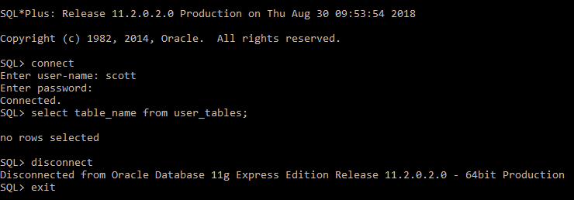

**Step 1 :**

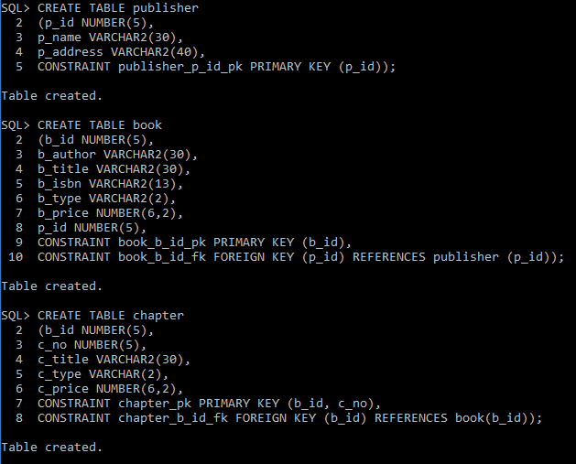

**Step 2 :**

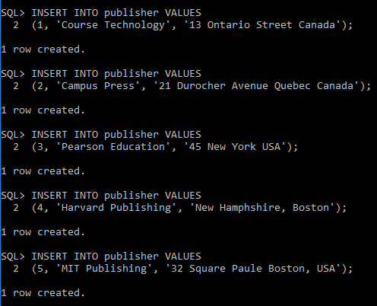

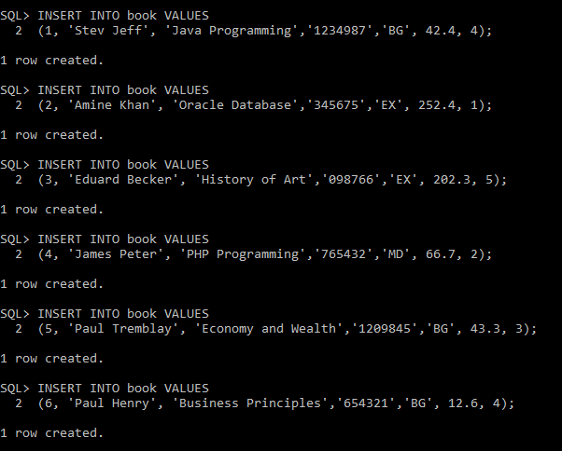

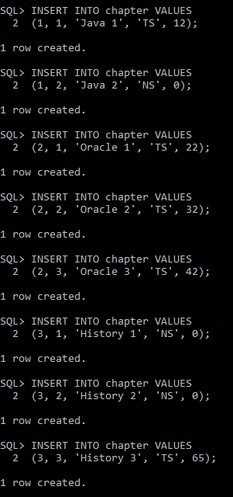

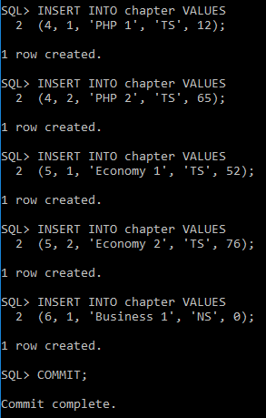

**Step 3 :**



