**Vanier College**

**Computer Science Department**

**420-320-VA Database I**

**Fall 2018**

**Lab/Assignment Number and Title:** Lab 3

**Submitted by:**

**Student Name:** Marissa Gonçalves

**Student ID:** 1775227

**1.a)**

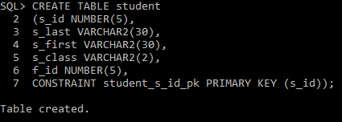

**b)**

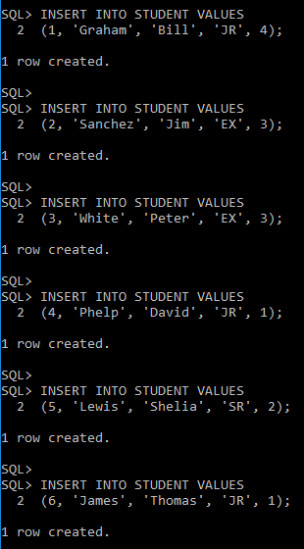

**c)**

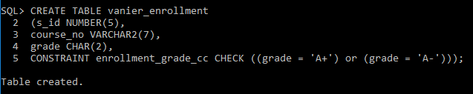

**d)**

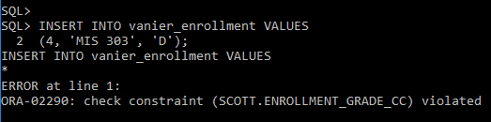

**2.a)**

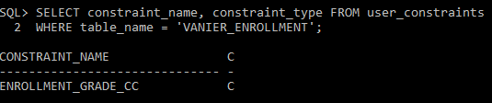

**3.a)**

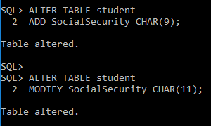

**b)**

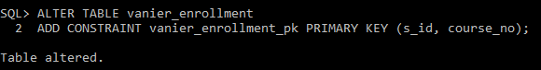

**c)**

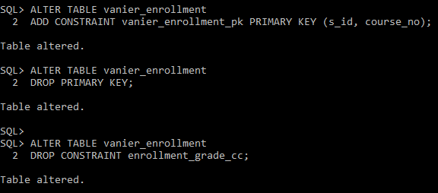

**d)**

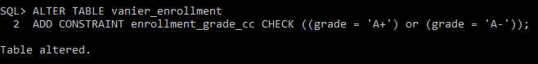

**e)**

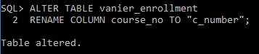

**4.a)**

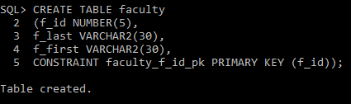

**b)**

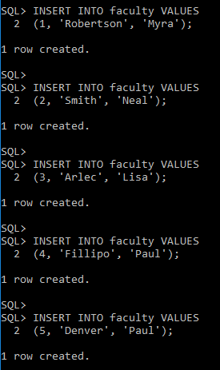

**c)**

This command selects the two columns f_last (renamed to Faculty Last) and f_first (renamed FacultyFirst), located in the faculty table.

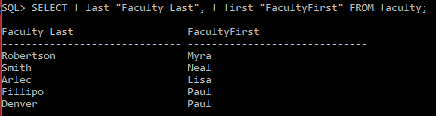

This command selects the two columns f_last and f_first, located in the faculty table. It displays the columns close to one another, mentioned by the characters “||”.

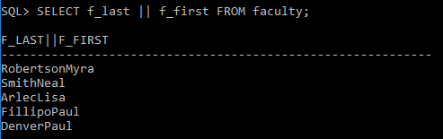

This command selects the unique records from the f_last column located from the faculty table.

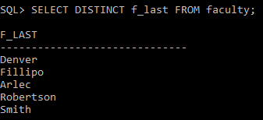

This command selects the f_last and f_first columns located from the faculty table. It asks for a specific record where the faculty ID (f_id) is the value 4.

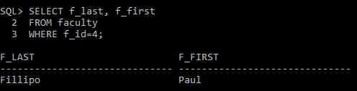

These commands select the f_id, f_last, f_first columns located from the faculty table. It asks for specific records where the faculty ID (f_id) is between 2 to 4 inclusive. Both commands determine the same output: one uses numerical operators (>= and <=), while the other uses Boolean operators (AND).

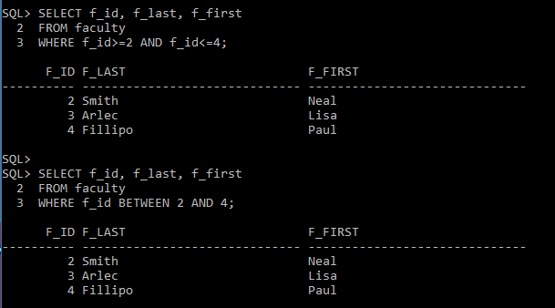

This command selects the f_id, f_last, f_first columns located from the faculty table. It asks for specific records where the faculty ID (f_id) is 2, 4 and 6.

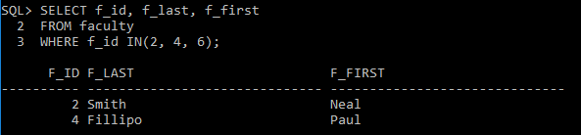

This command selects the f_id, f_last, f_first columns located from the faculty table. It asks for specific records where the faculty ID (f_id) is not 2, 4 and 6. Instead, the output produces the IDs, 1, 3 and 5.

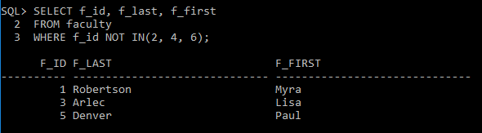

This command selects the f_id, f_last, f_first columns located from the faculty table. It asks for specific records where the first name (f_first) starts with capital “P”.

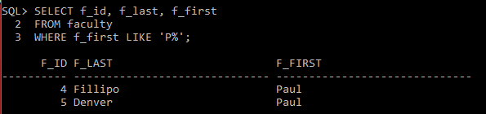

This command selects the f_id, f_last, f_first columns located from the faculty table. It displays all records in order based on the first name starting from Z to A, which explains why the order is descending (DESC).

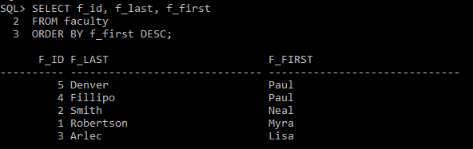

This command selects the book ID (b_id) column and sums the chapter prices (c_price) from the chapter table, grouped by each of the book IDs.

