**Vanier College**

**Computer Science Department**

**420-320-VA Database I**

**Fall 2018**

**Lab/Assignment Number and Title:** Lab 4

**Submitted by:**

**Student Name:** Marissa Gonçalves

**Student ID:** 1775227

**1.**





**2.a)**

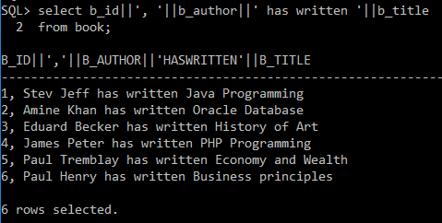

**b)**

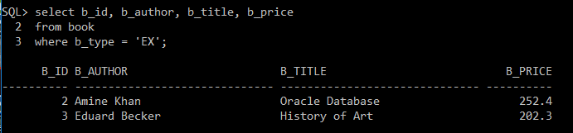

**c)**

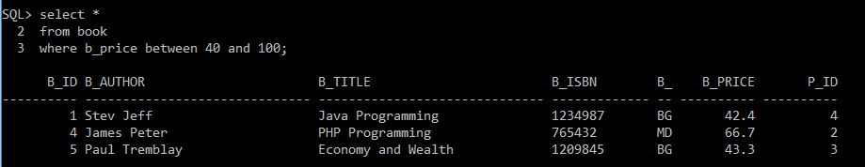

**d)**

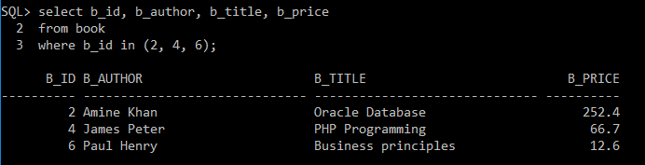

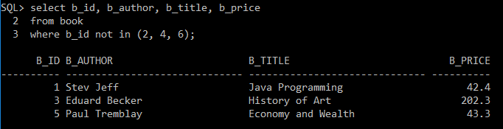

**e)**

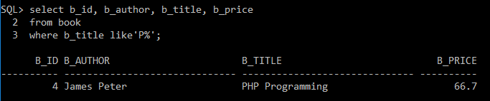

**f)**

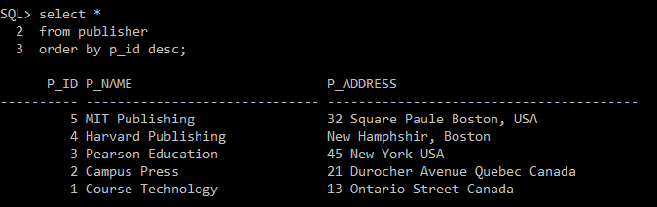

**g)**

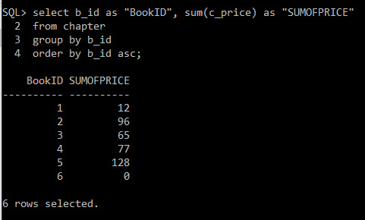

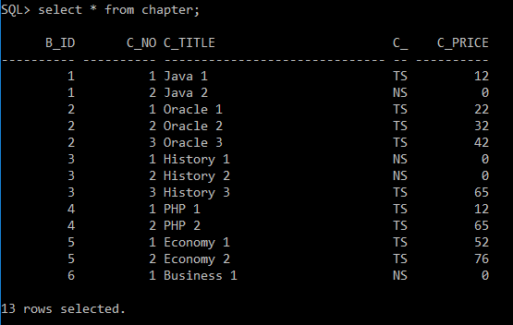

**h)**

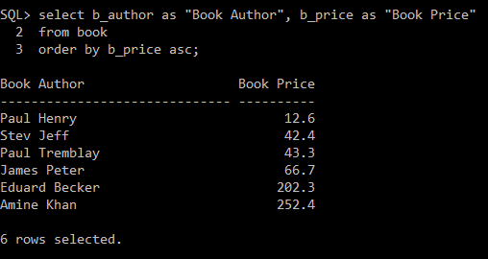

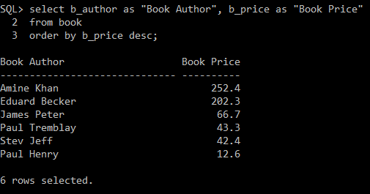

**i)**

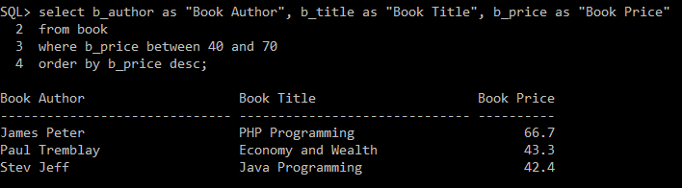

**j)**

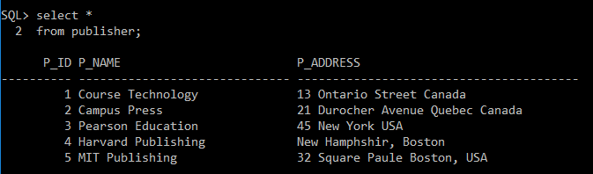

**k)**

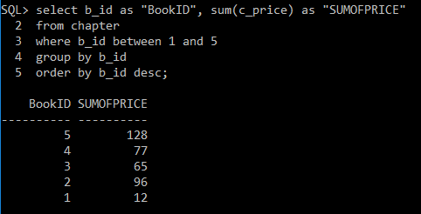

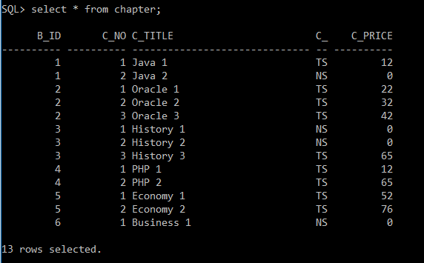

**l)**

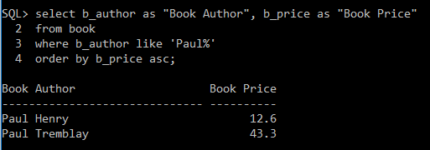

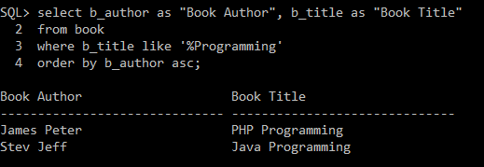

**m)**

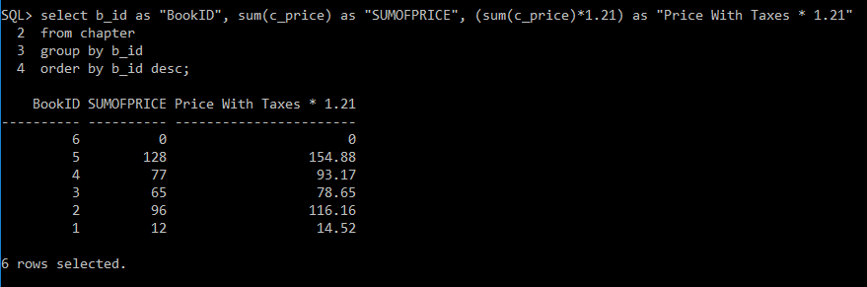

**n)**

